Course Code: CSA1305 Name: Elango M (192411026)
Faculty : Dr Balamanigandan R
EXPERIMENT NO: 11
Title
DESIGN A PUSH DOWN AUTOMATA (PDA) USING SIMULATOR TO ACCEPT THE STRING $a^{n}b^{2n}$
Aim
To design a Push Down Automata (PDA) using the AutoSim simulator to accept the language $a^{n}b^{2n}$.
Software Used
- AutoSim (Automata Simulator)
- Windows Operating System
Procedure
- Open the AutoSim software.
- Select Push Down Automata (PDA).
- Create the required states.
- Set the initial state.
- Mark the accepting (final) state.
- Define the stack alphabet.
- Add the PDA transitions for input symbols a and b.
- Save the PDA.
- Run the simulation.
- Enter the input strings.
- Verify whether the strings are accepted or rejected.

Algorithm
- Start.
- Read the input string.
- Push one stack symbol (for example, A) for every input a.
- After all as are read, process the bs.
- For every two bs, pop one A from the stack.
- Continue until the input is completely processed.
- If the stack contains only the bottom symbol and the input is exhausted, accept the string.
- Otherwise, reject the string.
- Stop.
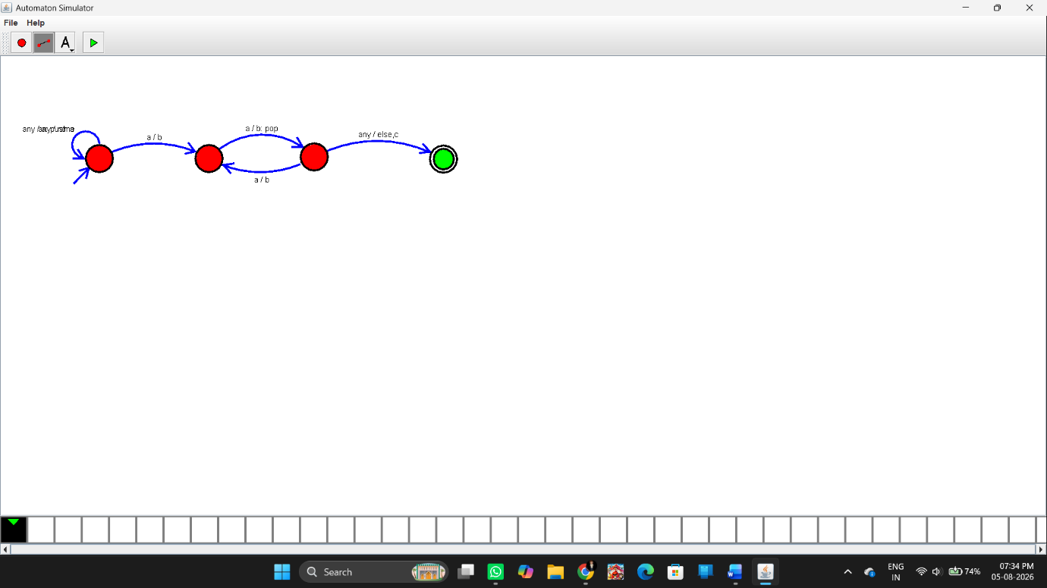Sample Input and Output:
Test Case 1
Input
abb
Output
Accepted
Result
Thus, the Push Down Automata (PDA) was successfully designed using the AutoSim simulator to accept the language $a^{n}b^{2n}$and correctly accepted or rejected the given input strings based on the language specification.

