Course Code: CSA1305 Name: Elango M (192411026)
Faculty: Dr Balamanigandan R
EXPERIMENT NO: 31
Title
Design DFA using simulator to accept even number of c's over the set {a,b,c}
This is the exact Experiment 31 listed in your lab manual.
Aim
To design a Deterministic Finite Automaton (DFA) using the simulator to accept strings containing an even number of c's over the alphabet {a,b,c}.
Software Used
- AutoSim / Automaton Simulator
- Windows Operating System
Procedure
- Open AutoSim / Automaton Simulator.
- Select DFA.
- Create two states:
  - q0 – even number of c's
  - q1 – odd number of c's
- Set q0 as the initial state.
- Mark q0 as the final state.
- For input c, toggle between q0 and q1.
- For inputs a and b, remain in the same state because they do not affect the number of c's.
- Enter the input string.
- Run the DFA.
- If the machine finishes in q0, the string is accepted.
Algorithm
- Start in state q0.
- Read the input string from left to right.
- If the input is a or b, remain in the current state.
- If the input is c:
  - q0 → q1
  - q1 → q0
- Continue until the complete input is read.
- If the final state is q0, Accept.
- If the final state is q1, Reject.
- Stop.
DFA Transition Table
Current State | a | b | c
→ ★ q0 | q0 | q0 | q1
q1 | q1 | q1 | q0
- q0 = Initial and Final state
- q1 = Odd number of c's
Easy way to remember
q0 --c--> q1
q1 --c--> q0
For a and b, stay in the same state.
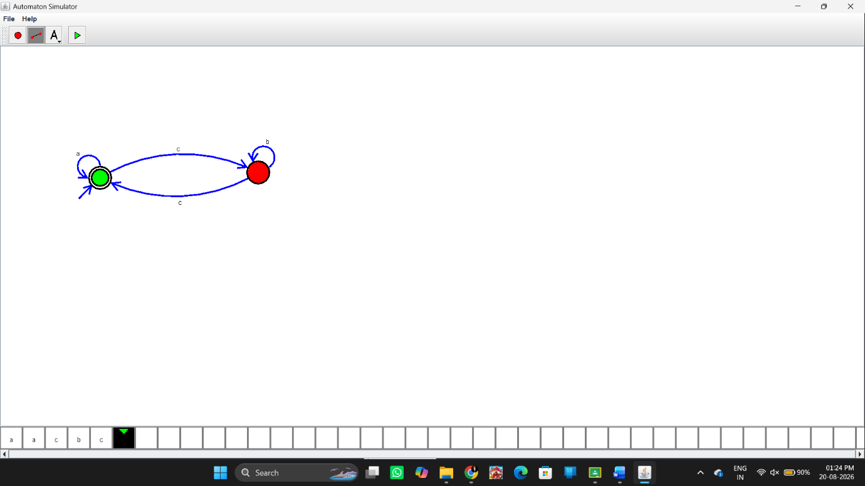Input
You can test strings such as:
Test Case 1
abccab
Number of c's = 2 → Even.
Output:
String Accepted
Test Case 2
abc
Number of c's = 1 → Odd.
Output:
String Not Accepted
Test Case 3
aabccbcc
Number of c's = 4 → Even.
Output:
String Accepted
Input / Output Table
Input | Number of c's | Output
abccab | 2 | Accepted
abc | 1 | Not Accepted
aabccbcc | 4 | Accepted
cc | 2 | Accepted
ccc | 3 | Not Accepted
Result
Thus, the DFA was successfully designed using the simulator to accept strings containing an even number of c's over {a,b,c}.

