Course Code: CSA1305 Name: Elango M (192411026)
Faculty: Dr Balamanigandan R
EXPERIMENT NO: 32
Title
Design DFA using simulator to accept strings in which a's always appear tripled over input {a,b}
The manual specifies the test strings:
aaa
ababa
Aim
To design a Deterministic Finite Automaton (DFA) using the simulator to accept strings in which a's always appear tripled, over the input alphabet {a,b}.
Software Used
- AutoSim / Automaton Simulator
- Windows Operating System
Procedure
- Open AutoSim / Automaton Simulator.
- Select DFA.
- Create states to track the number of consecutive a's:
  - q0 – no a currently being counted
  - q1 – one a
  - q2 – two a's
  - q3 – three a's
- Set q0 as the initial state.
- Make q0 and q3 accepting states if zero or multiples of three a's are allowed between b's.
- Add transitions for a and b.
- Enter the test string.
- Run the DFA.
- Check whether the machine ends in an accepting state.
- Record the output.
Algorithm
- Start at q0.
- Read the input from left to right.
- When a is read:
  - q0 → q1
  - q1 → q2
  - q2 → q3
- After three consecutive a's, return to q0 when b is encountered.
- For b, reset the a counting sequence.
- If an incomplete group of a's remains at the end, reject.
- If every group of a's contains exactly three a's, accept.
Important
The manual's phrase “a's always appear tripled” means groups such as:
aaa
or:
aaabaaa
are valid, while:
a
aa
aaaa
contain an incomplete group and are rejected.
DFA Transition Table
For groups of exactly three consecutive a's separated by b:
Current State | a | b
→ ★ q0 | q1 | q0
q1 | q2 | Dead
q2 | q3 | Dead
★ q3 | Dead | q0
Dead | Dead | Dead
- q0 = Initial/accepting state
- q1 = One a
- q2 = Two a's
- q3 = Three a's
- Dead = Invalid pattern
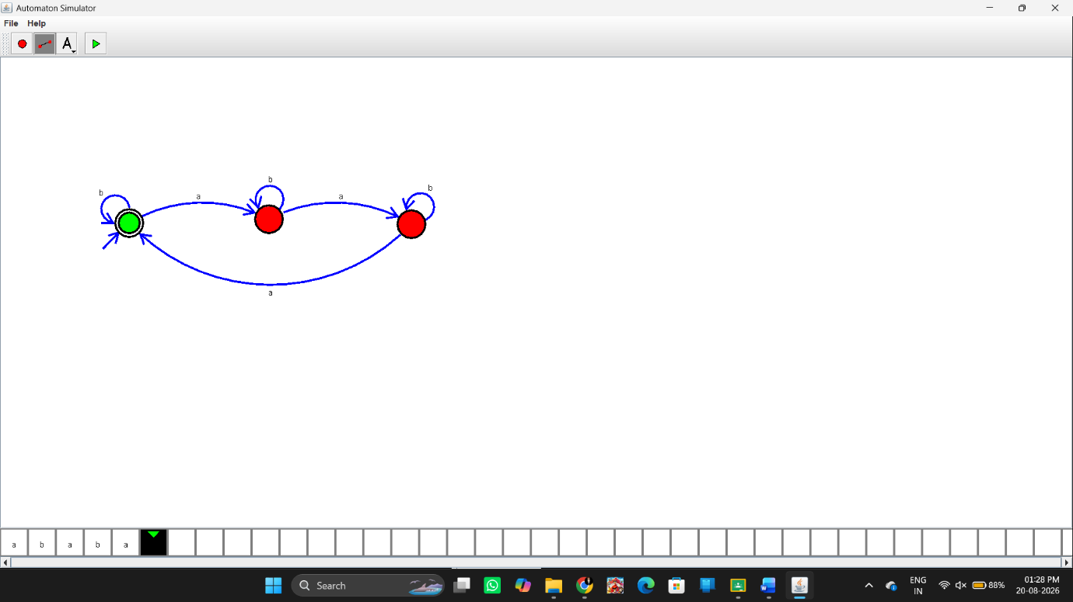Input
Test Case 1
aaa
This contains exactly three a's.
Output:
String Accepted
Test Case 2
ababa
This contains individual a's separated by b's, so the a's do not occur in groups of three.
Output:
String Not Accepted
The two test strings are the ones specified in the manual.
Input / Output Table
Input | Result
aaa | Accepted
ababa | Not Accepted
aaabaaa | Accepted
aab | Not Accepted
aaaa | Not Accepted
Result
Thus, the DFA was successfully designed using the simulator to accept strings in which a's always appear tripled over the input {a,b}. The specified input aaa is accepted, while ababa is not accepted.

