Course Code: CSA1305 Name: Elango M (192411026)
Faculty: Dr Balamanigandan R
EXPERIMENT NO: 33
Title
Design NFA using simulator to accept the string that starts with a and ends with b over the set {a,b} and check whether W = abaab is accepted or not.
Aim
To design a Non-Deterministic Finite Automaton (NFA) using the simulator to accept strings that start with a and end with b over the alphabet {a,b}, and to check whether the string abaab is accepted.
Software Used
- AutoSim / Automaton Simulator
- Windows Operating System
Procedure
- Open AutoSim / Automaton Simulator.
- Select NFA.
- Create the required states.
- Set q0 as the initial state.
- Create transitions for a and b.
- The first transition must ensure that the string starts with a.
- Use the NFA transitions to allow any combination of a and b in the middle.
- Make the state representing the final b an accepting state.
- Enter the input:
abaab
- Run the NFA.
- Check whether an accepting state is reached after the complete input is processed.
Algorithm
- Start at q0.
- Read the first symbol.
- If the first symbol is a, move to the next state.
- Allow a or b in the middle of the string.
- Ensure the final symbol is b.
- If the string starts with a and ends with b, accept.
- Otherwise, reject.
NFA Transition Table
A simple NFA can be designed as:
Current State | a | b
→ q0 | q1 | —
q1 | q1 | q1, q2
★ q2 | — | —
Here:
- q0 = Initial state
- q1 = Middle portion
- q2 = Final/accepting state
- The transition q1 --b--> q2 allows the NFA to guess that a particular b is the final symbol.
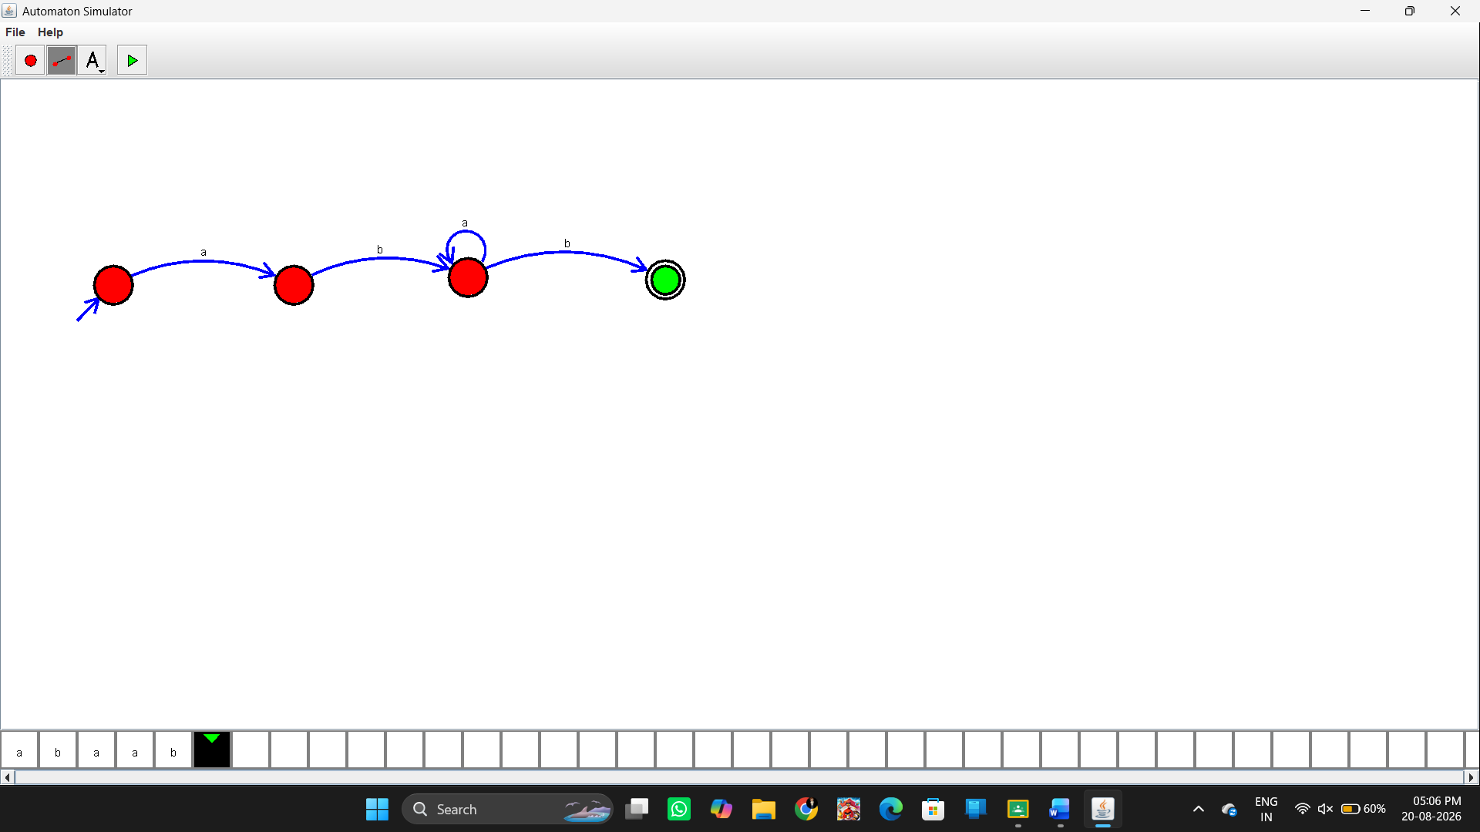Input
The manual specifies:
abaab
Checking the string
a b a a b
↑ ↑
start end
- First symbol = a ✅
- Last symbol = b ✅
Therefore:
abaab → Accepted
Output
Input: abaab
String Accepted

Result
Thus, the NFA was successfully designed using the simulator to accept strings starting with a and ending with b over {a,b}. The given string abaab is accepted.

