Course Code: CSA1305 Name: Elango M (192411026)
Faculty: Dr Balamanigandan R
EXPERIMENT NO: 34
Title
Design NFA using simulator to accept the string that starts and ends with different symbols over the input {a,b}.
Aim
To design a Non-Deterministic Finite Automaton (NFA) using the simulator to accept strings that start and end with different symbols over the alphabet {a,b}.
Software Used
- AutoSim / Automaton Simulator
- Windows Operating System
Procedure
- Open AutoSim / Automaton Simulator.
- Select NFA.
- Create the required states.
- Set the initial state.
- Create final states for strings beginning with a and ending with b, or beginning with b and ending with a.
- Add transitions for a and b.
- Allow any combination of a and b in the middle.
- Enter the input string.
- Run the NFA.
- Check whether the machine reaches a final state.
- Record the output.
Algorithm
- Start at the initial state.
- Read the first symbol.
- If the first symbol is a, follow the branch that expects the final symbol to be b.
- If the first symbol is b, follow the branch that expects the final symbol to be a.
- Allow a and b in the middle of the string.
- Check the last symbol.
- If the first and last symbols are different, Accept.
- If they are the same, Reject.
- Stop.
NFA Design
You can make two branches:
Branch 1: Starts with a, ends with b
q0 --a--> q1
q1 --a,b--> q1
q1 --b--> qF
Branch 2: Starts with b, ends with a
q0 --b--> q2
q2 --a,b--> q2
q2 --a--> qF
qF is the final state.
Important: In an NFA, the transition from q1 on b and from q2 on a can nondeterministically choose the final-state path.
Transition Table
State | a | b
→ q0 | q1 | q2
q1 | q1 | {q1,qF}
q2 | {q2,qF} | q2
★ qF | — | —
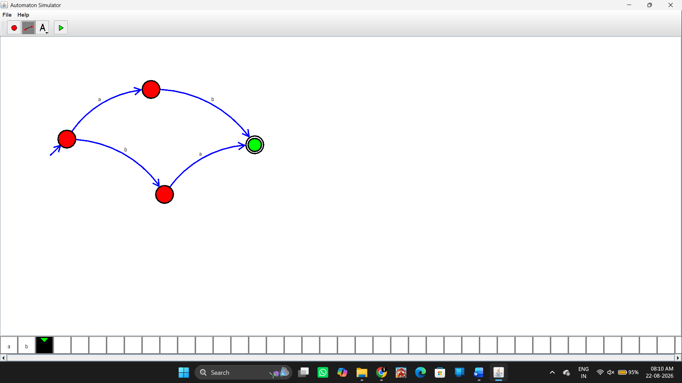Input and Output
Test Case 1
Input:
aab
First symbol = a
Last symbol = b
Output:
String Accepted
Test Case 2
Input:
bba
First symbol = b
Last symbol = a
Output:
String Accepted
Test Case 3
Input:
aba
First symbol = a
Last symbol = a
Output:
String Not Accepted
Test Case 4
Input:
abb
First symbol = a
Last symbol = b
Output:
String Accepted
Input / Output Table
Input | First | Last | Result
aab | a | b | Accepted
bba | b | a | Accepted
abb | a | b | Accepted
aba | a | a | Rejected
bab | b | b | Rejected
aa | a | a | Rejected
Result
Thus, the NFA was successfully designed using the simulator to accept strings whose first and last symbols are different over the input alphabet {a,b}.

