Course Code: CSA1305 Name: Elango M (192411026)
Faculty: Dr Balamanigandan R
EXPERIMENT NO: 35
Title
Design DFA to accept the language , where the number of a's minus the number of b's is less than or equal to 2.
This is the exact Experiment 35 statement in your lab manual.
Aim
To design a Deterministic Finite Automaton (DFA) to accept the regular language consisting of strings over {a,b} for which:
Software Used
- AutoSim / Automaton Simulator
- Windows Operating System
Procedure
- Open AutoSim / Automaton Simulator.
- Select DFA.
- Create states representing the difference between the number of a's and b's.
- Take q0 as the initial state, representing difference 0.
- On reading a, increase the difference by 1.
- On reading b, decrease the difference by 1.
- States corresponding to differences ≤ 2 are accepting.
- Create a rejecting/dead state for a difference greater than 2.
- Enter the input string.
- Run the DFA.
- If the final state represents a difference ≤ 2, accept the string.
- Otherwise, reject it.
Algorithm
- Start with difference d = 0.
- Read the input string character by character.
- If the symbol is a, increment the difference:
d = d + 1
- If the symbol is b, decrement the difference:
d = d - 1
- Continue until the entire input is read.
- If:
d <= 2
accept the string.
- If:
d > 2
reject the string.
- Stop.
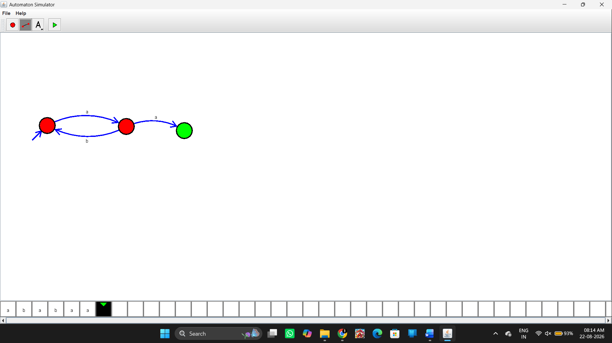
Input
The manual does not specify a particular input string for Experiment 35.
For understanding the condition, examples are:
Example 1
aab
Number of a's = 2
Number of b's = 1
Accepted
Example 2
aaa
Number of a's = 3
Number of b's = 0
Rejected
Example 3
aabb
Accepted
Input / Output
Input | #a | #b | #a − #b | Result
aab | 2 | 1 | 1 | Accepted
aabb | 2 | 2 | 0 | Accepted
ab | 1 | 1 | 0 | Accepted
aaa | 3 | 0 | 3 | Rejected
aaaa | 4 | 0 | 4 | Rejected
Result
Thus, the DFA was designed to accept strings satisfying the condition that the number of a's minus the number of b's is less than or equal to 2, as specified in Experiment 35 of the lab manual.

