Course Code: CSA1305 Name: Elango M (192411026)
Faculty: Dr Balamanigandan R
EXPERIMENT NO: 36
Title
Design DFA using simulator to accept the string that ends with abc over the set {a,b,c}
The manual specifies the test string:
abbaababc
Aim
To design a Deterministic Finite Automaton (DFA) using the simulator to accept strings that end with abc over the alphabet {a,b,c}.
Software Used
- AutoSim / Automaton Simulator
- Windows Operating System
Procedure
- Open AutoSim / Automaton Simulator.
- Select DFA.
- Create the required states.
- Set q0 as the initial state.
- Create states to remember the progress toward the ending sequence abc.
- Mark the state reached after reading the final c of abc as the accepting state.
- Add transitions for a, b, and c.
- Enter the input string:
abbaababc
- Run the DFA.
- Check whether the machine finishes in the accepting state.
- Record the output.
Algorithm
- Start at q0.
- Read the input from left to right.
- Track whether the latest symbols form:
  - nothing useful,
  - a,
  - ab,
  - abc.
- When a is detected as the beginning of the final sequence, move to the a state.
- When b follows it, move to the ab state.
- When c follows ab, move to the final state.
- Accept only if abc occurs at the end of the input.
- Otherwise, reject.
DFA Transition Table
A suitable DFA is:
Current State | a | b | c
→ q0 | q1 | q0 | q0
q1 | q1 | q2 | q0
q2 | q1 | q0 | q3
★ q3 | q1 | q0 | q0
- q0 → Initial state
- q1 → Last useful symbol is a
- q2 → Last two useful symbols are ab
- q3 → Input has just ended with abc (Final state)
For the simulator, q3 should be the final state.
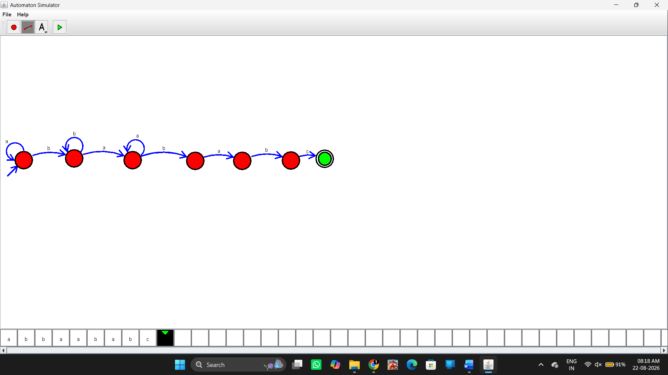Input
The input given in your manual is:
abbaababc
Checking the input
The string is:
a b b a a b a b c
The last three symbols are:
a b c
Therefore:
abbaababc → Accepted
Output
Input: abbaababc

String Accepted
Additional Examples
Input | Ending | Result
abbaababc | abc | Accepted
abc | abc | Accepted
aabc | abc | Accepted
abca | bca | Rejected
abcb | bcb | Rejected
Result
Thus, the DFA was successfully designed using the simulator to accept strings ending with abc over the alphabet {a,b,c}. The specified input abbaababc is accepted because its last three symbols are abc.

