Course Code: CSA1305 Name: Elango M (192411026)
Faculty: Dr Balamanigandan R
EXPERIMENT NO: 37
According to your lab manual, Experiment 37 is “Design NFA to accept any number of b’s where input = {a,b}.”
Aim
To design an NFA (Non-Deterministic Finite Automaton) using the simulator to accept any number of b's over the input alphabet {a,b}.
Software Used
- AutoSim / Automaton Simulator
- Windows Operating System
Procedure
- Open AutoSim / Automaton Simulator.
- Select NFA.
- Create the required states.
- Set q0 as the initial state.
- Mark the required accepting state.
- Add transitions for input symbols a and b.
- Create a self-loop for b on the accepting state so that any number of b's can be accepted.
- Enter the input string in the simulator.
- Run the NFA.
- Check whether the machine reaches the final state.
- Record the output.
Algorithm
- Start at the initial state q0.
- Read the input string from left to right.
- For every b, follow the b transition.
- Continue looping on b to allow any number of b's.
- If the input contains only b's, the string is accepted.
- If an a occurs, reject the string according to the language b*.
- Stop.
NFA Design
A simple NFA for any number of b's is:
b
↺
→ q0 ─────
★
- q0 = Initial state
- q0 = Final state
- b = self-loop on q0
- No transition for a
Transition Table
State | a | b
→ ★ q0 | — | q0
This accepts:
ε
b
bb
bbb
bbbb
...
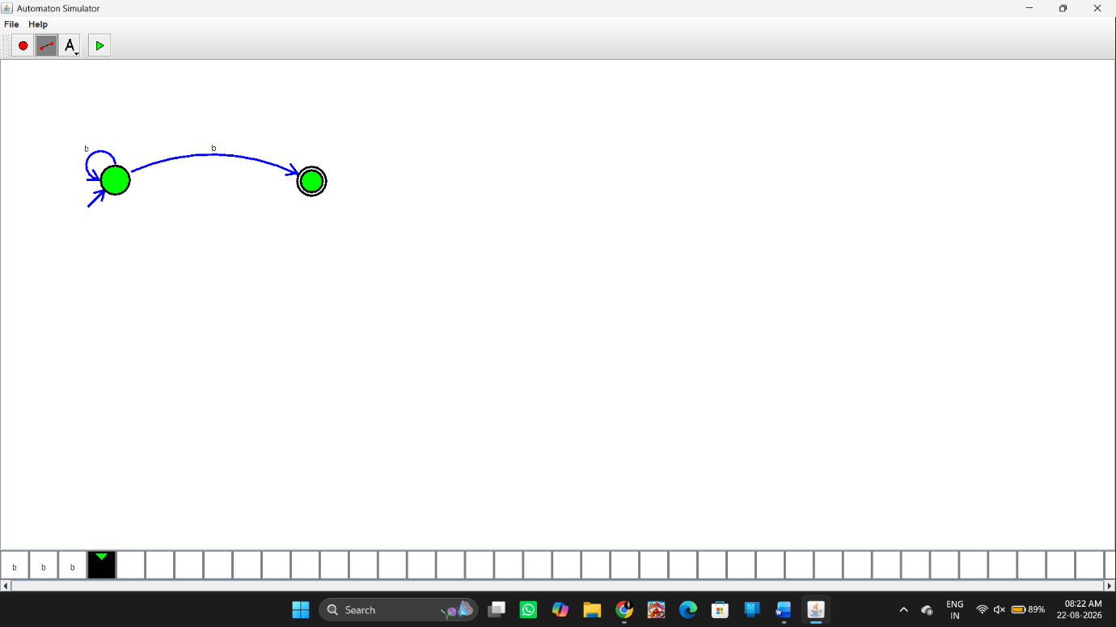Input
You can enter the following inputs in AutoSim:
Input 1
b
Output:
String Accepted
Input 2
bbb
Output:
String Accepted
Input 3
bbbbb
Output:
String Accepted
Rejected Input
abb
Output:
String Not Accepted
because it contains a.
Input / Output Table
Input | Number of b's | Result
b | 1 | Accepted
bb | 2 | Accepted
bbb | 3 | Accepted
bbbbb | 5 | Accepted
a | 0 | Rejected
abb | 2 | Rejected
bba | 2 | Rejected
Result
Thus, the NFA was successfully designed to accept any number of b's over the input alphabet {a,b}. Strings containing only b's are accepted, while strings containing a are rejected.

