Course Code: CSA1305 Name: Elango M (192411026)
Faculty: Dr Balamanigandan R
EXPERIMENT NO: 42
Title
Construct a Turing Machine to perform the function Multiplication, using Subroutines.
Aim
To construct a Turing Machine (TM) to perform the function of multiplication using subroutines.
Software Used
- AutoSim / Automaton Simulator
- Windows Operating System
Procedure
- Open the Automaton Simulator.
- Select Turing Machine (TM).
- Create the required states for the multiplication operation.
- Set the initial state.
- Define the tape symbols and blank symbol.
- Enter the two numbers to be multiplied in the format required by the simulator.
- Design the TM to process the first number.
- Use a subroutine to repeatedly add the second number.
- Continue the process until the required number of repetitions is completed.
- Return from the subroutine to the main multiplication routine.
- Store the final product on the tape.
- Run the machine step by step.
- Verify the final result.
Algorithm
- Start the Turing Machine.
- Read the first input number.
- Store the second number as the value to be repeatedly added.
- Initialize the result to zero.
- Call the addition subroutine.
- Add the second number to the current result.
- Decrease the multiplication counter.
- If the counter is not zero, call the addition subroutine again.
- Repeat until the counter becomes zero.
- The value remaining on the tape is the product.
- Move to the final state.
- Stop.
Example
For multiplication:
3 × 2
the machine performs:
2 + 2 + 2 = 6
Therefore:
3 × 2 = 6
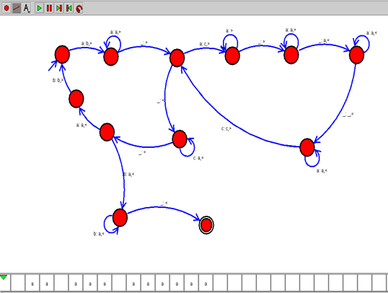Input
The manual does not specify a particular numerical input or input/output example for Experiment 42 in the retrieved section.
For demonstrating the experiment, you can use:
3 × 2
Output
Product = 6
Another example
4 × 3
Output:
Product = 12
Input / Output Table
Input | Output
2 × 3 | 6
3 × 2 | 6
4 × 3 | 12
5 × 2 | 10
Result
Thus, a Turing Machine for performing multiplication using subroutines was constructed and the multiplication operation was successfully performed. The exact encoding of the numbers on the tape depends on the TM design used in the simulator.

