Squid_prey_size

Elan Portner

4/12/2018

## Examining squid diet (new data from 2015, 2016, and 2017, and comparing to historical data from Unai)

Starting with summary of new data, collected by Portner 2015-2017

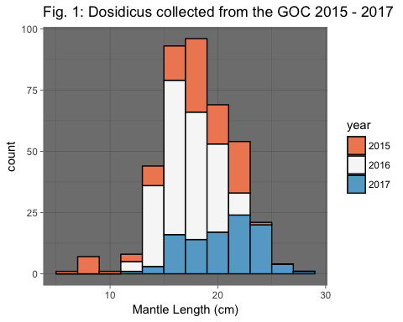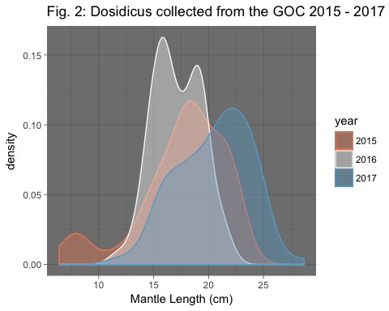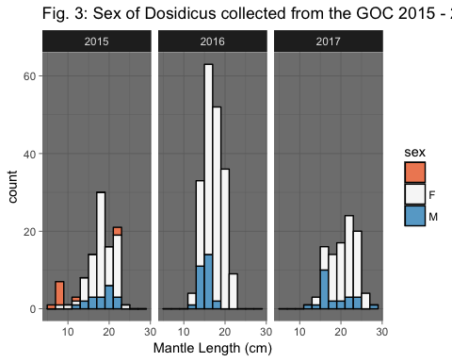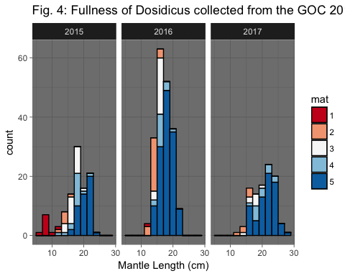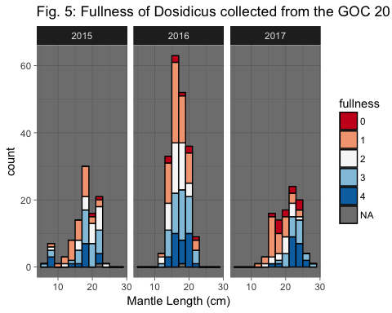

Diet summary examining variation in qualitative percent volume of prey proups by year

## File already exists ; loading 'marmap_coord_-113;25;-108;30_res_1.csv'

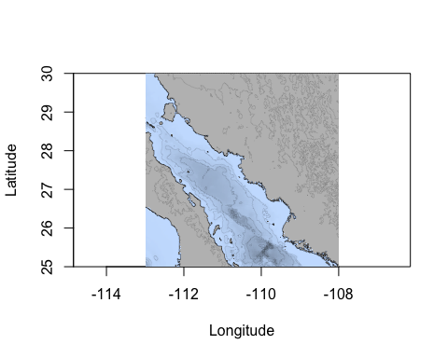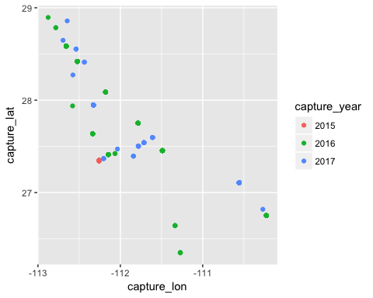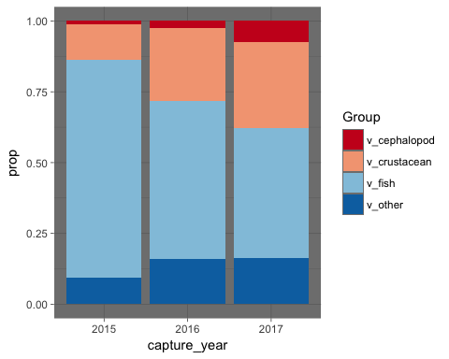 ####### Diet summary examining variation in percent number of prey species by year 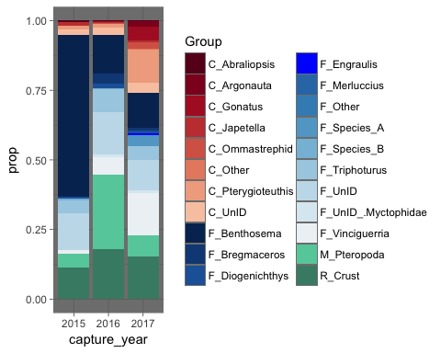 ####### To examine whether some of these differences are driven by spatial varitation in sampling coverage (2015 are all from santa rosalia, 2016 ans 2017 were collected during cruises that sampled throughout the central GOC), I removed samples that were collected in 2016 and 2017 outside of waters adjacent to Santa Rosalia. 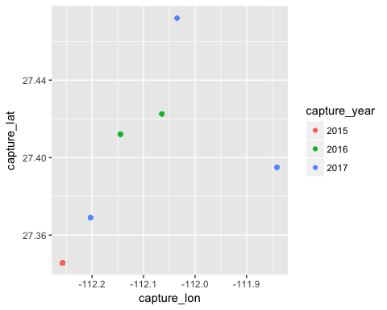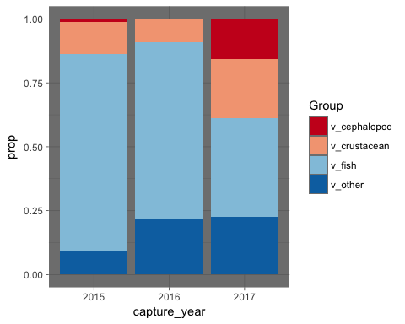 ### Preliminary exploration of variability in *Dosidicus* prey size during 1996-2017 ####### specimens removed from dataset due to stomach preservaiton (1995-August 1996 in formaldehyde, degraded otoliths), collection outside of central GOC (IMECOCAL, Volcan Marias, Off Magdalena), or low sample sizes (n = 1 measured prey from 2005)

Size distribution of specimens

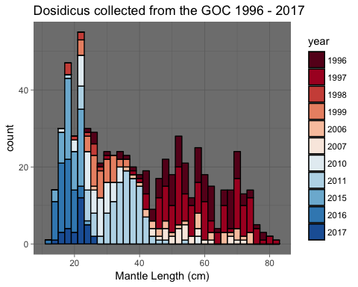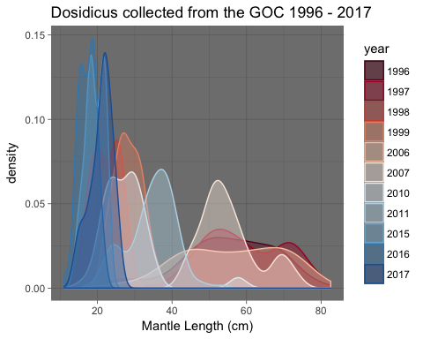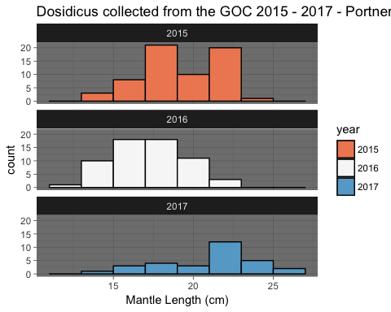

## Relationship between ML and prey length

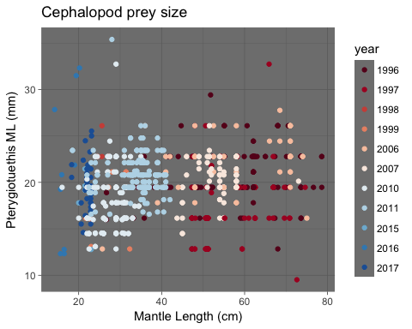

## Df Sum Sq Mean Sq F value Pr(>F)   
## year 10 1582 158.19 18.54 <2e-16 ***  
## Residuals 721 6150 8.53   
## ---  
## Signif. codes: 0 '***' 0.001 '**' 0.01 '*' 0.05 '.' 0.1 ' ' 1

#### Subsetting by summer months (June - October) to minimize variability driven by seasonality in prey size

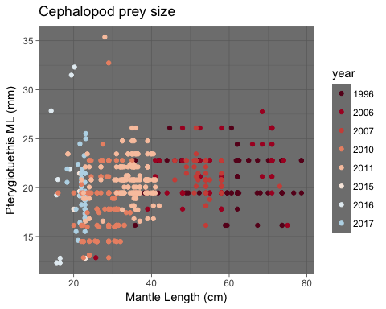

## Df Sum Sq Mean Sq F value Pr(>F)   
## year 7 1055 150.65 21.43 <2e-16 ***  
## Residuals 562 3950 7.03   
## ---  
## Signif. codes: 0 '***' 0.001 '**' 0.01 '*' 0.05 '.' 0.1 ' ' 1

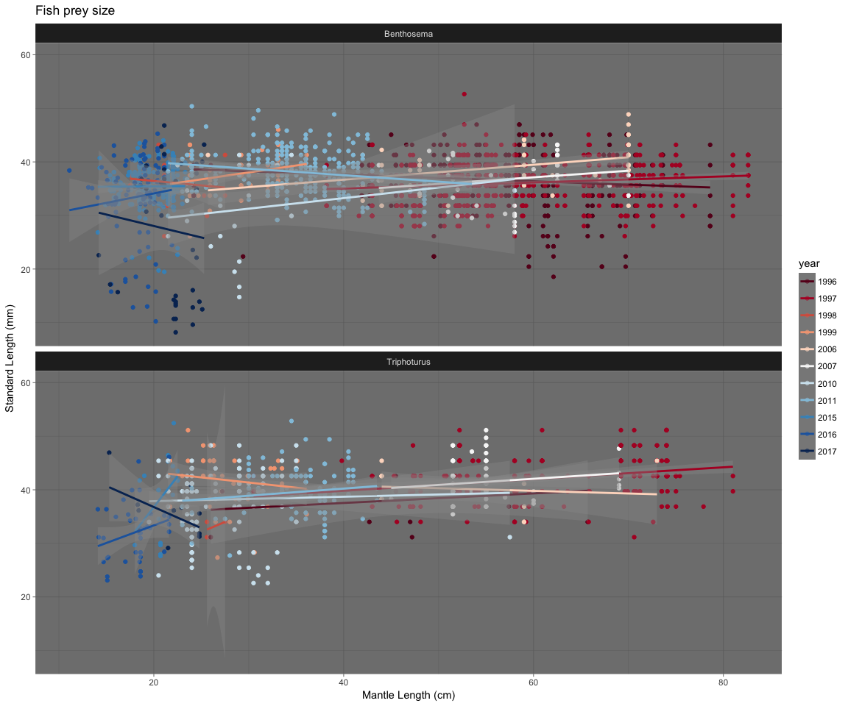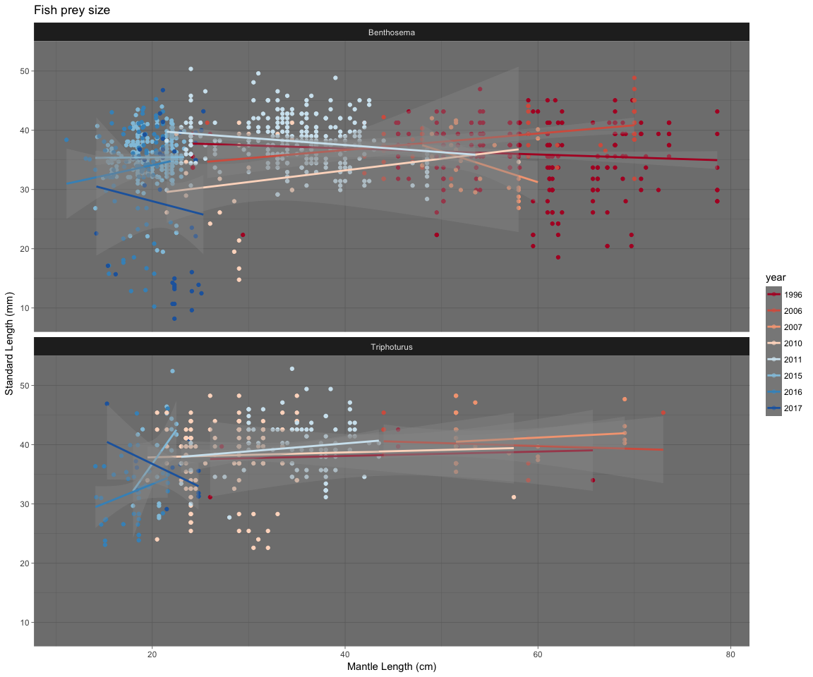

### Subsetting dataset for squid 20-25cm ML (highest overlap between new and historic diet datasets)

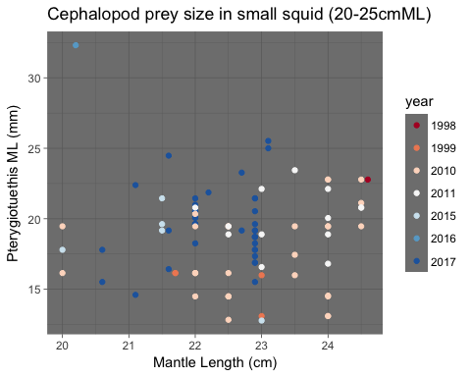

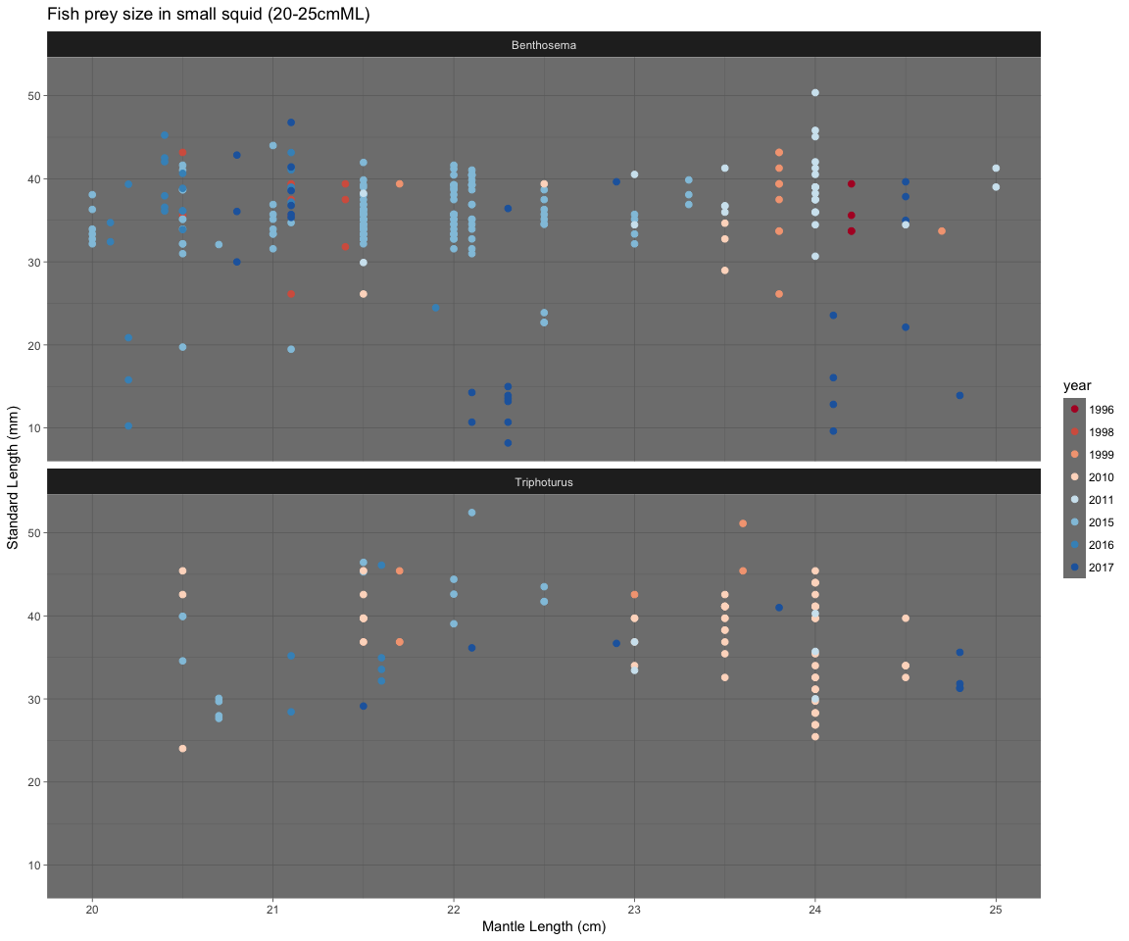 ### Assigned specimens to length bins

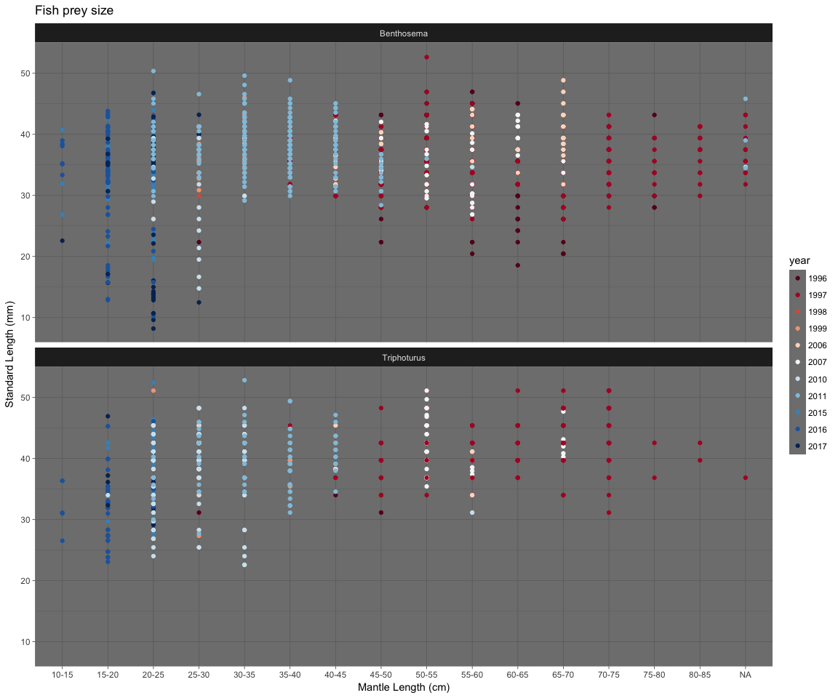

## Df Sum Sq Mean Sq F value Pr(>F)   
## year 6 929.2 154.86 67.98 <2e-16 ***  
## Residuals 243 553.6 2.28   
## ---  
## Signif. codes: 0 '***' 0.001 '**' 0.01 '*' 0.05 '.' 0.1 ' ' 1

## Tukey multiple comparisons of means  
## 95% family-wise confidence level  
##   
## Fit: aov(formula = ml ~ year, data = bentho20)  
##   
## $year  
## diff lwr upr p adj  
## 2006-1996 0.33333333 -4.5139041 5.1805707 0.9999938  
## 2010-1996 1.60555556 -0.5099523 3.7210634 0.2697491  
## 2011-1996 -0.00952381 -1.9505374 1.9314898 1.0000000  
## 2015-1996 -3.63030303 -5.5072606 -1.7533455 0.0000006  
## 2016-1996 -4.76666667 -6.8149983 -2.7183350 0.0000000  
## 2017-1996 -2.56344086 -4.5649855 -0.5618962 0.0033250  
## 2010-2006 1.27222222 -3.3384202 5.8828647 0.9826953  
## 2011-2006 -0.34285714 -4.8760882 4.1903739 0.9999891  
## 2015-2006 -3.96363636 -8.4698121 0.5425394 0.1259286  
## 2016-2006 -5.10000000 -9.6802088 -0.5197912 0.0182588  
## 2017-2006 -2.89677419 -7.4562513 1.6627029 0.4896190  
## 2011-2010 -1.61507937 -2.8519492 -0.3782095 0.0025232  
## 2015-2010 -5.23585859 -6.3695617 -4.1021554 0.0000000  
## 2016-2010 -6.37222222 -7.7714991 -4.9729453 0.0000000  
## 2017-2010 -4.16899642 -5.4988439 -2.8391489 0.0000000  
## 2015-2011 -3.62077922 -4.3806760 -2.8608824 0.0000000  
## 2016-2011 -4.75714286 -5.8752378 -3.6390480 0.0000000  
## 2017-2011 -2.55391705 -3.5837979 -1.5240362 0.0000000  
## 2016-2015 -1.13636364 -2.1391458 -0.1335815 0.0151331  
## 2017-2015 1.06686217 0.1634849 1.9702394 0.0094628  
## 2017-2016 2.20322581 0.9830686 3.4233830 0.0000038

year.aov <- aov(SL~year, bentho20)  
summary(year.aov)

## Df Sum Sq Mean Sq F value Pr(>F)   
## year 6 3118 519.6 11.65 1.8e-11 ***  
## Residuals 243 10834 44.6   
## ---  
## Signif. codes: 0 '***' 0.001 '**' 0.01 '*' 0.05 '.' 0.1 ' ' 1

TukeyHSD(year.aov)

## Tukey multiple comparisons of means  
## 95% family-wise confidence level  
##   
## Fit: aov(formula = SL ~ year, data = bentho20)  
##   
## $year  
## diff lwr upr p adj  
## 2006-1996 7.2584167 -14.1848363 28.7016696 0.9521957  
## 2010-1996 -4.2603750 -13.6189778 5.0982278 0.8256477  
## 2011-1996 4.1206167 -4.4660569 12.7072902 0.7868730  
## 2015-1996 1.3208181 -6.9824837 9.6241199 0.9991543  
## 2016-1996 1.1636737 -7.8977545 10.2251019 0.9997537  
## 2017-1996 -7.3963348 -16.2507863 1.4581167 0.1698798  
## 2010-2006 -11.5187917 -31.9153937 8.8778104 0.6306709  
## 2011-2006 -3.1378000 -23.1919490 16.9163490 0.9992305  
## 2015-2006 -5.9375986 -25.8720599 13.9968627 0.9744562  
## 2016-2006 -6.0947430 -26.3567125 14.1672266 0.9731654  
## 2017-2006 -14.6547515 -34.8250077 5.5155048 0.3212592  
## 2011-2010 8.3809917 2.9093155 13.8526678 0.0001675  
## 2015-2010 5.5811931 0.5659067 10.5964794 0.0183710  
## 2016-2010 5.4240487 -0.7660852 11.6141826 0.1289233  
## 2017-2010 -3.1359598 -9.0189512 2.7470316 0.6921537  
## 2015-2011 -2.7997986 -6.1614371 0.5618399 0.1726109  
## 2016-2011 -2.9569430 -7.9031813 1.9892954 0.5645926  
## 2017-2011 -11.5169515 -16.0729479 -6.9609550 0.0000000  
## 2016-2015 -0.1571444 -4.5932611 4.2789724 0.9999999  
## 2017-2015 -8.7171529 -12.7135214 -4.7207843 0.0000000  
## 2017-2016 -8.5600085 -13.9577509 -3.1622661 0.0000827

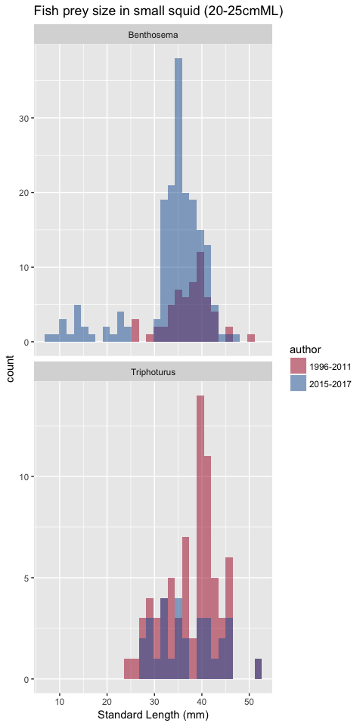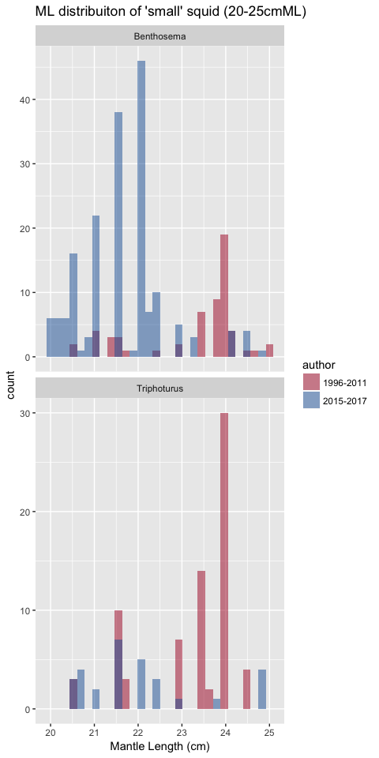

## Call:  
## aov(formula = ml ~ author * prey, data = smallfish)  
##   
## Terms:  
## author prey author:prey Residuals  
## Sum of Squares 197.7849 1.0356 2.8020 393.6407  
## Deg. of Freedom 1 1 1 337  
##   
## Residual standard error: 1.080774  
## Estimated effects may be unbalanced

##   
## Welch Two Sample t-test  
##   
## data: ml by author  
## t = 12.761, df = 262.53, p-value < 2.2e-16  
## alternative hypothesis: true difference in means is not equal to 0  
## 95 percent confidence interval:  
## 1.322291 1.804822  
## sample estimates:  
## mean in group 1996-2011 mean in group 2015-2017   
## 23.27121 21.70766

## Tukey multiple comparisons of means  
## 95% family-wise confidence level  
##   
## Fit: aov(formula = ml ~ author * prey, data = smallfish)  
##   
## $author  
## diff lwr upr p adj  
## 2015-2017-1996-2011 -1.563557 -1.79991 -1.327203 0  
##   
## $prey  
## diff lwr upr p adj  
## Triphoturus-Benthosema 0.1081097 -0.1426258 0.3588451 0.3969708  
##   
## $`author:prey`  
## diff lwr  
## 2015-2017:Benthosema-1996-2011:Benthosema -1.65201212 -2.0709114  
## 1996-2011:Triphoturus-1996-2011:Benthosema -0.06124913 -0.5497588  
## 2015-2017:Triphoturus-1996-2011:Benthosema -1.27175141 -1.8974743  
## 1996-2011:Triphoturus-2015-2017:Benthosema 1.59076299 1.2032503  
## 2015-2017:Triphoturus-2015-2017:Benthosema 0.38026071 -0.1702422  
## 2015-2017:Triphoturus-1996-2011:Triphoturus -1.21050228 -1.8156623  
## upr p adj  
## 2015-2017:Benthosema-1996-2011:Benthosema -1.2331129 0.0000000  
## 1996-2011:Triphoturus-1996-2011:Benthosema 0.4272605 0.9882612  
## 2015-2017:Triphoturus-1996-2011:Benthosema -0.6460286 0.0000016  
## 1996-2011:Triphoturus-2015-2017:Benthosema 1.9782757 0.0000000  
## 2015-2017:Triphoturus-2015-2017:Benthosema 0.9307636 0.2830838  
## 2015-2017:Triphoturus-1996-2011:Triphoturus -0.6053423 0.0000025