Regression

Elara

2016年5月4日

# 线性回归

## 线性模型

$$
\begin{equation}
Y_i=e^{\beta_1+\beta_2X_i+\epsilon_i} \\
Y_i=\frac{1}{e^{\beta_1+\beta_2X_i+\epsilon_i}} \\
Y_i=\beta_1+(0.75-\beta_1)e^{-\beta_2(X_i-2)}+\epsilon_i \\
Y_i=\beta_1+\beta_2^{3}X_i+\epsilon_i \\
Y_i=\beta_1+\beta_2(\frac{1}{X_i})+\epsilon_i \\
\end{equation}
$$

1. 125是线性模型
2. 没有截距项的时候R2不能用。此时OLS的FOC没有 $β_{0}$ 相关，得不到残差和=0
3. 无法把方差分解成可解释和不可解释部分。
4. 即使截距项不显著也不能去掉。去掉的话一定过原点。
5. R2受到模型变量数目影响。要用adj.R2

## LM线性模型估计OLS

#Y X 线性  
options(digits=3)  
fit <- lm(weight ~ height, data = women)  
summary(fit)

##   
## Call:  
## lm(formula = weight ~ height, data = women)  
##   
## Residuals:  
## Min 1Q Median 3Q Max   
## -1.733 -1.133 -0.383 0.742 3.117   
##   
## Coefficients:  
## Estimate Std. Error t value Pr(>|t|)   
## (Intercept) -87.5167 5.9369 -14.7 1.7e-09 ***  
## height 3.4500 0.0911 37.9 1.1e-14 ***  
## ---  
## Signif. codes: 0 '***' 0.001 '**' 0.01 '*' 0.05 '.' 0.1 ' ' 1  
##   
## Residual standard error: 1.53 on 13 degrees of freedom  
## Multiple R-squared: 0.991, Adjusted R-squared: 0.99   
## F-statistic: 1.43e+03 on 1 and 13 DF, p-value: 1.09e-14

coefficients(fit)

## (Intercept) height   
## -87.52 3.45

fitted(fit)

## 1 2 3 4 5 6 7 8 9 10 11 12 13 14 15   
## 113 116 119 123 126 130 133 137 140 144 147 151 154 157 161

residuals(fit)

## 1 2 3 4 5 6 7 8 9   
## 2.4167 0.9667 0.5167 0.0667 -0.3833 -0.8333 -1.2833 -1.7333 -1.1833   
## 10 11 12 13 14 15   
## -1.6333 -1.0833 -0.5333 0.0167 1.5667 3.1167

deviance(fit)

## [1] 30.2

#置信区间0.99  
confint(fit,level=0.99)

## 0.5 % 99.5 %  
## (Intercept) -105.40 -69.63  
## height 3.18 3.72

plot(women$height,women$weight,main="Women Age 30-39",xlab="Height",ylab="Weight")  
  
abline(fit)

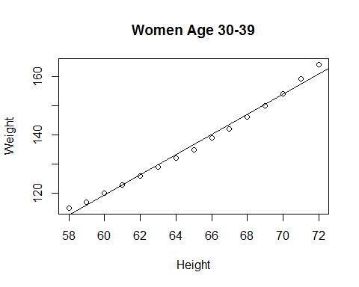

#x和y非线性  
fit2 <- lm(weight ~ height + I(height^2), data=women)  
summary(fit2)

##   
## Call:  
## lm(formula = weight ~ height + I(height^2), data = women)  
##   
## Residuals:  
## Min 1Q Median 3Q Max   
## -0.5094 -0.2961 -0.0094 0.2862 0.5971   
##   
## Coefficients:  
## Estimate Std. Error t value Pr(>|t|)   
## (Intercept) 261.87818 25.19677 10.39 2.4e-07 ***  
## height -7.34832 0.77769 -9.45 6.6e-07 ***  
## I(height^2) 0.08306 0.00598 13.89 9.3e-09 ***  
## ---  
## Signif. codes: 0 '***' 0.001 '**' 0.01 '*' 0.05 '.' 0.1 ' ' 1  
##   
## Residual standard error: 0.384 on 12 degrees of freedom  
## Multiple R-squared: 0.999, Adjusted R-squared: 0.999   
## F-statistic: 1.14e+04 on 2 and 12 DF, p-value: <2e-16

plot(women$height, women$weight, main = "Women Age 30-39",  
xlab = "Height", ylab = "Weight")  
lines(women$height, fitted(fit2))

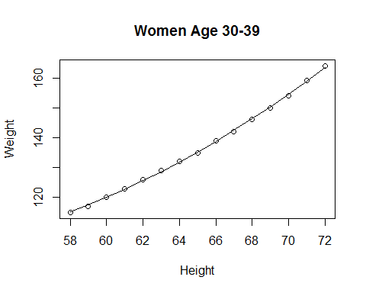

Anscombe<-data.frame(  
X =c(10.0, 8.0, 13.0, 9.0, 11.0, 14.0, 6.0, 4.0, 12.0, 7.0, 5.0),  
Y1=c(8.04, 6.95, 7.58, 8.81, 8.33, 9.96, 7.24, 4.26, 10.84, 4.82, 5.68),  
Y2=c(9.14, 8.14, 8.74, 8.77, 9.26, 8.10, 6.13, 3.10, 9.13, 7.26, 4.74),  
Y3=c(7.46, 6.77, 12.74, 7.11, 7.81, 8.84, 6.08, 5.39, 8.15, 6.44, 5.73),  
X4=c(rep(8,7), 19, rep(8,3)),  
Y4=c(6.58, 5.76, 7.71, 8.84, 8.47, 7.04, 5.25, 12.50, 5.56, 7.91, 6.89)  
)  
summary(lm(Y1~X, data=Anscombe))

##   
## Call:  
## lm(formula = Y1 ~ X, data = Anscombe)  
##   
## Residuals:  
## Min 1Q Median 3Q Max   
## -1.9213 -0.4558 -0.0414 0.7094 1.8388   
##   
## Coefficients:  
## Estimate Std. Error t value Pr(>|t|)   
## (Intercept) 3.000 1.125 2.67 0.0257 *   
## X 0.500 0.118 4.24 0.0022 **  
## ---  
## Signif. codes: 0 '***' 0.001 '**' 0.01 '*' 0.05 '.' 0.1 ' ' 1  
##   
## Residual standard error: 1.24 on 9 degrees of freedom  
## Multiple R-squared: 0.667, Adjusted R-squared: 0.629   
## F-statistic: 18 on 1 and 9 DF, p-value: 0.00217

summary(lm(Y2~X, data=Anscombe))

##   
## Call:  
## lm(formula = Y2 ~ X, data = Anscombe)  
##   
## Residuals:  
## Min 1Q Median 3Q Max   
## -1.901 -0.761 0.129 0.949 1.269   
##   
## Coefficients:  
## Estimate Std. Error t value Pr(>|t|)   
## (Intercept) 3.001 1.125 2.67 0.0258 *   
## X 0.500 0.118 4.24 0.0022 **  
## ---  
## Signif. codes: 0 '***' 0.001 '**' 0.01 '*' 0.05 '.' 0.1 ' ' 1  
##   
## Residual standard error: 1.24 on 9 degrees of freedom  
## Multiple R-squared: 0.666, Adjusted R-squared: 0.629   
## F-statistic: 18 on 1 and 9 DF, p-value: 0.00218

summary(lm(Y3~X, data=Anscombe))

##   
## Call:  
## lm(formula = Y3 ~ X, data = Anscombe)  
##   
## Residuals:  
## Min 1Q Median 3Q Max   
## -1.159 -0.616 -0.232 0.151 3.241   
##   
## Coefficients:  
## Estimate Std. Error t value Pr(>|t|)   
## (Intercept) 3.008 1.124 2.67 0.0254 *   
## X 0.499 0.118 4.24 0.0022 **  
## ---  
## Signif. codes: 0 '***' 0.001 '**' 0.01 '*' 0.05 '.' 0.1 ' ' 1  
##   
## Residual standard error: 1.24 on 9 degrees of freedom  
## Multiple R-squared: 0.666, Adjusted R-squared: 0.629   
## F-statistic: 17.9 on 1 and 9 DF, p-value: 0.00218

summary(lm(Y4~X4,data=Anscombe))

##   
## Call:  
## lm(formula = Y4 ~ X4, data = Anscombe)  
##   
## Residuals:  
## Min 1Q Median 3Q Max   
## -1.751 -0.831 0.000 0.809 1.839   
##   
## Coefficients:  
## Estimate Std. Error t value Pr(>|t|)   
## (Intercept) 3.002 1.124 2.67 0.0256 *   
## X4 0.500 0.118 4.24 0.0022 **  
## ---  
## Signif. codes: 0 '***' 0.001 '**' 0.01 '*' 0.05 '.' 0.1 ' ' 1  
##   
## Residual standard error: 1.24 on 9 degrees of freedom  
## Multiple R-squared: 0.667, Adjusted R-squared: 0.63   
## F-statistic: 18 on 1 and 9 DF, p-value: 0.00216

head(Anscombe)

## X Y1 Y2 Y3 X4 Y4  
## 1 10 8.04 9.14 7.46 8 6.58  
## 2 8 6.95 8.14 6.77 8 5.76  
## 3 13 7.58 8.74 12.74 8 7.71  
## 4 9 8.81 8.77 7.11 8 8.84  
## 5 11 8.33 9.26 7.81 8 8.47  
## 6 14 9.96 8.10 8.84 8 7.04

attach(Anscombe)  
par(mfrow = c(2,2))  
plot(c(3,20), c(3,13), type="n", xlab = "X", ylab = "Y"); points(X,Y1); abline(lm(Y1~X))  
plot(c(3,20), c(3,13), type="n", xlab = "X", ylab = "Y"); points(X,Y2); abline(lm(Y2~X))  
plot(c(3,20), c(3,13), type="n", xlab = "X", ylab = "Y"); points(X,Y3); abline(lm(Y3~X))  
plot(c(3,20), c(3,13), type="n", xlab = "X", ylab = "Y"); points(X4,Y4); abline(lm(Y4~X4))

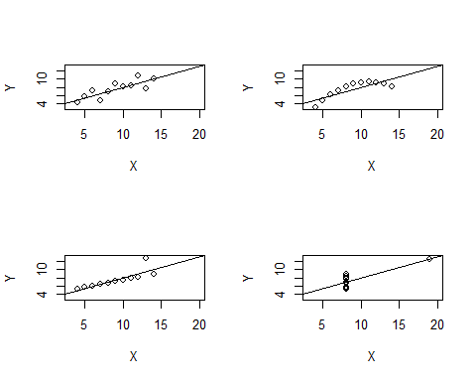

系数都是3和0.5并且都显著。可是作图结果形状完全不一致2是曲线3有异常值4除了一个点以外都是同一个竖线上

#1没有问题  
par(mfrow = c(1,1))  
#2是个曲线，加入平方拟合  
X2<-X^2  
#存放用平方拟合的系数  
lm2.sol<-lm(Y2~X+X2)  
summary(lm2.sol)

##   
## Call:  
## lm(formula = Y2 ~ X + X2)  
##   
## Residuals:  
## Min 1Q Median 3Q Max   
## -0.001329 -0.001189 -0.000629 0.000874 0.002378   
##   
## Coefficients:  
## Estimate Std. Error t value Pr(>|t|)   
## (Intercept) -6.00e+00 4.33e-03 -1385 <2e-16 ***  
## X 2.78e+00 1.04e-03 2674 <2e-16 ***  
## X2 -1.27e-01 5.71e-05 -2219 <2e-16 ***  
## ---  
## Signif. codes: 0 '***' 0.001 '**' 0.01 '*' 0.05 '.' 0.1 ' ' 1  
##   
## Residual standard error: 0.00167 on 8 degrees of freedom  
## Multiple R-squared: 1, Adjusted R-squared: 1   
## F-statistic: 7.38e+06 on 2 and 8 DF, p-value: <2e-16

#作图用x  
x<-seq(min(X), max(X), by=0.1)  
#作图用系数  
b<-coef(lm2.sol)  
y<-b[1]+b[2]*x+b[3]*x^2  
plot(c(3,20), c(3,13), type="n", xlab = "X", ylab = "Y")  
#plot原图  
points(X,Y2)  
lines(x,y)

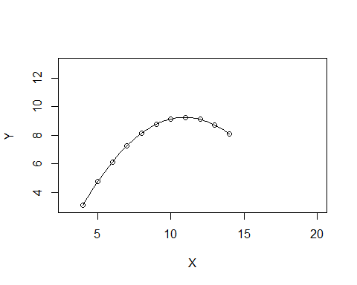

#3  
#去掉第三个（异常值）  
i<-1:11; Y31<-Y3[i!=3]; X3<-X[i!=3]  
lm3.sol<-lm(Y31~X3)  
summary(lm3.sol)

##   
## Call:  
## lm(formula = Y31 ~ X3)  
##   
## Residuals:  
## Min 1Q Median 3Q Max   
## -0.006017 -0.001212 -0.001017 -0.000823 0.014069   
##   
## Coefficients:  
## Estimate Std. Error t value Pr(>|t|)   
## (Intercept) 4.010628 0.005711 702 <2e-16 ***  
## X3 0.345043 0.000626 551 <2e-16 ***  
## ---  
## Signif. codes: 0 '***' 0.001 '**' 0.01 '*' 0.05 '.' 0.1 ' ' 1  
##   
## Residual standard error: 0.00602 on 8 degrees of freedom  
## Multiple R-squared: 1, Adjusted R-squared: 1   
## F-statistic: 3.04e+05 on 1 and 8 DF, p-value: <2e-16

plot(c(3,20), c(3,13), type="n", xlab = "X", ylab = "Y")  
points(X,Y3)  
abline(lm3.sol)

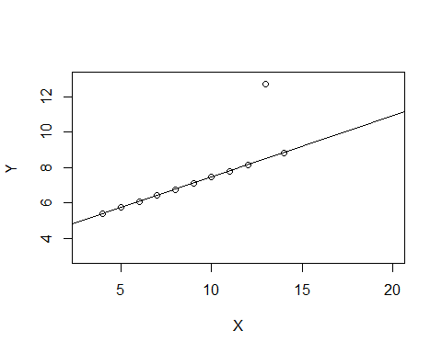

detach(Anscombe)

## 异常值检测

1.diffits指标

$$DFFITS=\frac{\hat{y_{i}}−\hat{y_{i(i)}}}{s_{(}i)\sqrt{h_{ii}}}\sqrt{h_{ii}/(1−h_{ii})}$$

h是帽子矩阵，y尖=hy

attach(Anscombe)  
p<-1; n<-length(X);d<-dffits(lm(Y3~X, data=Anscombe))  
cf<-1:n; cf[d>2*sqrt((p+1)/n)]

## [1] 3

#取出1到n里面满足dffits大于2根号（（p+1）/n）  
detach(Anscombe)

返回了异常值位置3

2.Cook's distance

$$D_{i}=\frac{(\hat{β}−{\hat{β}}^{(−i)})^{T}(X^{T}X)(\hat{β}−{\hat{β}}^{(−i)})}{(1+p)s^{2}}$$

Fit<-lm(Y3~X, data=Anscombe)  
cooks.distance(Fit)

## 1 2 3 4 5 6 7 8   
## 0.011831 0.002183 1.392828 0.005525 0.026072 0.300634 0.000480 0.033194   
## 9 10 11   
## 0.059650 0.000218 0.006752

par(mfrow=c(2,1))  
#散点图  
plot(cooks.distance(Fit),main="Cook's distance",cex=0.5)  
#线图，红线表示警戒线  
Np<-length(coefficients(Fit))-1#变量数  
N<-length(fitted(Fit))  
#红线算法  
CutLevel<-4/(N-Np-1)  
plot(Fit,which=4)  
abline(CutLevel,0,lty=2,col="red")

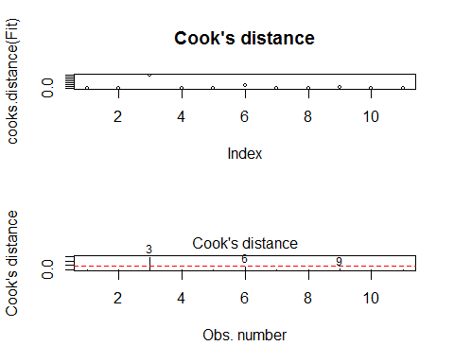

summary

#可以直接算dffit和cook，有问题的会带星号  
influence.measures(lm(Y3~X, data=Anscombe))

## Influence measures of  
## lm(formula = Y3 ~ X, data = Anscombe) :  
##   
## dfb.1_ dfb.X dffit cov.r cook.d hat inf  
## 1 -4.64e-03 -4.43e-02 -0.1468 1.34e+00 0.011831 0.1000   
## 2 -3.75e-02 1.88e-02 -0.0624 1.39e+00 0.002183 0.1000   
## 3 -1.83e+02 2.69e+02 342.7851 7.36e-10 1.392828 0.2364 *  
## 4 -3.31e-02 -2.66e-18 -0.0997 1.36e+00 0.005525 0.0909   
## 5 4.92e-02 -1.17e-01 -0.2197 1.34e+00 0.026072 0.1273   
## 6 4.90e-01 -6.67e-01 -0.7898 1.36e+00 0.300634 0.3182   
## 7 2.60e-02 -2.01e-02 0.0292 1.53e+00 0.000480 0.1727   
## 8 2.39e-01 -2.07e-01 0.2449 1.80e+00 0.033194 0.3182 *  
## 9 1.38e-01 -2.32e-01 -0.3365 1.34e+00 0.059650 0.1727   
## 10 -1.54e-02 1.05e-02 -0.0197 1.45e+00 0.000218 0.1273   
## 11 1.04e-01 -8.62e-02 0.1098 1.64e+00 0.006752 0.2364

## 最大似然估计

The following function is called a likelihood function, denoted by LF($β_{1}$; $β_{2}$; $σ^{2}$)

$$LF(β_{1},β_{2},σ^{2})=f(Y_{1},Y_{2},…,Y_{n}|β_{1}+β_{2}X_{i},σ^{2})=\frac{1}{σ^{n}(\sqrt{2π})^{n}}exp(\frac{1}{2}∑\frac{(Y_{i}−β_{1}−β_{2}X_{i})^{2}}{σ^{2}})$$

where $β_{1}$; $β_{2}$; $σ^{2}$ are not known. The method of maximum likelihood, as the name indicates, consists in estimating the unknown parameters in such a manner that the probability of observing the given Y’s is as high (or maximum) as possible. Therefore, we have to find the maximum of the function 6. For differentiation it is easier to express 6 in the log term as follows:

$$
ln LF = -nln\sigma -\frac{n}{2}ln(2\pi)-\frac{1}{2}\sum \frac{(Y_i-\beta_1-\beta_2X_i)^{2}}{\sigma^{2}} \\
= -\frac{n}{2}ln\sigma^{2} -\frac{n}{2}ln(2\pi)-\frac{1}{2}\sum \frac{(Y_i-\beta_1-\beta_2X_i)^{2}}{\sigma^{2}}
$$

Differentiating 7 partially with respect to $β_{1}$; $β_{2}$, and $σ^{2}$, we can obtain the ML estimators.

install.packages(maxLik)

library("maxLik")

## Loading required package: miscTools

##   
## Please cite the 'maxLik' package as:  
## Henningsen, Arne and Toomet, Ott (2011). maxLik: A package for maximum likelihood estimation in R. Computational Statistics 26(3), 443-458. DOI 10.1007/s00180-010-0217-1.  
##   
## If you have questions, suggestions, or comments regarding the 'maxLik' package, please use a forum or 'tracker' at maxLik's R-Forge site:  
## https://r-forge.r-project.org/projects/maxlik/

indfood<-read.csv(file="C:\\Users\\44180\\Documents\\sourcetree\\elara7\\soe\\Rmarkdown\\Chap_9\\Indfood.csv")  
#抽取数据  
foodexp<-indfood[,1]  
totalexp<-indfood[,2]  
#OLS回归  
lm_r <- lm(foodexp~totalexp)  
summary(lm_r)

##   
## Call:  
## lm(formula = foodexp ~ totalexp)  
##   
## Residuals:  
## Min 1Q Median 3Q Max   
## -153.77 -46.61 7.75 37.70 171.59   
##   
## Coefficients:  
## Estimate Std. Error t value Pr(>|t|)   
## (Intercept) 94.2088 50.8563 1.85 0.07 .   
## totalexp 0.4368 0.0783 5.58 8.5e-07 ***  
## ---  
## Signif. codes: 0 '***' 0.001 '**' 0.01 '*' 0.05 '.' 0.1 ' ' 1  
##   
## Residual standard error: 66.9 on 53 degrees of freedom  
## Multiple R-squared: 0.37, Adjusted R-squared: 0.358   
## F-statistic: 31.1 on 1 and 53 DF, p-value: 8.45e-07

#最大似然估计  
#对数似然函数  
loglik=function (para){  
N=length(foodexp)#样本量  
e=foodexp-para[1]-para[2]*totalexp#残差项表达式，para是参数估计量  
ll=-0.5*N*log(2*pi)-0.5*N*log(para[3]^2)-0.5*sum(e^2/para[3]^2)#对数似然函数，注意有个参数3  
return(ll)  
}  
#需要1，log后的似然函数，初始值  
mle1=maxLik(loglik,start=c(0.1,1,1))#3个参数，β1 β2，方差  
coef(mle1)

## [1] 94.266 0.437 -65.601

## 多元线性回归

OLS是线性无偏中方差最小的。如果有一个有偏估计方差很小也可以用

class(mtcars)

## [1] "data.frame"

mtcar <- as.data.frame(mtcars[,c("mpg", "cyl",  
"disp", "hp", "wt")])  
cor(mtcar)

## mpg cyl disp hp wt  
## mpg 1.000 -0.852 -0.848 -0.776 -0.868  
## cyl -0.852 1.000 0.902 0.832 0.782  
## disp -0.848 0.902 1.000 0.791 0.888  
## hp -0.776 0.832 0.791 1.000 0.659  
## wt -0.868 0.782 0.888 0.659 1.000

library(car)

##   
## Attaching package: 'car'

## The following object is masked _by_ '.GlobalEnv':  
##   
## Anscombe

scatterplotMatrix(mtcar, spread=FALSE, main="Scatter Plot Matrix")

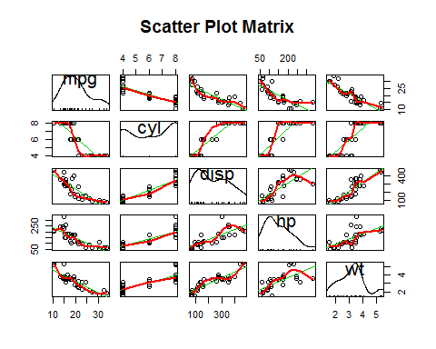

fit3 <- lm(mpg ~ hp + wt + hp:wt, data = mtcar)  
summary(fit3)

##   
## Call:  
## lm(formula = mpg ~ hp + wt + hp:wt, data = mtcar)  
##   
## Residuals:  
## Min 1Q Median 3Q Max   
## -3.063 -1.649 -0.736 1.421 4.551   
##   
## Coefficients:  
## Estimate Std. Error t value Pr(>|t|)   
## (Intercept) 49.80842 3.60516 13.82 5.0e-14 ***  
## hp -0.12010 0.02470 -4.86 4.0e-05 ***  
## wt -8.21662 1.26971 -6.47 5.2e-07 ***  
## hp:wt 0.02785 0.00742 3.75 0.00081 ***  
## ---  
## Signif. codes: 0 '***' 0.001 '**' 0.01 '*' 0.05 '.' 0.1 ' ' 1  
##   
## Residual standard error: 2.15 on 28 degrees of freedom  
## Multiple R-squared: 0.885, Adjusted R-squared: 0.872   
## F-statistic: 71.7 on 3 and 28 DF, p-value: 2.98e-13

fit <- lm(weight ~ height, data=women)  
par(mfrow=c(2,2))  
plot(fit)

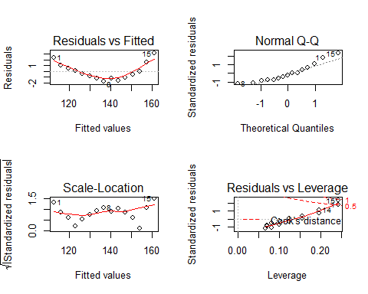

残差图如果是左右开口的喇叭状很可能有异方差

第四图：高杠杆有离群点，强影响(红实线是警戒线)

#加入平方项回归  
fit2 <- lm(weight ~ height + I(height^2), data=women)  
plot(fit2)

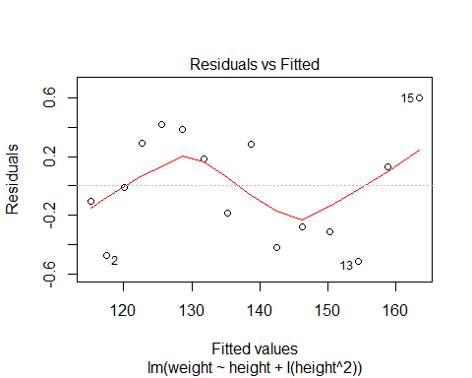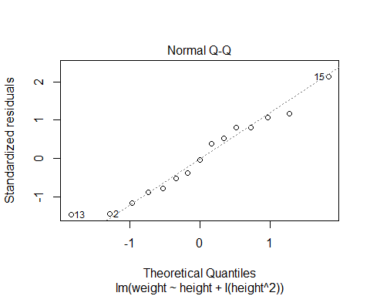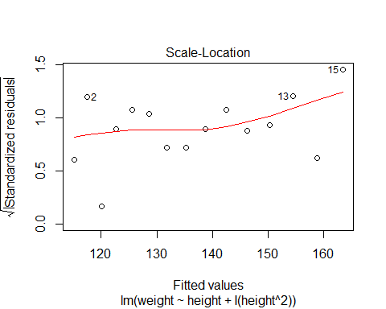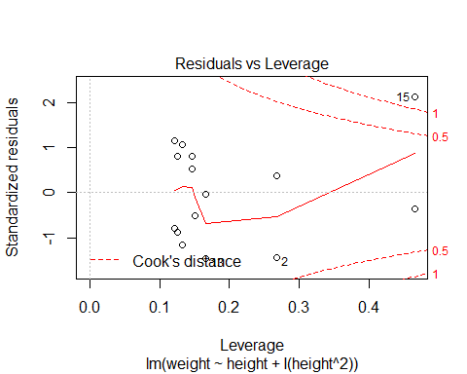

## 系数之间相关影响实验

In order to explain the meaning of coefficients ,we have the following step.  
Regression model:

$$y_{i}=β_{0}+β_{1}x_{i1}+β_{2}x_{i2}+u_{i}$$

Step 1:

$$w_{i}=y_{i}−{\hat{α}}_{0}−{\hat{α}}_{1}x_{i2}$$

Step 2:

$$v_{i}=x_{i1}−{\hat{b}}_{0}−{\hat{b}}_{1}x_{i2}$$

Step 3:

$${\overline{β}}_{1}=\frac{∑v_{i}w_{i}}{∑v_{i}^{2}}$$

mtcar <- as.data.frame(mtcars[,c("mpg", "cyl", "disp", "hp", "wt")])  
fit <- lm(mpg~wt+disp, data=mtcar)  
summary(fit)

##   
## Call:  
## lm(formula = mpg ~ wt + disp, data = mtcar)  
##   
## Residuals:  
## Min 1Q Median 3Q Max   
## -3.409 -2.324 -0.768 1.772 6.348   
##   
## Coefficients:  
## Estimate Std. Error t value Pr(>|t|)   
## (Intercept) 34.96055 2.16454 16.15 4.9e-16 ***  
## wt -3.35083 1.16413 -2.88 0.0074 **   
## disp -0.01772 0.00919 -1.93 0.0636 .   
## ---  
## Signif. codes: 0 '***' 0.001 '**' 0.01 '*' 0.05 '.' 0.1 ' ' 1  
##   
## Residual standard error: 2.92 on 29 degrees of freedom  
## Multiple R-squared: 0.781, Adjusted R-squared: 0.766   
## F-statistic: 51.7 on 2 and 29 DF, p-value: 2.74e-10

fit1 <- lm(mpg~disp, data=mtcar)  
fit2 <- lm(wt~disp, data=mtcar)  
fit3 <- lm(fit1$residuals~fit2$residuals-1)#没常数项用-1  
summary(fit3)

##   
## Call:  
## lm(formula = fit1$residuals ~ fit2$residuals - 1)  
##   
## Residuals:  
## Min 1Q Median 3Q Max   
## -3.409 -2.324 -0.768 1.772 6.348   
##   
## Coefficients:  
## Estimate Std. Error t value Pr(>|t|)   
## fit2$residuals -3.35 1.13 -2.98 0.0056 **  
## ---  
## Signif. codes: 0 '***' 0.001 '**' 0.01 '*' 0.05 '.' 0.1 ' ' 1  
##   
## Residual standard error: 2.82 on 31 degrees of freedom  
## Multiple R-squared: 0.222, Adjusted R-squared: 0.197   
## F-statistic: 8.86 on 1 and 31 DF, p-value: 0.00562

说明x2对x1系数没有影响

## 置信区间

mtcar <- as.data.frame(mtcars[,c("mpg", "cyl", "disp", "hp", "wt")])  
mtcarn<-mtcar[order(mtcar$wt),]  
fit <- lm(mpg~wt, data=mtcarn)  
conf=predict(fit,interval="confidence",level=0.95)  
conf

## fit lwr upr  
## Lotus Europa 29.20 26.96 31.4  
## Honda Civic 28.65 26.52 30.8  
## Toyota Corolla 27.48 25.55 29.4  
## Fiat X1-9 26.94 25.11 28.8  
## Porsche 914-2 25.85 24.20 27.5  
## Fiat 128 25.53 23.93 27.1  
## Datsun 710 24.89 23.38 26.4  
## Toyota Corona 24.11 22.72 25.5  
## Mazda RX4 23.28 21.99 24.6  
## Ferrari Dino 22.48 21.27 23.7  
## Volvo 142E 22.43 21.22 23.6  
## Mazda RX4 Wag 21.92 20.75 23.1  
## Merc 230 20.45 19.35 21.6  
## Ford Pantera L 20.34 19.24 21.4  
## Merc 240D 20.24 19.14 21.3  
## Hornet 4 Drive 20.10 19.00 21.2  
## AMC Javelin 18.93 17.80 20.1  
## Hornet Sportabout 18.90 17.77 20.0  
## Merc 280 18.90 17.77 20.0  
## Merc 280C 18.90 17.77 20.0  
## Valiant 18.79 17.66 19.9  
## Dodge Challenger 18.47 17.32 19.6  
## Duster 360 18.21 17.03 19.4  
## Maserati Bora 18.21 17.03 19.4  
## Merc 450SL 17.35 16.10 18.6  
## Merc 450SLC 17.08 15.81 18.4  
## Camaro Z28 16.76 15.45 18.1  
## Pontiac Firebird 16.74 15.42 18.0  
## Merc 450SE 15.53 14.06 17.0  
## Cadillac Fleetwood 9.23 6.66 11.8  
## Chrysler Imperial 8.72 6.05 11.4  
## Lincoln Continental 8.30 5.55 11.0

plot(mpg~wt, data=mtcarn)  
abline(fit)  
lines(mtcarn$wt,conf[,2],lty=3,col="blue")  
lines(mtcarn$wt,conf[,3],lty=3,col="blue")

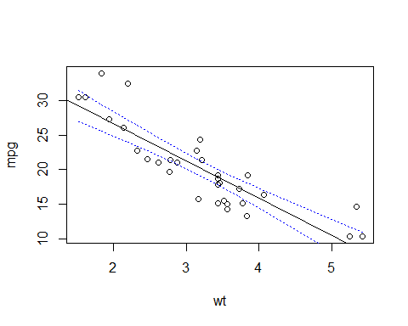

## 假设检验

mtcar <- as.data.frame(mtcars[,c("mpg", "cyl",  
"disp", "hp", "wt")])  
library(car)  
fit <- lm(mpg ~ hp + wt, data = mtcar)  
summary(fit)

##   
## Call:  
## lm(formula = mpg ~ hp + wt, data = mtcar)  
##   
## Residuals:  
## Min 1Q Median 3Q Max   
## -3.941 -1.600 -0.182 1.050 5.854   
##   
## Coefficients:  
## Estimate Std. Error t value Pr(>|t|)   
## (Intercept) 37.22727 1.59879 23.28 < 2e-16 ***  
## hp -0.03177 0.00903 -3.52 0.0015 **   
## wt -3.87783 0.63273 -6.13 1.1e-06 ***  
## ---  
## Signif. codes: 0 '***' 0.001 '**' 0.01 '*' 0.05 '.' 0.1 ' ' 1  
##   
## Residual standard error: 2.59 on 29 degrees of freedom  
## Multiple R-squared: 0.827, Adjusted R-squared: 0.815   
## F-statistic: 69.2 on 2 and 29 DF, p-value: 9.11e-12

linearHypothesis(fit, "hp = 0")#变量hp的系数=0

## Linear hypothesis test  
##   
## Hypothesis:  
## hp = 0  
##   
## Model 1: restricted model  
## Model 2: mpg ~ hp + wt  
##   
## Res.Df RSS Df Sum of Sq F Pr(>F)   
## 1 30 278   
## 2 29 195 1 83.3 12.4 0.0015 **  
## ---  
## Signif. codes: 0 '***' 0.001 '**' 0.01 '*' 0.05 '.' 0.1 ' ' 1

linearHypothesis(fit, "hp = -0.5")

## Linear hypothesis test  
##   
## Hypothesis:  
## hp = - 0.5  
##   
## Model 1: restricted model  
## Model 2: mpg ~ hp + wt  
##   
## Res.Df RSS Df Sum of Sq F Pr(>F)   
## 1 30 18280   
## 2 29 195 1 18085 2689 <2e-16 ***  
## ---  
## Signif. codes: 0 '***' 0.001 '**' 0.01 '*' 0.05 '.' 0.1 ' ' 1

linearHypothesis(fit, "hp - wt= 0")#hp和wt相等

## Linear hypothesis test  
##   
## Hypothesis:  
## hp - wt = 0  
##   
## Model 1: restricted model  
## Model 2: mpg ~ hp + wt  
##   
## Res.Df RSS Df Sum of Sq F Pr(>F)   
## 1 30 439   
## 2 29 195 1 244 36.3 1.5e-06 ***  
## ---  
## Signif. codes: 0 '***' 0.001 '**' 0.01 '*' 0.05 '.' 0.1 ' ' 1

F检验的f值，总是对应假设中T检验t值的平方（要在相同原假设下采用正确形式）