Monte Carlo Simulation

Monte Carlo simulation has four stages: Selection, Expansion, Rollout, and Back propagation. Selection will decide which node to explore with a balance of exploration and exploitation using UCB1 formula. Expansion generates all possible moves with the current board configuration. Rollout simulates n-number of random games with the current board configuration. And Back propagation will update all node or previous board configurations values.

Analysis

The agent uses a Monte Carlo simulation and runs on different parameters. Initial number of simulation taken before picking the next move is 5 and increments by 5 for each set of 30 games. The second analysis is similar but of set of 50 games.

Observation

The more games played in each set the smaller the variance in the win rate, i.e., sets 30 games has more variation than games of set 50. Moreover, as the number of simulation increases the win rate increases logarithmically.

Number of games played: 30

Win rate: 73.33%

Simulations per move: 5

Number of games played: 30

Win rate: 76.66%

Simulations per move: 10

Number of games played: 30

Win rate: 93.33%

Simulations per move: 15

Number of games played: 30

Win rate: 96.66%

Simulations per move: 20

Number of games played: 30

Win rate: 96.66%

Simulations per move: 25

Number of games played: 30

Win rate: 90.0%

Simulations per move: 30

Number of games played: 30

Win rate: 93. 33%

Simulations per move: 35

Number of games played: 30

Win rate: 93.33%

Simulations per move: 40

Number of games played: 30

Win rate: 96.66%

Simulations per move: 45

Number of games played: 30

Win rate: 96.66%

Simulations per move: 50

Number of games played: 30

Win rate: 90.0%

Simulations per move: 55

Number of games played: 30

Win rate: 80.0%

Simulations per move: 60

Number of games played: 30

Win rate: 93.33%

Simulations per move: 65

Number of games played: 30

Win rate: 93.33%

Simulations per move: 70

Number of games played: 30

Win rate: 93.33%

Simulations per move: 75

Win rates:

[73.33, 76.66, 93.33, 96.66, 96.66, 90.0, 93.33, 93.33, 96.66, 96.66, 90.0, 80.0, 93.33, 93.33, 93.33]

Number of simulations per action:

[5, 10, 15, 20, 25, 30, 35, 40, 45, 50, 55, 60, 65, 70, 75]

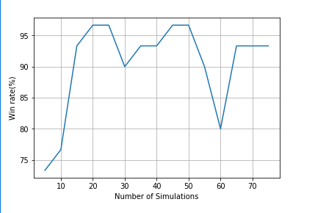 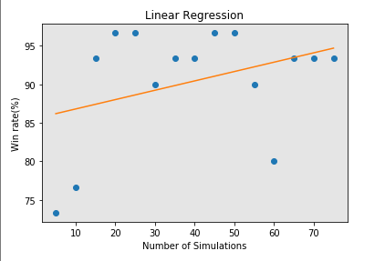 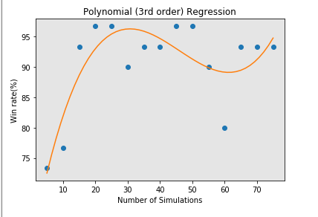

Number of games played: 50

Win rate: 76.0%

Simulations per move: 5

Number of games played: 50

Win rate: 84.0%

Simulations per move: 10

Number of games played: 50

Win rate: 96.0%

Simulations per move: 15

Number of games played: 50

Win rate: 94.0%

Simulations per move: 20

Number of games played: 50

Win rate: 78.0%

Simulations per move: 25

Number of games played: 50

Win rate: 96.0%

Simulations per move: 30

Number of games played: 50

Win rate: 94.0%

Simulations per move: 35

Number of games played: 50

Win rate: 94.0%

Simulations per move: 40

Number of games played: 50

Win rate: 82.0%

Simulations per move: 45

Number of games played: 50

Win rate: 84.0%

Simulations per move: 50

Number of games played: 50

Win rate: 98.0%

Simulations per move: 55

Number of games played: 50

Win rate: 88.0%

Simulations per move: 60

Number of games played: 50

Win rate: 82.0%

Simulations per move: 65

Number of games played: 50

Win rate: 92.0%

Simulations per move: 70

Number of games played: 50

Win rate: 94.0%

Simulations per move: 75

Number of games played: 50

Win rate: 96.0%

Simulations per move: 80

Number of games played: 50

Win rate: 90.0%

Simulations per move: 85

Number of games played: 50

Win rate: 92.0%

Simulations per move: 90

Number of games played: 50

Win rate: 92.0%

Simulations per move: 95

Number of games played: 50

Win rate: 92.0%

Simulations per move: 100

Win Rates:

[76.0, 84.0, 96.0, 94.0, 78.0, 96.0, 94.0, 94.0, 82.0, 84.0,

98.0, 88.0, 82.0, 92.0, 94.0, 96.0, 90.0, 92.0, 92.0, 92.0]

Number of simulations per action:

[5, 10, 15, 20, 25, 30, 35, 40, 45, 50, 55, 60, 65, 70, 75, 80, 85, 90, 95, 100]

