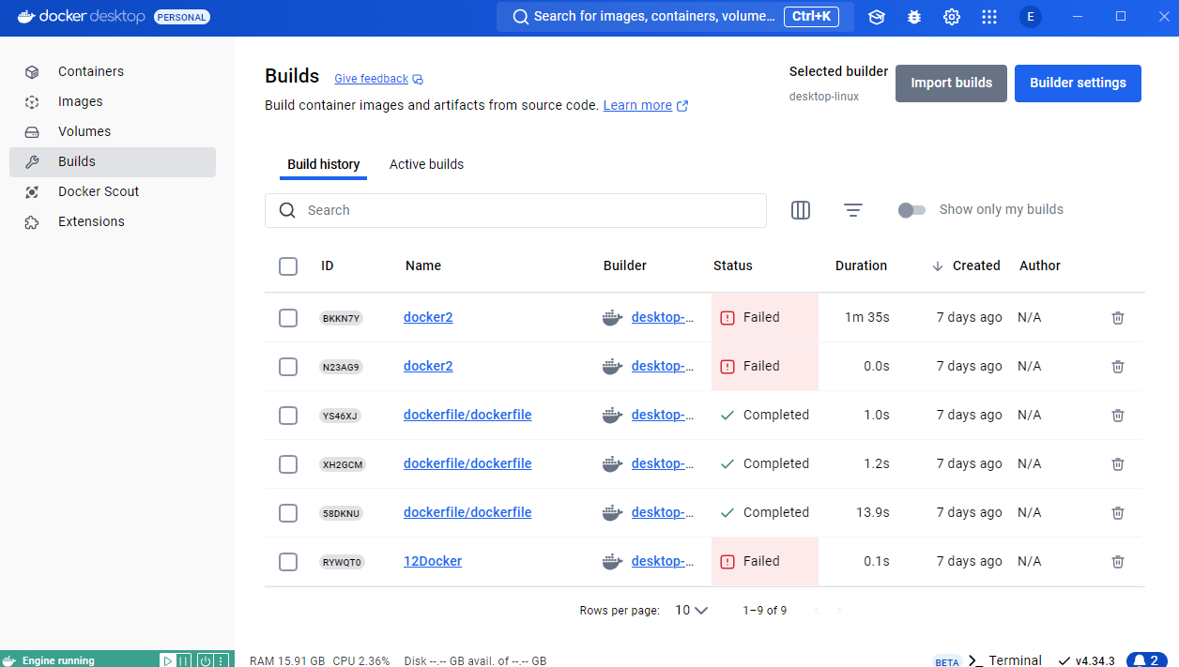

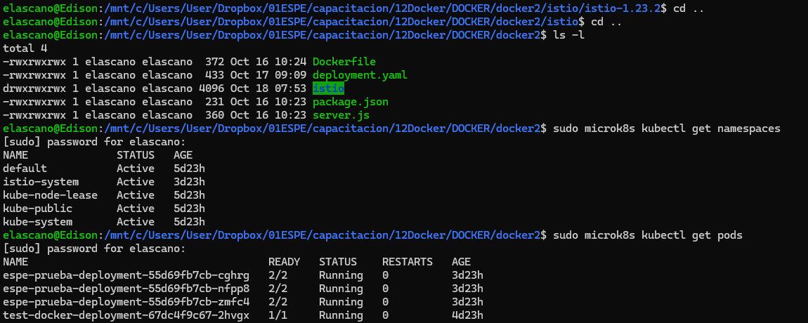

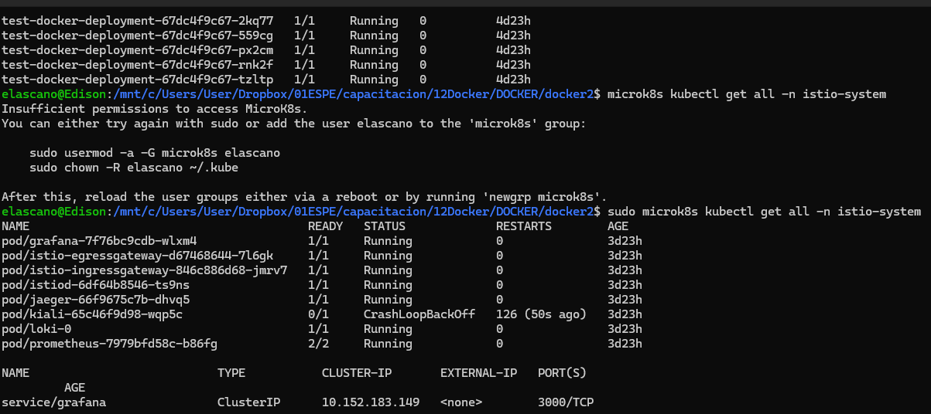

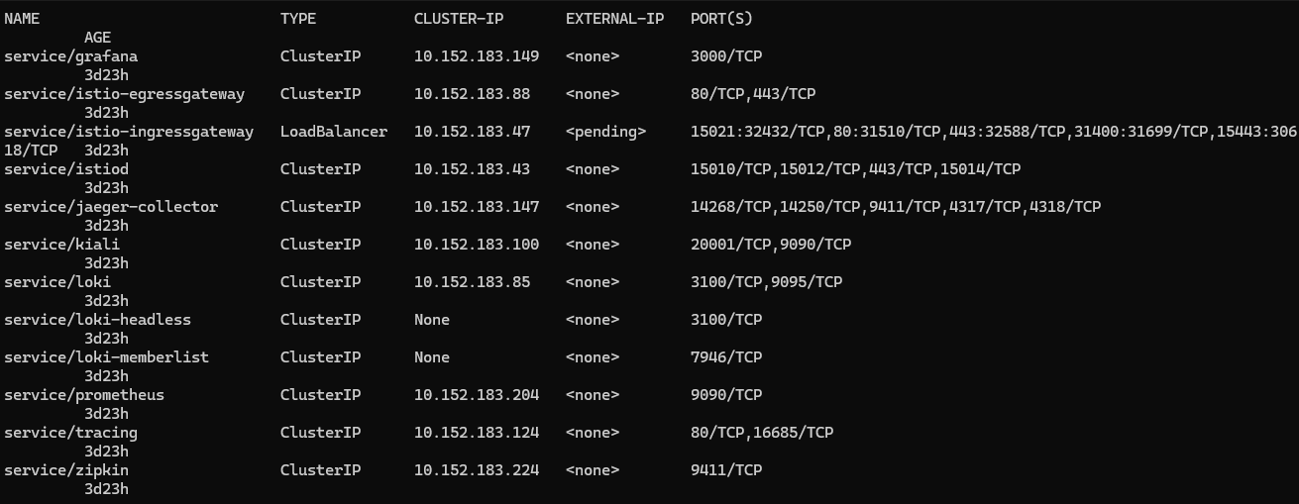

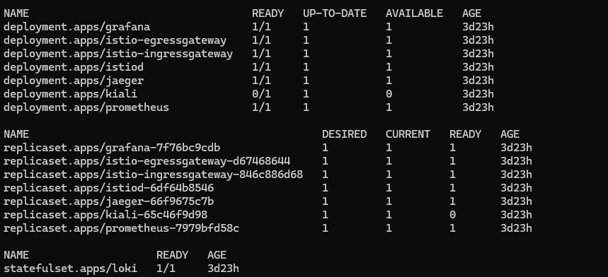

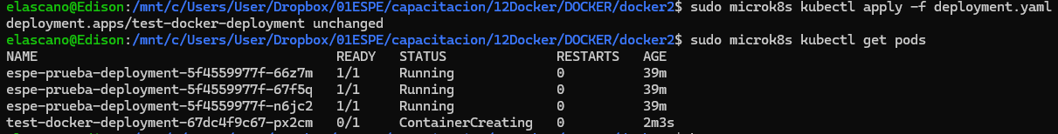

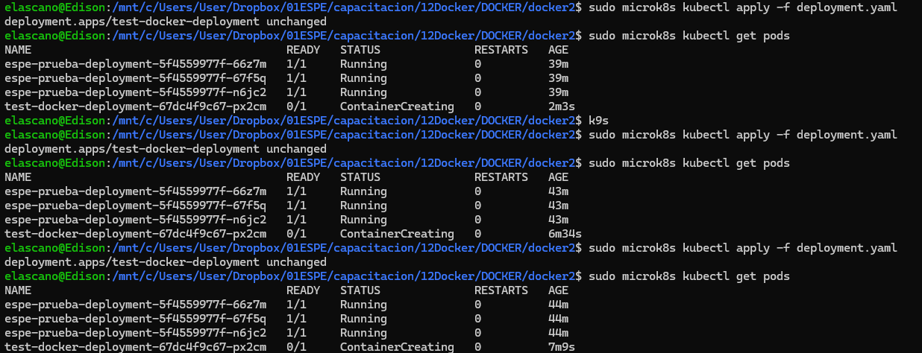

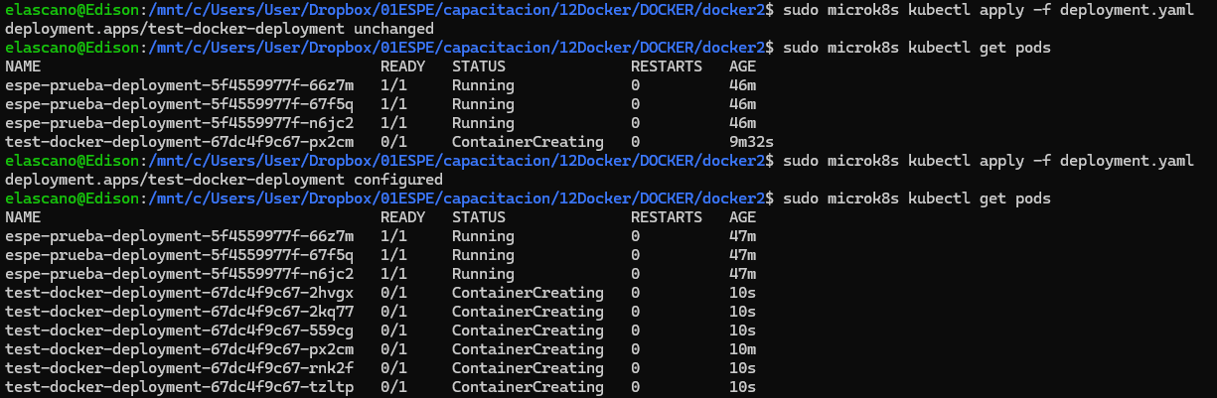

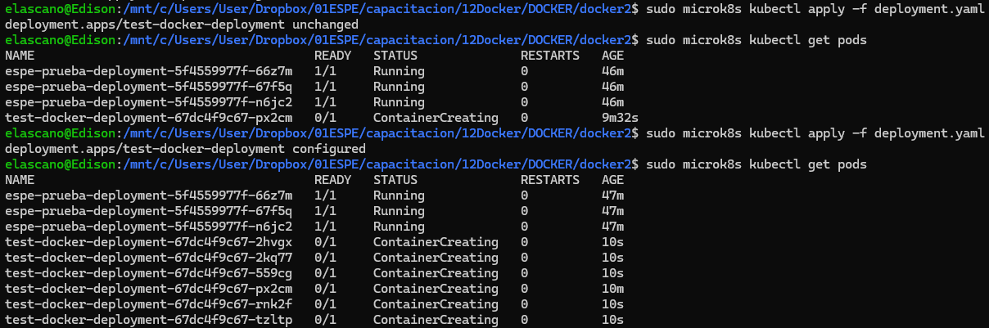

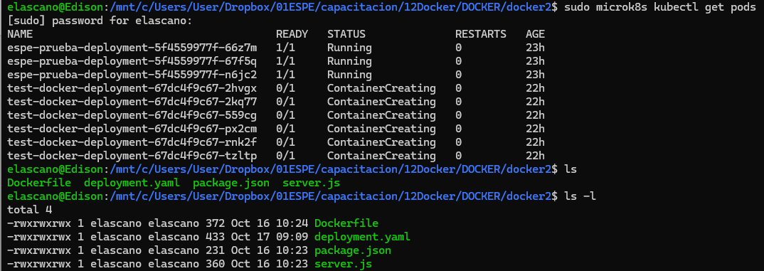

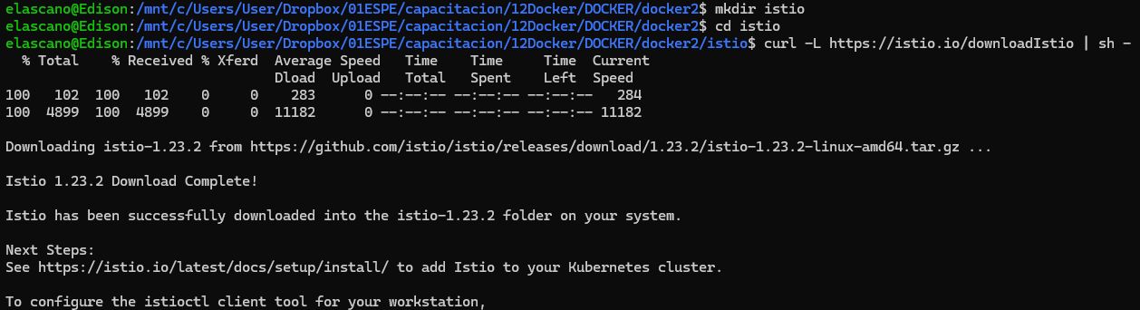

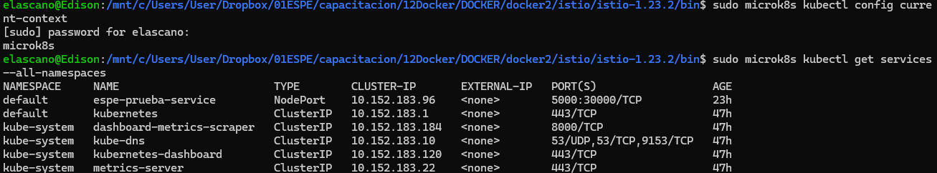



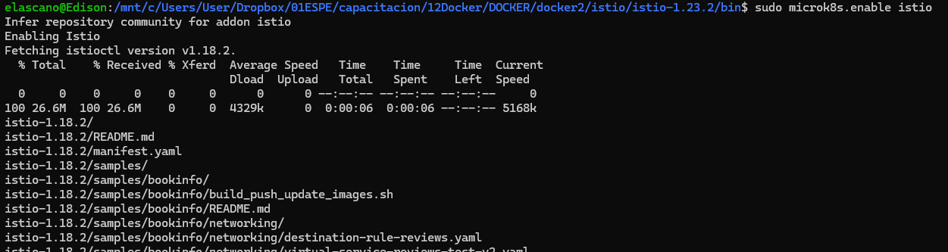

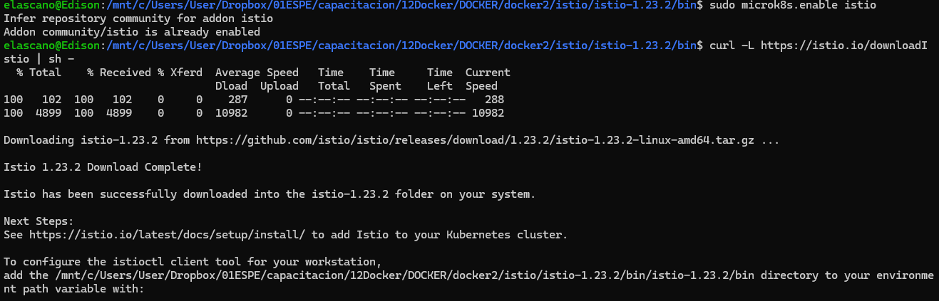

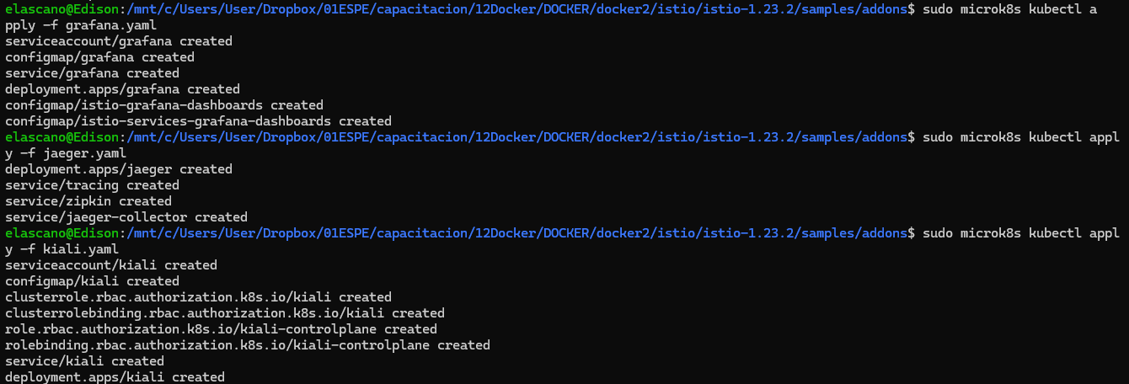

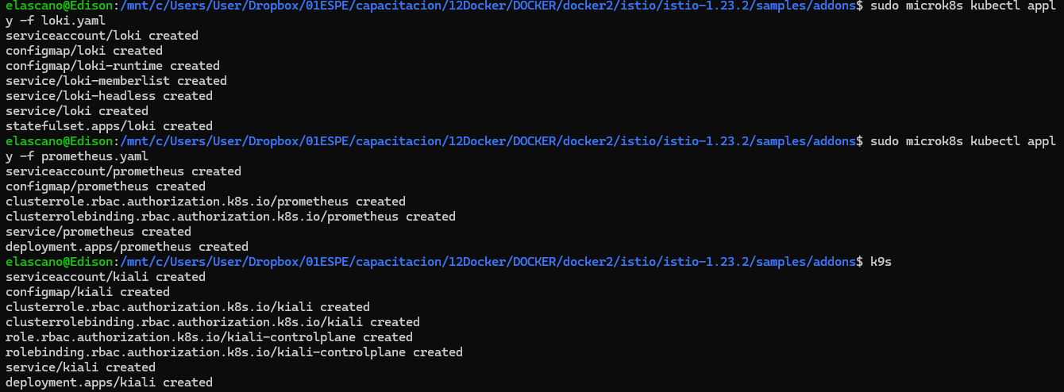

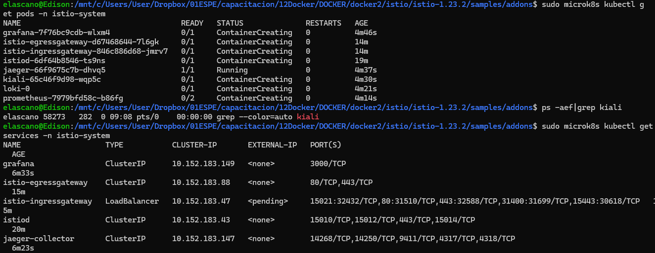

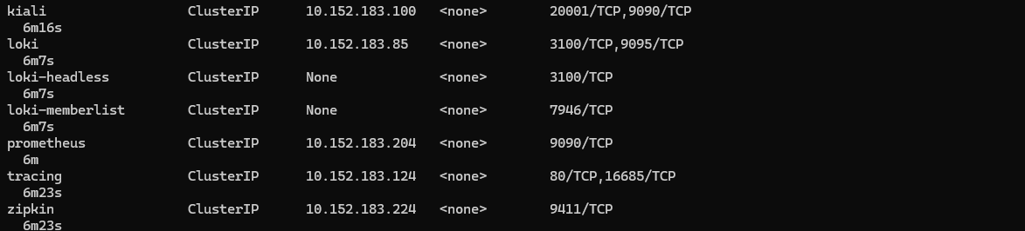

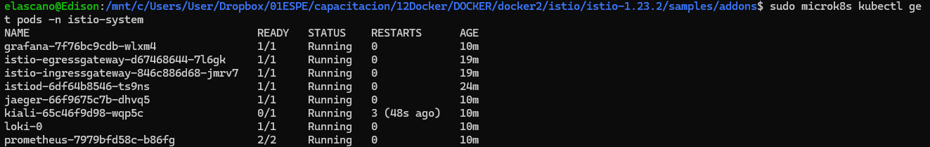

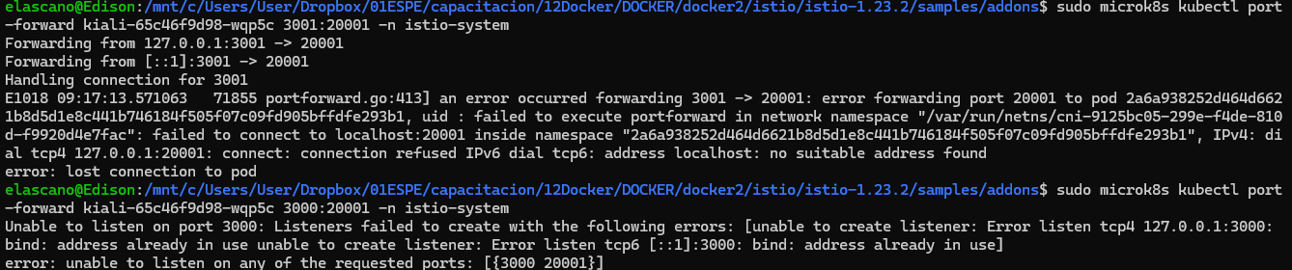

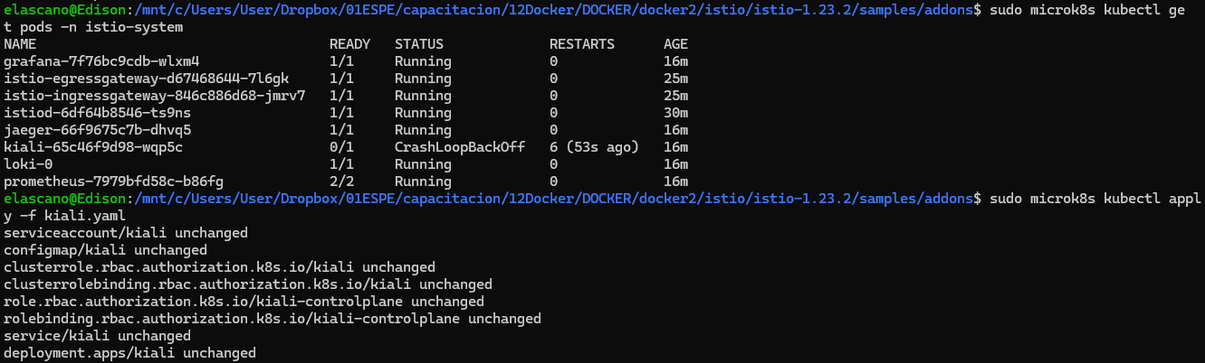

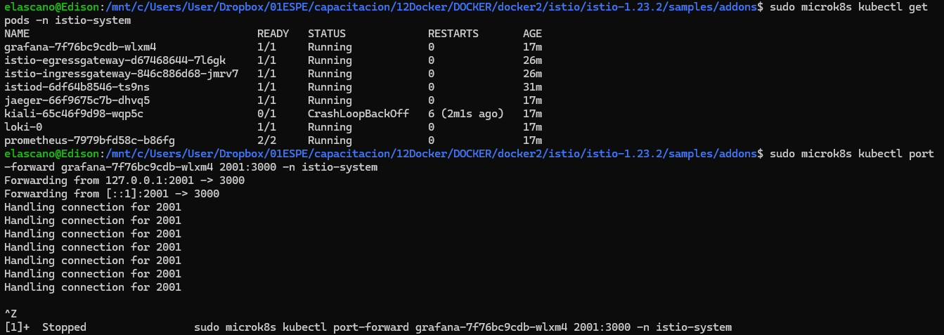

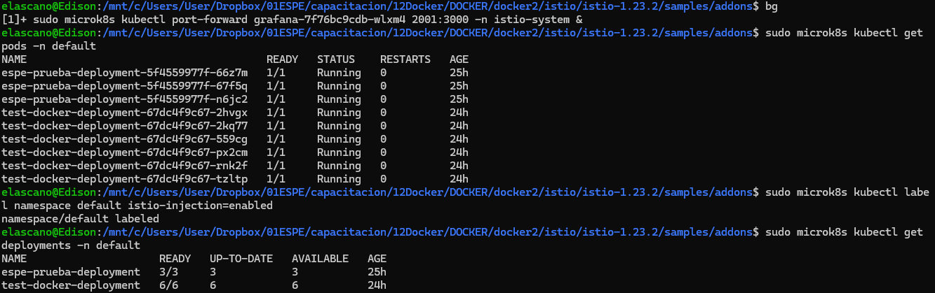

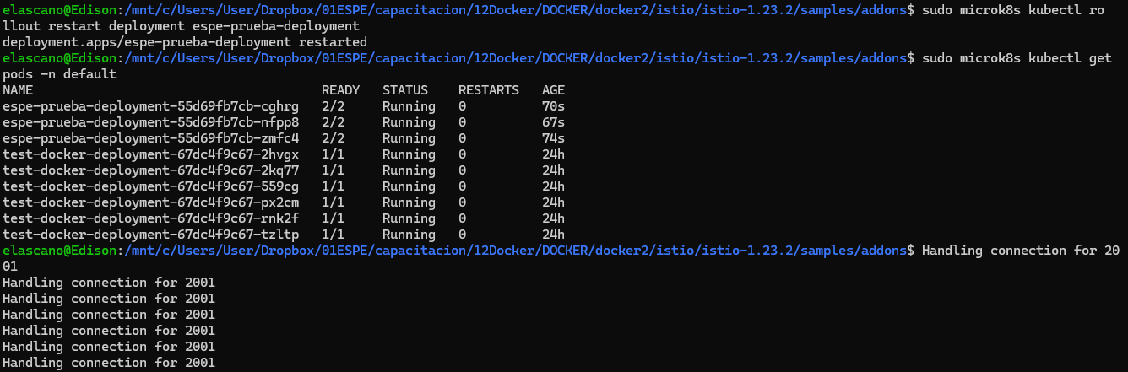

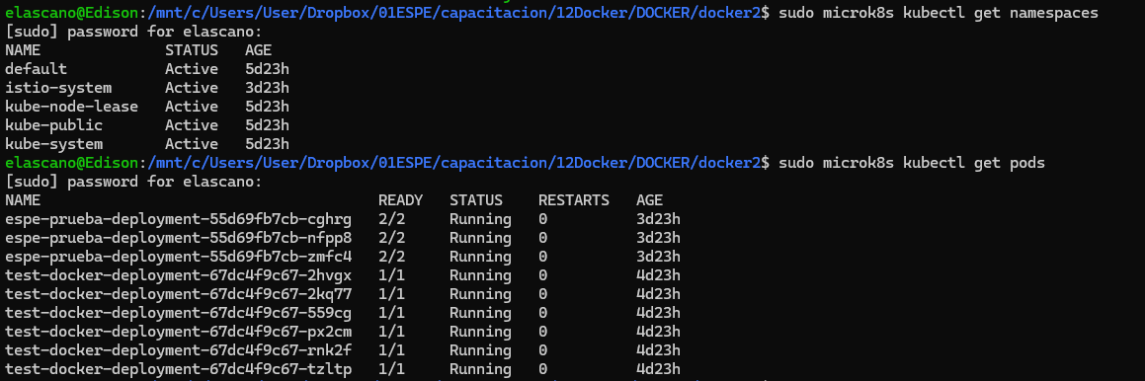

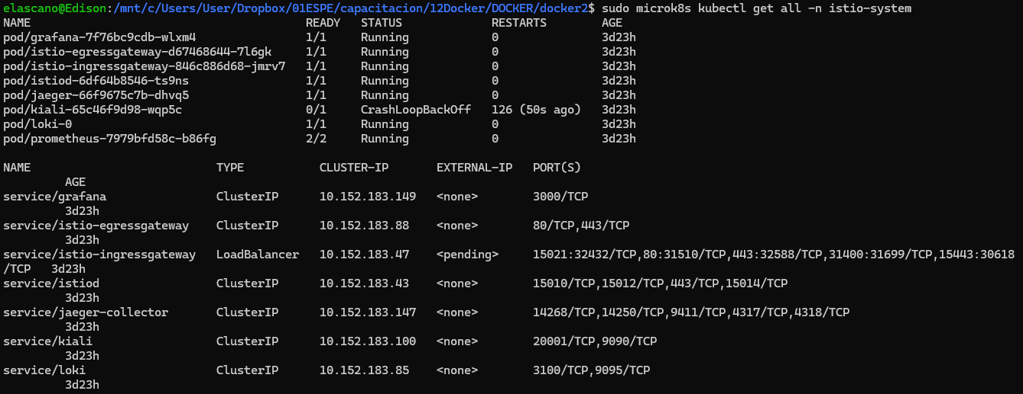

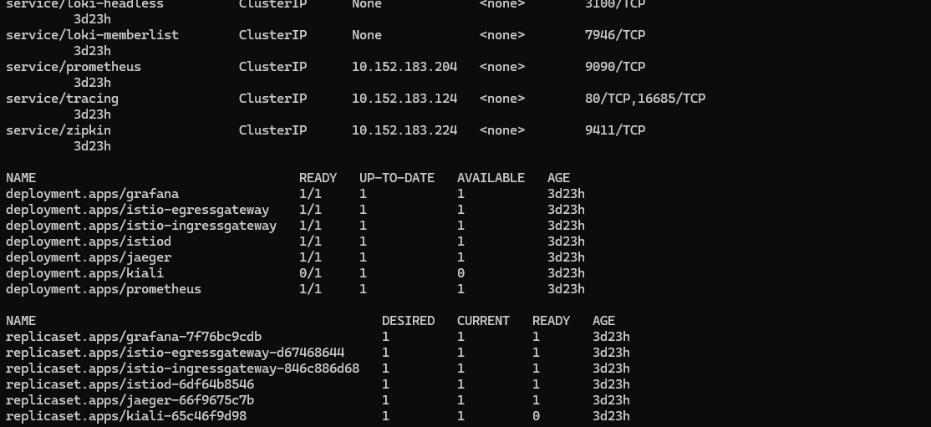

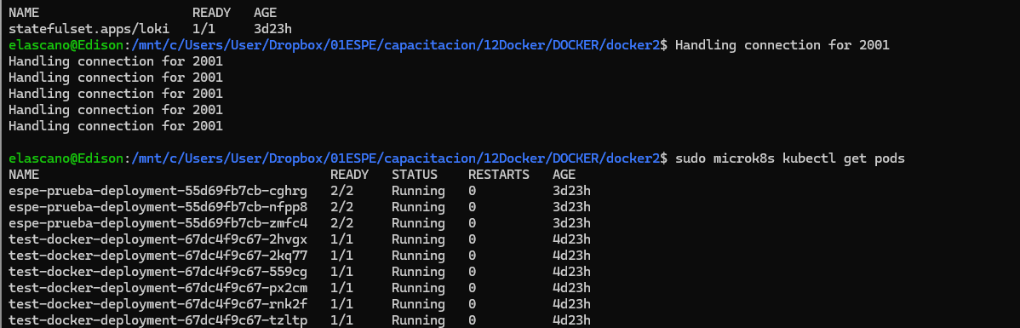

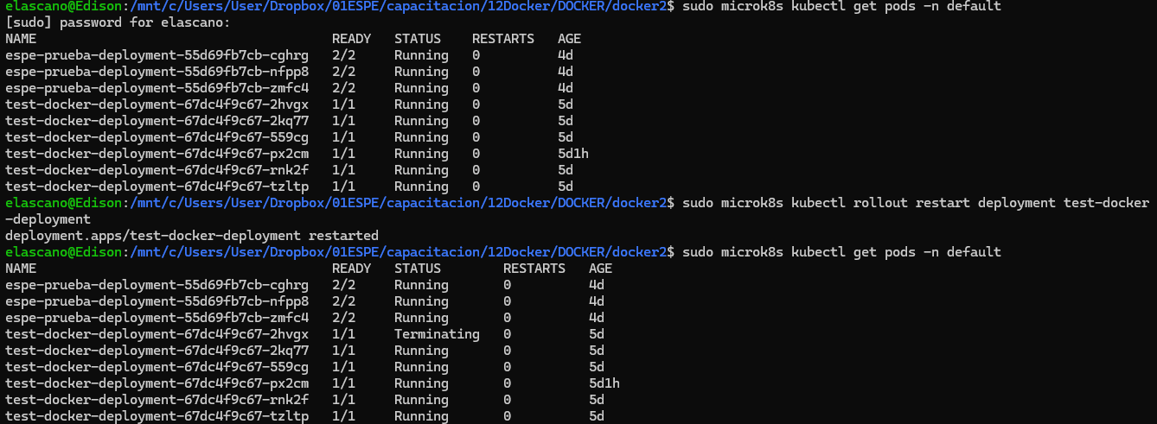

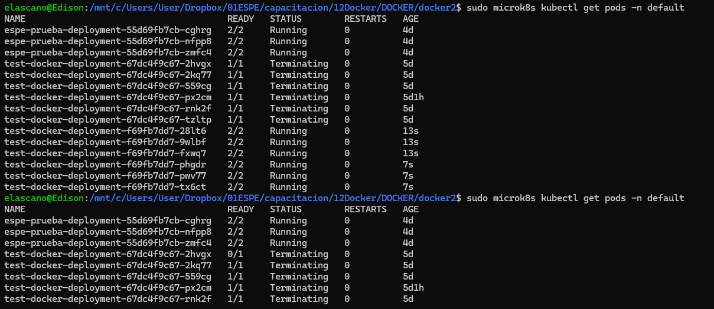

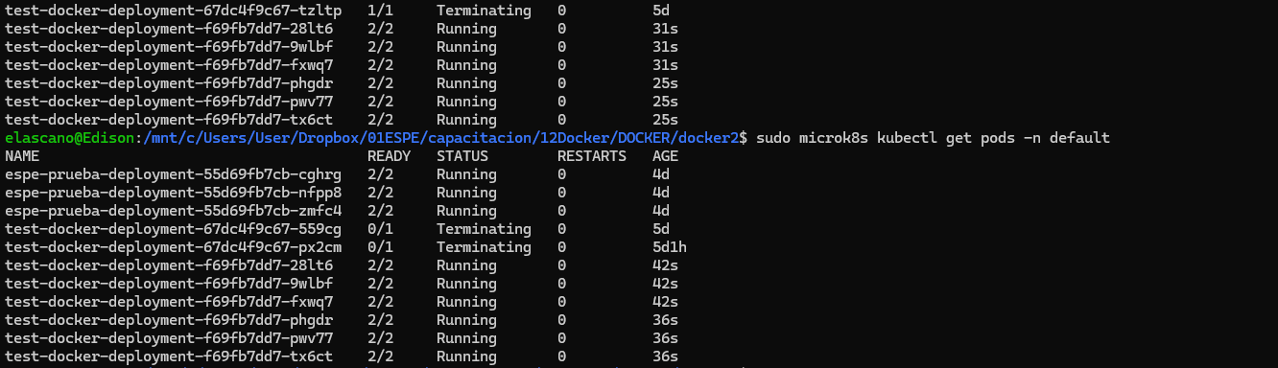

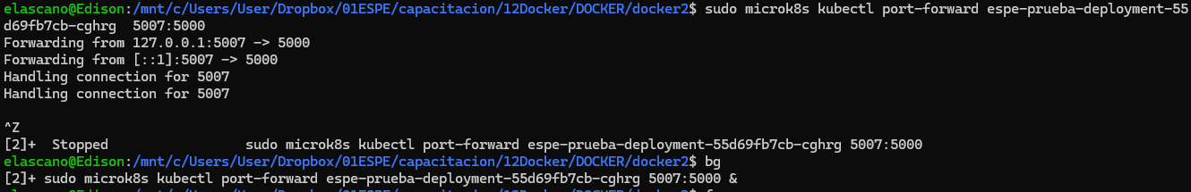



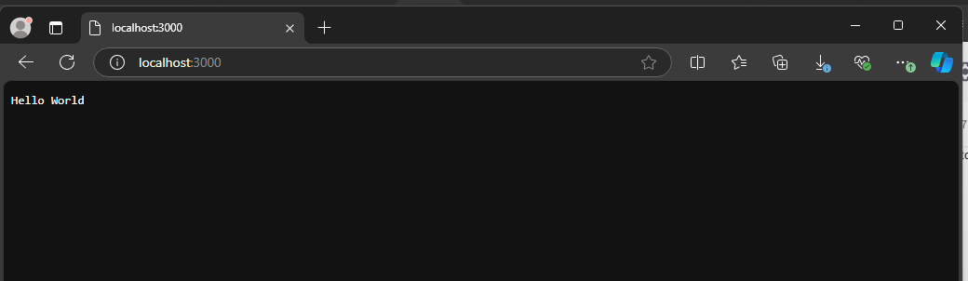

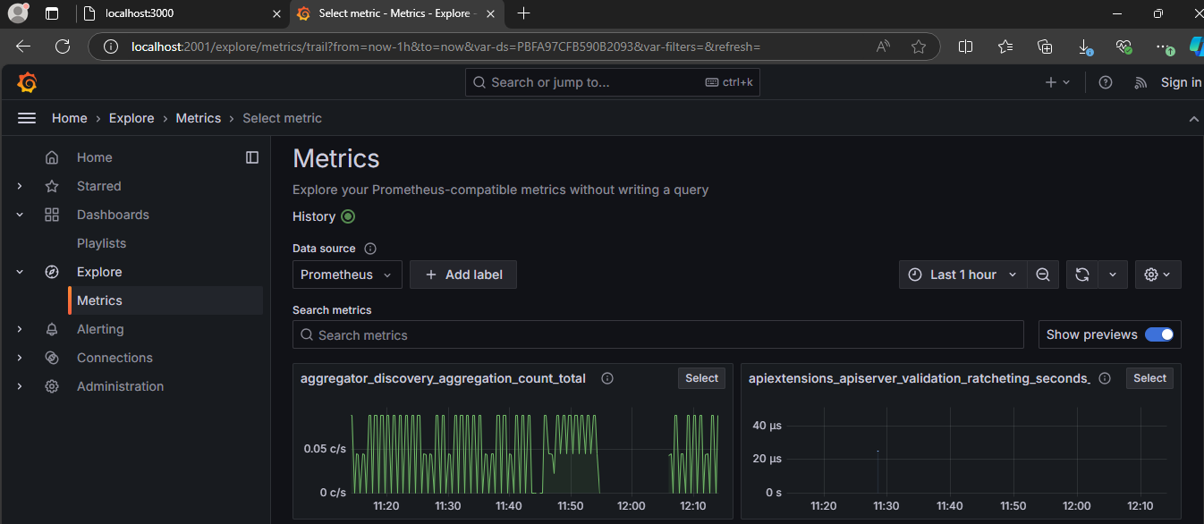

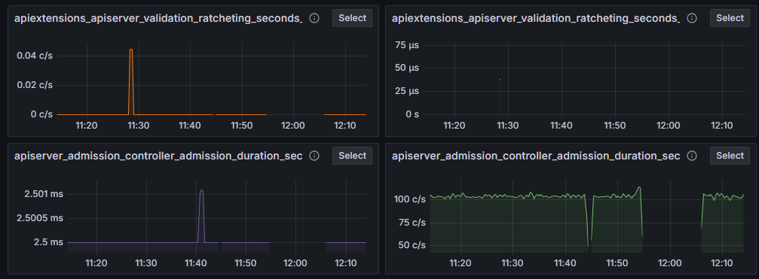

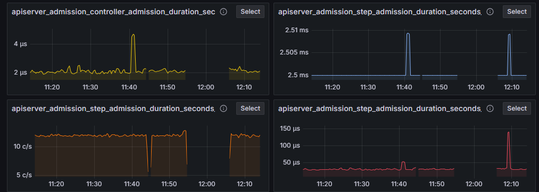

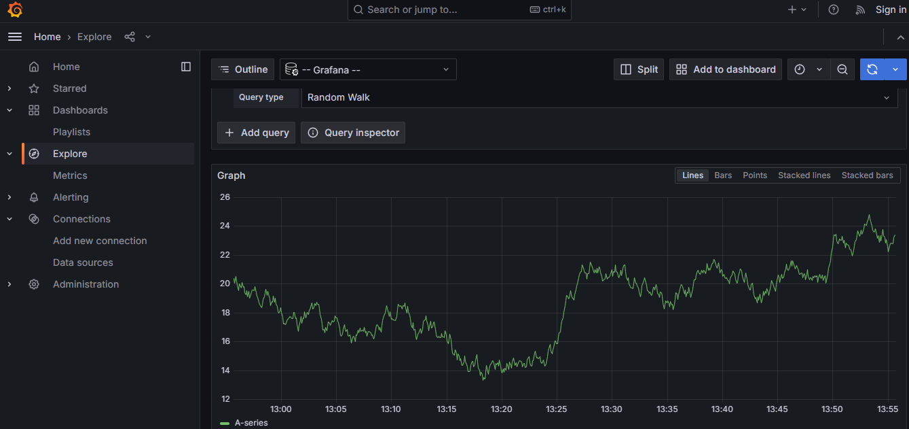

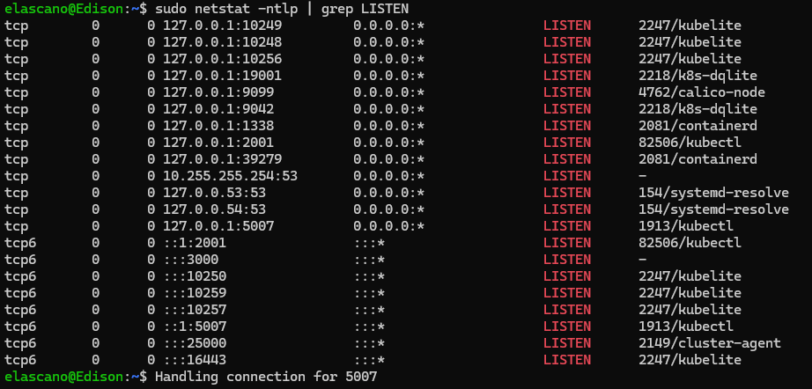

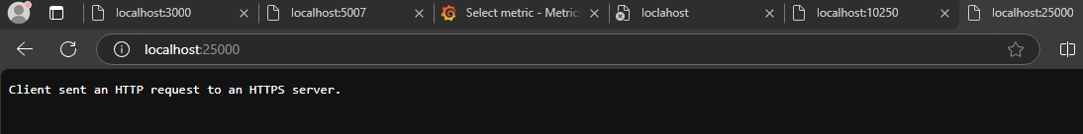

elascano@Edison:/mnt/c/Users/User/Dropbox/01ESPE/capacitacion/12Docker/DOCKER/docker2$ sudo k9s

sudo: k9s: command not found

elascano@Edison:/mnt/c/Users/User/Dropbox/01ESPE/capacitacion/12Docker/DOCKER/docker2$ k9s

Command 'k9s' not found, did you mean:

command 'ks' from deb qdl (1.0+git20230411.3b22df2-1)

command 'kas' from deb kas (4.0-1)

Try: sudo apt install <deb name>

elascano@Edison:/mnt/c/Users/User/Dropbox/01ESPE/capacitacion/12Docker/DOCKER/docker2$ sudo apt install k9s

Reading package lists... Done

Building dependency tree... Done

Reading state information... Done

E: Unable to locate package k9s

elascano@Edison:/mnt/c/Users/User/Dropbox/01ESPE/capacitacion/12Docker/DOCKER/docker2$ export PATH=$PATH:/snap/bin

elascano@Edison:/mnt/c/Users/User/Dropbox/01ESPE/capacitacion/12Docker/DOCKER/docker2$ k9s

Command 'k9s' not found, did you mean:

command 'kas' from deb kas (4.0-1)

command 'ks' from deb qdl (1.0+git20230411.3b22df2-1)

Try: sudo apt install <deb name>

elascano@Edison:/mnt/c/Users/User/Dropbox/01ESPE/capacitacion/12Docker/DOCKER/docker2$ source ~/.bashc

-bash: /home/elascano/.bashc: No such file or directory

elascano@Edison:/mnt/c/Users/User/Dropbox/01ESPE/capacitacion/12Docker/DOCKER/docker2$ source ~/.bash

.bash_logout .bashrc

elascano@Edison:/mnt/c/Users/User/Dropbox/01ESPE/capacitacion/12Docker/DOCKER/docker2$ source ~/.bashrc

elascano@Edison:/mnt/c/Users/User/Dropbox/01ESPE/capacitacion/12Docker/DOCKER/docker2$ k9s

Command 'k9s' not found, did you mean:

command 'ks' from deb qdl (1.0+git20230411.3b22df2-1)

command 'kas' from deb kas (4.0-1)

Try: sudo apt install <deb name>

elascano@Edison:/mnt/c/Users/User/Dropbox/01ESPE/capacitacion/12Docker/DOCKER/docker2$ sudo snap remove k9s

k9s removed

elascano@Edison:/mnt/c/Users/User/Dropbox/01ESPE/capacitacion/12Docker/DOCKER/docker2$ sudo snap install k9s

k9s v0.27.4 from Fernand Galiana (derailed) installed

elascano@Edison:/mnt/c/Users/User/Dropbox/01ESPE/capacitacion/12Docker/DOCKER/docker2$ k9s

Command 'k9s' not found, did you mean:

command 'kas' from deb kas (4.0-1)

command 'ks' from deb qdl (1.0+git20230411.3b22df2-1)

Try: sudo apt install <deb name>

elascano@Edison:/mnt/c/Users/User/Dropbox/01ESPE/capacitacion/12Docker/DOCKER/docker2$ sudo apt update

Hit:1 http://archive.ubuntu.com/ubuntu noble InRelease

Get:2 http://archive.ubuntu.com/ubuntu noble-updates InRelease [126 kB]

Hit:3 http://security.ubuntu.com/ubuntu noble-security InRelease

Hit:4 http://archive.ubuntu.com/ubuntu noble-backports InRelease

Fetched 126 kB in 1s (105 kB/s)

Reading package lists... Done

Building dependency tree... Done

Reading state information... Done

35 packages can be upgraded. Run 'apt list --upgradable' to see them.

elascano@Edison:/mnt/c/Users/User/Dropbox/01ESPE/capacitacion/12Docker/DOCKER/docker2$ sudo apt install snapd

Reading package lists... Done

Building dependency tree... Done

Reading state information... Done

Suggested packages:

zenity | kdialog

The following packages will be upgraded:

snapd

1 upgraded, 0 newly installed, 0 to remove and 34 not upgraded.

Need to get 28.8 MB of archives.

After this operation, 2073 kB of additional disk space will be used.

Get:1 http://archive.ubuntu.com/ubuntu noble-updates/main amd64 snapd amd64 2.65.3+24.04 [28.8 MB]

Fetched 28.8 MB in 4s (7697 kB/s)

(Reading database ... 40788 files and directories currently installed.)

Preparing to unpack .../snapd_2.65.3+24.04_amd64.deb ...

Unpacking snapd (2.65.3+24.04) over (2.63.1+24.04) ...

Setting up snapd (2.65.3+24.04) ...

Installing new version of config file /etc/apparmor.d/usr.lib.snapd.snap-confine.real ...

snapd.failure.service is a disabled or a static unit not running, not starting it.

snapd.snap-repair.service is a disabled or a static unit not running, not starting it.

Processing triggers for dbus (1.14.10-4ubuntu4.1) ...

Processing triggers for man-db (2.12.0-4build2) ...

elascano@Edison:/mnt/c/Users/User/Dropbox/01ESPE/capacitacion/12Docker/DOCKER/docker2$ sudo snap install core

core 16-2.61.4-20240607 from Canonical✓ installed

elascano@Edison:/mnt/c/Users/User/Dropbox/01ESPE/capacitacion/12Docker/DOCKER/docker2$ sudo snap remove k9s

k9s removed

elascano@Edison:/mnt/c/Users/User/Dropbox/01ESPE/capacitacion/12Docker/DOCKER/docker2$ sudo snap install k9s

k9s v0.27.4 from Fernand Galiana (derailed) installed

elascano@Edison:/mnt/c/Users/User/Dropbox/01ESPE/capacitacion/12Docker/DOCKER/docker2$ k9s

Command 'k9s' not found, did you mean:

command 'ks' from deb qdl (1.0+git20230411.3b22df2-1)

command 'kas' from deb kas (4.0-1)

Try: sudo apt install <deb name>

elascano@Edison:/mnt/c/Users/User/Dropbox/01ESPE/capacitacion/12Docker/DOCKER/docker2$ sudo snap remove k9s^C

elascano@Edison:/mnt/c/Users/User/Dropbox/01ESPE/capacitacion/12Docker/DOCKER/docker2$ bash

elascano@Edison:/mnt/c/Users/User/Dropbox/01ESPE/capacitacion/12Docker/DOCKER/docker2$ exit

exit

elascano@Edison:/mnt/c/Users/User/Dropbox/01ESPE/capacitacion/12Docker/DOCKER/docker2$ echo $SHELL

/bin/bash

elascano@Edison:/mnt/c/Users/User/Dropbox/01ESPE/capacitacion/12Docker/DOCKER/docker2$ echo $PATH

/usr/local/sbin:/usr/local/bin:/usr/sbin:/usr/bin:/sbin:/bin:/usr/games:/usr/local/games:/usr/lib/wsl/lib:/mnt/c/Windows/system32:/mnt/c/Windows:/mnt/c/Windows/System32/Wbem:/mnt/c/Windows/System32/WindowsPowerShell/v1.0/:/mnt/c/Windows/System32/OpenSSH/:/mnt/c/Program Files/Git/cmd:/mnt/c/Program Files/Docker/Docker/resources/bin:/mnt/c/Program Files (x86)/Bitvise SSH Client:/mnt/c/Program Files/PuTTY/:/mnt/c/Users/User/scoop/shims:/mnt/c/Windows/system32/config/systemprofile/AppData/Local/Microsoft/WindowsApps:/mnt/c/Users/User/AppData/Local/Programs/Microsoft VS Code/bin:/mnt/c/Program Files/Lens/resources/cli/bin:/mnt/c/Program Files/Multipass/bin:/mnt/c/Program Files/MicroK8s:/mnt/c/Program Files/MicroK8s/kubectl:/snap/bin:/snap/bin

elascano@Edison:/mnt/c/Users/User/Dropbox/01ESPE/capacitacion/12Docker/DOCKER/docker2$ cd /snap

elascano@Edison:/snap$ cd bin

elascano@Edison:/snap/bin$ ls -l

total 0

lrwxrwxrwx 1 root root 13 Oct 16 09:42 docker -> /usr/bin/snap

lrwxrwxrwx 1 root root 14 Oct 16 09:42 docker-compose -> docker.compose

lrwxrwxrwx 1 root root 13 Oct 16 09:42 docker.compose -> /usr/bin/snap

lrwxrwxrwx 1 root root 13 Oct 16 09:42 docker.help -> /usr/bin/snap

lrwxrwxrwx 1 root root 13 Oct 16 08:26 microk8s -> /usr/bin/snap

lrwxrwxrwx 1 root root 13 Oct 16 08:26 microk8s.add-node -> /usr/bin/snap

lrwxrwxrwx 1 root root 13 Oct 16 08:26 microk8s.addons -> /usr/bin/snap

lrwxrwxrwx 1 root root 13 Oct 16 08:26 microk8s.config -> /usr/bin/snap

lrwxrwxrwx 1 root root 13 Oct 16 08:26 microk8s.ctr -> /usr/bin/snap

lrwxrwxrwx 1 root root 13 Oct 16 08:26 microk8s.dashboard-proxy -> /usr/bin/snap

lrwxrwxrwx 1 root root 13 Oct 16 08:26 microk8s.dbctl -> /usr/bin/snap

lrwxrwxrwx 1 root root 13 Oct 16 08:26 microk8s.disable -> /usr/bin/snap

lrwxrwxrwx 1 root root 13 Oct 16 08:26 microk8s.enable -> /usr/bin/snap

lrwxrwxrwx 1 root root 13 Oct 16 08:26 microk8s.helm -> /usr/bin/snap

lrwxrwxrwx 1 root root 13 Oct 16 08:26 microk8s.helm3 -> /usr/bin/snap

lrwxrwxrwx 1 root root 13 Oct 16 08:26 microk8s.images -> /usr/bin/snap

lrwxrwxrwx 1 root root 13 Oct 16 08:26 microk8s.inspect -> /usr/bin/snap

lrwxrwxrwx 1 root root 13 Oct 16 08:26 microk8s.istioctl -> /usr/bin/snap

lrwxrwxrwx 1 root root 13 Oct 16 08:26 microk8s.join -> /usr/bin/snap

lrwxrwxrwx 1 root root 13 Oct 16 08:26 microk8s.kubectl -> /usr/bin/snap

lrwxrwxrwx 1 root root 13 Oct 16 08:26 microk8s.leave -> /usr/bin/snap

lrwxrwxrwx 1 root root 13 Oct 16 08:26 microk8s.linkerd -> /usr/bin/snap

lrwxrwxrwx 1 root root 13 Oct 16 08:26 microk8s.refresh-certs -> /usr/bin/snap

lrwxrwxrwx 1 root root 13 Oct 16 08:26 microk8s.remove-node -> /usr/bin/snap

lrwxrwxrwx 1 root root 13 Oct 16 08:26 microk8s.reset -> /usr/bin/snap

lrwxrwxrwx 1 root root 13 Oct 16 08:26 microk8s.start -> /usr/bin/snap

lrwxrwxrwx 1 root root 13 Oct 16 08:26 microk8s.status -> /usr/bin/snap

lrwxrwxrwx 1 root root 13 Oct 16 08:26 microk8s.stop -> /usr/bin/snap

lrwxrwxrwx 1 root root 13 Oct 16 08:26 microk8s.version -> /usr/bin/snap

elascano@Edison:/snap/bin$ sudo snap remove k9s

k9s removed

elascano@Edison:/snap/bin$ sudo snap install k9s

k9s v0.27.4 from Fernand Galiana (derailed) installed

elascano@Edison:/snap/bin$ k9s

Command 'k9s' not found, did you mean:

command 'ks' from deb qdl (1.0+git20230411.3b22df2-1)

command 'kas' from deb kas (4.0-1)

Try: sudo apt install <deb name>

elascano@Edison:/snap/bin$ sudo find / -name k9s -print

/var/snap/k9s

/snap/k9s

/snap/k9s/155/bin/k9s

find: ‘/mnt/c/$Recycle.Bin/S-1-5-18’: Permission denied

find: ‘/mnt/c/$Recycle.Bin/S-1-5-21-1725726762-1468504978-2221779196-1002’: Permission denied

find: ‘/mnt/c/PerfLogs’: Permission denied

^C

elascano@Edison:/snap/bin$ /var/snap/k9s

-bash: /var/snap/k9s: Is a directory

elascano@Edison:/snap/bin$ /var/snap/k9s/

155/ common/ current/

elascano@Edison:/snap/bin$ /snap/k9s/

155/ current/

elascano@Edison:/snap/bin$ /snap/k9s/current/

bin/ meta/

elascano@Edison:/snap/bin$ /snap/k9s/current/bin/k9s

elascano@Edison:/snap/bin$ sudo snap remove k9s

k9s removed

elascano@Edison:/snap/bin$ sudo snap install k9s

k9s v0.27.4 from Fernand Galiana (derailed) installed

elascano@Edison:/snap/bin$ k9s

Command 'k9s' not found, did you mean:

command 'ks' from deb qdl (1.0+git20230411.3b22df2-1)

command 'kas' from deb kas (4.0-1)

Try: sudo apt install <deb name>

elascano@Edison:/snap/bin$ sudo find / -name k9s -print

/var/snap/k9s

/snap/k9s

/snap/k9s/155/bin/k9s

find: ‘/mnt/c/$Recycle.Bin/S-1-5-18’: Permission denied

find: ‘/mnt/c/$Recycle.Bin/S-1-5-21-1725726762-1468504978-2221779196-1002’: Permission denied

find: ‘/mnt/c/PerfLogs’: Permission denied

^C

elascano@Edison:/snap/bin$ /var/snap/k9s

-bash: /var/snap/k9s: Is a directory

elascano@Edison:/snap/bin$ /var/snap/k9s/

155/ common/ current/

elascano@Edison:/snap/bin$ /snap/k9s/

155/ current/

elascano@Edison:/snap/bin$ /snap/k9s/current/

bin/ meta/

elascano@Edison:/snap/bin$ /snap/k9s/current/bin/k9s

elascano@Edison:/snap/bin$ pwd

/snap/bin

elascano@Edison:/snap/bin$ /snap/k9s/current/bin/k9s

k9s v0.27.4 from Fernand Galiana (derailed) installed

elascano@Edison:/snap/bin$ k9s

Command 'k9s' not found, did you mean:

command 'ks' from deb qdl (1.0+git20230411.3b22df2-1)

command 'kas' from deb kas (4.0-1)

Try: sudo apt install <deb name>

elascano@Edison:/snap/bin$ sudo find / -name k9s -print

/var/snap/k9s

/snap/k9s

/snap/k9s/155/bin/k9s

find: ‘/mnt/c/$Recycle.Bin/S-1-5-18’: Permission denied

find: ‘/mnt/c/$Recycle.Bin/S-1-5-21-1725726762-1468504978-2221779196-1002’: Permission denied

find: ‘/mnt/c/PerfLogs’: Permission denied

^C

elascano@Edison:/snap/bin$ /var/snap/k9s

-bash: /var/snap/k9s: Is a directory

elascano@Edison:/snap/bin$ /var/snap/k9s/

155/ common/ current/

elascano@Edison:/snap/bin$ /snap/k9s/

155/ current/

elascano@Edison:/snap/bin$ /snap/k9s/current/

bin/ meta/

elascano@Edison:/snap/bin$ /snap/k9s/current/bin/k9s

elascano@Edison:/snap/bin$ pwd

/snap/bin

elascano@Edison:/snap/bin$ /snap/k9s/current/bin/k9s

elascano@Edison:/snap/bin$ export PATH=$PATH: /snap/k9s/current/bin/

-bash: export: `/snap/k9s/current/bin/': not a valid identifier

elascano@Edison:/snap/bin$ export PATH=$PATH:/snap/k9s/current/bin/

elascano@Edison:/snap/bin$ k9s

command 'kas' from deb kas (4.0-1)

Try: sudo apt install <deb name>

elascano@Edison:/snap/bin$ sudo find / -name k9s -print

/var/snap/k9s

/snap/k9s

/snap/k9s/155/bin/k9s

find: ‘/mnt/c/$Recycle.Bin/S-1-5-18’: Permission denied

find: ‘/mnt/c/$Recycle.Bin/S-1-5-21-1725726762-1468504978-2221779196-1002’: Permission denied

find: ‘/mnt/c/PerfLogs’: Permission denied

^C

elascano@Edison:/snap/bin$ /var/snap/k9s

-bash: /var/snap/k9s: Is a directory

elascano@Edison:/snap/bin$ /var/snap/k9s/

155/ common/ current/

elascano@Edison:/snap/bin$ /snap/k9s/

155/ current/

elascano@Edison:/snap/bin$ /snap/k9s/current/

bin/ meta/

elascano@Edison:/snap/bin$ /snap/k9s/current/bin/k9s

elascano@Edison:/snap/bin$ pwd

/snap/bin

elascano@Edison:/snap/bin$ /snap/k9s/current/bin/k9s

elascano@Edison:/snap/bin$ export PATH=$PATH: /snap/k9s/current/bin/

-bash: export: `/snap/k9s/current/bin/': not a valid identifier

elascano@Edison:/snap/bin$ export PATH=$PATH:/snap/k9s/current/bin/

elascano@Edison:/snap/bin$ k9s

elascano@Edison:/snap/bin$ cd

elascano@Edison:~$ pwd

/home/elascano

elascano@Edison:~$ ls

snap

elascano@Edison:~$ cd ..

elascano@Edison:/home$ cd /mnt

elascano@Edison:/mnt$ ls -l

total 0

drwxrwxrwx 1 elascano elascano 4096 Oct 17 07:07 c

drwxrwxrwt 4 root root 100 Oct 16 09:45 wsl

drwxrwxrwt 7 root root 300 Oct 16 15:26 wslg

elascano@Edison:/mnt$ cd c

elascano@Edison:/mnt/c$ ls -l

ls: DumpStack.log: Permission denied

ls: cannot access 'DumpStack.log.tmp': Permission denied

ls: cannot access 'hiberfil.sys': Permission denied

ls: cannot access 'pagefile.sys': Permission denied

ls: PerfLogs: Permission denied

ls: Recovery: Permission denied

ls: cannot access 'swapfile.sys': Permission denied

ls: 'System Volume Information': Permission denied

total 12

drwxrwxrwx 1 elascano elascano 4096 Aug 17 21:31 '$Recycle.Bin'

lrwxrwxrwx 1 elascano elascano 12 Aug 6 11:48 'Documents and Settings' -> /mnt/c/Users

---------- 1 elascano elascano 12288 Aug 15 07:00 DumpStack.log

-????????? ? ? ? ? ? DumpStack.log.tmp

d--x--x--x 1 elascano elascano 4096 May 7 2022 PerfLogs

dr-xr-xr-x 1 elascano elascano 4096 Oct 17 07:07 'Program Files'

dr-xr-xr-x 1 elascano elascano 4096 Oct 15 07:50 'Program Files (x86)'

drwxrwxrwx 1 elascano elascano 4096 Oct 16 08:00 ProgramData

d--x--x--x 1 elascano elascano 4096 Aug 6 11:47 Recovery

drwxrwxrwx 1 elascano elascano 4096 Oct 14 07:44 SWSetup

d--x--x--x 1 elascano elascano 4096 Aug 6 11:48 'System Volume Information'

dr-xr-xr-x 1 elascano elascano 4096 Aug 17 21:30 Users

dr-xr-xr-x 1 elascano elascano 4096 Oct 15 07:50 Windows

-????????? ? ? ? ? ? hiberfil.sys

-????????? ? ? ? ? ? pagefile.sys

-????????? ? ? ? ? ? swapfile.sys

drwxrwxrwx 1 elascano elascano 4096 Aug 6 11:18 system.sav

elascano@Edison:/mnt/c$ cd Users/

elascano@Edison:/mnt/c/Users$ ls -l

ls: elascano: Permission denied

total 0

lrwxrwxrwx 1 elascano elascano 18 May 7 2022 'All Users' -> /mnt/c/ProgramData

dr-xr-xr-x 1 elascano elascano 4096 Aug 6 11:01 Default

lrwxrwxrwx 1 elascano elascano 20 May 7 2022 'Default User' -> /mnt/c/Users/Default

drwxrwxrwx 1 elascano elascano 4096 Aug 6 11:52 Public

drwxrwxrwx 1 elascano elascano 4096 Oct 16 09:45 User

-r-xr-xr-x 1 elascano elascano 174 May 7 2022 desktop.ini

d--x--x--x 1 elascano elascano 4096 Aug 18 09:15 elascano

elascano@Edison:/mnt/c/Users$ cd User/Dropbox/01ESPE/capacitacion/12Docker/

DOCKER/ ssh/

elascano@Edison:/mnt/c/Users$ cd User/Dropbox/01ESPE/capacitacion/12Docker/DOCKER/docker2/

elascano@Edison:/mnt/c/Users/User/Dropbox/01ESPE/capacitacion/12Docker/DOCKER/docker2$ ls -l

total 4

-rwxrwxrwx 1 elascano elascano 372 Oct 16 10:24 Dockerfile

-rwxrwxrwx 1 elascano elascano 415 Oct 17 08:28 deployment.yaml

-rwxrwxrwx 1 elascano elascano 231 Oct 16 10:23 package.json

-rwxrwxrwx 1 elascano elascano 360 Oct 16 10:23 server.js

elascano@Edison:/mnt/c/Users/User/Dropbox/01ESPE/capacitacion/12Docker/DOCKER/docker2$ k9s

dr-xr-xr-x 1 elascano elascano 4096 Oct 15 07:50 Windows

-????????? ? ? ? ? ? hiberfil.sys

-????????? ? ? ? ? ? pagefile.sys

-????????? ? ? ? ? ? swapfile.sys

drwxrwxrwx 1 elascano elascano 4096 Aug 6 11:18 system.sav

elascano@Edison:/mnt/c$ cd Users/

elascano@Edison:/mnt/c/Users$ ls -l

ls: elascano: Permission denied

total 0

lrwxrwxrwx 1 elascano elascano 18 May 7 2022 'All Users' -> /mnt/c/ProgramData

dr-xr-xr-x 1 elascano elascano 4096 Aug 6 11:01 Default

lrwxrwxrwx 1 elascano elascano 20 May 7 2022 'Default User' -> /mnt/c/Users/Default

drwxrwxrwx 1 elascano elascano 4096 Aug 6 11:52 Public

drwxrwxrwx 1 elascano elascano 4096 Oct 16 09:45 User

-r-xr-xr-x 1 elascano elascano 174 May 7 2022 desktop.ini

d--x--x--x 1 elascano elascano 4096 Aug 18 09:15 elascano

elascano@Edison:/mnt/c/Users$ cd User/Dropbox/01ESPE/capacitacion/12Docker/

DOCKER/ ssh/

elascano@Edison:/mnt/c/Users$ cd User/Dropbox/01ESPE/capacitacion/12Docker/DOCKER/docker2/

elascano@Edison:/mnt/c/Users/User/Dropbox/01ESPE/capacitacion/12Docker/DOCKER/docker2$ ls -l

total 4

-rwxrwxrwx 1 elascano elascano 372 Oct 16 10:24 Dockerfile

-rwxrwxrwx 1 elascano elascano 415 Oct 17 08:28 deployment.yaml

-rwxrwxrwx 1 elascano elascano 231 Oct 16 10:23 package.json

-rwxrwxrwx 1 elascano elascano 360 Oct 16 10:23 server.js

elascano@Edison:/mnt/c/Users/User/Dropbox/01ESPE/capacitacion/12Docker/DOCKER/docker2$ k9s

elascano@Edison:/mnt/c/Users/User/Dropbox/01ESPE/capacitacion/12Docker/DOCKER/docker2$ k9s -n defualt

-????????? ? ? ? ? ? hiberfil.sys

-????????? ? ? ? ? ? pagefile.sys

-????????? ? ? ? ? ? swapfile.sys

drwxrwxrwx 1 elascano elascano 4096 Aug 6 11:18 system.sav

elascano@Edison:/mnt/c$ cd Users/

elascano@Edison:/mnt/c/Users$ ls -l

ls: elascano: Permission denied

total 0

lrwxrwxrwx 1 elascano elascano 18 May 7 2022 'All Users' -> /mnt/c/ProgramData

dr-xr-xr-x 1 elascano elascano 4096 Aug 6 11:01 Default

lrwxrwxrwx 1 elascano elascano 20 May 7 2022 'Default User' -> /mnt/c/Users/Default

drwxrwxrwx 1 elascano elascano 4096 Aug 6 11:52 Public

drwxrwxrwx 1 elascano elascano 4096 Oct 16 09:45 User

-r-xr-xr-x 1 elascano elascano 174 May 7 2022 desktop.ini

d--x--x--x 1 elascano elascano 4096 Aug 18 09:15 elascano

elascano@Edison:/mnt/c/Users$ cd User/Dropbox/01ESPE/capacitacion/12Docker/

DOCKER/ ssh/

elascano@Edison:/mnt/c/Users$ cd User/Dropbox/01ESPE/capacitacion/12Docker/DOCKER/docker2/

elascano@Edison:/mnt/c/Users/User/Dropbox/01ESPE/capacitacion/12Docker/DOCKER/docker2$ ls -l

total 4

-rwxrwxrwx 1 elascano elascano 372 Oct 16 10:24 Dockerfile

-rwxrwxrwx 1 elascano elascano 415 Oct 17 08:28 deployment.yaml

-rwxrwxrwx 1 elascano elascano 231 Oct 16 10:23 package.json

-rwxrwxrwx 1 elascano elascano 360 Oct 16 10:23 server.js

elascano@Edison:/mnt/c/Users/User/Dropbox/01ESPE/capacitacion/12Docker/DOCKER/docker2$ k9s

elascano@Edison:/mnt/c/Users/User/Dropbox/01ESPE/capacitacion/12Docker/DOCKER/docker2$ k9s -n defualt

elascano@Edison:/mnt/c/Users/User/Dropbox/01ESPE/capacitacion/12Docker/DOCKER/docker2$ top

top - 08:48:41 up 6:31, 2 users, load average: 0.25, 0.35, 0.39

Tasks: 92 total, 1 running, 91 sleeping, 0 stopped, 0 zombie

%Cpu(s): 0.8 us, 0.0 sy, 0.0 ni, 99.2 id, 0.0 wa, 0.0 hi, 0.0 si, 0.0 st

MiB Mem : 15833.2 total, 5846.7 free, 2312.2 used, 7890.4 buff/cache

MiB Swap: 4096.0 total, 4096.0 free, 0.0 used. 13521.0 avail Mem

PID USER PR NI VIRT RES SHR S %CPU %MEM TIME+ COMMAND

2247 root 20 0 1635268 406972 93084 S 10.0 2.5 26:34.93 kubelite

1 root 20 0 23020 14480 9676 S 0.0 0.1 0:44.20 systemd

2 root 20 0 2616 1444 1320 S 0.0 0.0 0:00.02 init-systemd(Ub

6 root 20 0 2616 132 132 S 0.0 0.0 0:00.00 init

51 root 19 -1 67536 18876 16852 S 0.0 0.1 0:03.65 systemd-journal

91 root 20 0 24524 6688 4900 S 0.0 0.0 0:00.97 systemd-udevd

154 systemd+ 20 0 21580 13080 10812 S 0.0 0.1 0:00.23 systemd-resolve

157 systemd+ 20 0 91020 6544 5696 S 0.0 0.0 0:00.44 systemd-timesyn

163 root 20 0 4236 2736 2484 S 0.0 0.0 0:00.03 cron

164 message+ 20 0 9912 5524 4528 S 0.0 0.0 0:04.60 dbus-daemon

179 root 20 0 17976 8712 7640 S 0.0 0.1 0:01.63 systemd-logind

187 root 20 0 1904456 17276 10004 S 0.0 0.1 0:00.47 wsl-pro-service

201 root 20 0 3160 1100 1012 S 0.0 0.0 0:00.00 agetty

205 syslog 20 0 222508 5300 4452 S 0.0 0.0 0:00.98 rsyslogd

207 root 20 0 3116 1148 1060 S 0.0 0.0 0:00.00 agetty

223 root 20 0 106984 23120 13292 S 0.0 0.1 0:00.07 unattended-upgr

280 root 20 0 2620 124 0 S 0.0 0.0 0:00.00 SessionLeader

281 root 20 0 2620 128 0 S 0.0 0.0 0:00.31 Relay(282)

282 elascano 20 0 6836 6040 3548 S 0.0 0.0 0:00.50 bash

283 root 20 0 6696 4544 3760 S 0.0 0.0 0:00.00 login

elascano@Edison:/mnt/c/Users/User/Dropbox/01ESPE/capacitacion/12Docker/DOCKER/docker2$ dir

Dockerfile deployment.yaml package.json server.js

elascano@Edison:/mnt/c/Users/User/Dropbox/01ESPE/capacitacion/12Docker/DOCKER/docker2$ ls -l

total 4

-rwxrwxrwx 1 elascano elascano 372 Oct 16 10:24 Dockerfile

-rwxrwxrwx 1 elascano elascano 415 Oct 17 08:28 deployment.yaml

-rwxrwxrwx 1 elascano elascano 231 Oct 16 10:23 package.json

-rwxrwxrwx 1 elascano elascano 360 Oct 16 10:23 server.js

elascano@Edison:/mnt/c/Users/User/Dropbox/01ESPE/capacitacion/12Docker/DOCKER/docker2$ sudo microk8s kubectl apply -f deployment.yaml

deployment.apps/espe-prueba-deployment unchanged

elascano@Edison:/mnt/c/Users/User/Dropbox/01ESPE/capacitacion/12Docker/DOCKER/docker2$ k9s

91 root 20 0 24524 6688 4900 S 0.0 0.0 0:00.97 systemd-udevd

154 systemd+ 20 0 21580 13080 10812 S 0.0 0.1 0:00.23 systemd-resolve

157 systemd+ 20 0 91020 6544 5696 S 0.0 0.0 0:00.44 systemd-timesyn

163 root 20 0 4236 2736 2484 S 0.0 0.0 0:00.03 cron

164 message+ 20 0 9912 5524 4528 S 0.0 0.0 0:04.60 dbus-daemon

179 root 20 0 17976 8712 7640 S 0.0 0.1 0:01.63 systemd-logind

187 root 20 0 1904456 17276 10004 S 0.0 0.1 0:00.47 wsl-pro-service

201 root 20 0 3160 1100 1012 S 0.0 0.0 0:00.00 agetty

205 syslog 20 0 222508 5300 4452 S 0.0 0.0 0:00.98 rsyslogd

207 root 20 0 3116 1148 1060 S 0.0 0.0 0:00.00 agetty

223 root 20 0 106984 23120 13292 S 0.0 0.1 0:00.07 unattended-upgr

280 root 20 0 2620 124 0 S 0.0 0.0 0:00.00 SessionLeader

281 root 20 0 2620 128 0 S 0.0 0.0 0:00.31 Relay(282)

282 elascano 20 0 6836 6040 3548 S 0.0 0.0 0:00.50 bash

283 root 20 0 6696 4544 3760 S 0.0 0.0 0:00.00 login

elascano@Edison:/mnt/c/Users/User/Dropbox/01ESPE/capacitacion/12Docker/DOCKER/docker2$ dir

Dockerfile deployment.yaml package.json server.js

elascano@Edison:/mnt/c/Users/User/Dropbox/01ESPE/capacitacion/12Docker/DOCKER/docker2$ ls -l

total 4

-rwxrwxrwx 1 elascano elascano 372 Oct 16 10:24 Dockerfile

-rwxrwxrwx 1 elascano elascano 415 Oct 17 08:28 deployment.yaml

-rwxrwxrwx 1 elascano elascano 231 Oct 16 10:23 package.json

-rwxrwxrwx 1 elascano elascano 360 Oct 16 10:23 server.js

elascano@Edison:/mnt/c/Users/User/Dropbox/01ESPE/capacitacion/12Docker/DOCKER/docker2$ sudo microk8s kubectl apply -f deployment.yaml

deployment.apps/espe-prueba-deployment unchanged

elascano@Edison:/mnt/c/Users/User/Dropbox/01ESPE/capacitacion/12Docker/DOCKER/docker2$ k9s

elascano@Edison:/mnt/c/Users/User/Dropbox/01ESPE/capacitacion/12Docker/DOCKER/docker2$ k9s

154 systemd+ 20 0 21580 13080 10812 S 0.0 0.1 0:00.23 systemd-resolve

157 systemd+ 20 0 91020 6544 5696 S 0.0 0.0 0:00.44 systemd-timesyn

163 root 20 0 4236 2736 2484 S 0.0 0.0 0:00.03 cron

164 message+ 20 0 9912 5524 4528 S 0.0 0.0 0:04.60 dbus-daemon

179 root 20 0 17976 8712 7640 S 0.0 0.1 0:01.63 systemd-logind

187 root 20 0 1904456 17276 10004 S 0.0 0.1 0:00.47 wsl-pro-service

201 root 20 0 3160 1100 1012 S 0.0 0.0 0:00.00 agetty

205 syslog 20 0 222508 5300 4452 S 0.0 0.0 0:00.98 rsyslogd

207 root 20 0 3116 1148 1060 S 0.0 0.0 0:00.00 agetty

223 root 20 0 106984 23120 13292 S 0.0 0.1 0:00.07 unattended-upgr

280 root 20 0 2620 124 0 S 0.0 0.0 0:00.00 SessionLeader

281 root 20 0 2620 128 0 S 0.0 0.0 0:00.31 Relay(282)

282 elascano 20 0 6836 6040 3548 S 0.0 0.0 0:00.50 bash

283 root 20 0 6696 4544 3760 S 0.0 0.0 0:00.00 login

elascano@Edison:/mnt/c/Users/User/Dropbox/01ESPE/capacitacion/12Docker/DOCKER/docker2$ dir

Dockerfile deployment.yaml package.json server.js

elascano@Edison:/mnt/c/Users/User/Dropbox/01ESPE/capacitacion/12Docker/DOCKER/docker2$ ls -l

total 4

-rwxrwxrwx 1 elascano elascano 372 Oct 16 10:24 Dockerfile

-rwxrwxrwx 1 elascano elascano 415 Oct 17 08:28 deployment.yaml

-rwxrwxrwx 1 elascano elascano 231 Oct 16 10:23 package.json

-rwxrwxrwx 1 elascano elascano 360 Oct 16 10:23 server.js

elascano@Edison:/mnt/c/Users/User/Dropbox/01ESPE/capacitacion/12Docker/DOCKER/docker2$ sudo microk8s kubectl apply -f deployment.yaml

deployment.apps/espe-prueba-deployment unchanged

elascano@Edison:/mnt/c/Users/User/Dropbox/01ESPE/capacitacion/12Docker/DOCKER/docker2$ k9s

elascano@Edison:/mnt/c/Users/User/Dropbox/01ESPE/capacitacion/12Docker/DOCKER/docker2$ k9s

elascano@Edison:/mnt/c/Users/User/Dropbox/01ESPE/capacitacion/12Docker/DOCKER/docker2$ k9s

157 systemd+ 20 0 91020 6544 5696 S 0.0 0.0 0:00.44 systemd-timesyn

163 root 20 0 4236 2736 2484 S 0.0 0.0 0:00.03 cron

164 message+ 20 0 9912 5524 4528 S 0.0 0.0 0:04.60 dbus-daemon

179 root 20 0 17976 8712 7640 S 0.0 0.1 0:01.63 systemd-logind

187 root 20 0 1904456 17276 10004 S 0.0 0.1 0:00.47 wsl-pro-service

201 root 20 0 3160 1100 1012 S 0.0 0.0 0:00.00 agetty

205 syslog 20 0 222508 5300 4452 S 0.0 0.0 0:00.98 rsyslogd

207 root 20 0 3116 1148 1060 S 0.0 0.0 0:00.00 agetty

223 root 20 0 106984 23120 13292 S 0.0 0.1 0:00.07 unattended-upgr

280 root 20 0 2620 124 0 S 0.0 0.0 0:00.00 SessionLeader

281 root 20 0 2620 128 0 S 0.0 0.0 0:00.31 Relay(282)

282 elascano 20 0 6836 6040 3548 S 0.0 0.0 0:00.50 bash

283 root 20 0 6696 4544 3760 S 0.0 0.0 0:00.00 login

elascano@Edison:/mnt/c/Users/User/Dropbox/01ESPE/capacitacion/12Docker/DOCKER/docker2$ dir

Dockerfile deployment.yaml package.json server.js

elascano@Edison:/mnt/c/Users/User/Dropbox/01ESPE/capacitacion/12Docker/DOCKER/docker2$ ls -l

total 4

-rwxrwxrwx 1 elascano elascano 372 Oct 16 10:24 Dockerfile

-rwxrwxrwx 1 elascano elascano 415 Oct 17 08:28 deployment.yaml

-rwxrwxrwx 1 elascano elascano 231 Oct 16 10:23 package.json

-rwxrwxrwx 1 elascano elascano 360 Oct 16 10:23 server.js

elascano@Edison:/mnt/c/Users/User/Dropbox/01ESPE/capacitacion/12Docker/DOCKER/docker2$ sudo microk8s kubectl apply -f deployment.yaml

deployment.apps/espe-prueba-deployment unchanged

elascano@Edison:/mnt/c/Users/User/Dropbox/01ESPE/capacitacion/12Docker/DOCKER/docker2$ k9s

elascano@Edison:/mnt/c/Users/User/Dropbox/01ESPE/capacitacion/12Docker/DOCKER/docker2$ k9s

elascano@Edison:/mnt/c/Users/User/Dropbox/01ESPE/capacitacion/12Docker/DOCKER/docker2$ k9s

elascano@Edison:/mnt/c/Users/User/Dropbox/01ESPE/capacitacion/12Docker/DOCKER/docker2$ k9s

163 root 20 0 4236 2736 2484 S 0.0 0.0 0:00.03 cron

164 message+ 20 0 9912 5524 4528 S 0.0 0.0 0:04.60 dbus-daemon

179 root 20 0 17976 8712 7640 S 0.0 0.1 0:01.63 systemd-logind

187 root 20 0 1904456 17276 10004 S 0.0 0.1 0:00.47 wsl-pro-service

201 root 20 0 3160 1100 1012 S 0.0 0.0 0:00.00 agetty

205 syslog 20 0 222508 5300 4452 S 0.0 0.0 0:00.98 rsyslogd

207 root 20 0 3116 1148 1060 S 0.0 0.0 0:00.00 agetty

223 root 20 0 106984 23120 13292 S 0.0 0.1 0:00.07 unattended-upgr

280 root 20 0 2620 124 0 S 0.0 0.0 0:00.00 SessionLeader

281 root 20 0 2620 128 0 S 0.0 0.0 0:00.31 Relay(282)

282 elascano 20 0 6836 6040 3548 S 0.0 0.0 0:00.50 bash

283 root 20 0 6696 4544 3760 S 0.0 0.0 0:00.00 login

elascano@Edison:/mnt/c/Users/User/Dropbox/01ESPE/capacitacion/12Docker/DOCKER/docker2$ dir

Dockerfile deployment.yaml package.json server.js

elascano@Edison:/mnt/c/Users/User/Dropbox/01ESPE/capacitacion/12Docker/DOCKER/docker2$ ls -l

total 4

-rwxrwxrwx 1 elascano elascano 372 Oct 16 10:24 Dockerfile

-rwxrwxrwx 1 elascano elascano 415 Oct 17 08:28 deployment.yaml

-rwxrwxrwx 1 elascano elascano 231 Oct 16 10:23 package.json

-rwxrwxrwx 1 elascano elascano 360 Oct 16 10:23 server.js

elascano@Edison:/mnt/c/Users/User/Dropbox/01ESPE/capacitacion/12Docker/DOCKER/docker2$ sudo microk8s kubectl apply -f deployment.yaml

deployment.apps/espe-prueba-deployment unchanged

elascano@Edison:/mnt/c/Users/User/Dropbox/01ESPE/capacitacion/12Docker/DOCKER/docker2$ k9s

elascano@Edison:/mnt/c/Users/User/Dropbox/01ESPE/capacitacion/12Docker/DOCKER/docker2$ k9s

elascano@Edison:/mnt/c/Users/User/Dropbox/01ESPE/capacitacion/12Docker/DOCKER/docker2$ k9s

elascano@Edison:/mnt/c/Users/User/Dropbox/01ESPE/capacitacion/12Docker/DOCKER/docker2$ k9s

elascano@Edison:/mnt/c/Users/User/Dropbox/01ESPE/capacitacion/12Docker/DOCKER/docker2$ k9s

164 message+ 20 0 9912 5524 4528 S 0.0 0.0 0:04.60 dbus-daemon

179 root 20 0 17976 8712 7640 S 0.0 0.1 0:01.63 systemd-logind

187 root 20 0 1904456 17276 10004 S 0.0 0.1 0:00.47 wsl-pro-service

201 root 20 0 3160 1100 1012 S 0.0 0.0 0:00.00 agetty

205 syslog 20 0 222508 5300 4452 S 0.0 0.0 0:00.98 rsyslogd

207 root 20 0 3116 1148 1060 S 0.0 0.0 0:00.00 agetty

223 root 20 0 106984 23120 13292 S 0.0 0.1 0:00.07 unattended-upgr

280 root 20 0 2620 124 0 S 0.0 0.0 0:00.00 SessionLeader

281 root 20 0 2620 128 0 S 0.0 0.0 0:00.31 Relay(282)

282 elascano 20 0 6836 6040 3548 S 0.0 0.0 0:00.50 bash

283 root 20 0 6696 4544 3760 S 0.0 0.0 0:00.00 login

elascano@Edison:/mnt/c/Users/User/Dropbox/01ESPE/capacitacion/12Docker/DOCKER/docker2$ dir

Dockerfile deployment.yaml package.json server.js

elascano@Edison:/mnt/c/Users/User/Dropbox/01ESPE/capacitacion/12Docker/DOCKER/docker2$ ls -l

total 4

-rwxrwxrwx 1 elascano elascano 372 Oct 16 10:24 Dockerfile

-rwxrwxrwx 1 elascano elascano 415 Oct 17 08:28 deployment.yaml

-rwxrwxrwx 1 elascano elascano 231 Oct 16 10:23 package.json

-rwxrwxrwx 1 elascano elascano 360 Oct 16 10:23 server.js

elascano@Edison:/mnt/c/Users/User/Dropbox/01ESPE/capacitacion/12Docker/DOCKER/docker2$ sudo microk8s kubectl apply -f deployment.yaml

deployment.apps/espe-prueba-deployment unchanged

elascano@Edison:/mnt/c/Users/User/Dropbox/01ESPE/capacitacion/12Docker/DOCKER/docker2$ k9s

elascano@Edison:/mnt/c/Users/User/Dropbox/01ESPE/capacitacion/12Docker/DOCKER/docker2$ k9s

elascano@Edison:/mnt/c/Users/User/Dropbox/01ESPE/capacitacion/12Docker/DOCKER/docker2$ k9s

elascano@Edison:/mnt/c/Users/User/Dropbox/01ESPE/capacitacion/12Docker/DOCKER/docker2$ k9s

elascano@Edison:/mnt/c/Users/User/Dropbox/01ESPE/capacitacion/12Docker/DOCKER/docker2$ k9s

elascano@Edison:/mnt/c/Users/User/Dropbox/01ESPE/capacitacion/12Docker/DOCKER/docker2$ kubectl cluster-info

E1017 08:54:21.009392 79883 memcache.go:265] couldn't get current server API group list: Get "http://localhost:8080/api?timeout=32s": dial tcp 127.0.0.1:8080: connect: connection refused

E1017 08:54:21.009806 79883 memcache.go:265] couldn't get current server API group list: Get "http://localhost:8080/api?timeout=32s": dial tcp 127.0.0.1:8080: connect: connection refused

E1017 08:54:21.011192 79883 memcache.go:265] couldn't get current server API group list: Get "http://localhost:8080/api?timeout=32s": dial tcp 127.0.0.1:8080: connect: connection refused

E1017 08:54:21.011578 79883 memcache.go:265] couldn't get current server API group list: Get "http://localhost:8080/api?timeout=32s": dial tcp 127.0.0.1:8080: connect: connection refused

E1017 08:54:21.013366 79883 memcache.go:265] couldn't get current server API group list: Get "http://localhost:8080/api?timeout=32s": dial tcp 127.0.0.1:8080: connect: connection refused

To further debug and diagnose cluster problems, use 'kubectl cluster-info dump'.

The connection to the server localhost:8080 was refused - did you specify the right host or port?

elascano@Edison:/mnt/c/Users/User/Dropbox/01ESPE/capacitacion/12Docker/DOCKER/docker2$ sudo kubectl cluster-info

E1017 08:55:30.187024 81500 memcache.go:265] couldn't get current server API group list: Get "http://localhost:8080/api?timeout=32s": dial tcp 127.0.0.1:8080: connect: connection refused

E1017 08:55:30.187625 81500 memcache.go:265] couldn't get current server API group list: Get "http://localhost:8080/api?timeout=32s": dial tcp 127.0.0.1:8080: connect: connection refused

E1017 08:55:30.189782 81500 memcache.go:265] couldn't get current server API group list: Get "http://localhost:8080/api?timeout=32s": dial tcp 127.0.0.1:8080: connect: connection refused

E1017 08:55:30.190279 81500 memcache.go:265] couldn't get current server API group list: Get "http://localhost:8080/api?timeout=32s": dial tcp 127.0.0.1:8080: connect: connection refused

E1017 08:55:30.191559 81500 memcache.go:265] couldn't get current server API group list: Get "http://localhost:8080/api?timeout=32s": dial tcp 127.0.0.1:8080: connect: connection refused

To further debug and diagnose cluster problems, use 'kubectl cluster-info dump'.

The connection to the server localhost:8080 was refused - did you specify the right host or port?

elascano@Edison:/mnt/c/Users/User/Dropbox/01ESPE/capacitacion/12Docker/DOCKER/docker2$ sudo kubectl get pods

E1017 08:55:36.756890 81685 memcache.go:265] couldn't get current server API group list: Get "http://localhost:8080/api?timeout=32s": dial tcp 127.0.0.1:8080: connect: connection refused

E1017 08:55:36.757136 81685 memcache.go:265] couldn't get current server API group list: Get "http://localhost:8080/api?timeout=32s": dial tcp 127.0.0.1:8080: connect: connection refused

E1017 08:55:36.758595 81685 memcache.go:265] couldn't get current server API group list: Get "http://localhost:8080/api?timeout=32s": dial tcp 127.0.0.1:8080: connect: connection refused

E1017 08:55:36.758806 81685 memcache.go:265] couldn't get current server API group list: Get "http://localhost:8080/api?timeout=32s": dial tcp 127.0.0.1:8080: connect: connection refused

E1017 08:55:36.760386 81685 memcache.go:265] couldn't get current server API group list: Get "http://localhost:8080/api?timeout=32s": dial tcp 127.0.0.1:8080: connect: connection refused

The connection to the server localhost:8080 was refused - did you specify the right host or port?

elascano@Edison:/mnt/c/Users/User/Dropbox/01ESPE/capacitacion/12Docker/DOCKER/docker2$

elascano@Edison:/mnt/c/Users/User/Dropbox/01ESPE/capacitacion/12Docker/DOCKER/docker2$ sudo microk8s kubectl apply -f deployment.yaml

deployment.apps/espe-prueba-deployment unchanged

elascano@Edison:/mnt/c/Users/User/Dropbox/01ESPE/capacitacion/12Docker/DOCKER/docker2$ sudo kubectl get pods

E1017 08:57:09.255732 83894 memcache.go:265] couldn't get current server API group list: Get "http://localhost:8080/api?timeout=32s": dial tcp 127.0.0.1:8080: connect: connection refused

E1017 08:57:09.256030 83894 memcache.go:265] couldn't get current server API group list: Get "http://localhost:8080/api?timeout=32s": dial tcp 127.0.0.1:8080: connect: connection refused

E1017 08:57:09.257372 83894 memcache.go:265] couldn't get current server API group list: Get "http://localhost:8080/api?timeout=32s": dial tcp 127.0.0.1:8080: connect: connection refused

E1017 08:57:09.257578 83894 memcache.go:265] couldn't get current server API group list: Get "http://localhost:8080/api?timeout=32s": dial tcp 127.0.0.1:8080: connect: connection refused

E1017 08:57:09.258929 83894 memcache.go:265] couldn't get current server API group list: Get "http://localhost:8080/api?timeout=32s": dial tcp 127.0.0.1:8080: connect: connection refused

The connection to the server localhost:8080 was refused - did you specify the right host or port?

elascano@Edison:/mnt/c/Users/User/Dropbox/01ESPE/capacitacion/12Docker/DOCKER/docker2$ sudo microk8s kubectl apply -f deployment.yaml

deployment.apps/test-docker-deployment created

error: error parsing deployment.yaml: error converting YAML to JSON: yaml: line 13: could not find expected ':'

elascano@Edison:/mnt/c/Users/User/Dropbox/01ESPE/capacitacion/12Docker/DOCKER/docker2$ sudo microk8s kubectl apply -f deployment.yaml

deployment.apps/test-docker-deployment unchanged

elascano@Edison:/mnt/c/Users/User/Dropbox/01ESPE/capacitacion/12Docker/DOCKER/docker2$ sudo kubectl get pods

E1017 09:00:36.499244 88998 memcache.go:265] couldn't get current server API group list: Get "http://localhost:8080/api?timeout=32s": dial tcp 127.0.0.1:8080: connect: connection refused

E1017 09:00:36.499571 88998 memcache.go:265] couldn't get current server API group list: Get "http://localhost:8080/api?timeout=32s": dial tcp 127.0.0.1:8080: connect: connection refused

E1017 09:00:36.500891 88998 memcache.go:265] couldn't get current server API group list: Get "http://localhost:8080/api?timeout=32s": dial tcp 127.0.0.1:8080: connect: connection refused

E1017 09:00:36.501197 88998 memcache.go:265] couldn't get current server API group list: Get "http://localhost:8080/api?timeout=32s": dial tcp 127.0.0.1:8080: connect: connection refused

E1017 09:00:36.502683 88998 memcache.go:265] couldn't get current server API group list: Get "http://localhost:8080/api?timeout=32s": dial tcp 127.0.0.1:8080: connect: connection refused

The connection to the server localhost:8080 was refused - did you specify the right host or port?

elascano@Edison:/mnt/c/Users/User/Dropbox/01ESPE/capacitacion/12Docker/DOCKER/docker2$ sudo microk8s kubectl apply -f deployment.yaml

deployment.apps/test-docker-deployment unchanged

elascano@Edison:/mnt/c/Users/User/Dropbox/01ESPE/capacitacion/12Docker/DOCKER/docker2$ sudo microk8s kubectl get pods

NAME READY STATUS RESTARTS AGE

espe-prueba-deployment-5f4559977f-66z7m 1/1 Running 0 39m

espe-prueba-deployment-5f4559977f-67f5q 1/1 Running 0 39m

espe-prueba-deployment-5f4559977f-n6jc2 1/1 Running 0 39m

test-docker-deployment-67dc4f9c67-px2cm 0/1 ContainerCreating 0 2m3s

elascano@Edison:/mnt/c/Users/User/Dropbox/01ESPE/capacitacion/12Docker/DOCKER/docker2$ k9s

elascano@Edison:/mnt/c/Users/User/Dropbox/01ESPE/capacitacion/12Docker/DOCKER/docker2$ sudo microk8s kubectl apply -f deployment.yaml

deployment.apps/test-docker-deployment created

error: error parsing deployment.yaml: error converting YAML to JSON: yaml: line 13: could not find expected ':'

elascano@Edison:/mnt/c/Users/User/Dropbox/01ESPE/capacitacion/12Docker/DOCKER/docker2$ sudo microk8s kubectl apply -f deployment.yaml

deployment.apps/test-docker-deployment unchanged

elascano@Edison:/mnt/c/Users/User/Dropbox/01ESPE/capacitacion/12Docker/DOCKER/docker2$ sudo kubectl get pods

E1017 09:00:36.499244 88998 memcache.go:265] couldn't get current server API group list: Get "http://localhost:8080/api?timeout=32s": dial tcp 127.0.0.1:8080: connect: connection refused

E1017 09:00:36.499571 88998 memcache.go:265] couldn't get current server API group list: Get "http://localhost:8080/api?timeout=32s": dial tcp 127.0.0.1:8080: connect: connection refused

E1017 09:00:36.500891 88998 memcache.go:265] couldn't get current server API group list: Get "http://localhost:8080/api?timeout=32s": dial tcp 127.0.0.1:8080: connect: connection refused

E1017 09:00:36.501197 88998 memcache.go:265] couldn't get current server API group list: Get "http://localhost:8080/api?timeout=32s": dial tcp 127.0.0.1:8080: connect: connection refused

E1017 09:00:36.502683 88998 memcache.go:265] couldn't get current server API group list: Get "http://localhost:8080/api?timeout=32s": dial tcp 127.0.0.1:8080: connect: connection refused

The connection to the server localhost:8080 was refused - did you specify the right host or port?

elascano@Edison:/mnt/c/Users/User/Dropbox/01ESPE/capacitacion/12Docker/DOCKER/docker2$ sudo microk8s kubectl apply -f deployment.yaml

deployment.apps/test-docker-deployment unchanged

elascano@Edison:/mnt/c/Users/User/Dropbox/01ESPE/capacitacion/12Docker/DOCKER/docker2$ sudo microk8s kubectl get pods

NAME READY STATUS RESTARTS AGE

espe-prueba-deployment-5f4559977f-66z7m 1/1 Running 0 39m

espe-prueba-deployment-5f4559977f-67f5q 1/1 Running 0 39m

espe-prueba-deployment-5f4559977f-n6jc2 1/1 Running 0 39m

test-docker-deployment-67dc4f9c67-px2cm 0/1 ContainerCreating 0 2m3s

elascano@Edison:/mnt/c/Users/User/Dropbox/01ESPE/capacitacion/12Docker/DOCKER/docker2$ k9s

elascano@Edison:/mnt/c/Users/User/Dropbox/01ESPE/capacitacion/12Docker/DOCKER/docker2$ sudo microk8s kubectl apply -f deployment.yaml

deployment.apps/test-docker-deployment unchanged

elascano@Edison:/mnt/c/Users/User/Dropbox/01ESPE/capacitacion/12Docker/DOCKER/docker2$ sudo microk8s kubectl get pods

NAME READY STATUS RESTARTS AGE

espe-prueba-deployment-5f4559977f-66z7m 1/1 Running 0 43m

espe-prueba-deployment-5f4559977f-67f5q 1/1 Running 0 43m

espe-prueba-deployment-5f4559977f-n6jc2 1/1 Running 0 43m

test-docker-deployment-67dc4f9c67-px2cm 0/1 ContainerCreating 0 6m34s

elascano@Edison:/mnt/c/Users/User/Dropbox/01ESPE/capacitacion/12Docker/DOCKER/docker2$ sudo microk8s kubectl apply -f deployment.yaml

deployment.apps/test-docker-deployment unchanged

elascano@Edison:/mnt/c/Users/User/Dropbox/01ESPE/capacitacion/12Docker/DOCKER/docker2$ sudo microk8s kubectl get pods

NAME READY STATUS RESTARTS AGE

espe-prueba-deployment-5f4559977f-66z7m 1/1 Running 0 44m

espe-prueba-deployment-5f4559977f-67f5q 1/1 Running 0 44m

espe-prueba-deployment-5f4559977f-n6jc2 1/1 Running 0 44m

test-docker-deployment-67dc4f9c67-px2cm 0/1 ContainerCreating 0 7m9s

elascano@Edison:/mnt/c/Users/User/Dropbox/01ESPE/capacitacion/12Docker/DOCKER/docker2$ sudo microk8s kubectl apply -f

error: flag needs an argument: 'f' in -f

See 'kubectl apply --help' for usage.

elascano@Edison:/mnt/c/Users/User/Dropbox/01ESPE/capacitacion/12Docker/DOCKER/docker2$ sudo microk8s kubectl apply

error: must specify one of -f and -k

elascano@Edison:/mnt/c/Users/User/Dropbox/01ESPE/capacitacion/12Docker/DOCKER/docker2$ sudo microk8s kubectl -f apply

error: unknown shorthand flag: 'f' in -f

See 'kubectl --help' for usage.

elascano@Edison:/mnt/c/Users/User/Dropbox/01ESPE/capacitacion/12Docker/DOCKER/docker2$ sudo microk8s kubectl -f

error: unknown shorthand flag: 'f' in -f

See 'kubectl --help' for usage.

elascano@Edison:/mnt/c/Users/User/Dropbox/01ESPE/capacitacion/12Docker/DOCKER/docker2$ sudo microk8s kubectl apply

error: must specify one of -f and -k

elascano@Edison:/mnt/c/Users/User/Dropbox/01ESPE/capacitacion/12Docker/DOCKER/docker2$ sudo microk8s -f kubectl apply

'-f' is not a valid MicroK8s subcommand.

Available subcommands are:

add-node

addons

config

ctr

dashboard-proxy

dbctl

disable

enable

helm

helm3

images

istioctl

join

kubectl

leave

linkerd

refresh-certs

remove-node

reset

start

status

stop

version

inspect

elascano@Edison:/mnt/c/Users/User/Dropbox/01ESPE/capacitacion/12Docker/DOCKER/docker2$ sudo microk8s kubectl apply -f

error: flag needs an argument: 'f' in -f

See 'kubectl apply --help' for usage.

elascano@Edison:/mnt/c/Users/User/Dropbox/01ESPE/capacitacion/12Docker/DOCKER/docker2$ sudo microk8s kubectl apply -f deployment.yaml

deployment.apps/test-docker-deployment unchanged

elascano@Edison:/mnt/c/Users/User/Dropbox/01ESPE/capacitacion/12Docker/DOCKER/docker2$ sudo microk8s kubectl get pods

NAME READY STATUS RESTARTS AGE

espe-prueba-deployment-5f4559977f-66z7m 1/1 Running 0 46m

espe-prueba-deployment-5f4559977f-67f5q 1/1 Running 0 46m

espe-prueba-deployment-5f4559977f-n6jc2 1/1 Running 0 46m

test-docker-deployment-67dc4f9c67-px2cm 0/1 ContainerCreating 0 9m32s

elascano@Edison:/mnt/c/Users/User/Dropbox/01ESPE/capacitacion/12Docker/DOCKER/docker2$ sudo microk8s kubectl apply -f deployment.yaml

deployment.apps/test-docker-deployment configured

elascano@Edison:/mnt/c/Users/User/Dropbox/01ESPE/capacitacion/12Docker/DOCKER/docker2$ sudo microk8s kubectl get pods

NAME READY STATUS RESTARTS AGE

espe-prueba-deployment-5f4559977f-66z7m 1/1 Running 0 47m

espe-prueba-deployment-5f4559977f-67f5q 1/1 Running 0 47m

espe-prueba-deployment-5f4559977f-n6jc2 1/1 Running 0 47m

test-docker-deployment-67dc4f9c67-2hvgx 0/1 ContainerCreating 0 10s

test-docker-deployment-67dc4f9c67-2kq77 0/1 ContainerCreating 0 10s

test-docker-deployment-67dc4f9c67-559cg 0/1 ContainerCreating 0 10s

test-docker-deployment-67dc4f9c67-px2cm 0/1 ContainerCreating 0 10m

test-docker-deployment-67dc4f9c67-rnk2f 0/1 ContainerCreating 0 10s

test-docker-deployment-67dc4f9c67-tzltp 0/1 ContainerCreating 0 10s

elascano@Edison:/mnt/c/Users/User/Dropbox/01ESPE/capacitacion/12Docker/DOCKER/docker2$ k9s

inspect

elascano@Edison:/mnt/c/Users/User/Dropbox/01ESPE/capacitacion/12Docker/DOCKER/docker2$ sudo microk8s kubectl apply -f

error: flag needs an argument: 'f' in -f

See 'kubectl apply --help' for usage.

elascano@Edison:/mnt/c/Users/User/Dropbox/01ESPE/capacitacion/12Docker/DOCKER/docker2$ sudo microk8s kubectl apply -f deployment.yaml

deployment.apps/test-docker-deployment unchanged

elascano@Edison:/mnt/c/Users/User/Dropbox/01ESPE/capacitacion/12Docker/DOCKER/docker2$ sudo microk8s kubectl get pods

NAME READY STATUS RESTARTS AGE

espe-prueba-deployment-5f4559977f-66z7m 1/1 Running 0 46m

espe-prueba-deployment-5f4559977f-67f5q 1/1 Running 0 46m

espe-prueba-deployment-5f4559977f-n6jc2 1/1 Running 0 46m

test-docker-deployment-67dc4f9c67-px2cm 0/1 ContainerCreating 0 9m32s

elascano@Edison:/mnt/c/Users/User/Dropbox/01ESPE/capacitacion/12Docker/DOCKER/docker2$ sudo microk8s kubectl apply -f deployment.yaml

deployment.apps/test-docker-deployment configured

elascano@Edison:/mnt/c/Users/User/Dropbox/01ESPE/capacitacion/12Docker/DOCKER/docker2$ sudo microk8s kubectl get pods

NAME READY STATUS RESTARTS AGE

espe-prueba-deployment-5f4559977f-66z7m 1/1 Running 0 47m

espe-prueba-deployment-5f4559977f-67f5q 1/1 Running 0 47m

espe-prueba-deployment-5f4559977f-n6jc2 1/1 Running 0 47m

test-docker-deployment-67dc4f9c67-2hvgx 0/1 ContainerCreating 0 10s

test-docker-deployment-67dc4f9c67-2kq77 0/1 ContainerCreating 0 10s

test-docker-deployment-67dc4f9c67-559cg 0/1 ContainerCreating 0 10s

test-docker-deployment-67dc4f9c67-px2cm 0/1 ContainerCreating 0 10m

test-docker-deployment-67dc4f9c67-rnk2f 0/1 ContainerCreating 0 10s

test-docker-deployment-67dc4f9c67-tzltp 0/1 ContainerCreating 0 10s

elascano@Edison:/mnt/c/Users/User/Dropbox/01ESPE/capacitacion/12Docker/DOCKER/docker2$ k9s

elascano@Edison:/mnt/c/Users/User/Dropbox/01ESPE/capacitacion/12Docker/DOCKER/docker2$ sudo microk8s kubectl get pods

[sudo] password for elascano:

NAME READY STATUS RESTARTS AGE

espe-prueba-deployment-5f4559977f-66z7m 1/1 Running 0 23h

espe-prueba-deployment-5f4559977f-67f5q 1/1 Running 0 23h

espe-prueba-deployment-5f4559977f-n6jc2 1/1 Running 0 23h

test-docker-deployment-67dc4f9c67-2hvgx 0/1 ContainerCreating 0 22h

test-docker-deployment-67dc4f9c67-2kq77 0/1 ContainerCreating 0 22h

test-docker-deployment-67dc4f9c67-559cg 0/1 ContainerCreating 0 22h

test-docker-deployment-67dc4f9c67-px2cm 0/1 ContainerCreating 0 22h

test-docker-deployment-67dc4f9c67-rnk2f 0/1 ContainerCreating 0 22h

test-docker-deployment-67dc4f9c67-tzltp 0/1 ContainerCreating 0 22h

elascano@Edison:/mnt/c/Users/User/Dropbox/01ESPE/capacitacion/12Docker/DOCKER/docker2$ ls

Dockerfile deployment.yaml package.json server.js

elascano@Edison:/mnt/c/Users/User/Dropbox/01ESPE/capacitacion/12Docker/DOCKER/docker2$ ls -l

total 4

-rwxrwxrwx 1 elascano elascano 372 Oct 16 10:24 Dockerfile

-rwxrwxrwx 1 elascano elascano 433 Oct 17 09:09 deployment.yaml

-rwxrwxrwx 1 elascano elascano 231 Oct 16 10:23 package.json

-rwxrwxrwx 1 elascano elascano 360 Oct 16 10:23 server.js

elascano@Edison:/mnt/c/Users/User/Dropbox/01ESPE/capacitacion/12Docker/DOCKER/docker2$ mkdir istio

elascano@Edison:/mnt/c/Users/User/Dropbox/01ESPE/capacitacion/12Docker/DOCKER/docker2$ cd istio

elascano@Edison:/mnt/c/Users/User/Dropbox/01ESPE/capacitacion/12Docker/DOCKER/docker2/istio$ curl -L https://istio.io/downloadIstio | sh -

% Total % Received % Xferd Average Speed Time Time Time Current

Dload Upload Total Spent Left Speed

100 102 100 102 0 0 283 0 --:--:-- --:--:-- --:--:-- 284

100 4899 100 4899 0 0 11182 0 --:--:-- --:--:-- --:--:-- 11182

Downloading istio-1.23.2 from https://github.com/istio/istio/releases/download/1.23.2/istio-1.23.2-linux-amd64.tar.gz ...

Istio 1.23.2 Download Complete!

Istio has been successfully downloaded into the istio-1.23.2 folder on your system.

Next Steps:

See https://istio.io/latest/docs/setup/install/ to add Istio to your Kubernetes cluster.

To configure the istioctl client tool for your workstation,

add the /mnt/c/Users/User/Dropbox/01ESPE/capacitacion/12Docker/DOCKER/docker2/istio/istio-1.23.2/bin directory to your environment path variable with:

export PATH="$PATH:/mnt/c/Users/User/Dropbox/01ESPE/capacitacion/12Docker/DOCKER/docker2/istio/istio-1.23.2/bin"

Begin the Istio pre-installation check by running:

istioctl x precheck

Need more information? Visit https://istio.io/latest/docs/setup/install/

elascano@Edison:/mnt/c/Users/User/Dropbox/01ESPE/capacitacion/12Docker/DOCKER/docker2/istio$ ls

istio-1.23.2

elascano@Edison:/mnt/c/Users/User/Dropbox/01ESPE/capacitacion/12Docker/DOCKER/docker2/istio$ cd istio-1.23.2/

elascano@Edison:/mnt/c/Users/User/Dropbox/01ESPE/capacitacion/12Docker/DOCKER/docker2/istio/istio-1.23.2$ ls -l

total 24

-rwxrwxrwx 1 elascano elascano 11357 Sep 17 14:43 LICENSE

-rwxrwxrwx 1 elascano elascano 6759 Sep 17 14:43 README.md

drwxrwxrwx 1 elascano elascano 4096 Sep 17 14:43 bin

-rwxrwxrwx 1 elascano elascano 920 Sep 17 14:43 manifest.yaml

drwxrwxrwx 1 elascano elascano 4096 Sep 17 14:43 manifests

drwxrwxrwx 1 elascano elascano 4096 Sep 17 14:43 samples

drwxrwxrwx 1 elascano elascano 4096 Sep 17 14:43 tools

elascano@Edison:/mnt/c/Users/User/Dropbox/01ESPE/capacitacion/12Docker/DOCKER/docker2/istio/istio-1.23.2$ k9s

Next Steps:

See https://istio.io/latest/docs/setup/install/ to add Istio to your Kubernetes cluster.

To configure the istioctl client tool for your workstation,

add the /mnt/c/Users/User/Dropbox/01ESPE/capacitacion/12Docker/DOCKER/docker2/istio/istio-1.23.2/bin directory to your environment path variable with:

export PATH="$PATH:/mnt/c/Users/User/Dropbox/01ESPE/capacitacion/12Docker/DOCKER/docker2/istio/istio-1.23.2/bin"

Begin the Istio pre-installation check by running:

istioctl x precheck

Need more information? Visit https://istio.io/latest/docs/setup/install/

elascano@Edison:/mnt/c/Users/User/Dropbox/01ESPE/capacitacion/12Docker/DOCKER/docker2/istio$ ls

istio-1.23.2

elascano@Edison:/mnt/c/Users/User/Dropbox/01ESPE/capacitacion/12Docker/DOCKER/docker2/istio$ cd istio-1.23.2/

elascano@Edison:/mnt/c/Users/User/Dropbox/01ESPE/capacitacion/12Docker/DOCKER/docker2/istio/istio-1.23.2$ ls -l

total 24

-rwxrwxrwx 1 elascano elascano 11357 Sep 17 14:43 LICENSE

-rwxrwxrwx 1 elascano elascano 6759 Sep 17 14:43 README.md

drwxrwxrwx 1 elascano elascano 4096 Sep 17 14:43 bin

-rwxrwxrwx 1 elascano elascano 920 Sep 17 14:43 manifest.yaml

drwxrwxrwx 1 elascano elascano 4096 Sep 17 14:43 manifests

drwxrwxrwx 1 elascano elascano 4096 Sep 17 14:43 samples

drwxrwxrwx 1 elascano elascano 4096 Sep 17 14:43 tools

elascano@Edison:/mnt/c/Users/User/Dropbox/01ESPE/capacitacion/12Docker/DOCKER/docker2/istio/istio-1.23.2$ k9s

Error: view exit status Lost K8s connection (5). Bailing out!

elascano@Edison:/mnt/c/Users/User/Dropbox/01ESPE/capacitacion/12Docker/DOCKER/docker2/istio/istio-1.23.2$ ls -l

total 24

-rwxrwxrwx 1 elascano elascano 11357 Sep 17 14:43 LICENSE

-rwxrwxrwx 1 elascano elascano 6759 Sep 17 14:43 README.md

drwxrwxrwx 1 elascano elascano 4096 Sep 17 14:43 bin

-rwxrwxrwx 1 elascano elascano 920 Sep 17 14:43 manifest.yaml

drwxrwxrwx 1 elascano elascano 4096 Sep 17 14:43 manifests

drwxrwxrwx 1 elascano elascano 4096 Sep 17 14:43 samples

drwxrwxrwx 1 elascano elascano 4096 Sep 17 14:43 tools

elascano@Edison:/mnt/c/Users/User/Dropbox/01ESPE/capacitacion/12Docker/DOCKER/docker2/istio/istio-1.23.2$ cd bin/

elascano@Edison:/mnt/c/Users/User/Dropbox/01ESPE/capacitacion/12Docker/DOCKER/docker2/istio/istio-1.23.2/bin$ ls

istioctl

elascano@Edison:/mnt/c/Users/User/Dropbox/01ESPE/capacitacion/12Docker/DOCKER/docker2/istio/istio-1.23.2/bin$ istioctl install

|\

| \

| \

| \

/|| \

/ || \

/ || \

/ || \

/ || \

/ || \

/______||__________\

____________________

\__ _____/

\_____/

Error: check minimum supported Kubernetes version: error getting Kubernetes version: Get "http://localhost:8080/version?timeout=5s": dial tcp 127.0.0.1:8080: connect: connection refused

elascano@Edison:/mnt/c/Users/User/Dropbox/01ESPE/capacitacion/12Docker/DOCKER/docker2/istio/istio-1.23.2/bin$ istioctl config current-context

Error: unknown command "config" for "istioctl"

Run 'istioctl --help' for usage.

elascano@Edison:/mnt/c/Users/User/Dropbox/01ESPE/capacitacion/12Docker/DOCKER/docker2/istio/istio-1.23.2/bin$ istioctl install

|\

| \

| \

| \

/|| \

/ || \

/ || \

/ || \

/ || \

/ || \

/______||__________\

____________________

\__ _____/

\_____/

Error: check minimum supported Kubernetes version: error getting Kubernetes version: Get "http://localhost:8080/version?timeout=5s": dial tcp 127.0.0.1:8080: connect: connection refused

elascano@Edison:/mnt/c/Users/User/Dropbox/01ESPE/capacitacion/12Docker/DOCKER/docker2/istio/istio-1.23.2/bin$ microk8s kubectl config current-context

Insufficient permissions to access MicroK8s.

You can either try again with sudo or add the user elascano to the 'microk8s' group:

sudo usermod -a -G microk8s elascano

sudo chown -R elascano ~/.kube

After this, reload the user groups either via a reboot or by running 'newgrp microk8s'.

elascano@Edison:/mnt/c/Users/User/Dropbox/01ESPE/capacitacion/12Docker/DOCKER/docker2/istio/istio-1.23.2/bin$ sudo microk8s kubectl config curre

nt-context

[sudo] password for elascano:

microk8s

elascano@Edison:/mnt/c/Users/User/Dropbox/01ESPE/capacitacion/12Docker/DOCKER/docker2/istio/istio-1.23.2/bin$ sudo microk8s kubectl get services --all-namespaces

NAMESPACE NAME TYPE CLUSTER-IP EXTERNAL-IP PORT(S) AGE

default espe-prueba-service NodePort 10.152.183.96 <none> 5000:30000/TCP 23h

default kubernetes ClusterIP 10.152.183.1 <none> 443/TCP 47h

kube-system dashboard-metrics-scraper ClusterIP 10.152.183.184 <none> 8000/TCP 47h

kube-system kube-dns ClusterIP 10.152.183.10 <none> 53/UDP,53/TCP,9153/TCP 47h

kube-system kubernetes-dashboard ClusterIP 10.152.183.120 <none> 443/TCP 47h

kube-system metrics-server ClusterIP 10.152.183.22 <none> 443/TCP 47h

elascano@Edison:/mnt/c/Users/User/Dropbox/01ESPE/capacitacion/12Docker/DOCKER/docker2/istio/istio-1.23.2/bin$ k9s

Error: check minimum supported Kubernetes version: error getting Kubernetes version: Get "http://localhost:8080/version?timeout=5s": dial tcp 127.0.0.1:8080: connect: connection refused

elascano@Edison:/mnt/c/Users/User/Dropbox/01ESPE/capacitacion/12Docker/DOCKER/docker2/istio/istio-1.23.2/bin$ microk8s kubectl config current-context

Insufficient permissions to access MicroK8s.

You can either try again with sudo or add the user elascano to the 'microk8s' group:

sudo usermod -a -G microk8s elascano

sudo chown -R elascano ~/.kube

After this, reload the user groups either via a reboot or by running 'newgrp microk8s'.

elascano@Edison:/mnt/c/Users/User/Dropbox/01ESPE/capacitacion/12Docker/DOCKER/docker2/istio/istio-1.23.2/bin$ sudo microk8s kubectl config curre

nt-context

[sudo] password for elascano:

microk8s

elascano@Edison:/mnt/c/Users/User/Dropbox/01ESPE/capacitacion/12Docker/DOCKER/docker2/istio/istio-1.23.2/bin$ sudo microk8s kubectl get services --all-namespaces

NAMESPACE NAME TYPE CLUSTER-IP EXTERNAL-IP PORT(S) AGE

default espe-prueba-service NodePort 10.152.183.96 <none> 5000:30000/TCP 23h

default kubernetes ClusterIP 10.152.183.1 <none> 443/TCP 47h

kube-system dashboard-metrics-scraper ClusterIP 10.152.183.184 <none> 8000/TCP 47h

kube-system kube-dns ClusterIP 10.152.183.10 <none> 53/UDP,53/TCP,9153/TCP 47h

kube-system kubernetes-dashboard ClusterIP 10.152.183.120 <none> 443/TCP 47h

kube-system metrics-server ClusterIP 10.152.183.22 <none> 443/TCP 47h

elascano@Edison:/mnt/c/Users/User/Dropbox/01ESPE/capacitacion/12Docker/DOCKER/docker2/istio/istio-1.23.2/bin$ k9s

elascano@Edison:/mnt/c/Users/User/Dropbox/01ESPE/capacitacion/12Docker/DOCKER/docker2/istio/istio-1.23.2/bin$ sudo istioctl install

sudo: istioctl: command not found

elascano@Edison:/mnt/c/Users/User/Dropbox/01ESPE/capacitacion/12Docker/DOCKER/docker2/istio/istio-1.23.2/bin$ sudo ./istioctl install

|\

| \

| \

| \

/|| \

/ || \

/ || \

/ || \

/ || \

/ || \

/______||__________\

____________________

\__ _____/

\_____/

Error: check minimum supported Kubernetes version: error getting Kubernetes version: Get "http://localhost:8080/version?timeout=5s": dial tcp 127.0.0.1:8080: connect: connection refused

elascano@Edison:/mnt/c/Users/User/Dropbox/01ESPE/capacitacion/12Docker/DOCKER/docker2/istio/istio-1.23.2/bin$ sudo microk8s kubectl get services --all-namespaces

NAMESPACE NAME TYPE CLUSTER-IP EXTERNAL-IP PORT(S) AGE

default espe-prueba-service NodePort 10.152.183.96 <none> 5000:30000/TCP 23h

default kubernetes ClusterIP 10.152.183.1 <none> 443/TCP 47h

kube-system dashboard-metrics-scraper ClusterIP 10.152.183.184 <none> 8000/TCP 47h

kube-system kube-dns ClusterIP 10.152.183.10 <none> 53/UDP,53/TCP,9153/TCP 47h

kube-system kubernetes-dashboard ClusterIP 10.152.183.120 <none> 443/TCP 47h

kube-system metrics-server ClusterIP 10.152.183.22 <none> 443/TCP 47h

elascano@Edison:/mnt/c/Users/User/Dropbox/01ESPE/capacitacion/12Docker/DOCKER/docker2/istio/istio-1.23.2/bin$ sudo microk8s kubectl auth can-i get services --all-namespaces

yes

elascano@Edison:/mnt/c/Users/User/Dropbox/01ESPE/capacitacion/12Docker/DOCKER/docker2/istio/istio-1.23.2/bin$ k9s

/|| \

/ || \

/ || \

/ || \

/ || \

/ || \

/______||__________\

____________________

\__ _____/

\_____/

Error: check minimum supported Kubernetes version: error getting Kubernetes version: Get "http://localhost:8080/version?timeout=5s": dial tcp 127.0.0.1:8080: connect: connection refused

elascano@Edison:/mnt/c/Users/User/Dropbox/01ESPE/capacitacion/12Docker/DOCKER/docker2/istio/istio-1.23.2/bin$ sudo microk8s kubectl get services --all-namespaces

NAMESPACE NAME TYPE CLUSTER-IP EXTERNAL-IP PORT(S) AGE

default espe-prueba-service NodePort 10.152.183.96 <none> 5000:30000/TCP 23h

default kubernetes ClusterIP 10.152.183.1 <none> 443/TCP 47h

kube-system dashboard-metrics-scraper ClusterIP 10.152.183.184 <none> 8000/TCP 47h

kube-system kube-dns ClusterIP 10.152.183.10 <none> 53/UDP,53/TCP,9153/TCP 47h

kube-system kubernetes-dashboard ClusterIP 10.152.183.120 <none> 443/TCP 47h

kube-system metrics-server ClusterIP 10.152.183.22 <none> 443/TCP 47h

elascano@Edison:/mnt/c/Users/User/Dropbox/01ESPE/capacitacion/12Docker/DOCKER/docker2/istio/istio-1.23.2/bin$ sudo microk8s kubectl auth can-i get services --all-namespaces

yes

elascano@Edison:/mnt/c/Users/User/Dropbox/01ESPE/capacitacion/12Docker/DOCKER/docker2/istio/istio-1.23.2/bin$ k9s

elascano@Edison:/mnt/c/Users/User/Dropbox/01ESPE/capacitacion/12Docker/DOCKER/docker2/istio/istio-1.23.2/bin$ sudo k9s

sudo: k9s: command not found

elascano@Edison:/mnt/c/Users/User/Dropbox/01ESPE/capacitacion/12Docker/DOCKER/docker2/istio/istio-1.23.2/bin$ k9s

/ || \

/ || \

/ || \

/______||__________\

____________________

\__ _____/

\_____/

Error: check minimum supported Kubernetes version: error getting Kubernetes version: Get "http://localhost:8080/version?timeout=5s": dial tcp 127.0.0.1:8080: connect: connection refused

elascano@Edison:/mnt/c/Users/User/Dropbox/01ESPE/capacitacion/12Docker/DOCKER/docker2/istio/istio-1.23.2/bin$ sudo microk8s kubectl get services --all-namespaces

NAMESPACE NAME TYPE CLUSTER-IP EXTERNAL-IP PORT(S) AGE

default espe-prueba-service NodePort 10.152.183.96 <none> 5000:30000/TCP 23h

default kubernetes ClusterIP 10.152.183.1 <none> 443/TCP 47h

kube-system dashboard-metrics-scraper ClusterIP 10.152.183.184 <none> 8000/TCP 47h

kube-system kube-dns ClusterIP 10.152.183.10 <none> 53/UDP,53/TCP,9153/TCP 47h

kube-system kubernetes-dashboard ClusterIP 10.152.183.120 <none> 443/TCP 47h

kube-system metrics-server ClusterIP 10.152.183.22 <none> 443/TCP 47h

elascano@Edison:/mnt/c/Users/User/Dropbox/01ESPE/capacitacion/12Docker/DOCKER/docker2/istio/istio-1.23.2/bin$ sudo microk8s kubectl auth can-i get services --all-namespaces

yes

elascano@Edison:/mnt/c/Users/User/Dropbox/01ESPE/capacitacion/12Docker/DOCKER/docker2/istio/istio-1.23.2/bin$ k9s

elascano@Edison:/mnt/c/Users/User/Dropbox/01ESPE/capacitacion/12Docker/DOCKER/docker2/istio/istio-1.23.2/bin$ sudo k9s

sudo: k9s: command not found

elascano@Edison:/mnt/c/Users/User/Dropbox/01ESPE/capacitacion/12Docker/DOCKER/docker2/istio/istio-1.23.2/bin$ k9s

elascano@Edison:/mnt/c/Users/User/Dropbox/01ESPE/capacitacion/12Docker/DOCKER/docker2/istio/istio-1.23.2/bin$ whereis k9s

k9s: /snap/k9s/155/bin/k9s

elascano@Edison:/mnt/c/Users/User/Dropbox/01ESPE/capacitacion/12Docker/DOCKER/docker2/istio/istio-1.23.2/bin$ sudo /snap/k9s/155/bin/k9s

/______||__________\

____________________

\__ _____/

\_____/

Error: check minimum supported Kubernetes version: error getting Kubernetes version: Get "http://localhost:8080/version?timeout=5s": dial tcp 127.0.0.1:8080: connect: connection refused

elascano@Edison:/mnt/c/Users/User/Dropbox/01ESPE/capacitacion/12Docker/DOCKER/docker2/istio/istio-1.23.2/bin$ sudo microk8s kubectl get services --all-namespaces

NAMESPACE NAME TYPE CLUSTER-IP EXTERNAL-IP PORT(S) AGE

default espe-prueba-service NodePort 10.152.183.96 <none> 5000:30000/TCP 23h

default kubernetes ClusterIP 10.152.183.1 <none> 443/TCP 47h

kube-system dashboard-metrics-scraper ClusterIP 10.152.183.184 <none> 8000/TCP 47h

kube-system kube-dns ClusterIP 10.152.183.10 <none> 53/UDP,53/TCP,9153/TCP 47h

kube-system kubernetes-dashboard ClusterIP 10.152.183.120 <none> 443/TCP 47h

kube-system metrics-server ClusterIP 10.152.183.22 <none> 443/TCP 47h

elascano@Edison:/mnt/c/Users/User/Dropbox/01ESPE/capacitacion/12Docker/DOCKER/docker2/istio/istio-1.23.2/bin$ sudo microk8s kubectl auth can-i get services --all-namespaces

yes

elascano@Edison:/mnt/c/Users/User/Dropbox/01ESPE/capacitacion/12Docker/DOCKER/docker2/istio/istio-1.23.2/bin$ k9s

elascano@Edison:/mnt/c/Users/User/Dropbox/01ESPE/capacitacion/12Docker/DOCKER/docker2/istio/istio-1.23.2/bin$ sudo k9s

sudo: k9s: command not found

elascano@Edison:/mnt/c/Users/User/Dropbox/01ESPE/capacitacion/12Docker/DOCKER/docker2/istio/istio-1.23.2/bin$ k9s

elascano@Edison:/mnt/c/Users/User/Dropbox/01ESPE/capacitacion/12Docker/DOCKER/docker2/istio/istio-1.23.2/bin$ whereis k9s

k9s: /snap/k9s/155/bin/k9s

elascano@Edison:/mnt/c/Users/User/Dropbox/01ESPE/capacitacion/12Docker/DOCKER/docker2/istio/istio-1.23.2/bin$ sudo /snap/k9s/155/bin/k9s

elascano@Edison:/mnt/c/Users/User/Dropbox/01ESPE/capacitacion/12Docker/DOCKER/docker2/istio/istio-1.23.2/bin$

elascano@Edison:/mnt/c/Users/User/Dropbox/01ESPE/capacitacion/12Docker/DOCKER/docker2/istio/istio-1.23.2/bin$ sudo /snap/k9s/155/bin/k9s

\__ _____/

\_____/

Error: check minimum supported Kubernetes version: error getting Kubernetes version: Get "http://localhost:8080/version?timeout=5s": dial tcp 127.0.0.1:8080: connect: connection refused

elascano@Edison:/mnt/c/Users/User/Dropbox/01ESPE/capacitacion/12Docker/DOCKER/docker2/istio/istio-1.23.2/bin$ sudo microk8s kubectl get services --all-namespaces

NAMESPACE NAME TYPE CLUSTER-IP EXTERNAL-IP PORT(S) AGE

default espe-prueba-service NodePort 10.152.183.96 <none> 5000:30000/TCP 23h

default kubernetes ClusterIP 10.152.183.1 <none> 443/TCP 47h

kube-system dashboard-metrics-scraper ClusterIP 10.152.183.184 <none> 8000/TCP 47h

kube-system kube-dns ClusterIP 10.152.183.10 <none> 53/UDP,53/TCP,9153/TCP 47h

kube-system kubernetes-dashboard ClusterIP 10.152.183.120 <none> 443/TCP 47h

kube-system metrics-server ClusterIP 10.152.183.22 <none> 443/TCP 47h

elascano@Edison:/mnt/c/Users/User/Dropbox/01ESPE/capacitacion/12Docker/DOCKER/docker2/istio/istio-1.23.2/bin$ sudo microk8s kubectl auth can-i get services --all-namespaces

yes

elascano@Edison:/mnt/c/Users/User/Dropbox/01ESPE/capacitacion/12Docker/DOCKER/docker2/istio/istio-1.23.2/bin$ k9s

elascano@Edison:/mnt/c/Users/User/Dropbox/01ESPE/capacitacion/12Docker/DOCKER/docker2/istio/istio-1.23.2/bin$ sudo k9s

sudo: k9s: command not found

elascano@Edison:/mnt/c/Users/User/Dropbox/01ESPE/capacitacion/12Docker/DOCKER/docker2/istio/istio-1.23.2/bin$ k9s

elascano@Edison:/mnt/c/Users/User/Dropbox/01ESPE/capacitacion/12Docker/DOCKER/docker2/istio/istio-1.23.2/bin$ whereis k9s

k9s: /snap/k9s/155/bin/k9s

elascano@Edison:/mnt/c/Users/User/Dropbox/01ESPE/capacitacion/12Docker/DOCKER/docker2/istio/istio-1.23.2/bin$ sudo /snap/k9s/155/bin/k9s

elascano@Edison:/mnt/c/Users/User/Dropbox/01ESPE/capacitacion/12Docker/DOCKER/docker2/istio/istio-1.23.2/bin$

elascano@Edison:/mnt/c/Users/User/Dropbox/01ESPE/capacitacion/12Docker/DOCKER/docker2/istio/istio-1.23.2/bin$ sudo /snap/k9s/155/bin/k9s

elascano@Edison:/mnt/c/Users/User/Dropbox/01ESPE/capacitacion/12Docker/DOCKER/docker2/istio/istio-1.23.2/bin$ export PATH=$PWD/bin:$PATH

elascano@Edison:/mnt/c/Users/User/Dropbox/01ESPE/capacitacion/12Docker/DOCKER/docker2/istio/istio-1.23.2/bin$ ls -l

total 89084

-rwxrwxrwx 1 elascano elascano 91218072 Sep 17 14:43 istioctl

elascano@Edison:/mnt/c/Users/User/Dropbox/01ESPE/capacitacion/12Docker/DOCKER/docker2/istio/istio-1.23.2/bin$ istioctl install

|\

| \

| \

| \

/|| \

/ || \

/ || \

/ || \

/ || \

/ || \

/______||__________\

____________________

\__ _____/

\_____/

Error: check minimum supported Kubernetes version: error getting Kubernetes version: Get "http://localhost:8080/version?timeout=5s": dial tcp 127.0.0.1:8080: connect: connection refused

elascano@Edison:/mnt/c/Users/User/Dropbox/01ESPE/capacitacion/12Docker/DOCKER/docker2/istio/istio-1.23.2/bin$ cubectl --version

Command 'cubectl' not found, did you mean:

command 'kubectl' from snap kubectl (1.31.1)

See 'snap info <snapname>' for additional versions.

elascano@Edison:/mnt/c/Users/User/Dropbox/01ESPE/capacitacion/12Docker/DOCKER/docker2/istio/istio-1.23.2/bin$ k8s microcubectl --version

Command 'k8s' not found, did you mean:

command 'ks' from deb qdl (1.0+git20230411.3b22df2-1)

command 'kas' from deb kas (4.0-1)

Try: sudo apt install <deb name>

elascano@Edison:/mnt/c/Users/User/Dropbox/01ESPE/capacitacion/12Docker/DOCKER/docker2/istio/istio-1.23.2/bin$ microk8s microcubectl --version

'microcubectl' is not a valid MicroK8s subcommand.

Available subcommands are:

add-node

addons

config

ctr

dashboard-proxy

dbctl

disable

enable

helm

helm3

images

istioctl

join

kubectl

leave

linkerd

refresh-certs

remove-node

reset

start

status

stop

version

inspect

elascano@Edison:/mnt/c/Users/User/Dropbox/01ESPE/capacitacion/12Docker/DOCKER/docker2/istio/istio-1.23.2/bin$ microk8s cubectl --version

'cubectl' is not a valid MicroK8s subcommand.

Available subcommands are:

add-node

addons

config

ctr

dashboard-proxy

dbctl

disable

enable

helm

helm3

images

istioctl

join

kubectl

leave

linkerd

refresh-certs

remove-node

reset

start

status

stop

version

inspect

elascano@Edison:/mnt/c/Users/User/Dropbox/01ESPE/capacitacion/12Docker/DOCKER/docker2/istio/istio-1.23.2/bin$ sudo microk8s.enable istio

[sudo] password for elascano:

Addon istio was not found in any repository

To use the community maintained flavor enable the respective repository:

microk8s enable community

elascano@Edison:/mnt/c/Users/User/Dropbox/01ESPE/capacitacion/12Docker/DOCKER/docker2/istio/istio-1.23.2/bin$ sudo microk8s enable community

Infer repository core for addon community

Cloning into '/var/snap/microk8s/common/addons/community'...

done.

Community repository is now enabled

elascano@Edison:/mnt/c/Users/User/Dropbox/01ESPE/capacitacion/12Docker/DOCKER/docker2/istio/istio-1.23.2/bin$ istioctl install

|\

| \

| \

| \

/|| \

/ || \

/ || \

/ || \

/ || \

/ || \

/______||__________\

____________________

\__ _____/

\_____/

Error: check minimum supported Kubernetes version: error getting Kubernetes version: Get "http://localhost:8080/version?timeout=5s": dial tcp 127.0.0.1:8080: connect: connection refused

elascano@Edison:/mnt/c/Users/User/Dropbox/01ESPE/capacitacion/12Docker/DOCKER/docker2/istio/istio-1.23.2/bin$ sudo microk8s.enable istio

Infer repository community for addon istio

Enabling Istio

Fetching istioctl version v1.18.2.

% Total % Received % Xferd Average Speed Time Time Time Current

Dload Upload Total Spent Left Speed

0 0 0 0 0 0 0 0 --:--:-- --:--:-- --:--:-- 0

100 26.6M 100 26.6M 0 0 4329k 0 0:00:06 0:00:06 --:--:-- 5168k

istio-1.18.2/

istio-1.18.2/README.md

istio-1.18.2/manifest.yaml

istio-1.18.2/samples/

istio-1.18.2/samples/bookinfo/

istio-1.18.2/samples/bookinfo/build_push_update_images.sh

istio-1.18.2/samples/bookinfo/README.md

istio-1.18.2/samples/bookinfo/networking/

istio-1.18.2/samples/bookinfo/networking/destination-rule-reviews.yaml

istio-1.18.2/samples/bookinfo/networking/virtual-service-reviews-test-v2.yaml

istio-1.18.2/samples/bookinfo/networking/virtual-service-reviews-50-v3.yaml

istio-1.18.2/samples/bookinfo/networking/virtual-service-ratings-mysql-vm.yaml

istio-1.18.2/samples/bookinfo/networking/virtual-service-reviews-90-10.yaml

istio-1.18.2/samples/bookinfo/networking/virtual-service-ratings-test-abort.yaml

istio-1.18.2/samples/bookinfo/networking/virtual-service-reviews-jason-v2-v3.yaml

istio-1.18.2/samples/bookinfo/networking/virtual-service-reviews-v2-v3.yaml

istio-1.18.2/samples/bookinfo/networking/virtual-service-ratings-db.yaml

istio-1.18.2/samples/bookinfo/networking/egress-rule-google-apis.yaml

istio-1.18.2/samples/bookinfo/networking/virtual-service-ratings-test-delay.yaml

istio-1.18.2/samples/bookinfo/networking/virtual-service-all-v1.yaml

istio-1.18.2/samples/bookinfo/networking/destination-rule-all-mtls.yaml

istio-1.18.2/samples/bookinfo/networking/fault-injection-details-v1.yaml

istio-1.18.2/samples/bookinfo/networking/virtual-service-ratings-mysql.yaml

istio-1.18.2/samples/bookinfo/networking/virtual-service-details-v2.yaml

istio-1.18.2/samples/bookinfo/networking/certmanager-gateway.yaml

istio-1.18.2/samples/bookinfo/networking/virtual-service-reviews-80-20.yaml

istio-1.18.2/samples/bookinfo/networking/destination-rule-all.yaml

istio-1.18.2/samples/bookinfo/networking/virtual-service-reviews-v3.yaml

istio-1.18.2/samples/bookinfo/networking/bookinfo-gateway.yaml

istio-1.18.2/samples/bookinfo/platform/

istio-1.18.2/samples/bookinfo/platform/kube/

istio-1.18.2/samples/bookinfo/platform/kube/cleanup.sh

istio-1.18.2/samples/bookinfo/platform/kube/bookinfo-ratings-v2.yaml

istio-1.18.2/samples/bookinfo/platform/kube/bookinfo-ratings.yaml

istio-1.18.2/samples/bookinfo/platform/kube/bookinfo-versions.yaml

istio-1.18.2/samples/bookinfo/platform/kube/bookinfo-ratings-discovery.yaml

istio-1.18.2/samples/bookinfo/platform/kube/bookinfo-psa.yaml

istio-1.18.2/samples/bookinfo/platform/kube/bookinfo.yaml

istio-1.18.2/samples/bookinfo/platform/kube/productpage-nodeport.yaml

istio-1.18.2/samples/bookinfo/platform/kube/bookinfo-db.yaml

istio-1.18.2/samples/bookinfo/platform/kube/bookinfo-ingress.yaml

istio-1.18.2/samples/bookinfo/platform/kube/bookinfo-certificate.yaml

istio-1.18.2/samples/bookinfo/platform/kube/README.md

istio-1.18.2/samples/bookinfo/platform/kube/bookinfo-details.yaml

istio-1.18.2/samples/bookinfo/platform/kube/bookinfo-ratings-v2-mysql-vm.yaml

istio-1.18.2/samples/bookinfo/platform/kube/bookinfo-reviews-v2.yaml

istio-1.18.2/samples/bookinfo/platform/kube/bookinfo-details-v2.yaml

istio-1.18.2/samples/bookinfo/platform/kube/bookinfo-ratings-v2-mysql.yaml

istio-1.18.2/samples/bookinfo/platform/kube/bookinfo-mysql.yaml

istio-1.18.2/samples/bookinfo/gateway-api/

istio-1.18.2/samples/bookinfo/gateway-api/route-reviews-v3.yaml

istio-1.18.2/samples/bookinfo/gateway-api/route-all-v1.yaml

istio-1.18.2/samples/bookinfo/gateway-api/route-reviews-90-10.yaml

istio-1.18.2/samples/bookinfo/gateway-api/route-reviews-v1.yaml

istio-1.18.2/samples/bookinfo/gateway-api/route-reviews-50-v3.yaml

istio-1.18.2/samples/bookinfo/gateway-api/bookinfo-gateway.yaml

istio-1.18.2/samples/bookinfo/policy/

istio-1.18.2/samples/bookinfo/policy/productpage_envoy_ratelimit.yaml

istio-1.18.2/samples/bookinfo/src/

istio-1.18.2/samples/bookinfo/src/build-services.sh

istio-1.18.2/samples/bookinfo/src/ratings/

istio-1.18.2/samples/bookinfo/src/ratings/package.json

istio-1.18.2/samples/bookinfo/src/details/

istio-1.18.2/samples/bookinfo/src/productpage/

istio-1.18.2/samples/bookinfo/src/productpage/templates/

istio-1.18.2/samples/bookinfo/src/productpage/static/

istio-1.18.2/samples/bookinfo/src/productpage/static/bootstrap/

istio-1.18.2/samples/bookinfo/src/productpage/static/bootstrap/js/

istio-1.18.2/samples/bookinfo/src/productpage/static/bootstrap/fonts/

istio-1.18.2/samples/bookinfo/src/productpage/static/bootstrap/css/

istio-1.18.2/samples/bookinfo/src/productpage/requirements.txt

istio-1.18.2/samples/bookinfo/src/productpage/test-requirements.txt

istio-1.18.2/samples/bookinfo/src/productpage/tests/

istio-1.18.2/samples/bookinfo/src/productpage/tests/unit/

istio-1.18.2/samples/bookinfo/src/mongodb/

istio-1.18.2/samples/bookinfo/src/mongodb/ratings_data.json

istio-1.18.2/samples/bookinfo/src/mongodb/script.sh

istio-1.18.2/samples/bookinfo/src/reviews/

istio-1.18.2/samples/bookinfo/src/reviews/reviews-wlpcfg/

istio-1.18.2/samples/bookinfo/src/reviews/reviews-wlpcfg/servers/

istio-1.18.2/samples/bookinfo/src/reviews/reviews-wlpcfg/servers/LibertyProjectServer/

istio-1.18.2/samples/bookinfo/src/reviews/reviews-wlpcfg/shared/

istio-1.18.2/samples/bookinfo/src/reviews/reviews-wlpcfg/src/

istio-1.18.2/samples/bookinfo/src/reviews/reviews-wlpcfg/src/test/

istio-1.18.2/samples/bookinfo/src/reviews/reviews-wlpcfg/src/test/java/

istio-1.18.2/samples/bookinfo/src/reviews/reviews-wlpcfg/src/test/java/it/

istio-1.18.2/samples/bookinfo/src/reviews/reviews-wlpcfg/src/test/java/it/rest/

istio-1.18.2/samples/bookinfo/src/reviews/reviews-application/

istio-1.18.2/samples/bookinfo/src/reviews/reviews-application/src/

istio-1.18.2/samples/bookinfo/src/reviews/reviews-application/src/test/

istio-1.18.2/samples/bookinfo/src/reviews/reviews-application/src/test/java/

istio-1.18.2/samples/bookinfo/src/reviews/reviews-application/src/test/java/test/

istio-1.18.2/samples/bookinfo/src/reviews/reviews-application/src/main/

istio-1.18.2/samples/bookinfo/src/reviews/reviews-application/src/main/webapp/

istio-1.18.2/samples/bookinfo/src/reviews/reviews-application/src/main/webapp/WEB-INF/

istio-1.18.2/samples/bookinfo/src/reviews/reviews-application/src/main/java/

istio-1.18.2/samples/bookinfo/src/reviews/reviews-application/src/main/java/application/

istio-1.18.2/samples/bookinfo/src/reviews/reviews-application/src/main/java/application/rest/

istio-1.18.2/samples/bookinfo/src/mysql/

istio-1.18.2/samples/bookinfo/swagger.yaml

istio-1.18.2/samples/bookinfo/demo-profile-no-gateways.yaml

istio-1.18.2/samples/open-telemetry/

istio-1.18.2/samples/open-telemetry/loki/

istio-1.18.2/samples/open-telemetry/loki/REAME.md

istio-1.18.2/samples/open-telemetry/loki/iop.yaml

istio-1.18.2/samples/open-telemetry/loki/otel.yaml

istio-1.18.2/samples/open-telemetry/loki/telemetry.yaml

istio-1.18.2/samples/open-telemetry/als/

istio-1.18.2/samples/open-telemetry/als/README.md

istio-1.18.2/samples/open-telemetry/tracing/

istio-1.18.2/samples/open-telemetry/tracing/README.md

istio-1.18.2/samples/open-telemetry/tracing/telemetry.yaml

istio-1.18.2/samples/open-telemetry/otel.yaml

istio-1.18.2/samples/websockets/

istio-1.18.2/samples/websockets/README.md

istio-1.18.2/samples/websockets/app.yaml

istio-1.18.2/samples/websockets/route.yaml

istio-1.18.2/samples/extauthz/

istio-1.18.2/samples/extauthz/cmd/

istio-1.18.2/samples/extauthz/cmd/extauthz/

istio-1.18.2/samples/extauthz/README.md

istio-1.18.2/samples/extauthz/local-ext-authz.yaml

istio-1.18.2/samples/extauthz/docker/

istio-1.18.2/samples/extauthz/ext-authz.yaml

istio-1.18.2/samples/helloworld/

istio-1.18.2/samples/helloworld/helloworld.yaml

istio-1.18.2/samples/helloworld/helloworld-gateway.yaml

istio-1.18.2/samples/helloworld/README.md

istio-1.18.2/samples/helloworld/gateway-api/

istio-1.18.2/samples/helloworld/gateway-api/helloworld-versions.yaml

istio-1.18.2/samples/helloworld/gateway-api/helloworld-route.yaml

istio-1.18.2/samples/helloworld/gateway-api/helloworld-gateway.yaml

istio-1.18.2/samples/helloworld/gateway-api/README.md

istio-1.18.2/samples/helloworld/gen-helloworld.sh

istio-1.18.2/samples/helloworld/src/

istio-1.18.2/samples/helloworld/src/build_service.sh

istio-1.18.2/samples/helloworld/src/requirements.txt

istio-1.18.2/samples/helloworld/loadgen.sh

istio-1.18.2/samples/ratelimit/

istio-1.18.2/samples/ratelimit/rate-limit-service.yaml

istio-1.18.2/samples/addons/

istio-1.18.2/samples/addons/grafana.yaml

istio-1.18.2/samples/addons/prometheus.yaml

istio-1.18.2/samples/addons/jaeger.yaml

istio-1.18.2/samples/addons/extras/

istio-1.18.2/samples/addons/extras/prometheus_vm_tls.yaml

istio-1.18.2/samples/addons/extras/prometheus-operator.yaml

istio-1.18.2/samples/addons/extras/prometheus_vm.yaml

istio-1.18.2/samples/addons/extras/zipkin.yaml

istio-1.18.2/samples/addons/extras/skywalking.yaml

istio-1.18.2/samples/addons/loki.yaml

istio-1.18.2/samples/addons/README.md

istio-1.18.2/samples/addons/kiali.yaml

istio-1.18.2/samples/security/

istio-1.18.2/samples/security/spire/

istio-1.18.2/samples/security/spire/sleep-spire.yaml

istio-1.18.2/samples/security/spire/README.md

istio-1.18.2/samples/security/spire/istio-spire-config.yaml

istio-1.18.2/samples/security/spire/spire-quickstart.yaml

istio-1.18.2/samples/security/spire/clusterspiffeid.yaml

istio-1.18.2/samples/security/psp/

istio-1.18.2/samples/security/psp/sidecar-psp.yaml

istio-1.18.2/samples/jwt-server/

istio-1.18.2/samples/jwt-server/testdata/

istio-1.18.2/samples/jwt-server/jwt-server.yaml

istio-1.18.2/samples/jwt-server/src/

istio-1.18.2/samples/jwt-server/src/Makefile

istio-1.18.2/samples/README.md

istio-1.18.2/samples/cicd/

istio-1.18.2/samples/cicd/skaffold/

istio-1.18.2/samples/cicd/skaffold/README.md

istio-1.18.2/samples/cicd/skaffold/skaffold.yaml

istio-1.18.2/samples/tcp-echo/

istio-1.18.2/samples/tcp-echo/tcp-echo-20-v2.yaml

istio-1.18.2/samples/tcp-echo/tcp-echo-dual-stack.yaml

istio-1.18.2/samples/tcp-echo/tcp-echo-ipv6.yaml

istio-1.18.2/samples/tcp-echo/README.md

istio-1.18.2/samples/tcp-echo/tcp-echo-all-v1.yaml

istio-1.18.2/samples/tcp-echo/gateway-api/

istio-1.18.2/samples/tcp-echo/gateway-api/tcp-echo-20-v2.yaml

istio-1.18.2/samples/tcp-echo/gateway-api/tcp-echo-all-v1.yaml

istio-1.18.2/samples/tcp-echo/tcp-echo-services.yaml

istio-1.18.2/samples/tcp-echo/src/

istio-1.18.2/samples/tcp-echo/tcp-echo-ipv4.yaml

istio-1.18.2/samples/tcp-echo/tcp-echo.yaml

istio-1.18.2/samples/multicluster/

istio-1.18.2/samples/multicluster/gen-eastwest-gateway.sh

istio-1.18.2/samples/multicluster/expose-istiod.yaml

istio-1.18.2/samples/multicluster/README.md

istio-1.18.2/samples/multicluster/expose-services.yaml

istio-1.18.2/samples/multicluster/expose-istiod-https.yaml

istio-1.18.2/samples/custom-bootstrap/

istio-1.18.2/samples/custom-bootstrap/example-app.yaml

istio-1.18.2/samples/custom-bootstrap/README.md

istio-1.18.2/samples/custom-bootstrap/custom-bootstrap.yaml

istio-1.18.2/samples/httpbin/

istio-1.18.2/samples/httpbin/httpbin.yaml

istio-1.18.2/samples/httpbin/httpbin-nodeport.yaml

istio-1.18.2/samples/httpbin/httpbin-vault.yaml

istio-1.18.2/samples/httpbin/README.md

istio-1.18.2/samples/httpbin/httpbin-gateway.yaml

istio-1.18.2/samples/httpbin/gateway-api/

istio-1.18.2/samples/httpbin/gateway-api/httpbin-gateway.yaml

istio-1.18.2/samples/httpbin/sample-client/

istio-1.18.2/samples/httpbin/sample-client/fortio-deploy.yaml

istio-1.18.2/samples/wasm_modules/

istio-1.18.2/samples/wasm_modules/README.md

istio-1.18.2/samples/wasm_modules/header_injector/

istio-1.18.2/samples/wasm_modules/header_injector/Makefile

istio-1.18.2/samples/external/

istio-1.18.2/samples/external/pypi.yaml

istio-1.18.2/samples/external/README.md

istio-1.18.2/samples/external/github.yaml

istio-1.18.2/samples/external/aptget.yaml

istio-1.18.2/samples/kind-lb/

istio-1.18.2/samples/kind-lb/setupkind.sh

istio-1.18.2/samples/kind-lb/README.md

istio-1.18.2/samples/operator/

istio-1.18.2/samples/operator/values-pilot.yaml

istio-1.18.2/samples/operator/pilot-k8s.yaml

istio-1.18.2/samples/operator/cni-on.yaml

istio-1.18.2/samples/operator/values-global.yaml

istio-1.18.2/samples/operator/default-install.yaml

istio-1.18.2/samples/operator/pilot-advanced-override.yaml

istio-1.18.2/samples/grpc-echo/

istio-1.18.2/samples/grpc-echo/README.md

istio-1.18.2/samples/grpc-echo/grpc-echo.yaml

istio-1.18.2/samples/health-check/

istio-1.18.2/samples/health-check/liveness-command.yaml

istio-1.18.2/samples/health-check/liveness-http-same-port.yaml

istio-1.18.2/samples/certs/

istio-1.18.2/samples/certs/workload-bar-key.pem

istio-1.18.2/samples/certs/ca-key.pem

istio-1.18.2/samples/certs/leaf-workload-bar-cert.pem

istio-1.18.2/samples/certs/workload-bar-root-certs.pem

istio-1.18.2/samples/certs/workload-foo-key.pem

istio-1.18.2/samples/certs/README.md

istio-1.18.2/samples/certs/ca-key-alt.pem

istio-1.18.2/samples/certs/root-cert-alt.pem

istio-1.18.2/samples/certs/cert-chain.pem

istio-1.18.2/samples/certs/cert-chain-alt.pem

istio-1.18.2/samples/certs/workload-foo-root-certs.pem

istio-1.18.2/samples/certs/root-cert.pem

istio-1.18.2/samples/certs/ca-cert-alt.pem

istio-1.18.2/samples/certs/ca-cert.pem

istio-1.18.2/samples/certs/workload-bar-cert.pem

istio-1.18.2/samples/certs/leaf-workload-foo-cert.pem

istio-1.18.2/samples/certs/workload-foo-cert.pem

istio-1.18.2/samples/certs/generate-workload.sh

istio-1.18.2/samples/sleep/

istio-1.18.2/samples/sleep/README.md

istio-1.18.2/samples/sleep/sleep-vault.yaml

istio-1.18.2/samples/sleep/sleep.yaml

istio-1.18.2/samples/sleep/notsleep.yaml

istio-1.18.2/tools/

istio-1.18.2/tools/_istioctl

istio-1.18.2/tools/certs/

istio-1.18.2/tools/certs/common.mk

istio-1.18.2/tools/certs/Makefile.selfsigned.mk

istio-1.18.2/tools/certs/README.md

istio-1.18.2/tools/certs/Makefile.k8s.mk

istio-1.18.2/tools/istioctl.bash

istio-1.18.2/LICENSE

istio-1.18.2/manifests/

istio-1.18.2/manifests/charts/

istio-1.18.2/manifests/charts/default/

istio-1.18.2/manifests/charts/default/templates/

istio-1.18.2/manifests/charts/default/templates/validatingwebhook.yaml

istio-1.18.2/manifests/charts/default/templates/mutatingwebhook.yaml

istio-1.18.2/manifests/charts/default/Chart.yaml

istio-1.18.2/manifests/charts/default/values.yaml

istio-1.18.2/manifests/charts/istiod-remote/

istio-1.18.2/manifests/charts/istiod-remote/NOTES.txt

istio-1.18.2/manifests/charts/istiod-remote/templates/

istio-1.18.2/manifests/charts/istiod-remote/templates/endpoints.yaml

istio-1.18.2/manifests/charts/istiod-remote/templates/default.yaml

istio-1.18.2/manifests/charts/istiod-remote/templates/_helpers.tpl

istio-1.18.2/manifests/charts/istiod-remote/templates/clusterrole.yaml

istio-1.18.2/manifests/charts/istiod-remote/templates/telemetryv2_1.18.yaml

istio-1.18.2/manifests/charts/istiod-remote/templates/reader-clusterrolebinding.yaml

istio-1.18.2/manifests/charts/istiod-remote/templates/clusterrolebinding.yaml

istio-1.18.2/manifests/charts/istiod-remote/templates/configmap.yaml

istio-1.18.2/manifests/charts/istiod-remote/templates/telemetryv2_1.17.yaml

istio-1.18.2/manifests/charts/istiod-remote/templates/services.yaml

istio-1.18.2/manifests/charts/istiod-remote/templates/role.yaml

istio-1.18.2/manifests/charts/istiod-remote/templates/reader-serviceaccount.yaml

istio-1.18.2/manifests/charts/istiod-remote/templates/reader-clusterrole.yaml

istio-1.18.2/manifests/charts/istiod-remote/templates/mutatingwebhook.yaml

istio-1.18.2/manifests/charts/istiod-remote/templates/serviceaccount.yaml

istio-1.18.2/manifests/charts/istiod-remote/templates/crd-all.gen.yaml

istio-1.18.2/manifests/charts/istiod-remote/templates/rolebinding.yaml

istio-1.18.2/manifests/charts/istiod-remote/templates/validatingwebhookconfiguration.yaml

istio-1.18.2/manifests/charts/istiod-remote/templates/istiod-injector-configmap.yaml

istio-1.18.2/manifests/charts/istiod-remote/templates/crd-operator.yaml

istio-1.18.2/manifests/charts/istiod-remote/templates/telemetryv2_1.16.yaml

istio-1.18.2/manifests/charts/istiod-remote/Chart.yaml

istio-1.18.2/manifests/charts/istiod-remote/values.yaml

istio-1.18.2/manifests/charts/istiod-remote/files/

istio-1.18.2/manifests/charts/istiod-remote/files/injection-template.yaml

istio-1.18.2/manifests/charts/istiod-remote/files/gateway-injection-template.yaml

istio-1.18.2/manifests/charts/istio-control/

istio-1.18.2/manifests/charts/istio-control/istio-discovery/

istio-1.18.2/manifests/charts/istio-control/istio-discovery/templates/

istio-1.18.2/manifests/charts/istio-control/istio-discovery/templates/revision-tags.yaml

istio-1.18.2/manifests/charts/istio-control/istio-discovery/templates/_helpers.tpl

istio-1.18.2/manifests/charts/istio-control/istio-discovery/templates/clusterrole.yaml

istio-1.18.2/manifests/charts/istio-control/istio-discovery/templates/telemetryv2_1.18.yaml

istio-1.18.2/manifests/charts/istio-control/istio-discovery/templates/NOTES.txt

istio-1.18.2/manifests/charts/istio-control/istio-discovery/templates/reader-clusterrolebinding.yaml

istio-1.18.2/manifests/charts/istio-control/istio-discovery/templates/service.yaml

istio-1.18.2/manifests/charts/istio-control/istio-discovery/templates/clusterrolebinding.yaml

istio-1.18.2/manifests/charts/istio-control/istio-discovery/templates/configmap.yaml

istio-1.18.2/manifests/charts/istio-control/istio-discovery/templates/telemetryv2_1.17.yaml

istio-1.18.2/manifests/charts/istio-control/istio-discovery/templates/role.yaml

istio-1.18.2/manifests/charts/istio-control/istio-discovery/templates/reader-clusterrole.yaml

istio-1.18.2/manifests/charts/istio-control/istio-discovery/templates/poddisruptionbudget.yaml

istio-1.18.2/manifests/charts/istio-control/istio-discovery/templates/configmap-jwks.yaml

istio-1.18.2/manifests/charts/istio-control/istio-discovery/templates/mutatingwebhook.yaml

istio-1.18.2/manifests/charts/istio-control/istio-discovery/templates/serviceaccount.yaml

istio-1.18.2/manifests/charts/istio-control/istio-discovery/templates/rolebinding.yaml

istio-1.18.2/manifests/charts/istio-control/istio-discovery/templates/validatingwebhookconfiguration.yaml

istio-1.18.2/manifests/charts/istio-control/istio-discovery/templates/istiod-injector-configmap.yaml

istio-1.18.2/manifests/charts/istio-control/istio-discovery/templates/autoscale.yaml

istio-1.18.2/manifests/charts/istio-control/istio-discovery/templates/deployment.yaml

istio-1.18.2/manifests/charts/istio-control/istio-discovery/templates/telemetryv2_1.16.yaml

istio-1.18.2/manifests/charts/istio-control/istio-discovery/README.md

istio-1.18.2/manifests/charts/istio-control/istio-discovery/Chart.yaml

istio-1.18.2/manifests/charts/istio-control/istio-discovery/values.yaml

istio-1.18.2/manifests/charts/istio-control/istio-discovery/files/

istio-1.18.2/manifests/charts/istio-control/istio-discovery/files/injection-template.yaml

istio-1.18.2/manifests/charts/istio-control/istio-discovery/files/kube-gateway.yaml

istio-1.18.2/manifests/charts/istio-control/istio-discovery/files/grpc-agent.yaml

istio-1.18.2/manifests/charts/istio-control/istio-discovery/files/waypoint.yaml

istio-1.18.2/manifests/charts/istio-control/istio-discovery/files/grpc-simple.yaml

istio-1.18.2/manifests/charts/istio-control/istio-discovery/files/gateway-injection-template.yaml

istio-1.18.2/manifests/charts/ztunnel/

istio-1.18.2/manifests/charts/ztunnel/templates/

istio-1.18.2/manifests/charts/ztunnel/templates/daemonset.yaml

istio-1.18.2/manifests/charts/ztunnel/templates/NOTES.txt

istio-1.18.2/manifests/charts/ztunnel/templates/rbac.yaml

istio-1.18.2/manifests/charts/ztunnel/README.md

istio-1.18.2/manifests/charts/ztunnel/Chart.yaml

istio-1.18.2/manifests/charts/ztunnel/values.yaml

istio-1.18.2/manifests/charts/istio-cni/

istio-1.18.2/manifests/charts/istio-cni/templates/

istio-1.18.2/manifests/charts/istio-cni/templates/daemonset.yaml

istio-1.18.2/manifests/charts/istio-cni/templates/clusterrole.yaml

istio-1.18.2/manifests/charts/istio-cni/templates/NOTES.txt

istio-1.18.2/manifests/charts/istio-cni/templates/clusterrolebinding.yaml

istio-1.18.2/manifests/charts/istio-cni/templates/resourcequota.yaml

istio-1.18.2/manifests/charts/istio-cni/templates/serviceaccount.yaml

istio-1.18.2/manifests/charts/istio-cni/templates/configmap-cni.yaml

istio-1.18.2/manifests/charts/istio-cni/README.md

istio-1.18.2/manifests/charts/istio-cni/Chart.yaml

istio-1.18.2/manifests/charts/istio-cni/values.yaml

istio-1.18.2/manifests/charts/README.md

istio-1.18.2/manifests/charts/gateway/

istio-1.18.2/manifests/charts/gateway/templates/

istio-1.18.2/manifests/charts/gateway/templates/hpa.yaml

istio-1.18.2/manifests/charts/gateway/templates/_helpers.tpl

istio-1.18.2/manifests/charts/gateway/templates/NOTES.txt

istio-1.18.2/manifests/charts/gateway/templates/service.yaml

istio-1.18.2/manifests/charts/gateway/templates/role.yaml

istio-1.18.2/manifests/charts/gateway/templates/poddisruptionbudget.yaml

istio-1.18.2/manifests/charts/gateway/templates/serviceaccount.yaml

istio-1.18.2/manifests/charts/gateway/templates/deployment.yaml

istio-1.18.2/manifests/charts/gateway/README.md

istio-1.18.2/manifests/charts/gateway/Chart.yaml

istio-1.18.2/manifests/charts/gateway/values.yaml

istio-1.18.2/manifests/charts/gateway/values.schema.json

istio-1.18.2/manifests/charts/base/

istio-1.18.2/manifests/charts/base/templates/

istio-1.18.2/manifests/charts/base/templates/endpoints.yaml

istio-1.18.2/manifests/charts/base/templates/default.yaml

istio-1.18.2/manifests/charts/base/templates/clusterrole.yaml

istio-1.18.2/manifests/charts/base/templates/crds.yaml

istio-1.18.2/manifests/charts/base/templates/NOTES.txt

istio-1.18.2/manifests/charts/base/templates/clusterrolebinding.yaml

istio-1.18.2/manifests/charts/base/templates/services.yaml

istio-1.18.2/manifests/charts/base/templates/role.yaml

istio-1.18.2/manifests/charts/base/templates/reader-serviceaccount.yaml

istio-1.18.2/manifests/charts/base/templates/serviceaccount.yaml

istio-1.18.2/manifests/charts/base/templates/rolebinding.yaml

istio-1.18.2/manifests/charts/base/README.md

istio-1.18.2/manifests/charts/base/Chart.yaml

istio-1.18.2/manifests/charts/base/values.yaml

istio-1.18.2/manifests/charts/base/crds/

istio-1.18.2/manifests/charts/base/crds/crd-all.gen.yaml

istio-1.18.2/manifests/charts/base/crds/crd-operator.yaml

istio-1.18.2/manifests/charts/install-OpenShift.md

istio-1.18.2/manifests/charts/UPDATING-CHARTS.md

istio-1.18.2/manifests/charts/gateways/

istio-1.18.2/manifests/charts/gateways/istio-egress/

istio-1.18.2/manifests/charts/gateways/istio-egress/NOTES.txt

istio-1.18.2/manifests/charts/gateways/istio-egress/templates/

istio-1.18.2/manifests/charts/gateways/istio-egress/templates/rolebindings.yaml

istio-1.18.2/manifests/charts/gateways/istio-egress/templates/injected-deployment.yaml

istio-1.18.2/manifests/charts/gateways/istio-egress/templates/service.yaml

istio-1.18.2/manifests/charts/gateways/istio-egress/templates/_affinity.tpl

istio-1.18.2/manifests/charts/gateways/istio-egress/templates/role.yaml

istio-1.18.2/manifests/charts/gateways/istio-egress/templates/poddisruptionbudget.yaml

istio-1.18.2/manifests/charts/gateways/istio-egress/templates/serviceaccount.yaml

istio-1.18.2/manifests/charts/gateways/istio-egress/templates/autoscale.yaml

istio-1.18.2/manifests/charts/gateways/istio-egress/templates/deployment.yaml

istio-1.18.2/manifests/charts/gateways/istio-egress/Chart.yaml

istio-1.18.2/manifests/charts/gateways/istio-egress/values.yaml

istio-1.18.2/manifests/charts/gateways/istio-ingress/

istio-1.18.2/manifests/charts/gateways/istio-ingress/NOTES.txt

istio-1.18.2/manifests/charts/gateways/istio-ingress/templates/

istio-1.18.2/manifests/charts/gateways/istio-ingress/templates/rolebindings.yaml

istio-1.18.2/manifests/charts/gateways/istio-ingress/templates/injected-deployment.yaml

istio-1.18.2/manifests/charts/gateways/istio-ingress/templates/service.yaml

istio-1.18.2/manifests/charts/gateways/istio-ingress/templates/_affinity.tpl

istio-1.18.2/manifests/charts/gateways/istio-ingress/templates/role.yaml

istio-1.18.2/manifests/charts/gateways/istio-ingress/templates/poddisruptionbudget.yaml

istio-1.18.2/manifests/charts/gateways/istio-ingress/templates/serviceaccount.yaml

istio-1.18.2/manifests/charts/gateways/istio-ingress/templates/autoscale.yaml

istio-1.18.2/manifests/charts/gateways/istio-ingress/templates/deployment.yaml

istio-1.18.2/manifests/charts/gateways/istio-ingress/Chart.yaml

istio-1.18.2/manifests/charts/gateways/istio-ingress/values.yaml

istio-1.18.2/manifests/charts/istio-operator/

istio-1.18.2/manifests/charts/istio-operator/templates/

istio-1.18.2/manifests/charts/istio-operator/templates/clusterrole.yaml

istio-1.18.2/manifests/charts/istio-operator/templates/crds.yaml

istio-1.18.2/manifests/charts/istio-operator/templates/service_account.yaml

istio-1.18.2/manifests/charts/istio-operator/templates/service.yaml

istio-1.18.2/manifests/charts/istio-operator/templates/clusterrole_binding.yaml

istio-1.18.2/manifests/charts/istio-operator/templates/deployment.yaml

istio-1.18.2/manifests/charts/istio-operator/Chart.yaml

istio-1.18.2/manifests/charts/istio-operator/values.yaml

istio-1.18.2/manifests/charts/istio-operator/crds/

istio-1.18.2/manifests/charts/istio-operator/crds/crd-operator.yaml

istio-1.18.2/manifests/examples/

istio-1.18.2/manifests/examples/customresource/

istio-1.18.2/manifests/examples/customresource/istio_v1alpha1_istiooperator_cr.yaml

istio-1.18.2/manifests/examples/user-gateway/

istio-1.18.2/manifests/examples/user-gateway/ingress-gateway-only.yaml

istio-1.18.2/manifests/profiles/

istio-1.18.2/manifests/profiles/default.yaml

istio-1.18.2/manifests/profiles/demo.yaml

istio-1.18.2/manifests/profiles/remote.yaml

istio-1.18.2/manifests/profiles/external.yaml

istio-1.18.2/manifests/profiles/empty.yaml

istio-1.18.2/manifests/profiles/ambient.yaml

istio-1.18.2/manifests/profiles/preview.yaml

istio-1.18.2/manifests/profiles/minimal.yaml

istio-1.18.2/manifests/profiles/openshift.yaml

istio-1.18.2/bin/

istio-1.18.2/bin/istioctl

Infer repository core for addon dns

Addon core/dns is already enabled

✔ Istio core installed

✘ Istiod encountered an error: failed to wait for resource: resources not ready after 5m0s: context deadline exceeded

Deployment/istio-system/istiod (container failed to start: ContainerCreating: )

Processing resources for Egress gateways, Ingress gateways. Waiting for Deployment/istio-system/istio-egressgateway, Deployment/istio-syste...^Celascano@Edison:/mnt/c/Users/User/Dropbox/01ESPE/capacitacion/12Docker/DOCKER/docker2/istio/istio-1.23.2/bin$ ^C

elascano@Edison:/mnt/c/Users/User/Dropbox/01ESPE/capacitacion/12Docker/DOCKER/docker2/istio/istio-1.23.2/bin$ ^C

elascano@Edison:/mnt/c/Users/User/Dropbox/01ESPE/capacitacion/12Docker/DOCKER/docker2/istio/istio-1.23.2/bin$ sudo microk8s.enable istio

Infer repository community for addon istio

Addon community/istio is already enabled

elascano@Edison:/mnt/c/Users/User/Dropbox/01ESPE/capacitacion/12Docker/DOCKER/docker2/istio/istio-1.23.2/bin$ curl -L https://istio.io/downloadI

stio | sh -

% Total % Received % Xferd Average Speed Time Time Time Current

Dload Upload Total Spent Left Speed

100 102 100 102 0 0 287 0 --:--:-- --:--:-- --:--:-- 288

100 4899 100 4899 0 0 10982 0 --:--:-- --:--:-- --:--:-- 10982

Downloading istio-1.23.2 from https://github.com/istio/istio/releases/download/1.23.2/istio-1.23.2-linux-amd64.tar.gz ...

Istio 1.23.2 Download Complete!

Istio has been successfully downloaded into the istio-1.23.2 folder on your system.

Next Steps:

See https://istio.io/latest/docs/setup/install/ to add Istio to your Kubernetes cluster.

To configure the istioctl client tool for your workstation,

add the /mnt/c/Users/User/Dropbox/01ESPE/capacitacion/12Docker/DOCKER/docker2/istio/istio-1.23.2/bin/istio-1.23.2/bin directory to your environment path variable with:

export PATH="$PATH:/mnt/c/Users/User/Dropbox/01ESPE/capacitacion/12Docker/DOCKER/docker2/istio/istio-1.23.2/bin/istio-1.23.2/bin"

Begin the Istio pre-installation check by running:

istioctl x precheck

Need more information? Visit https://istio.io/latest/docs/setup/install/

elascano@Edison:/mnt/c/Users/User/Dropbox/01ESPE/capacitacion/12Docker/DOCKER/docker2/istio/istio-1.23.2/bin$ ls -l

total 89084

drwxrwxrwx 1 elascano elascano 4096 Sep 17 14:43 istio-1.23.2

-rwxrwxrwx 1 elascano elascano 91218072 Sep 17 14:43 istioctl

elascano@Edison:/mnt/c/Users/User/Dropbox/01ESPE/capacitacion/12Docker/DOCKER/docker2/istio/istio-1.23.2/bin$ rm -rf istio-1.23.2/

rm: cannot remove 'istio-1.23.2/bin': Permission denied

rm: cannot remove 'istio-1.23.2/manifests/charts/default': Permission denied

rm: cannot remove 'istio-1.23.2/manifests/charts/gateways/istio-ingress': Permission denied

rm: cannot remove 'istio-1.23.2/manifests/charts/ztunnel': Permission denied

rm: cannot remove 'istio-1.23.2/samples/bookinfo/src/reviews/reviews-application/src/main': Permission denied

rm: cannot remove 'istio-1.23.2/samples/helloworld': Permission denied

rm: cannot remove 'istio-1.23.2/samples/open-telemetry': Permission denied

elascano@Edison:/mnt/c/Users/User/Dropbox/01ESPE/capacitacion/12Docker/DOCKER/docker2/istio/istio-1.23.2/bin$ sudo rm -rf istio-1.23.2/

rm: cannot remove 'istio-1.23.2/manifests/charts/default': Permission denied

elascano@Edison:/mnt/c/Users/User/Dropbox/01ESPE/capacitacion/12Docker/DOCKER/docker2/istio/istio-1.23.2/bin$ ls -l

total 89084

drwxrwxrwx 1 elascano elascano 4096 Oct 18 08:58 istio-1.23.2

-rwxrwxrwx 1 elascano elascano 91218072 Sep 17 14:43 istioctl

elascano@Edison:/mnt/c/Users/User/Dropbox/01ESPE/capacitacion/12Docker/DOCKER/docker2/istio/istio-1.23.2/bin$ cd istio-1.23.2/

elascano@Edison:/mnt/c/Users/User/Dropbox/01ESPE/capacitacion/12Docker/DOCKER/docker2/istio/istio-1.23.2/bin/istio-1.23.2$ ls -l

total 0

drwxrwxrwx 1 elascano elascano 4096 Oct 18 08:58 manifests

elascano@Edison:/mnt/c/Users/User/Dropbox/01ESPE/capacitacion/12Docker/DOCKER/docker2/istio/istio-1.23.2/bin/istio-1.23.2$ cd manifests/

elascano@Edison:/mnt/c/Users/User/Dropbox/01ESPE/capacitacion/12Docker/DOCKER/docker2/istio/istio-1.23.2/bin/istio-1.23.2/manifests$ ls -l

total 0

drwxrwxrwx 1 elascano elascano 4096 Oct 18 08:58 charts

elascano@Edison:/mnt/c/Users/User/Dropbox/01ESPE/capacitacion/12Docker/DOCKER/docker2/istio/istio-1.23.2/bin/istio-1.23.2/manifests$ cd charts/

elascano@Edison:/mnt/c/Users/User/Dropbox/01ESPE/capacitacion/12Docker/DOCKER/docker2/istio/istio-1.23.2/bin/istio-1.23.2/manifests/charts$ ls -

l

total 0

drwxrwxrwx 1 elascano elascano 4096 Oct 18 08:58 default

elascano@Edison:/mnt/c/Users/User/Dropbox/01ESPE/capacitacion/12Docker/DOCKER/docker2/istio/istio-1.23.2/bin/istio-1.23.2/manifests/charts$ rm -

rf default/

elascano@Edison:/mnt/c/Users/User/Dropbox/01ESPE/capacitacion/12Docker/DOCKER/docker2/istio/istio-1.23.2/bin/istio-1.23.2/manifests/charts$ cd .

.

elascano@Edison:/mnt/c/Users/User/Dropbox/01ESPE/capacitacion/12Docker/DOCKER/docker2/istio/istio-1.23.2/bin/istio-1.23.2/manifests$ rm -rf charts/

elascano@Edison:/mnt/c/Users/User/Dropbox/01ESPE/capacitacion/12Docker/DOCKER/docker2/istio/istio-1.23.2/bin/istio-1.23.2/manifests$ ls -l

total 0

elascano@Edison:/mnt/c/Users/User/Dropbox/01ESPE/capacitacion/12Docker/DOCKER/docker2/istio/istio-1.23.2/bin/istio-1.23.2/manifests$ cd ..

elascano@Edison:/mnt/c/Users/User/Dropbox/01ESPE/capacitacion/12Docker/DOCKER/docker2/istio/istio-1.23.2/bin/istio-1.23.2$ ls -l

total 0

drwxrwxrwx 1 elascano elascano 4096 Oct 18 08:59 manifests

elascano@Edison:/mnt/c/Users/User/Dropbox/01ESPE/capacitacion/12Docker/DOCKER/docker2/istio/istio-1.23.2/bin/istio-1.23.2$ cd ..

elascano@Edison:/mnt/c/Users/User/Dropbox/01ESPE/capacitacion/12Docker/DOCKER/docker2/istio/istio-1.23.2/bin$ ls -l

total 89084

drwxrwxrwx 1 elascano elascano 4096 Oct 18 08:58 istio-1.23.2

-rwxrwxrwx 1 elascano elascano 91218072 Sep 17 14:43 istioctl

elascano@Edison:/mnt/c/Users/User/Dropbox/01ESPE/capacitacion/12Docker/DOCKER/docker2/istio/istio-1.23.2/bin$ rm -rf istio-1.23.2/

elascano@Edison:/mnt/c/Users/User/Dropbox/01ESPE/capacitacion/12Docker/DOCKER/docker2/istio/istio-1.23.2/bin$ ls -l

total 89084

-rwxrwxrwx 1 elascano elascano 91218072 Sep 17 14:43 istioctl

elascano@Edison:/mnt/c/Users/User/Dropbox/01ESPE/capacitacion/12Docker/DOCKER/docker2/istio/istio-1.23.2/bin$ cd ..

elascano@Edison:/mnt/c/Users/User/Dropbox/01ESPE/capacitacion/12Docker/DOCKER/docker2/istio/istio-1.23.2$ ls -l

total 24

-rwxrwxrwx 1 elascano elascano 11357 Sep 17 14:43 LICENSE

-rwxrwxrwx 1 elascano elascano 6759 Sep 17 14:43 README.md

drwxrwxrwx 1 elascano elascano 4096 Oct 18 08:59 bin

-rwxrwxrwx 1 elascano elascano 920 Sep 17 14:43 manifest.yaml

drwxrwxrwx 1 elascano elascano 4096 Sep 17 14:43 manifests

drwxrwxrwx 1 elascano elascano 4096 Sep 17 14:43 samples

drwxrwxrwx 1 elascano elascano 4096 Sep 17 14:43 tools

elascano@Edison:/mnt/c/Users/User/Dropbox/01ESPE/capacitacion/12Docker/DOCKER/docker2/istio/istio-1.23.2$ cd samples/

elascano@Edison:/mnt/c/Users/User/Dropbox/01ESPE/capacitacion/12Docker/DOCKER/docker2/istio/istio-1.23.2/samples$ ls -l

total 0

-rwxrwxrwx 1 elascano elascano 98 Sep 17 14:43 README.md

drwxrwxrwx 1 elascano elascano 4096 Sep 17 14:43 addons

drwxrwxrwx 1 elascano elascano 4096 Sep 17 14:43 ambient-argo

drwxrwxrwx 1 elascano elascano 4096 Sep 17 14:43 bookinfo

drwxrwxrwx 1 elascano elascano 4096 Sep 17 14:43 builder

drwxrwxrwx 1 elascano elascano 4096 Sep 17 14:43 certs

drwxrwxrwx 1 elascano elascano 4096 Sep 17 14:43 cicd

drwxrwxrwx 1 elascano elascano 4096 Sep 17 14:43 custom-bootstrap

drwxrwxrwx 1 elascano elascano 4096 Sep 17 14:43 extauthz

drwxrwxrwx 1 elascano elascano 4096 Sep 17 14:43 external

drwxrwxrwx 1 elascano elascano 4096 Sep 17 14:43 grpc-echo

drwxrwxrwx 1 elascano elascano 4096 Sep 17 14:43 health-check

drwxrwxrwx 1 elascano elascano 4096 Sep 17 14:43 helloworld

drwxrwxrwx 1 elascano elascano 4096 Sep 17 14:43 httpbin

drwxrwxrwx 1 elascano elascano 4096 Sep 17 14:43 jwt-server

drwxrwxrwx 1 elascano elascano 4096 Sep 17 14:43 kind-lb

drwxrwxrwx 1 elascano elascano 4096 Sep 17 14:43 multicluster

drwxrwxrwx 1 elascano elascano 4096 Sep 17 14:43 open-telemetry

drwxrwxrwx 1 elascano elascano 4096 Sep 17 14:43 operator

drwxrwxrwx 1 elascano elascano 4096 Sep 17 14:43 ratelimit

drwxrwxrwx 1 elascano elascano 4096 Sep 17 14:43 security

drwxrwxrwx 1 elascano elascano 4096 Sep 17 14:43 sleep

drwxrwxrwx 1 elascano elascano 4096 Sep 17 14:43 tcp-echo

drwxrwxrwx 1 elascano elascano 4096 Sep 17 14:43 wasm_modules

drwxrwxrwx 1 elascano elascano 4096 Sep 17 14:43 websockets

elascano@Edison:/mnt/c/Users/User/Dropbox/01ESPE/capacitacion/12Docker/DOCKER/docker2/istio/istio-1.23.2/samples$ cd addons/

elascano@Edison:/mnt/c/Users/User/Dropbox/01ESPE/capacitacion/12Docker/DOCKER/docker2/istio/istio-1.23.2/samples/addons$ ls -l

total 296

-rwxrwxrwx 1 elascano elascano 5441 Sep 17 14:43 README.md

drwxrwxrwx 1 elascano elascano 4096 Sep 17 14:43 extras

-rwxrwxrwx 1 elascano elascano 248162 Sep 17 14:43 grafana.yaml

-rwxrwxrwx 1 elascano elascano 2603 Sep 17 14:43 jaeger.yaml

-rwxrwxrwx 1 elascano elascano 10882 Sep 17 14:43 kiali.yaml

-rwxrwxrwx 1 elascano elascano 7990 Sep 17 14:43 loki.yaml

-rwxrwxrwx 1 elascano elascano 16603 Sep 17 14:43 prometheus.yaml

elascano@Edison:/mnt/c/Users/User/Dropbox/01ESPE/capacitacion/12Docker/DOCKER/docker2/istio/istio-1.23.2/samples/addons$ sudo microk8s cubectl a

pply -f grafana.yaml

'cubectl' is not a valid MicroK8s subcommand.

Available subcommands are:

add-node

addons

config

ctr

dashboard-proxy

dbctl

disable

enable

helm

helm3

images

istioctl

join

kubectl

leave

linkerd

refresh-certs

remove-node

reset

start

status

stop

version

inspect

elascano@Edison:/mnt/c/Users/User/Dropbox/01ESPE/capacitacion/12Docker/DOCKER/docker2/istio/istio-1.23.2/samples/addons$ sudo microk8s kubectl a

pply -f grafana.yaml

serviceaccount/grafana created

configmap/grafana created

service/grafana created

deployment.apps/grafana created

configmap/istio-grafana-dashboards created

configmap/istio-services-grafana-dashboards created

elascano@Edison:/mnt/c/Users/User/Dropbox/01ESPE/capacitacion/12Docker/DOCKER/docker2/istio/istio-1.23.2/samples/addons$ sudo microk8s kubectl apply -f jaeger.yaml

deployment.apps/jaeger created

service/tracing created

service/zipkin created

service/jaeger-collector created

elascano@Edison:/mnt/c/Users/User/Dropbox/01ESPE/capacitacion/12Docker/DOCKER/docker2/istio/istio-1.23.2/samples/addons$ sudo microk8s kubectl apply -f kiali.yaml

serviceaccount/kiali created

configmap/kiali created

clusterrole.rbac.authorization.k8s.io/kiali created

clusterrolebinding.rbac.authorization.k8s.io/kiali created

role.rbac.authorization.k8s.io/kiali-controlplane created

rolebinding.rbac.authorization.k8s.io/kiali-controlplane created

service/kiali created

deployment.apps/kiali created

elascano@Edison:/mnt/c/Users/User/Dropbox/01ESPE/capacitacion/12Docker/DOCKER/docker2/istio/istio-1.23.2/samples/addons$ sudo microk8s kubectl apply -f loki.yaml

serviceaccount/loki created

configmap/loki created

configmap/loki-runtime created

service/loki-memberlist created

service/loki-headless created

service/loki created

statefulset.apps/loki created

elascano@Edison:/mnt/c/Users/User/Dropbox/01ESPE/capacitacion/12Docker/DOCKER/docker2/istio/istio-1.23.2/samples/addons$ sudo microk8s kubectl apply -f prometheus.yaml

serviceaccount/prometheus created

configmap/prometheus created

clusterrole.rbac.authorization.k8s.io/prometheus created

clusterrolebinding.rbac.authorization.k8s.io/prometheus created

service/prometheus created

deployment.apps/prometheus created

elascano@Edison:/mnt/c/Users/User/Dropbox/01ESPE/capacitacion/12Docker/DOCKER/docker2/istio/istio-1.23.2/samples/addons$ k9s

serviceaccount/kiali created

configmap/kiali created

clusterrole.rbac.authorization.k8s.io/kiali created

clusterrolebinding.rbac.authorization.k8s.io/kiali created

role.rbac.authorization.k8s.io/kiali-controlplane created

rolebinding.rbac.authorization.k8s.io/kiali-controlplane created

service/kiali created

deployment.apps/kiali created

elascano@Edison:/mnt/c/Users/User/Dropbox/01ESPE/capacitacion/12Docker/DOCKER/docker2/istio/istio-1.23.2/samples/addons$ sudo microk8s kubectl apply -f loki.yaml

serviceaccount/loki created

configmap/loki created

configmap/loki-runtime created

service/loki-memberlist created

service/loki-headless created

service/loki created

statefulset.apps/loki created

elascano@Edison:/mnt/c/Users/User/Dropbox/01ESPE/capacitacion/12Docker/DOCKER/docker2/istio/istio-1.23.2/samples/addons$ sudo microk8s kubectl apply -f prometheus.yaml

serviceaccount/prometheus created

configmap/prometheus created

clusterrole.rbac.authorization.k8s.io/prometheus created

clusterrolebinding.rbac.authorization.k8s.io/prometheus created

service/prometheus created

deployment.apps/prometheus created

elascano@Edison:/mnt/c/Users/User/Dropbox/01ESPE/capacitacion/12Docker/DOCKER/docker2/istio/istio-1.23.2/samples/addons$ k9s

elascano@Edison:/mnt/c/Users/User/Dropbox/01ESPE/capacitacion/12Docker/DOCKER/docker2/istio/istio-1.23.2/samples/addons$ sudo microk8s cubectl g

et pods -n istio-system

'cubectl' is not a valid MicroK8s subcommand.

Available subcommands are:

add-node

addons

config

ctr

dashboard-proxy

dbctl

disable

enable

helm

helm3

images

istioctl

join

kubectl

leave

linkerd

refresh-certs

remove-node

reset

start

status

stop

version

inspect

elascano@Edison:/mnt/c/Users/User/Dropbox/01ESPE/capacitacion/12Docker/DOCKER/docker2/istio/istio-1.23.2/samples/addons$ sudo microk8s kubectl g

et pods -n istio-system

NAME READY STATUS RESTARTS AGE

grafana-7f76bc9cdb-wlxm4 0/1 ContainerCreating 0 4m46s

istio-egressgateway-d67468644-7l6gk 0/1 ContainerCreating 0 14m

istio-ingressgateway-846c886d68-jmrv7 0/1 ContainerCreating 0 14m

istiod-6df64b8546-ts9ns 0/1 ContainerCreating 0 19m

jaeger-66f9675c7b-dhvq5 1/1 Running 0 4m37s

kiali-65c46f9d98-wqp5c 0/1 ContainerCreating 0 4m30s

loki-0 0/1 ContainerCreating 0 4m21s

prometheus-7979bfd58c-b86fg 0/2 ContainerCreating 0 4m14s

elascano@Edison:/mnt/c/Users/User/Dropbox/01ESPE/capacitacion/12Docker/DOCKER/docker2/istio/istio-1.23.2/samples/addons$ ps -aef|grep kiali

elascano 58273 282 0 09:08 pts/0 00:00:00 grep --color=auto kiali

elascano@Edison:/mnt/c/Users/User/Dropbox/01ESPE/capacitacion/12Docker/DOCKER/docker2/istio/istio-1.23.2/samples/addons$ sudo microk8s kubectl get services -n istio-system

NAME TYPE CLUSTER-IP EXTERNAL-IP PORT(S) AGE

grafana ClusterIP 10.152.183.149 <none> 3000/TCP 6m33s

istio-egressgateway ClusterIP 10.152.183.88 <none> 80/TCP,443/TCP 15m

istio-ingressgateway LoadBalancer 10.152.183.47 <pending> 15021:32432/TCP,80:31510/TCP,443:32588/TCP,31400:31699/TCP,15443:30618/TCP 15m

istiod ClusterIP 10.152.183.43 <none> 15010/TCP,15012/TCP,443/TCP,15014/TCP 20m

jaeger-collector ClusterIP 10.152.183.147 <none> 14268/TCP,14250/TCP,9411/TCP,4317/TCP,4318/TCP 6m23s

kiali ClusterIP 10.152.183.100 <none> 20001/TCP,9090/TCP 6m16s

loki ClusterIP 10.152.183.85 <none> 3100/TCP,9095/TCP 6m7s

loki-headless ClusterIP None <none> 3100/TCP 6m7s

loki-memberlist ClusterIP None <none> 7946/TCP 6m7s

prometheus ClusterIP 10.152.183.204 <none> 9090/TCP 6m

tracing ClusterIP 10.152.183.124 <none> 80/TCP,16685/TCP 6m23s

zipkin ClusterIP 10.152.183.224 <none> 9411/TCP 6m23s

elascano@Edison:/mnt/c/Users/User/Dropbox/01ESPE/capacitacion/12Docker/DOCKER/docker2/istio/istio-1.23.2/samples/addons$ sudo microk8s cubectl get pods -n istio-system

'cubectl' is not a valid MicroK8s subcommand.

Available subcommands are:

add-node

addons

config

ctr

dashboard-proxy

dbctl

disable

enable

helm

helm3

images

istioctl

join

kubectl

leave

linkerd

refresh-certs

remove-node

reset

start

status

stop

version

inspect

elascano@Edison:/mnt/c/Users/User/Dropbox/01ESPE/capacitacion/12Docker/DOCKER/docker2/istio/istio-1.23.2/samples/addons$ sudo microk8s kubectl ge

t pods -n istio-system

NAME READY STATUS RESTARTS AGE

grafana-7f76bc9cdb-wlxm4 1/1 Running 0 10m

istio-egressgateway-d67468644-7l6gk 1/1 Running 0 19m

istio-ingressgateway-846c886d68-jmrv7 1/1 Running 0 19m

istiod-6df64b8546-ts9ns 1/1 Running 0 24m

jaeger-66f9675c7b-dhvq5 1/1 Running 0 10m

kiali-65c46f9d98-wqp5c 0/1 Running 3 (48s ago) 10m

loki-0 1/1 Running 0 10m

prometheus-7979bfd58c-b86fg 2/2 Running 0 10m

elascano@Edison:/mnt/c/Users/User/Dropbox/01ESPE/capacitacion/12Docker/DOCKER/docker2/istio/istio-1.23.2/samples/addons$ sudo microk8s kubectl port-forward kiali-65c46f9d98-wqp5c 3000:20001 -n istio-system

Unable to listen on port 3000: Listeners failed to create with the following errors: [unable to create listener: Error listen tcp4 127.0.0.1:3000: bind: address already in use unable to create listener: Error listen tcp6 [::1]:3000: bind: address already in use]

error: unable to listen on any of the requested ports: [{3000 20001}]

elascano@Edison:/mnt/c/Users/User/Dropbox/01ESPE/capacitacion/12Docker/DOCKER/docker2/istio/istio-1.23.2/samples/addons$ sudo microk8s kubectl port-forward kiali-65c46f9d98-wqp5c 3001:20001 -n istio-system

Forwarding from 127.0.0.1:3001 -> 20001

Forwarding from [::1]:3001 -> 20001

Handling connection for 3001

E1018 09:17:13.571063 71855 portforward.go:413] an error occurred forwarding 3001 -> 20001: error forwarding port 20001 to pod 2a6a938252d464d6621b8d5d1e8c441b746184f505f07c09fd905bffdfe293b1, uid : failed to execute portforward in network namespace "/var/run/netns/cni-9125bc05-299e-f4de-810d-f9920d4e7fac": failed to connect to localhost:20001 inside namespace "2a6a938252d464d6621b8d5d1e8c441b746184f505f07c09fd905bffdfe293b1", IPv4: dial tcp4 127.0.0.1:20001: connect: connection refused IPv6 dial tcp6: address localhost: no suitable address found

error: lost connection to pod

elascano@Edison:/mnt/c/Users/User/Dropbox/01ESPE/capacitacion/12Docker/DOCKER/docker2/istio/istio-1.23.2/samples/addons$ sudo microk8s kubectl port-forward kiali-65c46f9d98-wqp5c 3000:20001 -n istio-system

Unable to listen on port 3000: Listeners failed to create with the following errors: [unable to create listener: Error listen tcp4 127.0.0.1:3000: bind: address already in use unable to create listener: Error listen tcp6 [::1]:3000: bind: address already in use]

error: unable to listen on any of the requested ports: [{3000 20001}]

elascano@Edison:/mnt/c/Users/User/Dropbox/01ESPE/capacitacion/12Docker/DOCKER/docker2/istio/istio-1.23.2/samples/addons$ sudo microk8s kubectl port-forward kiali-65c46f9d98-wqp5c 3001:20001 -n istio-system

Forwarding from 127.0.0.1:3001 -> 20001

Forwarding from [::1]:3001 -> 20001

Handling connection for 3001

E1018 09:17:59.229411 73473 portforward.go:413] an error occurred forwarding 3001 -> 20001: error forwarding port 20001 to pod 2a6a938252d464d6621b8d5d1e8c441b746184f505f07c09fd905bffdfe293b1, uid : failed to execute portforward in network namespace "/var/run/netns/cni-9125bc05-299e-f4de-810d-f9920d4e7fac": failed to connect to localhost:20001 inside namespace "2a6a938252d464d6621b8d5d1e8c441b746184f505f07c09fd905bffdfe293b1", IPv4: dial tcp4 127.0.0.1:20001: connect: connection refused IPv6 dial tcp6: address localhost: no suitable address found

error: lost connection to pod

elascano@Edison:/mnt/c/Users/User/Dropbox/01ESPE/capacitacion/12Docker/DOCKER/docker2/istio/istio-1.23.2/samples/addons$ sudo microk8s kubectl port-forward kiali-65c46f9d98-wqp5c 2000:20001 -n istio-system

Forwarding from 127.0.0.1:2000 -> 20001

Forwarding from [::1]:2000 -> 20001

Handling connection for 2000

E1018 09:18:37.117322 74411 portforward.go:413] an error occurred forwarding 2000 -> 20001: error forwarding port 20001 to pod 2a6a938252d464d6621b8d5d1e8c441b746184f505f07c09fd905bffdfe293b1, uid : failed to execute portforward in network namespace "/var/run/netns/cni-9125bc05-299e-f4de-810d-f9920d4e7fac": failed to connect to localhost:20001 inside namespace "2a6a938252d464d6621b8d5d1e8c441b746184f505f07c09fd905bffdfe293b1", IPv4: dial tcp4 127.0.0.1:20001: connect: connection refused IPv6 dial tcp6: address localhost: no suitable address found

error: lost connection to pod

elascano@Edison:/mnt/c/Users/User/Dropbox/01ESPE/capacitacion/12Docker/DOCKER/docker2/istio/istio-1.23.2/samples/addons$ sudo microk8s cubectl get pods -n istio-system

'cubectl' is not a valid MicroK8s subcommand.

Available subcommands are:

add-node

addons

config

ctr

dashboard-proxy

dbctl

disable

enable

helm

helm3

images

istioctl

join

kubectl

leave

linkerd

refresh-certs

remove-node

reset

start

status

stop

version

inspect

elascano@Edison:/mnt/c/Users/User/Dropbox/01ESPE/capacitacion/12Docker/DOCKER/docker2/istio/istio-1.23.2/samples/addons$ sudo microk8s kubectl ge

t pods -n istio-system

NAME READY STATUS RESTARTS AGE

grafana-7f76bc9cdb-wlxm4 1/1 Running 0 16m

istio-egressgateway-d67468644-7l6gk 1/1 Running 0 25m

istio-ingressgateway-846c886d68-jmrv7 1/1 Running 0 25m

istiod-6df64b8546-ts9ns 1/1 Running 0 30m

jaeger-66f9675c7b-dhvq5 1/1 Running 0 16m

kiali-65c46f9d98-wqp5c 0/1 CrashLoopBackOff 6 (53s ago) 16m

loki-0 1/1 Running 0 16m

prometheus-7979bfd58c-b86fg 2/2 Running 0 16m

elascano@Edison:/mnt/c/Users/User/Dropbox/01ESPE/capacitacion/12Docker/DOCKER/docker2/istio/istio-1.23.2/samples/addons$ sudo microk8s kubectl apply -f kiali.yaml

serviceaccount/kiali unchanged

configmap/kiali unchanged

clusterrole.rbac.authorization.k8s.io/kiali unchanged

clusterrolebinding.rbac.authorization.k8s.io/kiali unchanged

role.rbac.authorization.k8s.io/kiali-controlplane unchanged

rolebinding.rbac.authorization.k8s.io/kiali-controlplane unchanged

service/kiali unchanged

deployment.apps/kiali unchanged

elascano@Edison:/mnt/c/Users/User/Dropbox/01ESPE/capacitacion/12Docker/DOCKER/docker2/istio/istio-1.23.2/samples/addons$ sudo microk8s kubectl get pods -n istio-system

NAME READY STATUS RESTARTS AGE

grafana-7f76bc9cdb-wlxm4 1/1 Running 0 17m

istio-egressgateway-d67468644-7l6gk 1/1 Running 0 26m

istio-ingressgateway-846c886d68-jmrv7 1/1 Running 0 26m

istiod-6df64b8546-ts9ns 1/1 Running 0 31m

jaeger-66f9675c7b-dhvq5 1/1 Running 0 17m

kiali-65c46f9d98-wqp5c 0/1 CrashLoopBackOff 6 (2m1s ago) 17m

loki-0 1/1 Running 0 17m

prometheus-7979bfd58c-b86fg 2/2 Running 0 17m

elascano@Edison:/mnt/c/Users/User/Dropbox/01ESPE/capacitacion/12Docker/DOCKER/docker2/istio/istio-1.23.2/samples/addons$ sudo microk8s kubectl port-forward grafana-7f76bc9cdb-wlxm4 2001:3000 -n istio-system

Forwarding from 127.0.0.1:2001 -> 3000

Forwarding from [::1]:2001 -> 3000

Handling connection for 2001

Handling connection for 2001

Handling connection for 2001

Handling connection for 2001

Handling connection for 2001

Handling connection for 2001

Handling connection for 2001

^Z

[1]+ Stopped sudo microk8s kubectl port-forward grafana-7f76bc9cdb-wlxm4 2001:3000 -n istio-system

elascano@Edison:/mnt/c/Users/User/Dropbox/01ESPE/capacitacion/12Docker/DOCKER/docker2/istio/istio-1.23.2/samples/addons$ bg

[1]+ sudo microk8s kubectl port-forward grafana-7f76bc9cdb-wlxm4 2001:3000 -n istio-system &

elascano@Edison:/mnt/c/Users/User/Dropbox/01ESPE/capacitacion/12Docker/DOCKER/docker2/istio/istio-1.23.2/samples/addons$ sudo microk8s kubectl get pods -n default

NAME READY STATUS RESTARTS AGE

espe-prueba-deployment-5f4559977f-66z7m 1/1 Running 0 25h

espe-prueba-deployment-5f4559977f-67f5q 1/1 Running 0 25h

espe-prueba-deployment-5f4559977f-n6jc2 1/1 Running 0 25h

test-docker-deployment-67dc4f9c67-2hvgx 1/1 Running 0 24h

test-docker-deployment-67dc4f9c67-2kq77 1/1 Running 0 24h

test-docker-deployment-67dc4f9c67-559cg 1/1 Running 0 24h

test-docker-deployment-67dc4f9c67-px2cm 1/1 Running 0 24h

test-docker-deployment-67dc4f9c67-rnk2f 1/1 Running 0 24h

test-docker-deployment-67dc4f9c67-tzltp 1/1 Running 0 24h

elascano@Edison:/mnt/c/Users/User/Dropbox/01ESPE/capacitacion/12Docker/DOCKER/docker2/istio/istio-1.23.2/samples/addons$ sudo microk8s kubectl label namespace default istio-injection=enabled

namespace/default labeled

elascano@Edison:/mnt/c/Users/User/Dropbox/01ESPE/capacitacion/12Docker/DOCKER/docker2/istio/istio-1.23.2/samples/addons$ sudo microk8s kubectl get deployments -n default

NAME READY UP-TO-DATE AVAILABLE AGE

espe-prueba-deployment 3/3 3 3 25h

test-docker-deployment 6/6 6 6 24h

elascano@Edison:/mnt/c/Users/User/Dropbox/01ESPE/capacitacion/12Docker/DOCKER/docker2/istio/istio-1.23.2/samples/addons$ sudo microk8s kubectl ro

llout restart deployment espe-prueba-deployment

deployment.apps/espe-prueba-deployment restarted

elascano@Edison:/mnt/c/Users/User/Dropbox/01ESPE/capacitacion/12Docker/DOCKER/docker2/istio/istio-1.23.2/samples/addons$ sudo microk8s kubectl get pods -n default

NAME READY STATUS RESTARTS AGE

espe-prueba-deployment-55d69fb7cb-cghrg 2/2 Running 0 70s

espe-prueba-deployment-55d69fb7cb-nfpp8 2/2 Running 0 67s

espe-prueba-deployment-55d69fb7cb-zmfc4 2/2 Running 0 74s

test-docker-deployment-67dc4f9c67-2hvgx 1/1 Running 0 24h

test-docker-deployment-67dc4f9c67-2kq77 1/1 Running 0 24h

test-docker-deployment-67dc4f9c67-559cg 1/1 Running 0 24h

test-docker-deployment-67dc4f9c67-px2cm 1/1 Running 0 24h

test-docker-deployment-67dc4f9c67-rnk2f 1/1 Running 0 24h

test-docker-deployment-67dc4f9c67-tzltp 1/1 Running 0 24h

elascano@Edison:/mnt/c/Users/User/Dropbox/01ESPE/capacitacion/12Docker/DOCKER/docker2/istio/istio-1.23.2/samples/addons$ Handling connection for 2001

Handling connection for 2001

Handling connection for 2001

Handling connection for 2001

Handling connection for 2001

Handling connection for 2001

Handling connection for 2001

Handling connection for 2001

Handling connection for 2001

Handling connection for 2001

Handling connection for 2001

Handling connection for 2001

Handling connection for 2001

Handling connection for 2001

Handling connection for 2001

Handling connection for 2001

Handling connection for 2001

Handling connection for 2001

Handling connection for 2001

elascano@Edison:/mnt/c/Users/User/Dropbox/01ESPE/capacitacion/12Docker/DOCKER/docker2/istio/istio-1.23.2/samples/addons$ k api-resources| egrep "NAME|Issuer"

k: command not found

elascano@Edison:/mnt/c/Users/User/Dropbox/01ESPE/capacitacion/12Docker/DOCKER/docker2/istio/istio-1.23.2/samples/addons$ microk8s k api-resources

| egrep "NAME|Issuer"

elascano@Edison:/mnt/c/Users/User/Dropbox/01ESPE/capacitacion/12Docker/DOCKER/docker2/istio/istio-1.23.2/samples/addons$ k9s

2001

Handling connection for 2001

Handling connection for 2001

Handling connection for 2001

Handling connection for 2001

Handling connection for 2001

Handling connection for 2001

Handling connection for 2001

Handling connection for 2001

Handling connection for 2001

Handling connection for 2001

Handling connection for 2001

Handling connection for 2001

Handling connection for 2001

Handling connection for 2001

Handling connection for 2001

Handling connection for 2001

Handling connection for 2001

Handling connection for 2001

elascano@Edison:/mnt/c/Users/User/Dropbox/01ESPE/capacitacion/12Docker/DOCKER/docker2/istio/istio-1.23.2/samples/addons$ k api-resources| egrep "NAME|Issuer"

k: command not found

elascano@Edison:/mnt/c/Users/User/Dropbox/01ESPE/capacitacion/12Docker/DOCKER/docker2/istio/istio-1.23.2/samples/addons$ microk8s k api-resources

| egrep "NAME|Issuer"

elascano@Edison:/mnt/c/Users/User/Dropbox/01ESPE/capacitacion/12Docker/DOCKER/docker2/istio/istio-1.23.2/samples/addons$ k9s

elascano@Edison:/mnt/c/Users/User/Dropbox/01ESPE/capacitacion/12Docker/DOCKER/docker2/istio/istio-1.23.2/samples/addons$ Handling connection for 2001

Handling connection for 2001

Handling connection for 2001

elascano@Edison:/mnt/c/Users/User/Dropbox/01ESPE/capacitacion/12Docker/DOCKER/docker2/istio/istio-1.23.2/samples/addons$

elascano@Edison:/mnt/c/Users/User/Dropbox/01ESPE/capacitacion/12Docker/DOCKER/docker2/istio/istio-1.23.2/samples/addons$ sudo microk8s kubectl^C

elascano@Edison:/mnt/c/Users/User/Dropbox/01ESPE/capacitacion/12Docker/DOCKER/docker2/istio/istio-1.23.2/samples/addons$ cd ..

elascano@Edison:/mnt/c/Users/User/Dropbox/01ESPE/capacitacion/12Docker/DOCKER/docker2/istio/istio-1.23.2/samples$ cd ..

elascano@Edison:/mnt/c/Users/User/Dropbox/01ESPE/capacitacion/12Docker/DOCKER/docker2/istio/istio-1.23.2$ cd ..

elascano@Edison:/mnt/c/Users/User/Dropbox/01ESPE/capacitacion/12Docker/DOCKER/docker2/istio$ cd ..

elascano@Edison:/mnt/c/Users/User/Dropbox/01ESPE/capacitacion/12Docker/DOCKER/docker2$ ls -l

total 4

-rwxrwxrwx 1 elascano elascano 372 Oct 16 10:24 Dockerfile

-rwxrwxrwx 1 elascano elascano 433 Oct 17 09:09 deployment.yaml

drwxrwxrwx 1 elascano elascano 4096 Oct 18 07:53 istio

-rwxrwxrwx 1 elascano elascano 231 Oct 16 10:23 package.json

-rwxrwxrwx 1 elascano elascano 360 Oct 16 10:23 server.js

elascano@Edison:/mnt/c/Users/User/Dropbox/01ESPE/capacitacion/12Docker/DOCKER/docker2$ sudo microk8s kubectl get namespaces

[sudo] password for elascano:

NAME STATUS AGE

default Active 5d23h

istio-system Active 3d23h

kube-node-lease Active 5d23h

kube-public Active 5d23h

kube-system Active 5d23h

elascano@Edison:/mnt/c/Users/User/Dropbox/01ESPE/capacitacion/12Docker/DOCKER/docker2$ sudo microk8s kubectl get pods

[sudo] password for elascano:

NAME READY STATUS RESTARTS AGE

espe-prueba-deployment-55d69fb7cb-cghrg 2/2 Running 0 3d23h

espe-prueba-deployment-55d69fb7cb-nfpp8 2/2 Running 0 3d23h

espe-prueba-deployment-55d69fb7cb-zmfc4 2/2 Running 0 3d23h

test-docker-deployment-67dc4f9c67-2hvgx 1/1 Running 0 4d23h

test-docker-deployment-67dc4f9c67-2kq77 1/1 Running 0 4d23h

test-docker-deployment-67dc4f9c67-559cg 1/1 Running 0 4d23h

test-docker-deployment-67dc4f9c67-px2cm 1/1 Running 0 4d23h

test-docker-deployment-67dc4f9c67-rnk2f 1/1 Running 0 4d23h

test-docker-deployment-67dc4f9c67-tzltp 1/1 Running 0 4d23h

elascano@Edison:/mnt/c/Users/User/Dropbox/01ESPE/capacitacion/12Docker/DOCKER/docker2$ microk8s kubectl get all -n istio-system

Insufficient permissions to access MicroK8s.

You can either try again with sudo or add the user elascano to the 'microk8s' group:

sudo usermod -a -G microk8s elascano

sudo chown -R elascano ~/.kube

After this, reload the user groups either via a reboot or by running 'newgrp microk8s'.

elascano@Edison:/mnt/c/Users/User/Dropbox/01ESPE/capacitacion/12Docker/DOCKER/docker2$ sudo microk8s kubectl get all -n istio-system

NAME READY STATUS RESTARTS AGE

pod/grafana-7f76bc9cdb-wlxm4 1/1 Running 0 3d23h

pod/istio-egressgateway-d67468644-7l6gk 1/1 Running 0 3d23h

pod/istio-ingressgateway-846c886d68-jmrv7 1/1 Running 0 3d23h

pod/istiod-6df64b8546-ts9ns 1/1 Running 0 3d23h

pod/jaeger-66f9675c7b-dhvq5 1/1 Running 0 3d23h

pod/kiali-65c46f9d98-wqp5c 0/1 CrashLoopBackOff 126 (50s ago) 3d23h

pod/loki-0 1/1 Running 0 3d23h

pod/prometheus-7979bfd58c-b86fg 2/2 Running 0 3d23h

NAME TYPE CLUSTER-IP EXTERNAL-IP PORT(S) AGE

service/grafana ClusterIP 10.152.183.149 <none> 3000/TCP 3d23h

service/istio-egressgateway ClusterIP 10.152.183.88 <none> 80/TCP,443/TCP 3d23h

service/istio-ingressgateway LoadBalancer 10.152.183.47 <pending> 15021:32432/TCP,80:31510/TCP,443:32588/TCP,31400:31699/TCP,15443:30618/TCP 3d23h

service/istiod ClusterIP 10.152.183.43 <none> 15010/TCP,15012/TCP,443/TCP,15014/TCP 3d23h

service/jaeger-collector ClusterIP 10.152.183.147 <none> 14268/TCP,14250/TCP,9411/TCP,4317/TCP,4318/TCP 3d23h

service/kiali ClusterIP 10.152.183.100 <none> 20001/TCP,9090/TCP 3d23h

service/loki ClusterIP 10.152.183.85 <none> 3100/TCP,9095/TCP 3d23h

service/loki-headless ClusterIP None <none> 3100/TCP 3d23h

service/loki-memberlist ClusterIP None <none> 7946/TCP 3d23h

service/prometheus ClusterIP 10.152.183.204 <none> 9090/TCP 3d23h

service/tracing ClusterIP 10.152.183.124 <none> 80/TCP,16685/TCP 3d23h

service/zipkin ClusterIP 10.152.183.224 <none> 9411/TCP 3d23h

NAME READY UP-TO-DATE AVAILABLE AGE

deployment.apps/grafana 1/1 1 1 3d23h

deployment.apps/istio-egressgateway 1/1 1 1 3d23h

deployment.apps/istio-ingressgateway 1/1 1 1 3d23h

deployment.apps/istiod 1/1 1 1 3d23h

deployment.apps/jaeger 1/1 1 1 3d23h

deployment.apps/kiali 0/1 1 0 3d23h

deployment.apps/prometheus 1/1 1 1 3d23h

NAME DESIRED CURRENT READY AGE

replicaset.apps/grafana-7f76bc9cdb 1 1 1 3d23h

replicaset.apps/istio-egressgateway-d67468644 1 1 1 3d23h

replicaset.apps/istio-ingressgateway-846c886d68 1 1 1 3d23h

replicaset.apps/istiod-6df64b8546 1 1 1 3d23h

replicaset.apps/jaeger-66f9675c7b 1 1 1 3d23h

replicaset.apps/kiali-65c46f9d98 1 1 0 3d23h

replicaset.apps/prometheus-7979bfd58c 1 1 1 3d23h

NAME READY AGE

statefulset.apps/loki 1/1 3d23h

elascano@Edison:/mnt/c/Users/User/Dropbox/01ESPE/capacitacion/12Docker/DOCKER/docker2$ Handling connection for 2001

Handling connection for 2001

Handling connection for 2001

Handling connection for 2001

Handling connection for 2001

Handling connection for 2001

elascano@Edison:/mnt/c/Users/User/Dropbox/01ESPE/capacitacion/12Docker/DOCKER/docker2$ sudo microk8s kubectl get pods

NAME READY STATUS RESTARTS AGE

espe-prueba-deployment-55d69fb7cb-cghrg 2/2 Running 0 3d23h

espe-prueba-deployment-55d69fb7cb-nfpp8 2/2 Running 0 3d23h

espe-prueba-deployment-55d69fb7cb-zmfc4 2/2 Running 0 3d23h

test-docker-deployment-67dc4f9c67-2hvgx 1/1 Running 0 4d23h

test-docker-deployment-67dc4f9c67-2kq77 1/1 Running 0 4d23h

test-docker-deployment-67dc4f9c67-559cg 1/1 Running 0 4d23h

test-docker-deployment-67dc4f9c67-px2cm 1/1 Running 0 4d23h

test-docker-deployment-67dc4f9c67-rnk2f 1/1 Running 0 4d23h

test-docker-deployment-67dc4f9c67-tzltp 1/1 Running 0 4d23h

elascano@Edison:/mnt/c/Users/User/Dropbox/01ESPE/capacitacion/12Docker/DOCKER/docker2$ sudo microk8s kubectl get pods -n default

[sudo] password for elascano:

NAME READY STATUS RESTARTS AGE

espe-prueba-deployment-55d69fb7cb-cghrg 2/2 Running 0 4d

espe-prueba-deployment-55d69fb7cb-nfpp8 2/2 Running 0 4d

espe-prueba-deployment-55d69fb7cb-zmfc4 2/2 Running 0 4d

test-docker-deployment-67dc4f9c67-2hvgx 1/1 Running 0 5d

test-docker-deployment-67dc4f9c67-2kq77 1/1 Running 0 5d

test-docker-deployment-67dc4f9c67-559cg 1/1 Running 0 5d

test-docker-deployment-67dc4f9c67-px2cm 1/1 Running 0 5d1h

test-docker-deployment-67dc4f9c67-rnk2f 1/1 Running 0 5d

test-docker-deployment-67dc4f9c67-tzltp 1/1 Running 0 5d

elascano@Edison:/mnt/c/Users/User/Dropbox/01ESPE/capacitacion/12Docker/DOCKER/docker2$ sudo microk8s kubectl rollout restart deployment test-docker-deployment

deployment.apps/test-docker-deployment restarted

elascano@Edison:/mnt/c/Users/User/Dropbox/01ESPE/capacitacion/12Docker/DOCKER/docker2$ sudo microk8s kubectl get pods -n default

NAME READY STATUS RESTARTS AGE

espe-prueba-deployment-55d69fb7cb-cghrg 2/2 Running 0 4d

espe-prueba-deployment-55d69fb7cb-nfpp8 2/2 Running 0 4d

espe-prueba-deployment-55d69fb7cb-zmfc4 2/2 Running 0 4d

test-docker-deployment-67dc4f9c67-2hvgx 1/1 Terminating 0 5d

test-docker-deployment-67dc4f9c67-2kq77 1/1 Running 0 5d

test-docker-deployment-67dc4f9c67-559cg 1/1 Running 0 5d

test-docker-deployment-67dc4f9c67-px2cm 1/1 Running 0 5d1h

test-docker-deployment-67dc4f9c67-rnk2f 1/1 Running 0 5d

test-docker-deployment-67dc4f9c67-tzltp 1/1 Running 0 5d

test-docker-deployment-f69fb7dd7-28lt6 1/2 Running 0 5s

test-docker-deployment-f69fb7dd7-9wlbf 1/2 Running 0 5s

test-docker-deployment-f69fb7dd7-fxwq7 1/2 Running 0 5s

elascano@Edison:/mnt/c/Users/User/Dropbox/01ESPE/capacitacion/12Docker/DOCKER/docker2$ sudo microk8s kubectl get pods -n default

NAME READY STATUS RESTARTS AGE

espe-prueba-deployment-55d69fb7cb-cghrg 2/2 Running 0 4d

espe-prueba-deployment-55d69fb7cb-nfpp8 2/2 Running 0 4d

espe-prueba-deployment-55d69fb7cb-zmfc4 2/2 Running 0 4d

test-docker-deployment-67dc4f9c67-2hvgx 1/1 Terminating 0 5d

test-docker-deployment-67dc4f9c67-2kq77 1/1 Terminating 0 5d

test-docker-deployment-67dc4f9c67-559cg 1/1 Terminating 0 5d

test-docker-deployment-67dc4f9c67-px2cm 1/1 Terminating 0 5d1h

test-docker-deployment-67dc4f9c67-rnk2f 1/1 Terminating 0 5d

test-docker-deployment-67dc4f9c67-tzltp 1/1 Terminating 0 5d

test-docker-deployment-f69fb7dd7-28lt6 2/2 Running 0 13s

test-docker-deployment-f69fb7dd7-9wlbf 2/2 Running 0 13s

test-docker-deployment-f69fb7dd7-fxwq7 2/2 Running 0 13s

test-docker-deployment-f69fb7dd7-phgdr 2/2 Running 0 7s

test-docker-deployment-f69fb7dd7-pwv77 2/2 Running 0 7s

test-docker-deployment-f69fb7dd7-tx6ct 2/2 Running 0 7s

elascano@Edison:/mnt/c/Users/User/Dropbox/01ESPE/capacitacion/12Docker/DOCKER/docker2$ sudo microk8s kubectl get pods -n default

NAME READY STATUS RESTARTS AGE

espe-prueba-deployment-55d69fb7cb-cghrg 2/2 Running 0 4d

espe-prueba-deployment-55d69fb7cb-nfpp8 2/2 Running 0 4d

espe-prueba-deployment-55d69fb7cb-zmfc4 2/2 Running 0 4d

test-docker-deployment-67dc4f9c67-2hvgx 0/1 Terminating 0 5d

test-docker-deployment-67dc4f9c67-2kq77 1/1 Terminating 0 5d

test-docker-deployment-67dc4f9c67-559cg 1/1 Terminating 0 5d

test-docker-deployment-67dc4f9c67-px2cm 1/1 Terminating 0 5d1h

test-docker-deployment-67dc4f9c67-rnk2f 1/1 Terminating 0 5d

test-docker-deployment-67dc4f9c67-tzltp 1/1 Terminating 0 5d

test-docker-deployment-f69fb7dd7-28lt6 2/2 Running 0 31s

test-docker-deployment-f69fb7dd7-9wlbf 2/2 Running 0 31s

test-docker-deployment-f69fb7dd7-fxwq7 2/2 Running 0 31s

test-docker-deployment-f69fb7dd7-phgdr 2/2 Running 0 25s

test-docker-deployment-f69fb7dd7-pwv77 2/2 Running 0 25s

test-docker-deployment-f69fb7dd7-tx6ct 2/2 Running 0 25s

elascano@Edison:/mnt/c/Users/User/Dropbox/01ESPE/capacitacion/12Docker/DOCKER/docker2$ sudo microk8s kubectl get pods -n default

NAME READY STATUS RESTARTS AGE

espe-prueba-deployment-55d69fb7cb-cghrg 2/2 Running 0 4d

espe-prueba-deployment-55d69fb7cb-nfpp8 2/2 Running 0 4d

espe-prueba-deployment-55d69fb7cb-zmfc4 2/2 Running 0 4d

test-docker-deployment-67dc4f9c67-559cg 0/1 Terminating 0 5d

test-docker-deployment-67dc4f9c67-px2cm 0/1 Terminating 0 5d1h

test-docker-deployment-f69fb7dd7-28lt6 2/2 Running 0 42s

test-docker-deployment-f69fb7dd7-9wlbf 2/2 Running 0 42s

test-docker-deployment-f69fb7dd7-fxwq7 2/2 Running 0 42s

test-docker-deployment-f69fb7dd7-phgdr 2/2 Running 0 36s

test-docker-deployment-f69fb7dd7-pwv77 2/2 Running 0 36s

test-docker-deployment-f69fb7dd7-tx6ct 2/2 Running 0 36s

elascano@Edison:/mnt/c/Users/User/Dropbox/01ESPE/capacitacion/12Docker/DOCKER/docker2$ sudo microk8s kubectl port-forward espe-prueba-deployment-55d69fb7cb-cghrg 5007:5000

Forwarding from 127.0.0.1:5007 -> 5000

Forwarding from [::1]:5007 -> 5000

Handling connection for 5007

Handling connection for 5007

^Z

[2]+ Stopped sudo microk8s kubectl port-forward espe-prueba-deployment-55d69fb7cb-cghrg 5007:5000

elascano@Edison:/mnt/c/Users/User/Dropbox/01ESPE/capacitacion/12Docker/DOCKER/docker2$ bg

[2]+ sudo microk8s kubectl port-forward espe-prueba-deployment-55d69fb7cb-cghrg 5007:5000 &

elascano@Edison:/mnt/c/Users/User/Dropbox/01ESPE/capacitacion/12Docker/DOCKER/docker2$ freemem

Command 'freemem' not found, did you mean:

command 'freefem' from deb freefem (3.5.8-7build1)

Try: sudo apt install <deb name>

elascano@Edison:/mnt/c/Users/User/Dropbox/01ESPE/capacitacion/12Docker/DOCKER/docker2$ free mem

Usage:

free [options]

Options:

-b, --bytes show output in bytes

--kilo show output in kilobytes

--mega show output in megabytes

--giga show output in gigabytes

--tera show output in terabytes

--peta show output in petabytes

-k, --kibi show output in kibibytes

-m, --mebi show output in mebibytes

-g, --gibi show output in gibibytes

--tebi show output in tebibytes

--pebi show output in pebibytes

-h, --human show human-readable output

--si use powers of 1000 not 1024

-l, --lohi show detailed low and high memory statistics

-L, --line show output on a single line

-t, --total show total for RAM + swap

-v, --committed show committed memory and commit limit

-s N, --seconds N repeat printing every N seconds

-c N, --count N repeat printing N times, then exit

-w, --wide wide output

--help display this help and exit

-V, --version output version information and exit

For more details see free(1).

elascano@Edison:/mnt/c/Users/User/Dropbox/01ESPE/capacitacion/12Docker/DOCKER/docker2$ free

total used free shared buff/cache available

Mem: 16213180 4650808 154928 16572 11660644 11562372

Swap: 4194304 1292 4193012