**UNIVERSITY OF THE ARMED FORCES ESPE**

**ASSIGNMENT 04 FINDING OBJECTS “BOOKSTORE”**

**Members:**

Achig Toapanta Steven Jossue

Asmal Haro Kevin David

Cadena Diaz Jeremy Joel

Caiza Tacuri Alisson Lisbeth

**NRC:** 3682

**OBJECTS:**

**Achig Toapanta, Steven Jossue**

* Book : color, material, numberOfPages, editorial, author, title, sell(), buy(), ...
* Dictionary: bilingual, conceptual, numberOfPages, sell(), buy(), bid()
* Pen: color, thickness, trademark, sell(), buy(), bid()
* EraserOfBoard: material, size, sell(), buy(), bid()
* Glue: trademark, size, status, sell(), buy(), bid()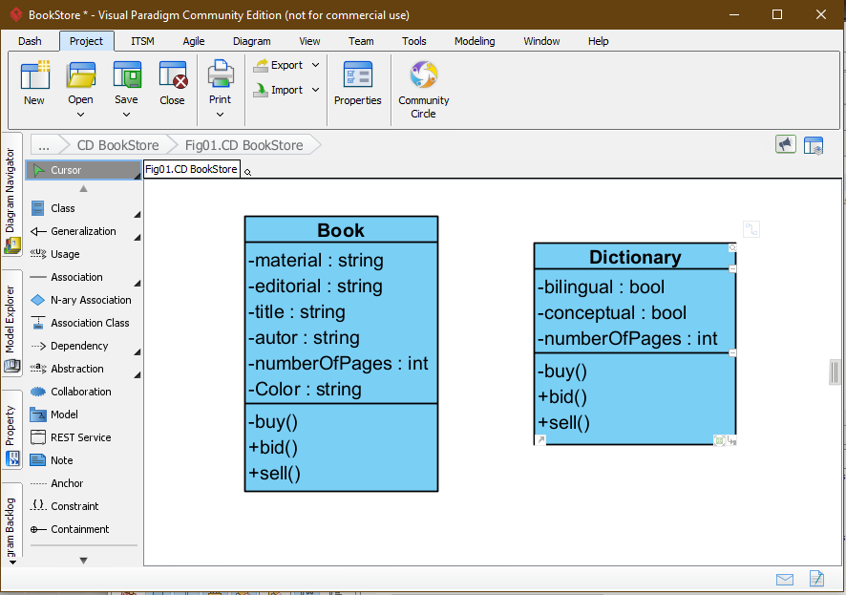

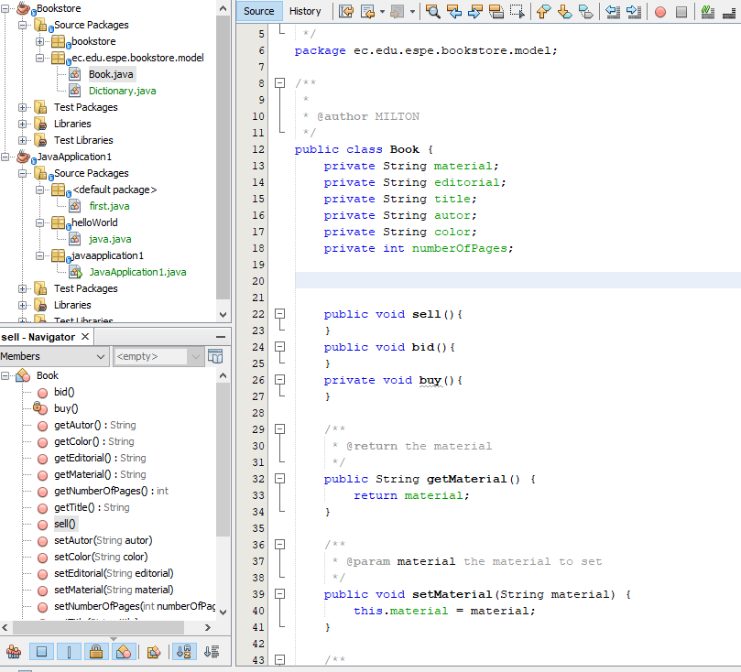

**Achig Toapanta, Steven Jossue**

* Book : color, material, numberOfPages, editorial, author, title, sell(), buy(), ...
* Dictionary: bilingual, conceptual, numberOfPages, sell(), buy(), bid()
* Invoice: mandatoryIssuance, broadcast(), cancel()
* Supplier: name, honest, bid(), sell()
* Employee: name, age, responsable, sell(), bid()
* Inventory: owner, storage, date, storeProducts(), showProducts(), makeSale(),..

**Caiza Tacuri Alisson Lisbeth**

* Painting: quality, number of colors, brand, sell(), buy(), check ()
* Rule: Size, quality, durability, brand, buy(), sell(), display()
* Sphere: Color, Quality, Brand, TipType, Buy(), Sell(), Try()
* Client: name, age, respectful, buy()
* Plotter: model, cost, makeGraphics(), calculate(), approximateGraph(), …..

**Asmal Haro Kevin David**

* Pencil:color,material,model,sell(), buy(), bid()
* Silicone:material,brand,sell(), buy(), bid()
* Notebook:material,model,numberOfPages,sell(), buy(), bid()
* HighlighterPen: Brand, color, durability, quantity, buy (), sell (), promote ()
* Folder: material, size, capacity, tipe, sell(), storeDocuments(), buy(), bid(), ……

**Cadena Díaz Jeremy Joel**

* Markers:colors,material,model,sell(), buy()
* Calculator:model,material,size,sell(), buy(), offer()
* Invoice: data, address, ID, date, valueWithoutTaxes(), calculateTaxes(), totalValue(), ……
* CardStock: Size, quality, type, color, buy(), sell(), offer()
* Photocopier: brand, size, cost, copy(), move(), combineImages(), …..