# Workshop: Finding Objects, then classes, then model

# Problem

We need a system that compares analysts from records of the analyst’s own stock buy/sell transactions, so we can recommend investors to invest with the best analyst.

To understand what the program needs to do, it is first necessary to understand a little bit about the stocks, buy and sell transactions, and their records. We’ll keep things simple, though, and only deal with basic stock purchases and sales.

# Overview

In the domain of financial investment, individual investors may base buy/sell decisions on the opinions of investment analysts, who spend considerable time studying the fundamentals and potential of selected companies. When an investor relies on an analyst’s recommendations to any degree, then that investor typically wants know something about the analyst’s track record.

# Background

Think of a share of stock as a piece of a company, albeit typically a very small piece. The value of a share is loosely related to the value of the company divide by the number of outstanding shares (i.e., total shares owned by shareholders.) For example, if a company was worth $10M and there was a total of 1M shares owned by shareholders, then each share would be worth $10.

In a stock market, all companies and their stock are identified by symbols, which are short character strings. For example, Amazon’s symbol is AMZN, Apple’s is AAPL, and Microsoft’s is

MSFT.

An investor will buy some number of shares at a specific purchase price and pay a small fee to a broker to complete that transaction. Then, at late time, the investor will sell all or some of those shares at a sales price and pay another small fee to a broker. Obviously, if an investor sells at a price higher than the purchase price (adjusting for the fees), the investor will make money. For example, if an investor buy 10 shares of AMZN at $800/share for a $10 fee, then sell those 10 shares at

$850/share for $10 fee, that investor will make a profit of $480 (850*10 – 10 – 800*10 – 10).

For taxes purpose and asset management, investors correlate the sale of a block of stocks to specific purchases. For example, consider an investor who buy 100 shares of ABC at $10/share and a little while later another 100 shares at $11/share. Then, image that the investor sell 125 shares. In making that sale, the investor will say how many of the 125 shares come from the first block of shares purchase and how many come from the second block, because it will impact how many profit the investor makes.

An investor does not actually make or loss money until shares are sold. Shares that an investor is holding onto only represent potential profits or losses. So, to rank an analyst perform, we need to know about completed purchase/sales cycles. Therefore, a history will contain records with following data:

Stock symbol A short string that identifies the company Quantity (Q) A integer that represent the number of shares purchase and sold Purchase Date/time (PT) A number that represents time of purchase in minutes since Jan 1, 2016 Purchase Price (PP) An integer represents the purchase price in cents. For example, 1234 would be a purchase price of $12.34. Purchase Trans. Fee (PF) An integer represents the purchase transaction fee in cents. Sale Date/time (ST) A number that represents time of purchase in minutes since Jan 1, 2016 Sale Price (SP) An integer represents the purchase price in cents.

For example, 1234 would be a purchase price of $12.34. Sale

Trans. Fee (SF) An integer represents the purchase transaction fee in cents. Q, PT, PP, PF, ST, SP, SF

See Table 1 for an example of a small history for an investor who purchased and sold stock for four companies: Amazon (AMZN), Apple (AAPL), Microsoft (MSFT), and Google (GOOGL).

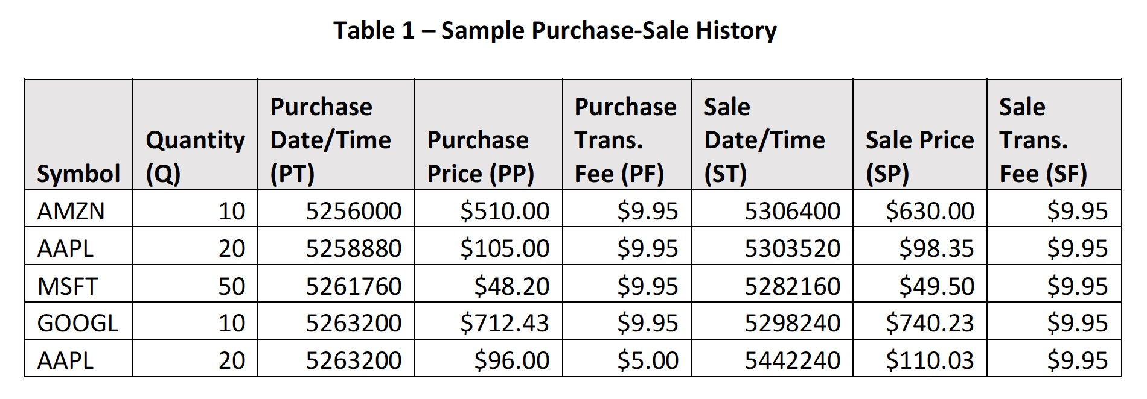 The amount of money invested (INV) in a purchase/sale is the cost of the shared adjust plus both the purchase fee and the sales fees INV = Q*PP + PF + SF

So, the profit/loss (PL) for each purchase/sale can be computed

as PL = Q*SP – INV

Table 2 shows INV and PL for each of the row, identified by the symbol and ST, of Table 1.

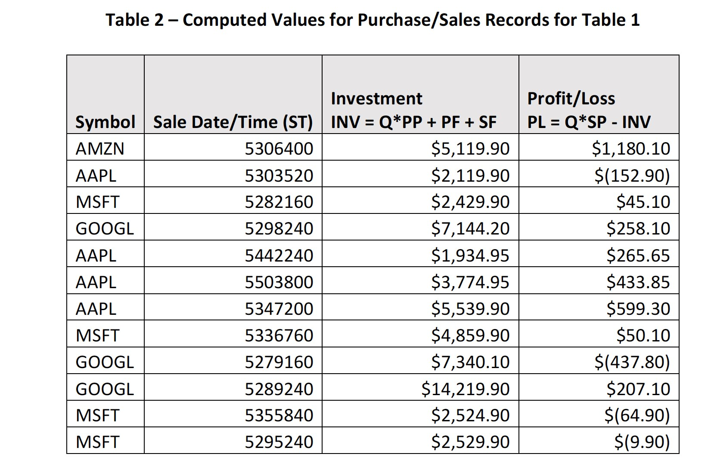

# Analyst Comparison

To compare analysts, we give each analyst “play” money (called the seed amount) and let them make whatever purchases and sales they desire, using simulated transaction. We record the purchase-sales for each investor in a separate purchase-sale histories file. Each investor starts off with same seed money, but they can start and end their simulation at different times. The number of days between the start and end of an analyst’s simulation is called the Simulation Days (D).

One measure of overall investor performance is total of all PL’s computed for each purchasesale in that investor’s history. We’ll call this Total Profit-Loss (TPL). Another measure of overall investor performance is TPL divided by the D. We’ll call this

Profit/Loss per Day (PLPD).

Another measure is an investor’s performance for an individual stock. This is the sum of PL for that stock, divided by the total days invested in that stock. See Table 3 for an example.

