**Universidad de las Fuerzas Armadas ESPE**

Name: Kevin Asmal

NRC: 3682

* Object-oriented programming

What are java exceptions?

They allow a method to inform the code that invoked it about an error or anomalous situation that occurred during its execution. An exception in Java is an object of the Exception class or one of its subclasses.

What are primitive data types in Java?

Java is a statically typed language. That is, the data type of the variable is defined at the time of defining the variable. That is why all variables will have a data type assigned to them.

The Java language is based on a series of primitive data types.

* byte
* short
* int
* long
* float
* double
* boolean
* char

It is important to know that these are data types of the language and that they do not represent objects. This is the case with the rest of the elements of the Java language.

* Byte

Represents an 8-bit signed data type. So it can store numeric values from -128 to 127 (both inclusive).

* short

Represents a 16-bit signed data type. Thus it stores numeric values from -32,768 to 32,767.

* int

It is a 32-bit signed data type for storing numeric values. Whose minimum value is -231 and maximum value is 231-1.

* long

Is a 64-bit signed data type that stores numeric values between -263 to 263-1.

* float

A data type for storing 32-bit single precision floating point numbers.

* double

A data type for storing 64-bit double precision floating point numbers.

* boolean

Used to define boolean data types. That is, those that have a value of true or false. It occupies 1 bit of information.

* char

It is a data type that represents a simple 16-bit Unicode character.

**Default values of primitive data types**

In the case that we define a variable and we do not give it any value, by default it will have the following values:

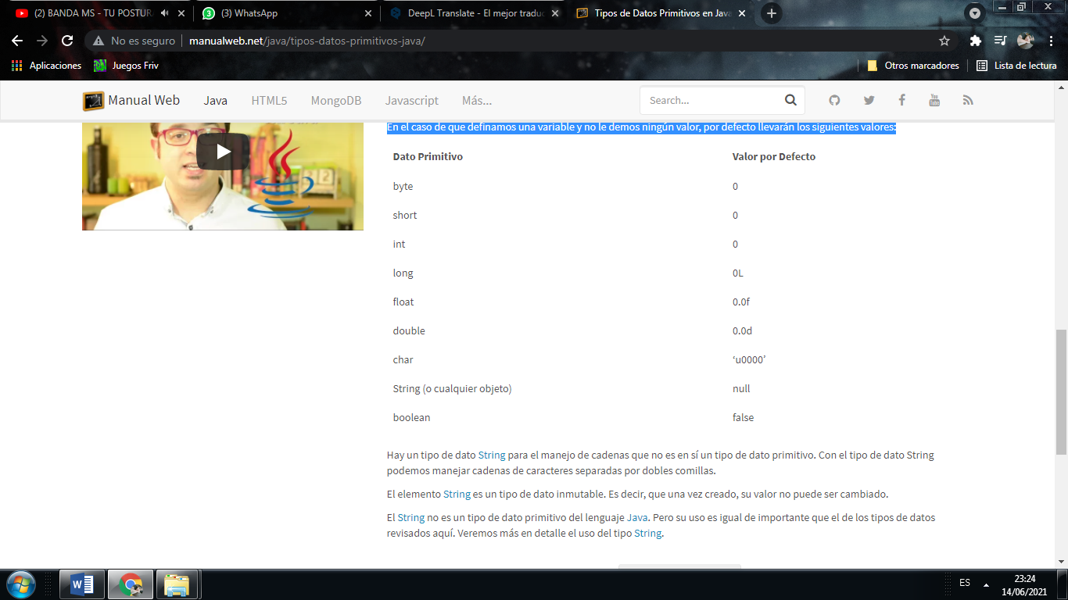

There is a String data type for string handling that is not itself a primitive data type. With the String data type we can handle character strings separated by double quotes.

The String element is an immutable data type. That is, once created, its value cannot be changed.

String is not a primitive data type in the Java language. But its use is just as important as that of the data types reviewed here. We will see in more detail the use of the String type.

Translated with www.DeepL.com/Translator (free version)

* **Research source:** http://www.manualweb.net/java/tipos-datos-primitivos-java/

TO SAVE TEXT FILES.

public static StringBuilder lector(String archivo) {

StringBuilder sb = new StringBuilder();

String linea;

File f = new File(archivo);

FileReader fr;

BufferedReader br = null;

try {

try {

fr = new FileReader(f);

br = new BufferedReader(fr);

while ((linea = br.readLine()) != null) {

sb.append(linea);

sb.append('\n');

}

} finally {

if (br != null) {

br.close();

}

}

} catch (FileNotFoundException e) {

System.out.println("Archivo no encontrado");

} catch (IOException e) {

System.out.println("Error entrada/salida");

}

return sb;

}