**T5: NullPointers  
Inspector:** Future Programming; Achig Steven, Asmal Kevin, Cadena Jeremy, Caiza Alisson.  
**Project:** ApplianceStore

-The "Product" class is not being used

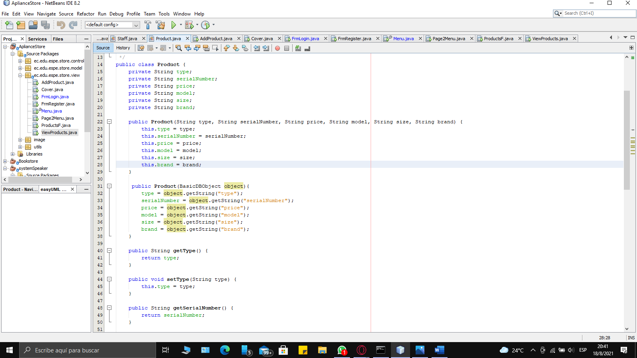

-These classes do not have getters and setters.

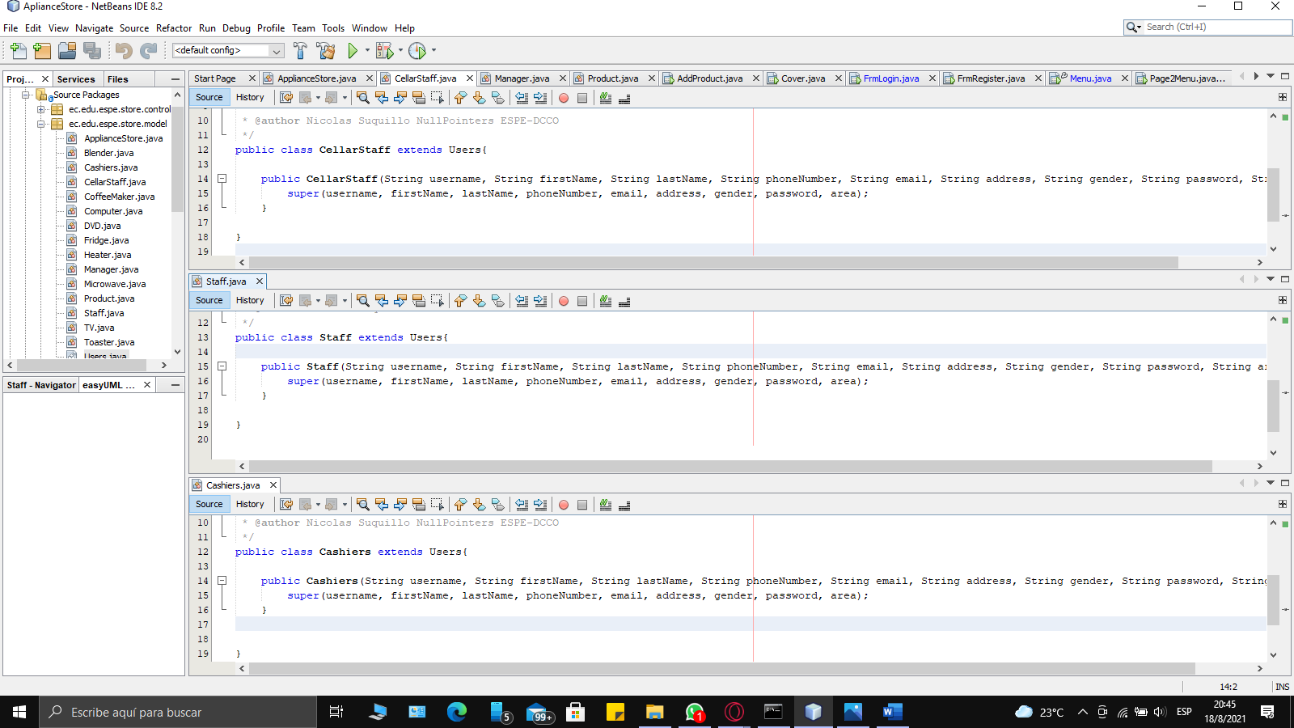

-The "Manager" class is not being used

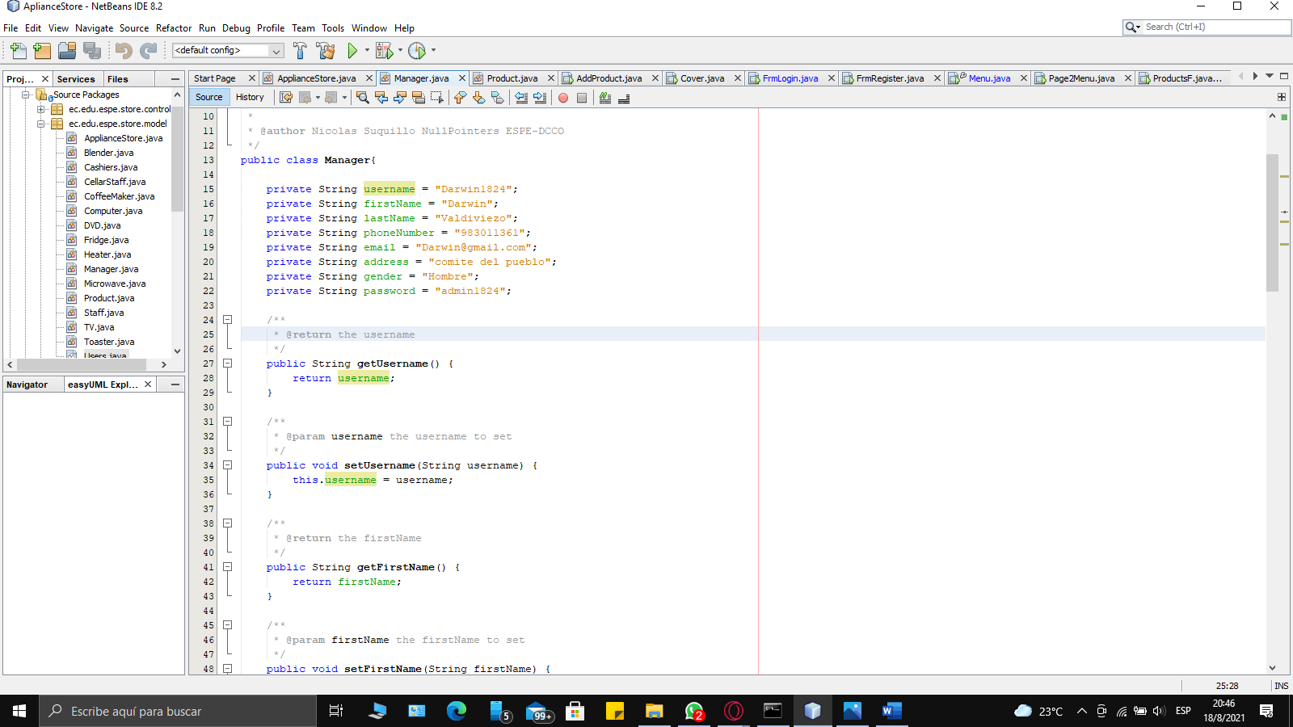

The use of local addresses causes errors in the code.

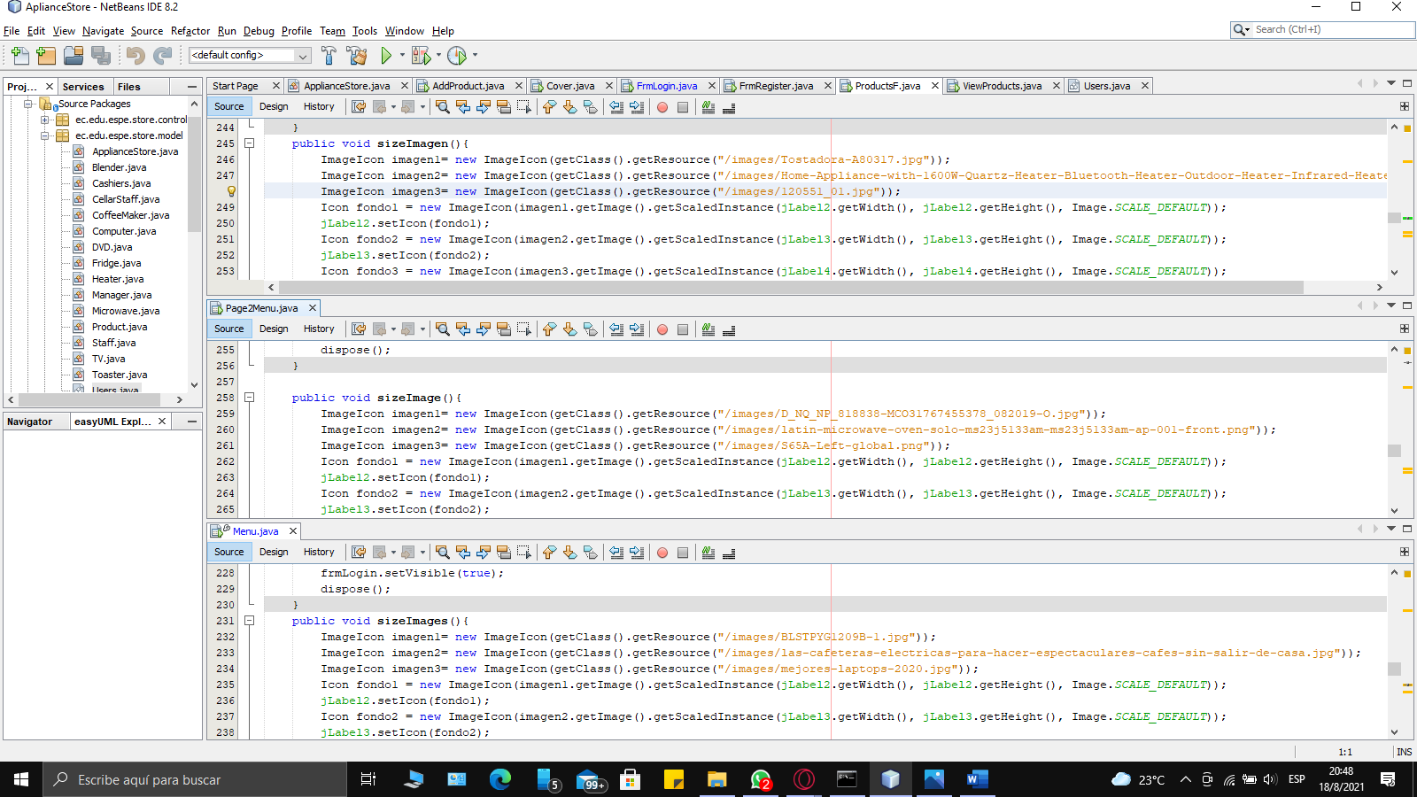

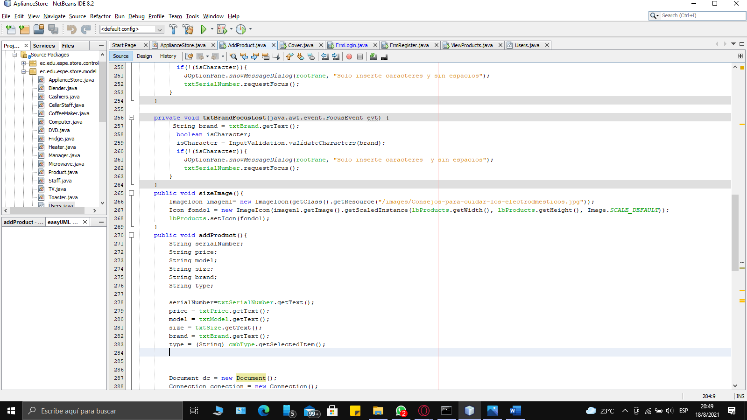

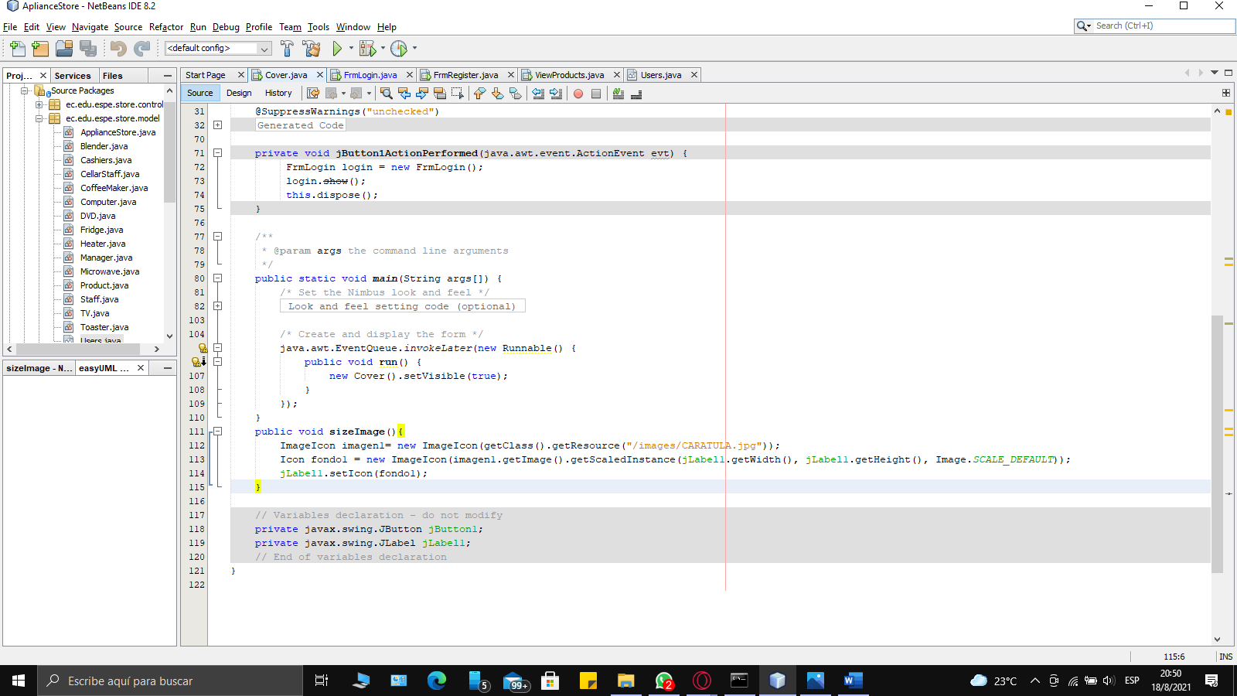

- The functions of this capture should be encapsulated elsewhere.

