**Homework 28**

**Inspection about cohesion**

**1 Achig Toapanta, Steven Jossue**

**2 Asmal Haro, Kevin David**

**3 Cadena Diaz, Jeremy Joel**

**4 Caiza Tacuri, Alisson Lisbeth**

**Inspector:Cajas Karla, Campoverde Carlos,Chablay Esteban, Chamorro Myckel**

**Screens:**

**contains in classes override unnecessary**

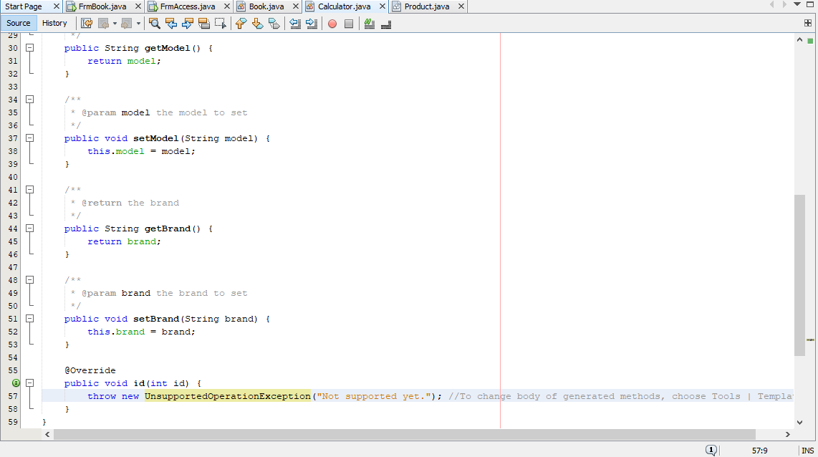

**use of unnecessary libraries**

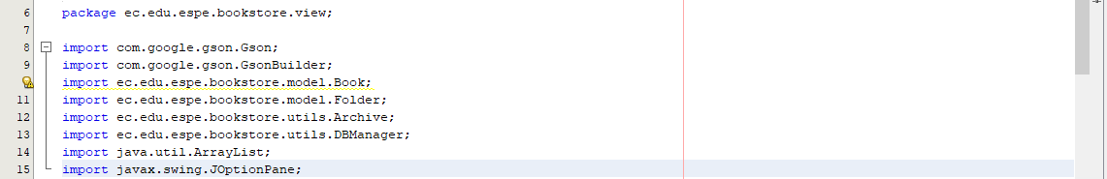

**empty method, it is not encapsulated**

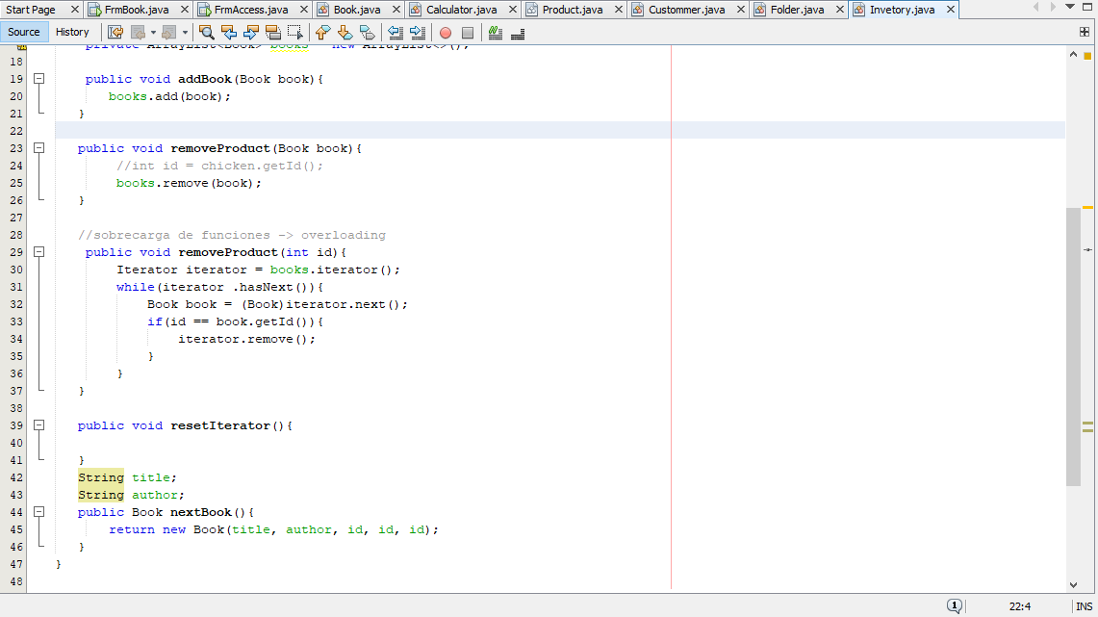

about unnecessary writing

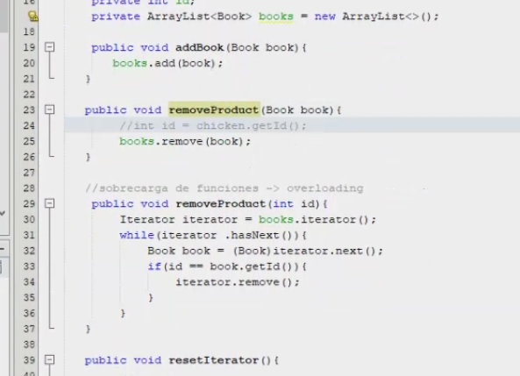

unnecessary methods

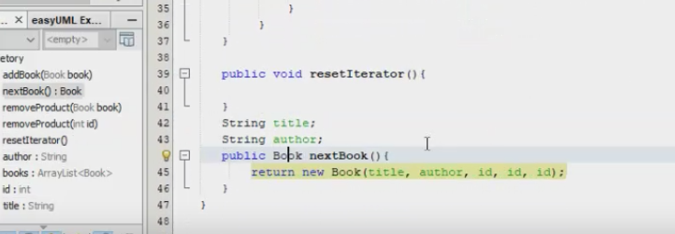

repeating code in classes can create a function

