University of the Armed Forces ESPE

Computer Science Department

Object Oriented Programming

Name: Diego Portilla

NRC: 3682

Cases Test

1._ public static float computeIva(float price){

|  |  |  |  |
| --- | --- | --- | --- |
|  | Input | Expected Result | Actual Result |
| 1 | 0.0 | 0.0 |  |
| 2 | 100.00 | 12.00 |  |
| 3 | 444.96 | 53.40 |  |
| 4 | 999.99 | 120.00 |  |
| 5 | -12.00 | 0.00 |  |
| 6 | 130.00 | 15.60 |  |
| 7 | 1556.66 | 186.80 |  |
| 8 | 5000.99 | 600.12 |  |
| 9 | 4.99 | 0.60 |  |
| 10 | 200.00 | 24.00 |  |

2._ public static float computeTotalPrice(float price)

|  |  |  |  |
| --- | --- | --- | --- |
|  | Input | Expected Result | Actual Result |
| 1 | 0.0 | 0.0 |  |
| 2 | 100.00 | 112.00 |  |
| 3 | 444.96 | 498.36 |  |
| 4 | 999.99 | 1119.99 |  |
| 5 | -12.00 | 0.00 |  |
| 6 | 130.00 | 145.60 |  |
| 7 | 1556.66 | 1743.46 |  |
| 8 | 5000.99 | 5601.11 |  |
| 9 | 4.99 | 5.59 |  |
| 10 | 200.00 | 24.00 |  |

Debugging:

444.96._

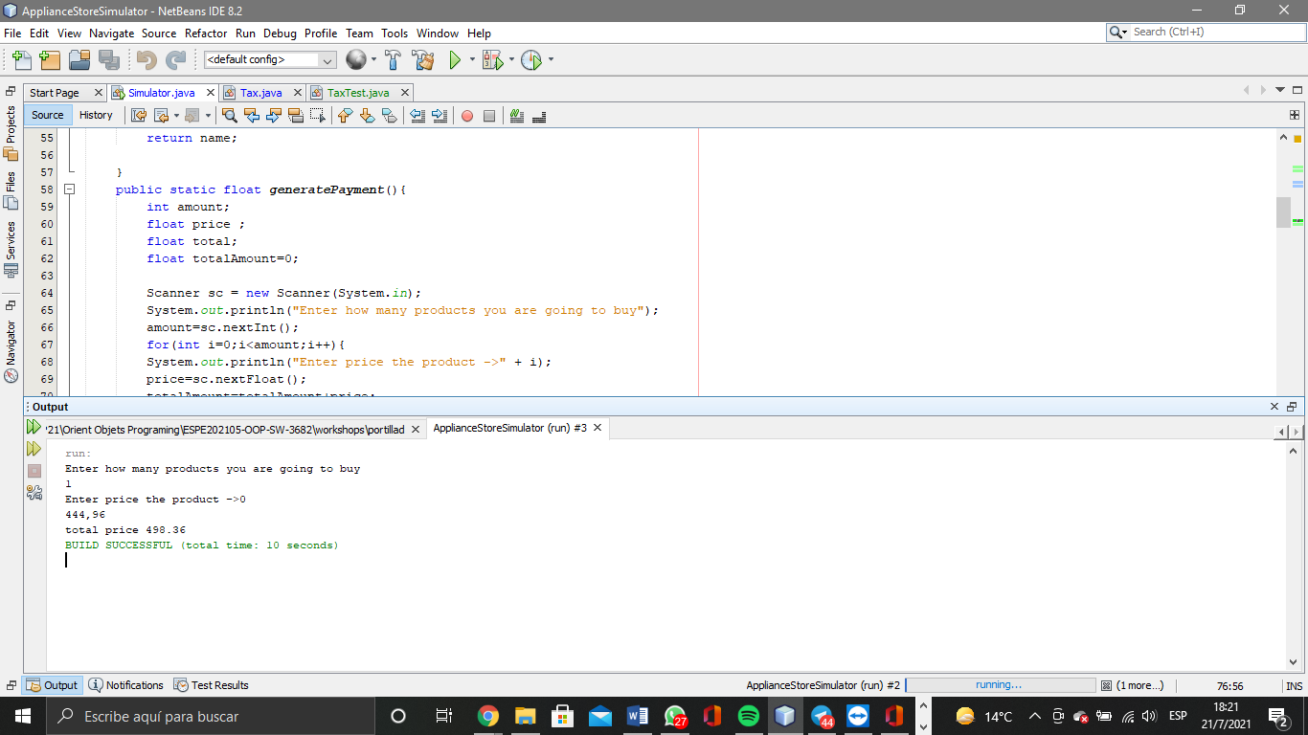

999.99._

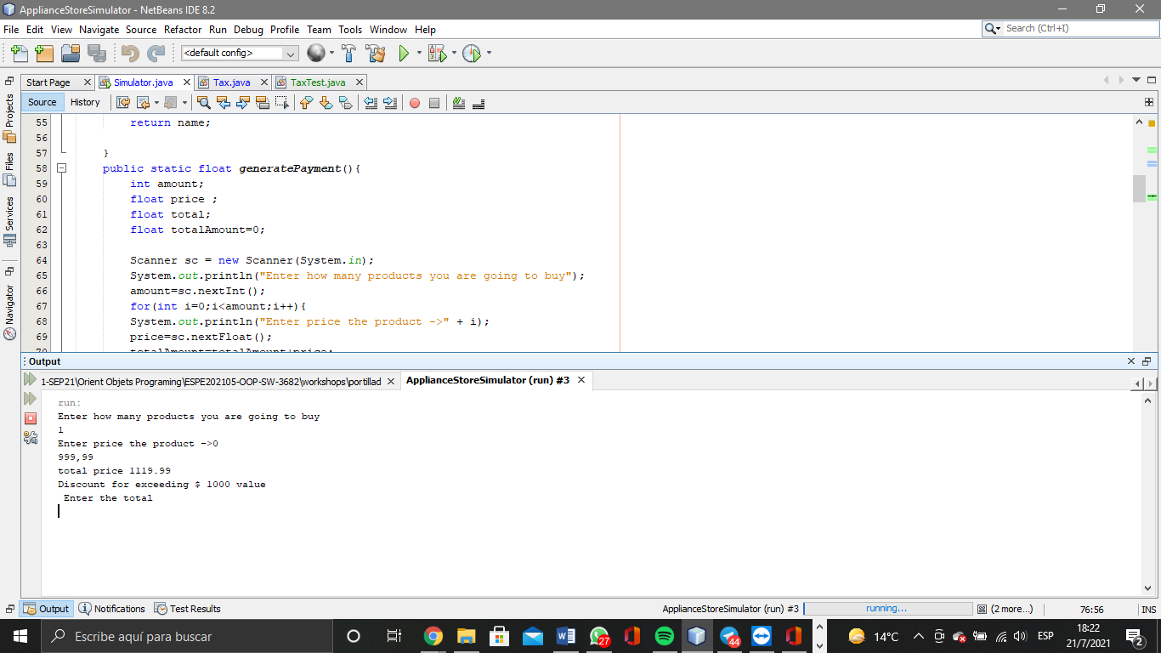

-12.00._

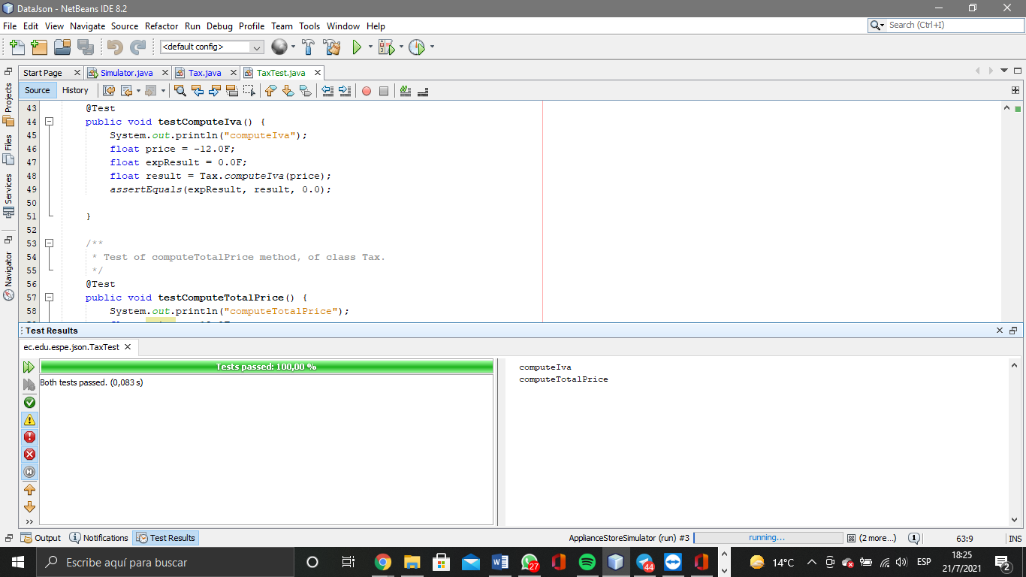

1556.66._

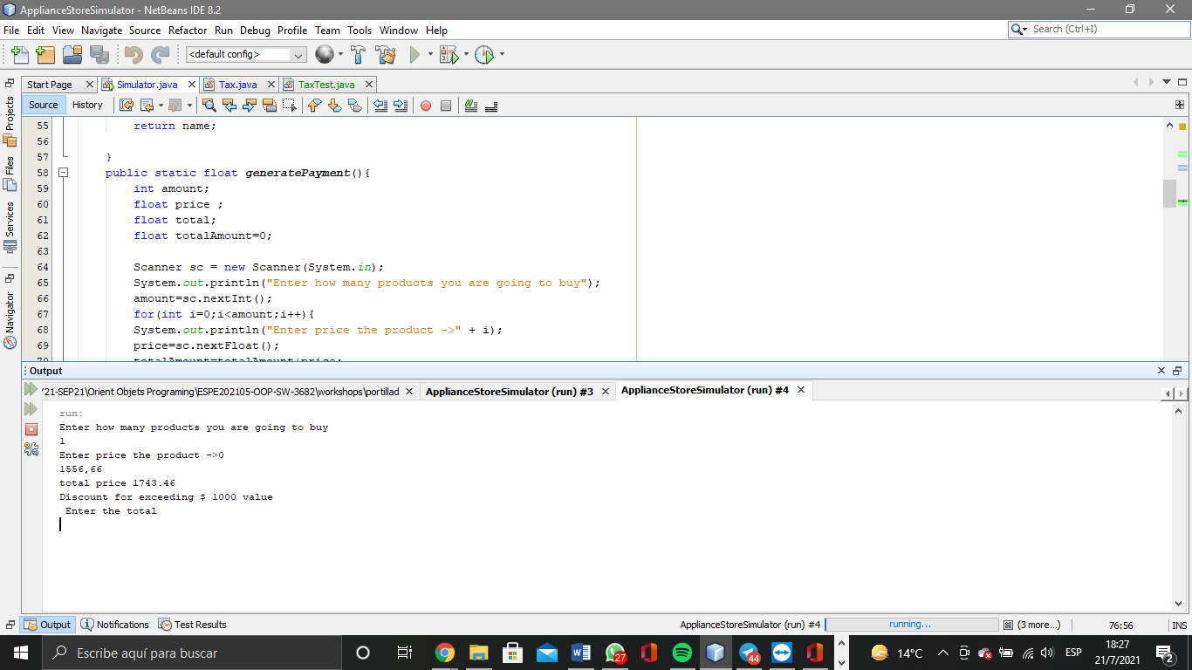

5000.99._

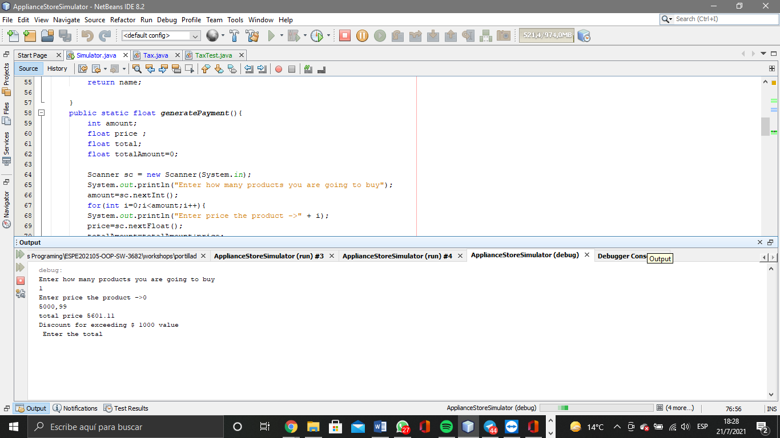

4.99._

