**LOGICAL OPERATORS**

**PROBLEM**

A program is required that allows us to discern how many older adults can receive the solidarity aid voucher from 5 rural areas, which must be shown in groups ordered by their gender and at the same time by their age range and that differs from those who receive a special pension for retirement or montepío.

The program must allow a filter to be carried out by the age that is considered for older adults and analyze if that person is suitable to receive the aid voucher from the Ecuadorian Government.

It must show the information of how many people were registered, how many are suitable to receive aid and indicate in which area they need more support for the delivery of government aid vouchers.

**OVERVIEW**

To solve this problem we will use a program where we enter all the possible personal data, where we could use the structures that is a type of data that groups several values ​​into one, these types of data can be of different types. For the part of discerning in the world of programming we could make the use of conditionals that help us to make an instruction or group of instructions that can be executed or not based on the value of a condition, therefore in our problem, this conditional would help us to go through filters to finally know how many older adults can receive the voucher.

**BACKGROUND**

The Bono Solidario or Bono de Desarrollo Humano is intended to help families with little income or in a situation of greater vulnerability during the coronavirus pandemic.

This is an amount of 120 dollars that 480,000 families will receive to cover their basic needs, thus offsetting somewhat the impacts of the pandemic as well as other risk factors such as poverty.

The Ministry of Economic and Social Inclusion (MIES) is in charge of processing the entire selection process and distributing the economic amount, which is expected to be carried out through the points of attention of the Ecuadorian financial system, thus being the most important point of attention. close to the person. Currently 10,200 payment points distributed in the country have been activated through the national financial network. They include Banco del Barrio, Tu Banco, Mi Vecino, Banco Aqui that work in stores, pharmacies and small supermarkets. In order to withdraw the economic amount, you will have to look at your last identity card number, that is, if it ends in 3, you can withdraw the economic amount of 120 dollars on 3, 13 and 23, so on with the rest of the numbers.

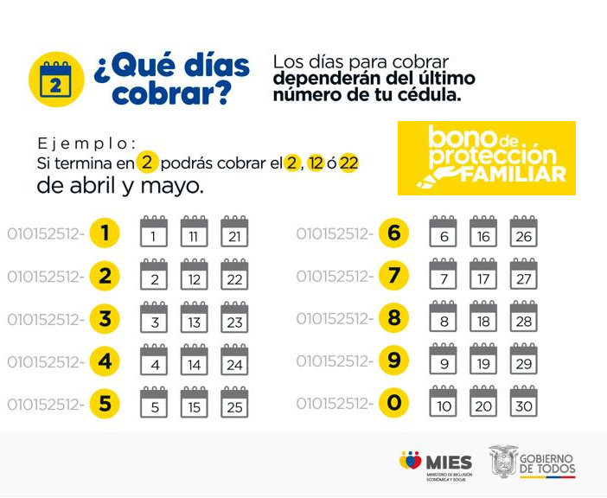

Illustration 1: schedule for the collection of bonds.

Currently the vouchers that are delivered by the Ministry of Economic and Social Inclusion (MIES) are the following:

Bonds for natural persons

* Human Development Bonus USD 50
* Human Development Voucher with Variable Component, up to USD 150.

Bonuses for seniors:

* My Best Years Pension USD 100
* Pension for Seniors USD 50

Bonuses for people with disabilities:

* Pension for Persons with Disabilities USD 50
* The new Pension Toda Una Vida USD 100.

In 2007, the Human Development Bond concentrated 1.2 million beneficiaries. In July 2009, Executive Decree No. 1838 determines the increase to 35.00 USD. Simultaneously, the beneficiaries grew to 1.5 million people who represented approximately 10.57% of the Ecuadorian population; of which 75% corresponded to mothers of families, with the remaining 25% having a high margin of young people and adults between 18 and 39 years of age. (Commerce, 2014).

Between 2009 and 2012 there was no increase in the perceived value, but there was an increase in subscribers that reached 1.9 million beneficiaries. Finally, in January 2013 an increase in the Human Development Bonus was decreed, reaching 50.00 USD per month, which persists to this day, with a variation in the number of affiliates that decreased due to a purification process that the government undertook leaving out of the program to approximately 390,000 people. (Commerce, 2014).

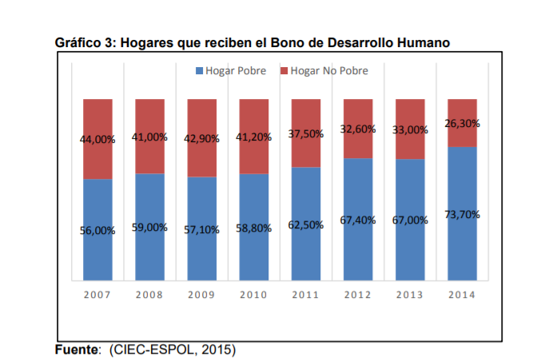

According to the data provided by the ESPOL Economic Observatory during the 7 years in which the study is carried out, there has been 17.7% of households that managed to get out of the Poverty Line represented in Graph 2 as a decrease in households poor people who receive this benefit.

However, when analyzing the information collected, it is shown that there are 73.7% of households that are not poor, but continue to receive the benefit of the Human Development Bonus in the urban sectors of Guayaquil, which shows poor allocation of resources.

According to the report presented by ESPOL in 2015, there has been a significant variation in the distribution of the state economic contribution to the beneficiaries within the last 7 years in which the analysis of Graph 3 is carried out. The result of the purification process shows a reduction of approximately 51.6% of beneficiaries "representatives of the family nucleus" drawn up in Executive Decree 486 as: single mothers with children under 18 years of age.

It is evident that the purification of the official registry, as well as the redistribution of resources, positively affected the elderly beneficiaries, who in the same period of analysis increased by 45% the number of subscribers who receive the Human Development Bonus. Finally, people with disabilities also had an increase of approximately 6.4% compared to 2007.

* **ANALYST COMPARISON**

For this analysis process, the first thing to do will be to examine the proposed objective and more if it requires it, what we mean is that the first thing would be to carry out a case study such as how many older adults can receive the solidarity aid voucher, then we would have who create a study on in which areas of the country are the least benefited and thus even those who need less in this way will facilitate the work when rebuilding the program since no disorder will be created and everyone will be able to receive the just and necessary help.

As the next point, we will have to separate the elderly by their gender and age since in this way we can serve people according to their age range and by their gender, thus demonstrating agility when it comes to distributing with the help of the vouchers for another Part of creating a program with these characteristics will help people, while they are charging, to know in an exact way who has already been helped and who has not yet, which will allow us to carry out the process in a more orderly and concise way.

The next thing would be to plant a series of characteristics such as, for example, see if that person is suitable to receive the aid voucher from the Ecuadorian government or see if that person receives any special mention or extra help, that way we can see who really needs the help first. and then we can carry out an analysis so that all older adults are helped equally.

In conclusion, when creating the program and all the information compiled on how many people were registered, how many are eligible to receive aid and indicate in which area they need more support for the delivery of government aid bonds will be useful for making the decision. , since in this way the elderly with very low resources would be chosen.