**TEAM 02 BIG BOYS TEAM**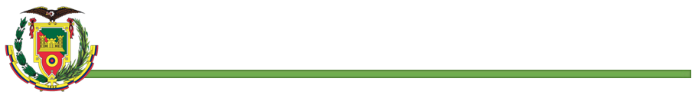

**LEADER:** Pablo Sebastian Bustillos Montenegro.

**TEAM MEMBERS:**

* Arroba Cristian.
* Asumaza Dylan.
* Bustillos Pablo
* Bravo Katherin.
* Bravo Christian.

**TOPIC/ IDEA -> TIDE :** BILLING AND INVENTORY SYSTEM.

**MODELING CLASSES**

* **Account**

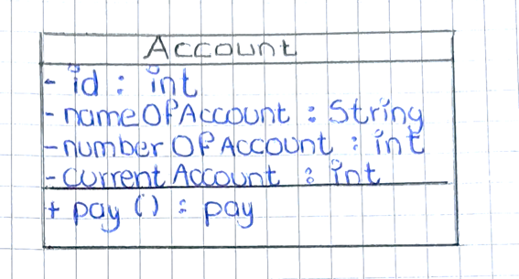

* **Inventory**

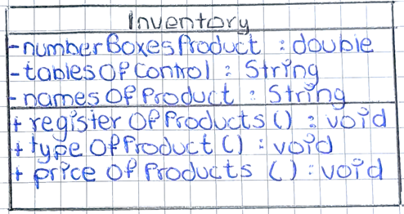

* **Customer**

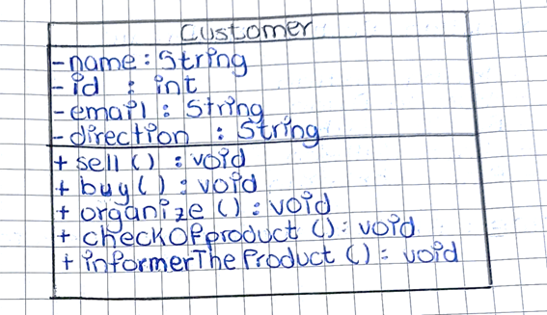

* **Quantity**

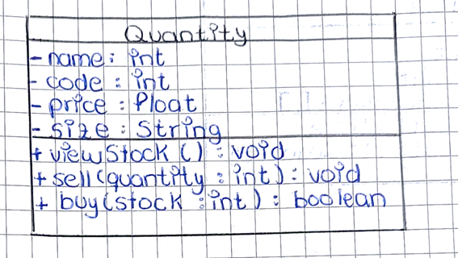

* **Supplier**

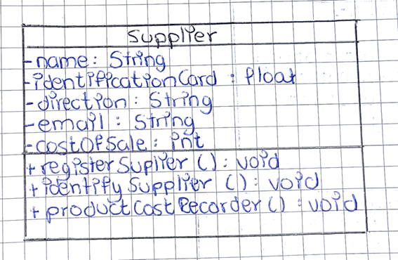

* **Merchandise**

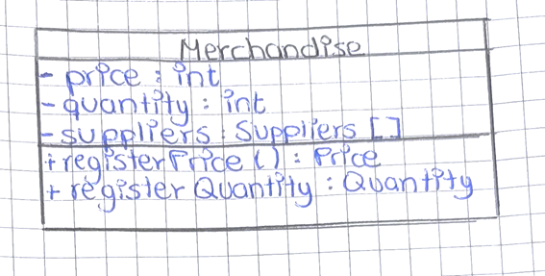

* **Invoice**

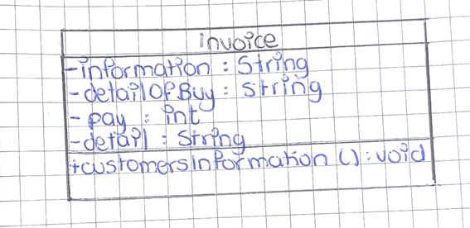

* **Debt**

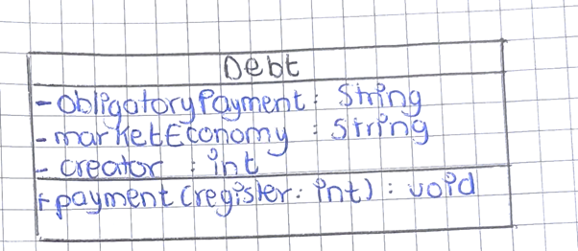

* **Product**

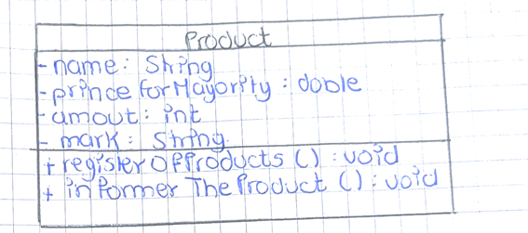

* **Finance**

