**WS14-EXAM INSPECTION**

**DATE: 02th december 2021**

**EXAM INSPECTION**

Solution, question 27

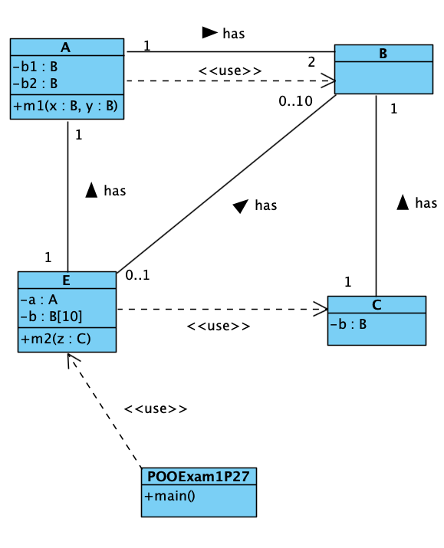

RUBIRC

1. A /1

2. B /1

3. C /1

4. E /1

5. POOExam1P27 /1

6. A-B assoc /1

7. A-E assoc /1

8. E-B assoc /1

9. E-C depend /1

10. C-B assoc /1

11. POOExam1P27-E (or any other class) depend /1

12. A-B depend /1

TOTAL /10

1 ALMACHE LITARDO ANDERSON MOISES

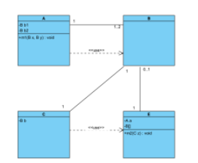

RUBIRC

1. A 1/1

2. B 1/1

3. C 1/1

4. E 1/1

5. POOExam1P27 0/1

6. A-B assoc 0.5/1

7. A-E assoc 0/1

8. E-B assoc 0.5/1

9. E-C depend 1/1

10. C-B assoc 1/1

11. POOExam1P27-E (or any other class) depend 0/1

12. A-B depend 0.5/1

TOTAL 7.5/10

2 ALTAMIRANO BENALCAZAR CRISTHIAN ALEXANDER

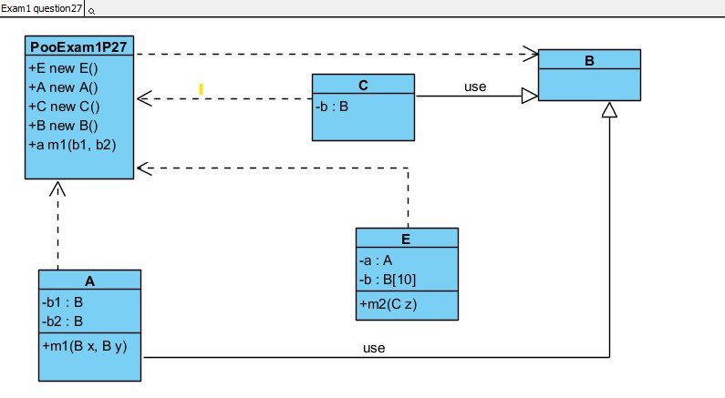

**RUBRIC**

1. A 1/1

2. B 1/1

3. C 1/1

4. E 1/1

5. POOExam1P27 0,5 /1

6. A-B assoc 0,8 /1

7. A-E assoc 0 /1

8. E-B assoc 0 /1

9. E-C depend 0 /1

10. C-B assoc 0,8 /1

11. POOExam1P27-E (or any other class) depend 1/10

12. A-B depend 0 /1

**TOTAL 7,1 /10**

3 ALVAREZ RAMIREZ MICHELLE ESTEFANIA

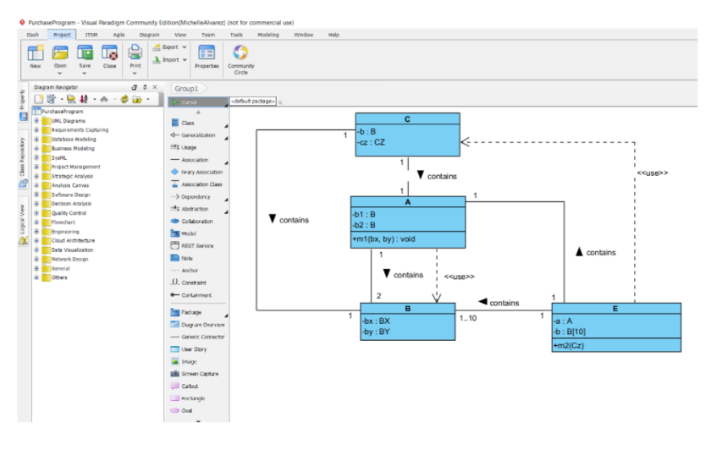

Inspector: Andrade Alan

RUBRIC

1. A 1/1

2. B 1/1

3. C 1/1

4. E 1/1

5. POOExam1P27 0/1

6. A-B assoc 1/1

7. A-E assoc 0,5/1

8. E-B assoc 1/1

9. E-C depend 1/1

10. C-B assoc 1/1

11. POOExam1P27-E (or any other class) depend 0/1

12. A-B depend 1/1

TOTAL 9,5/10

4 ANDRADE CARATE ALAN DAMIAN

Inspector: Andrango Espinosa Alex Paul

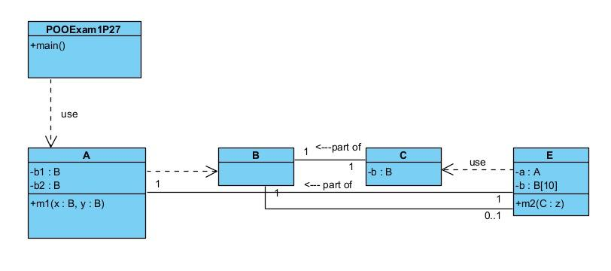

RUBIRC

1. A 1/1

2. B 1/1

3. C 1/1

4. E 1/1

5. POOExam1P27 1/1

6. A-B assoc 0/1

7. A-E assoc 0.75/1

8. E-B assoc 0.5/1

9. E-C depend 1/1

10. C-B assoc 1/1

11. POOExam1P27-E (or any other class) depend 1/10

12. A-B depend 0.75/1

TOTAL 10/10

5 ANDRANGO ESPINOSA ALEX PAUL

Inspector: Cristian Arroba

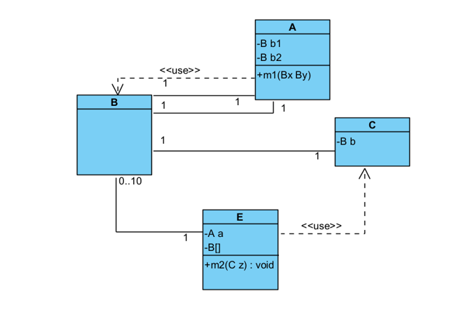

RUBIRC

1. A /1

2. B /1

3. C /1

4. E /1

5. POOExam1P27 /1

6. A-B assoc /1

7. A-E assoc /1

8. E-B assoc /1

9. E-C depend /1

10. C-B assoc /1

11. POOExam1P27-E (or any other class) depend /1

12. A-B depend /1

TOTAL /10

6 ARROBA SOLORZANO CRISTIAN ALEXANDER

Inspeccionado: por Dylan Asumaza

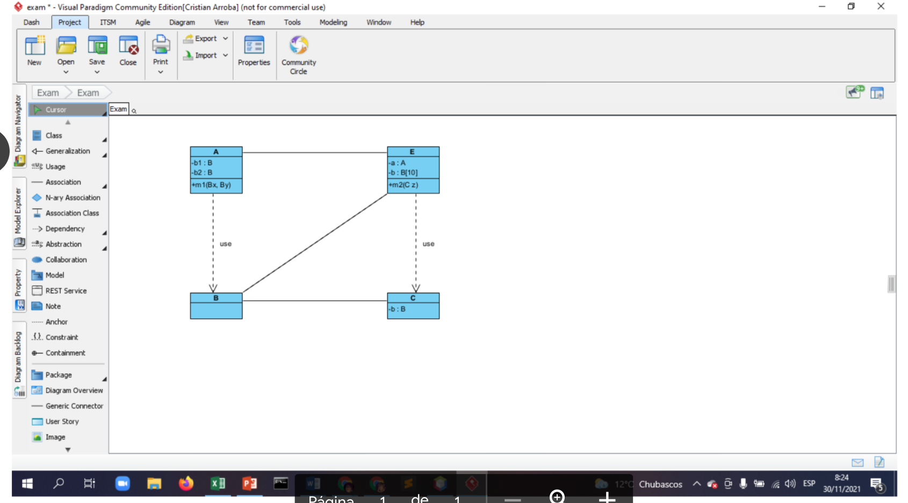

RUBIRC

1. A 1/1

2. B 1/1

3. C 1/1

4. E 1/1

5. POOExam1P27 0/1

6. A-B assoc 0/1

7. A-E assoc 0.5/1

8. E-B assoc 0.5/1

9. E-C depend 1/1

10. C-B assoc 0.5/1

11. POOExam1P27-E (or any other class) depend 0/10

12. A-B depend 0.5/1

TOTAL 7/10

7 ASUMAZA GUALOTO DYLAN ALEXANDER

Inspector: Bravo Katherin

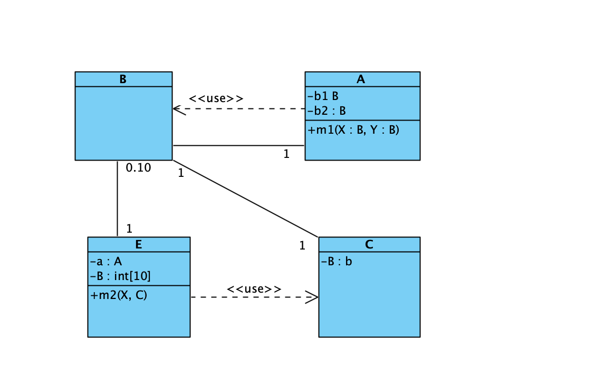

RUBIRC

1. A 1/1

2. B 1/1

3. C 1/1

4. E 1/1

5. POOExam1P27 1/1

6. A-B assoc 1/1

7. A-E assoc 0/1

8. E-B assoc 0.5/1 (Failure in the numbers )

9. E-C depend 0.5/1(Failure in the numbers )

10. C-B assoc 1/1

11. POOExam1P27-E (or any other class) depend 0/1

12. A-B depend 1/1

TOTAL 9/10

8 BRAVO RODRIGUEZ KATHERIN DAYANNE

INSPECTOR: Christian Bravo

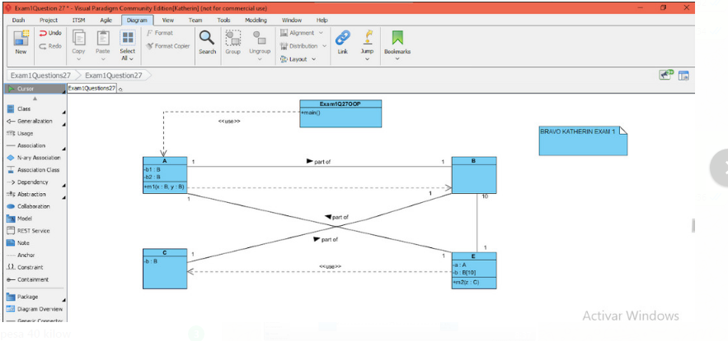

RUBIRC

1. A 1/1

2. B 1/1

3. C 1/1

4. E 1/1

5. POOExam1P271/1

6. A-B assoc 1/1

7. A-E assoc 1/1

8. E-B assoc 0/1

9. E-C depend 1/1

10. C-B assoc 1/1

11. POOExam1P27-E (or any other class) depend 0/1

12. A-B depend 1/1

TOTAL 10/10

9 BRAVO VILLALOBOS CHRISTIAN DAVID

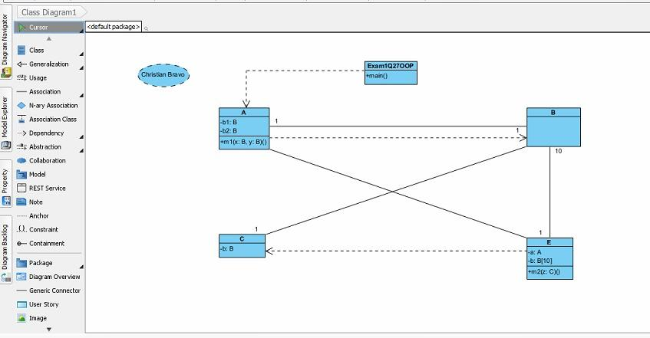

RUBIRC

1. A 1/1

2. B 1/1

3. C 1/1

4. E 1/1

5. POOExam1P271/1

the words "use" and “has” are missing

6. A-B assoc 0.5/1

7. A-E assoc 0.5/1

8. E-B assoc 0.5/1

9. E-C depend 0.5/1

10. C-B assoc 0.5/1

11. POOExam1P27-E (or any other class) depend 0/1

12. A-B depend 1/1

TOTAL 8.5/10

10 BUSTILLOS MONTENEGRO PABLO SEBASTIAN

INSPECTOR: Benjamin Cadena

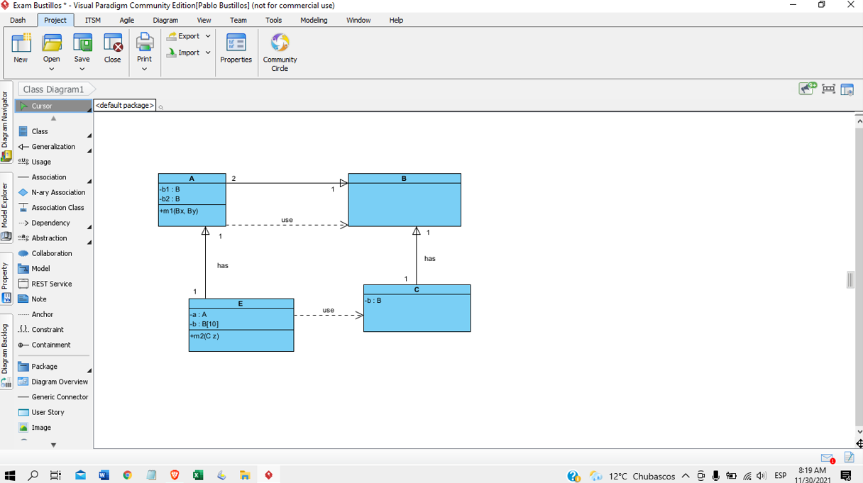

RUBIRC

1. A 1/1

2. B 1/1

3. C 1/1

4. E 1/1

5. POOExam1P27 0/1(does not exist)

6. A-B assoc 0.5/1(bad associated)

7. A-E assoc 1/1

8. E-B assoc 0/1(does not exist)

9. E-C depend 1/1

10. C-B assoc 1/1

11. POOExam1P27-E (or any other class) depend 0/1(does not exist)

12. A-B depend 1/1

TOTAL 8,5/10

11 CADENA ROMAN BENJAMIN ABEL

Inspector: Sebastián Caisatoa

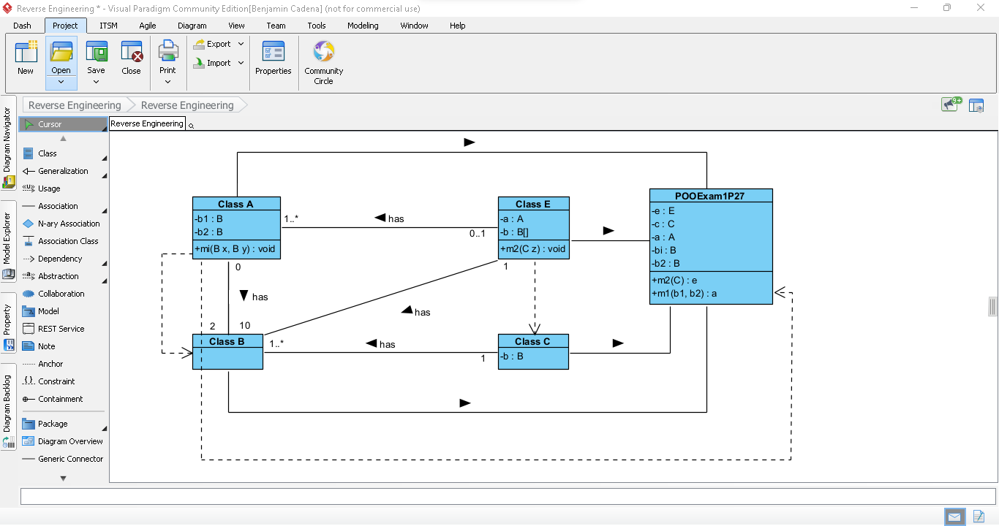

RUBIRC

1. A 1/1

2. B 1/1

3. C 1/1

4. E 1/1

5. POOExam1P27 0/1 (Misplaced the attributes in the main)

6. A-B assoc 0,5/1 (Misplaced multiplicity on one side )

7. A-E assoc 0,5/1 (Misplaced multiplicity on one side )

8. E-B assoc 1/1

9. E-C depend 1/1

10. C-B assoc 1/1

11. POOExam1P27-E (or any other class) depend 1/10

12. A-B depend 1/1

TOTAL 10/10

12 CAISATOA RAMIREZ SEBASTIAN BERNARDO

Inspector: Andy Calderón

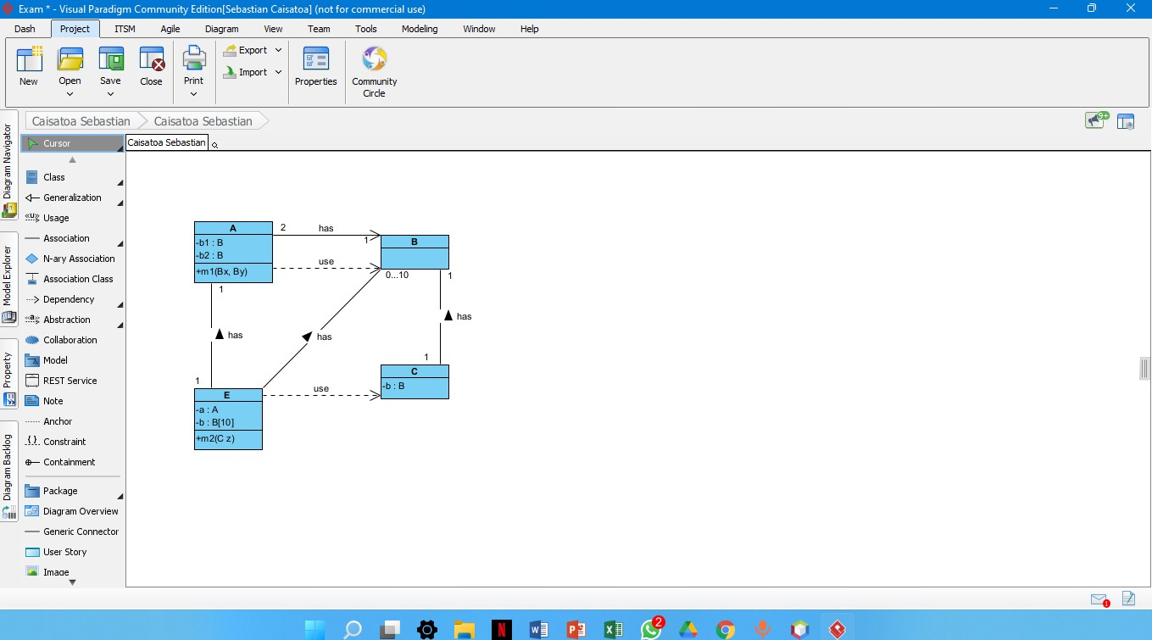

RUBIRC

1. A 1/1

2. B 1/1

3. C 1/1

4. E 1/1

5. POOExam1P27 0/1

6. A-B assoc 1/1

7. A-E assoc 1/1

8. E-B assoc 1/1

9. E-C depend 1/1

10. C-B assoc 1/1

11. POOExam1P27-E (or any other class) depend 0/1

12. A-B depend 1/1

TOTAL 10/10

13 CALDERON MERCHAN ANDY JOSUE

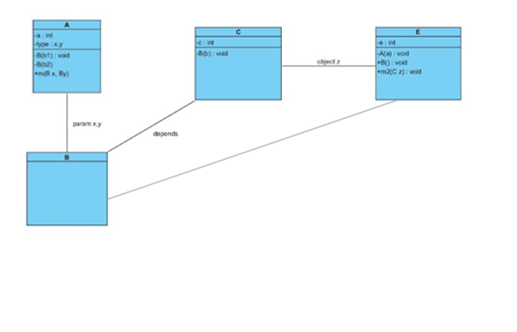

Inspector:Correa Kerly

RUBIRC

1. A 1/1

2. B 1/1

3. C 0.5/1

4. E 0.5/1

5. POOExam1P27 0/1

6. A-B assoc 1/1

7. A-E assoc 0/1

8. E-B assoc 1/1

9. E-C depend 0/1

10. C-B assoc 1/1

11. POOExam1P27-E (or any other class) depend 0/10

12. A-B depend 0/1

TOTAL 6/10

14 CORREA RUIZ KERLY YADIRA

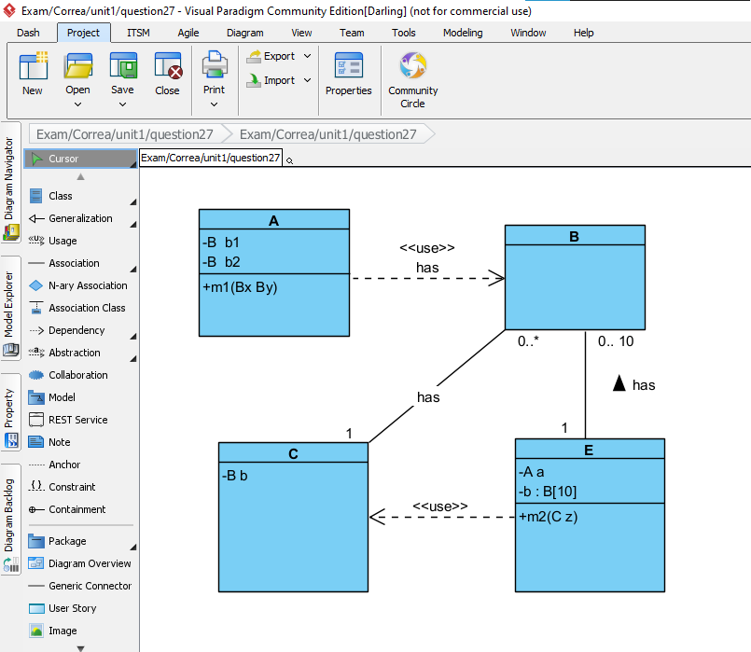

Inspector: Darling Cruz

RUBIRC

1. A 1/1

2. B 1/1

3. C 1/1

4. E 1/1

5. POOExam1P27 0/1

6. A-B assoc 0/1

7. A-E assoc 0/1

8. E-B assoc 1/1

9. E-C depend 1/1

10. C-B assoc 1/1

11. POOExam1P27-E (or any other class) depend 1/10

12. A-B depend 1/1

TOTAL 9/10

15 CRUZ PANTOJA DARLING MICAELA

RUBIRC

1. A 1/1

2. B 1/1

3. C 1/1

4. E 1/1

5. POOExam1P27 1/1

6. A-B assoc 1/1

7. A-E assoc 1/1

8. E-B assoc 1/1

9. E-C depend 0/1

10. C-B assoc 1/1

11. POOExam1P27-E (or any other class) depend 1/10

12. A-B depend 1/1  
  
Total 11/12

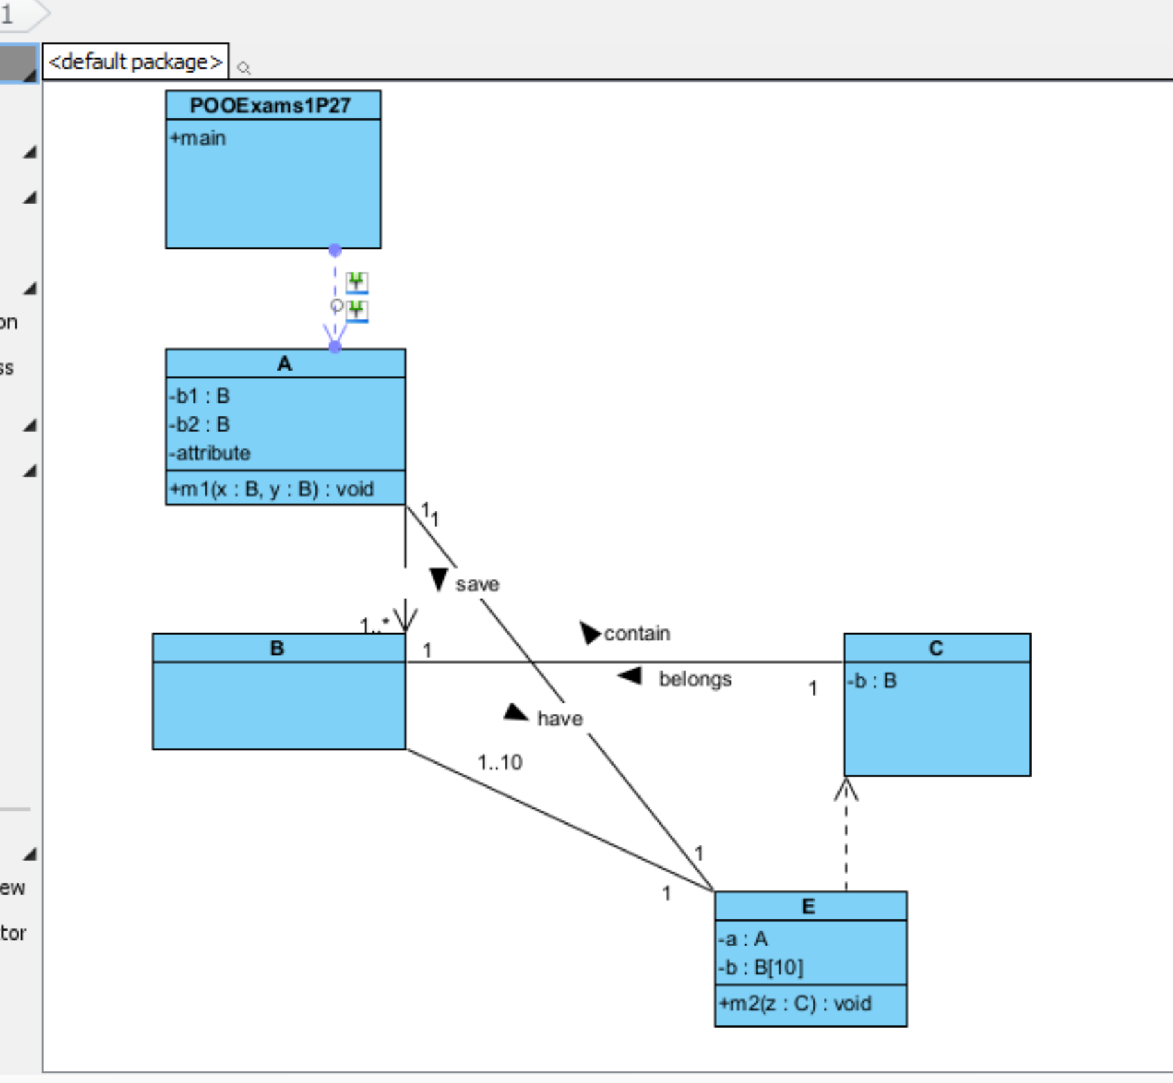

16 DE LA CRUZ QUINGA ALEJANDRO SEBASTIAN

RUBIRC

1. A 1/1

2. B 1/1

3. C 1/1

4. E 1/1

5. POOExam1P27 1/1

6. A-B assoc 1/1

7. A-E assoc 1/1

8. E-B assoc 0/1

9. E-C depend 1/1

10. C-B assoc 1/1

11. POOExam1P27-E (or any other class) depend 1/10

12. A-B depend 1/1  
  
Total 11/12

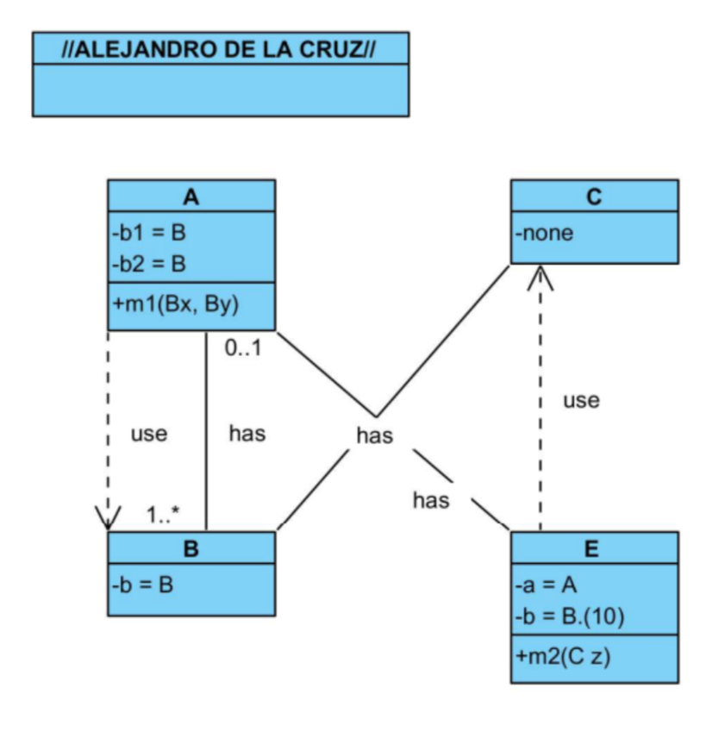

17 EIVAR DAGUA JAIME MAURICIO

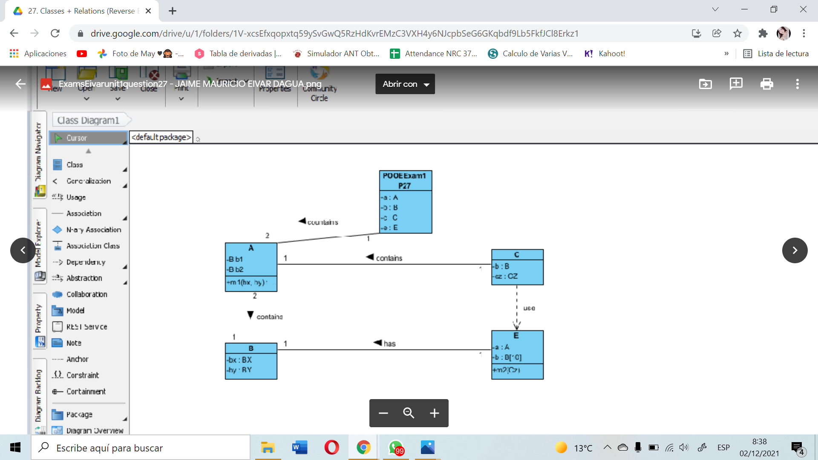

inspector: Mayerly Garcia

RUBIRC

1. A 0,5/1

2. B 0,5/1

3. C 0,5/1

4. E 1/1

5. POOExam1P27 1/1

6. A-B assoc 0,5/1

7. A-E assoc 0/1

8. E-B assoc 1/1

9. E-C depend 0,5/1

10. C-B assoc 0/1

11. POOExam1P27-E (or any other class) depend 1/1

total 7,5/10

18 GARCIA BARRETO MAYERLY PRISSILLA

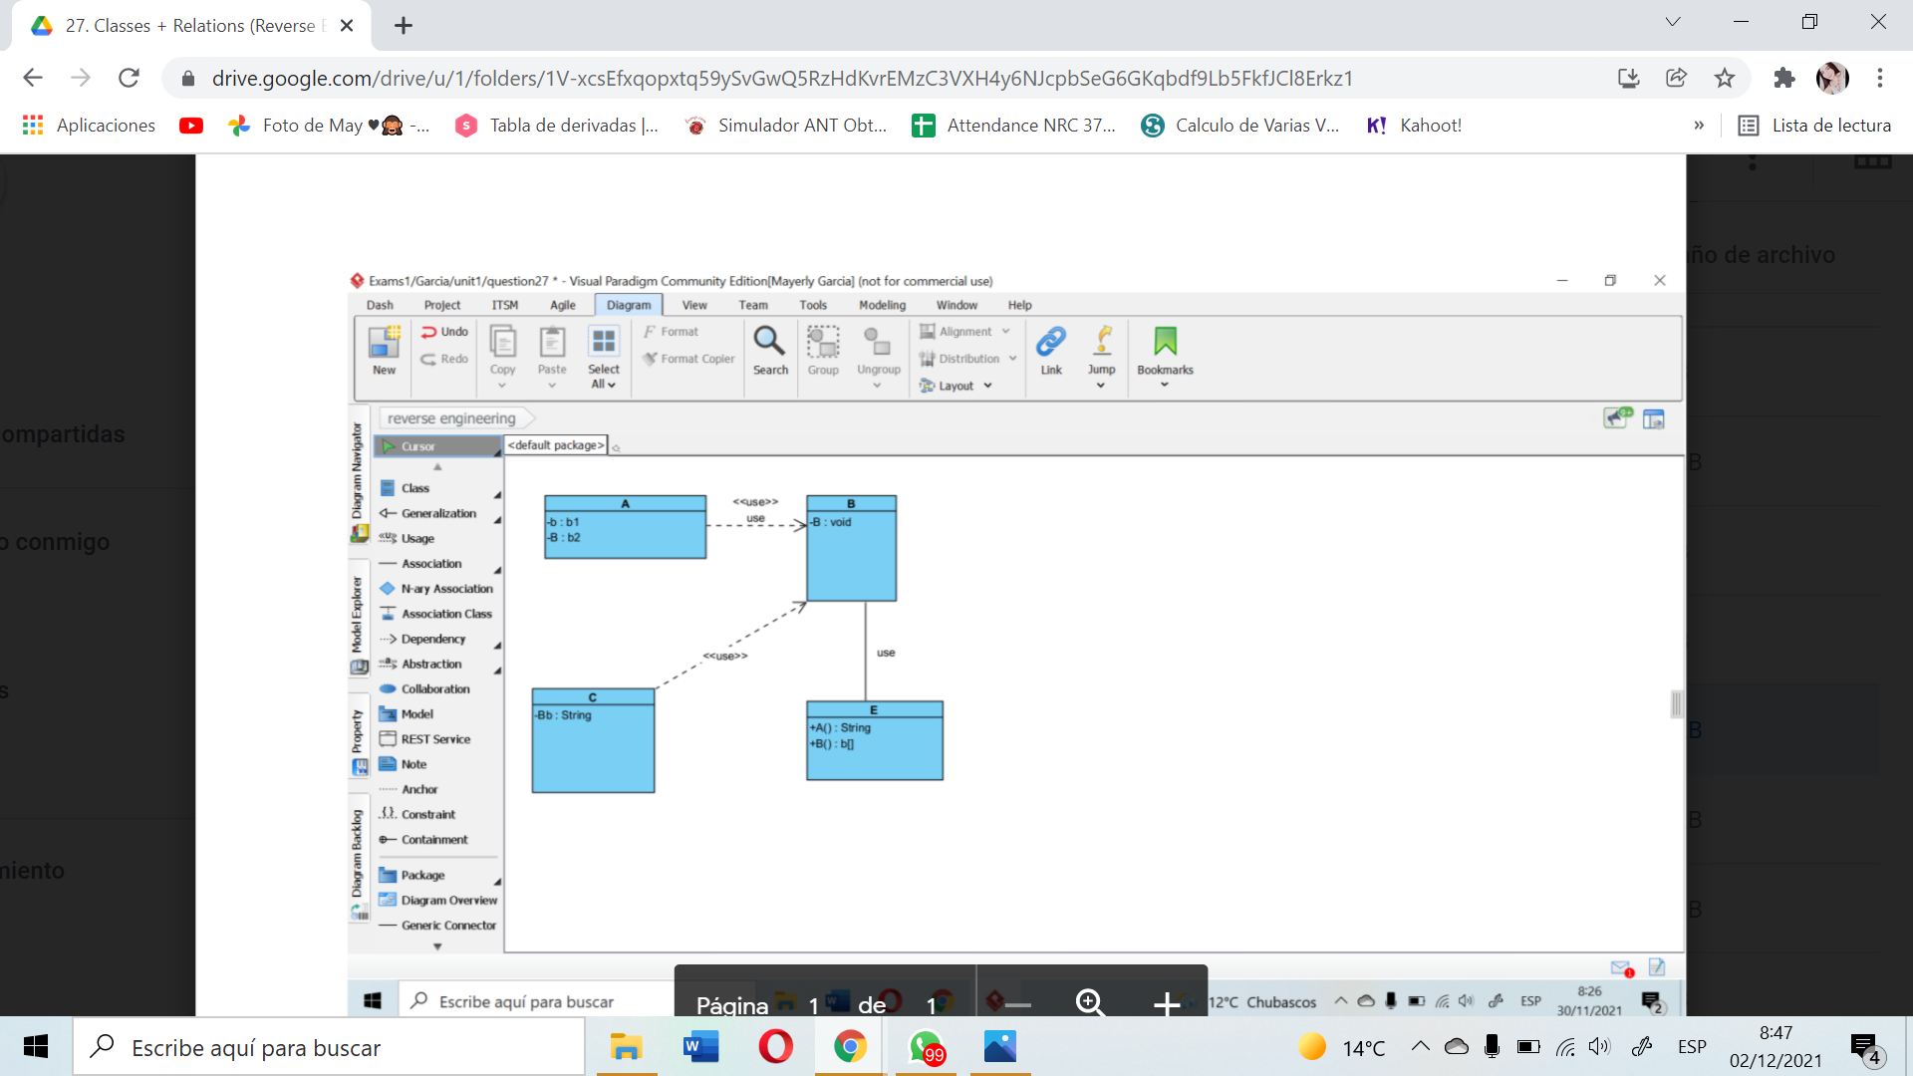

inspector: Melissa Gómez

RUBIRC

1. A 0.5/1

2. B 0.5/1

3. C 0.5/1

4. E 0.5/1

5. POOExam1P27 0/1

6. A-B assoc 0/1

7. A-E assoc 0/1

8. E-B assoc 1/1

9. E-C depend 0/1

10. C-B assoc 0/1

11. POOExam1P27-E (or any other class) depend 0/1

12. A-B depend 1/1

TOTAL 4/10

19 GOMEZ DIAZ MELISSA MALAYCA

1. A 1/1

2. B 1/1

3. C 1/1

4. E 1/1

5. POOExam1P27 1/1

6. A-B assoc 1/1

7. A-E assoc 1/1

8. E-B assoc 1/1

9. E-C depend 0.5/1 (falta el use)

10. C-B assoc 1/1

11. POOExam1P27-E (or any other class) depend 1//1

12. A-B depend 1/1

TOTAL 10/10

Inspector : Angel Guaman

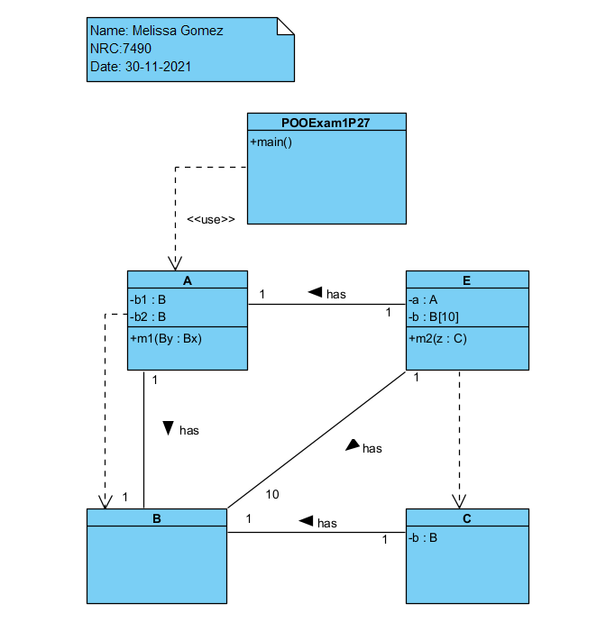

20 GUAMAN VEJARANO ANGEL DAVID

Inspector: Guitarra Jhon

1. A 1/1

2. B 1/1

3. C 1/1

4. E 1/1

5. POOExam1P27 0/1

6. A-B assoc 0.5/1

7. A-E assoc 0.5/1

8. E-B assoc 1/1

9. E-C depend 1/1

10. C-B assoc 1/1

11. POOExam1P27-E (or any other class) depend 1/1

12. A-B depend 1/1

TOTAL 10/10

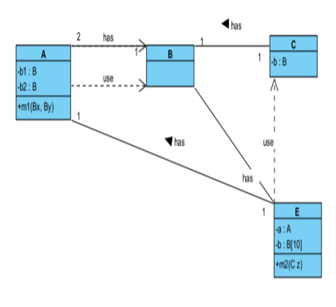

21 GUITARRA SANCHEZ JHON ALEXANDER

Inspector: Jose Guzman

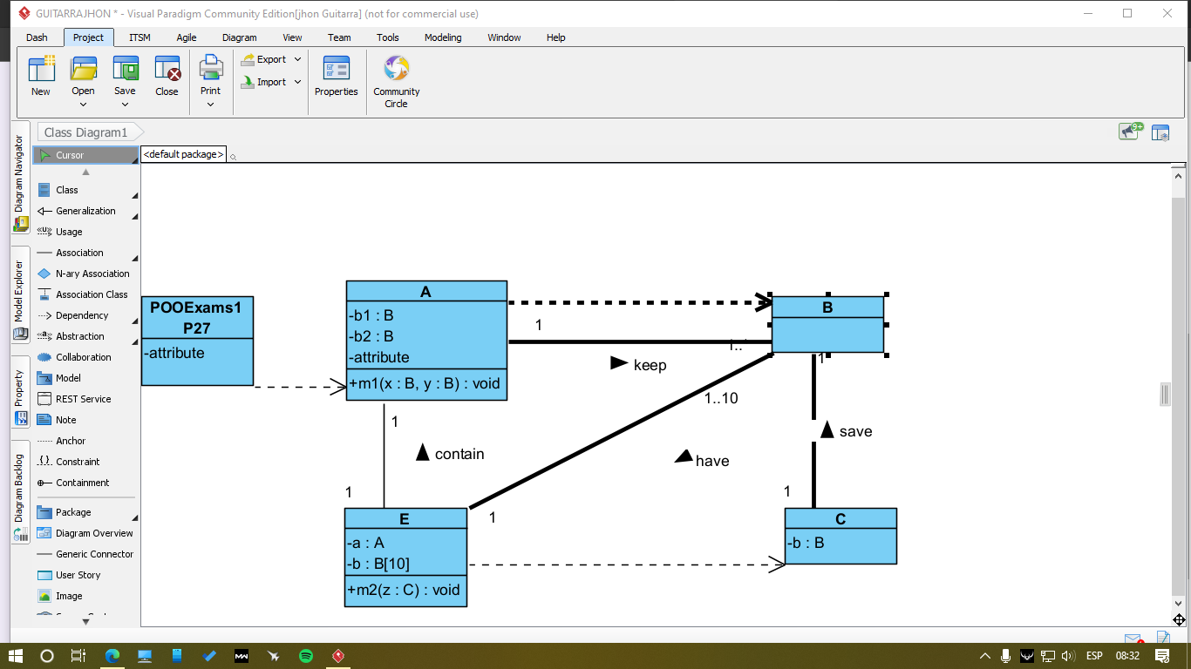

RUBIRC

1. A 1/1

2. B 1/1

3. C 1/1

4. E 1/1

5. POOExam1P27 0.5/1

6. A-B assoc 0/1

7. A-E assoc 1/1

8. E-B assoc 1/1

9. E-C depend 1/1

10. C-B assoc 0.5/1

11. POOExam1P27-E (or any other class) depend 1/10

12. A-B depend 1/1

TOTAL 10/10

22 GUZMAN LOPEZ JOSE DAVID

Inspector Jonathan Insuasti

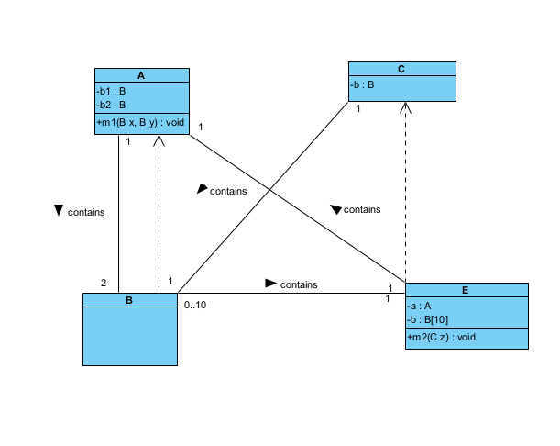

RUBIRC

1. A 1/1

2. B 1/1

3. C 1/1

4. E 1/1

5. POOExam1P27 0/1

6. A-B assoc 1/1

7. A-E assoc 1/1

8. E-B assoc 1/1

9. E-C depend 1/1

10. C-B assoc 1/1

11. POOExam1P27-E (or any other class) depend 0/10

12. A-B depend 1/1

TOTAL 10/10

23 INSUASTI LOPEZ JONATHAN ESTEBA

Inspector Mateo Landázuri

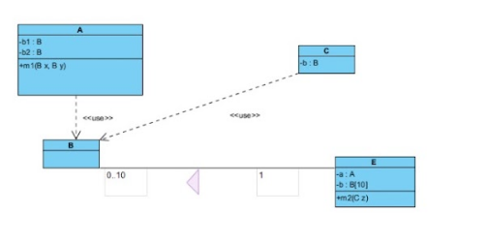

RUBIRC

1. A 1/1

2. B 1/1

3. C 1/1

4. E 1/1

5. POOExam1P27 0/1

6. A-B assoc 0/1

7. A-E assoc 0/1

8. E-B assoc 1/1

9. E-C depend 0/1

10. C-B assoc 0/1

11. POOExam1P27-E (or any other class) depend 0/10

12. A-B depend 1/1

TOTAL 6/10

24 LANDAZURI SEGOVIA MATEO ISRAEL

Inspector: Daniel Lincango

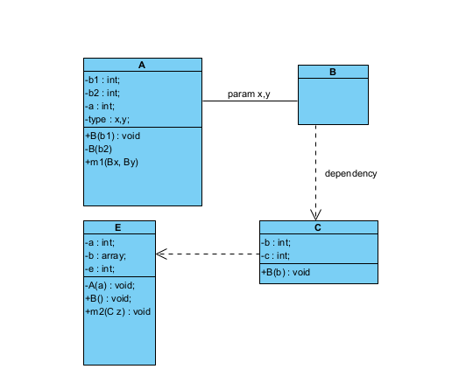

RUBIRC

1. A 0/1

2. B 1/1

3. C 0/1

4. E 0/1

5. POOExam1P27 0/1

6. A-B assoc 1/1

7. A-E assoc 0/1

8. E-B assoc 0/1

9. E-C depend 1/1

10. C-B assoc 1/1

11. POOExam1P27-E (or any other class) depend 0/10

12. A-B depend 1/1

TOTAL 5/10

25 LINCANGO CRIOLLO JOSE DANIEL

Inspector: Maisincho Richar

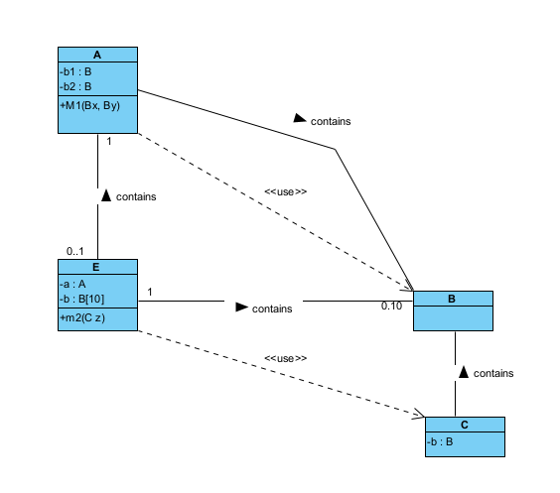

RUBIRC

1. A 1/1

2. B 1/1

3. C 1/1

4. E 1/1

5. POOExam1P27 0 /1

6. A-B assoc 1/1

7. A-E assoc 0/1

8. E-B assoc 1/1

9. E-C depend 1/1

10. C-B assoc 1/1

11. POOExam1P27-E (or any other class) depend 0/10

12. A-B depend 0/1

TOTAL 8/10

26 MAISINCHO PAUCAR RICHAR ALEXANDER

Inspector: Mateo Maldonado

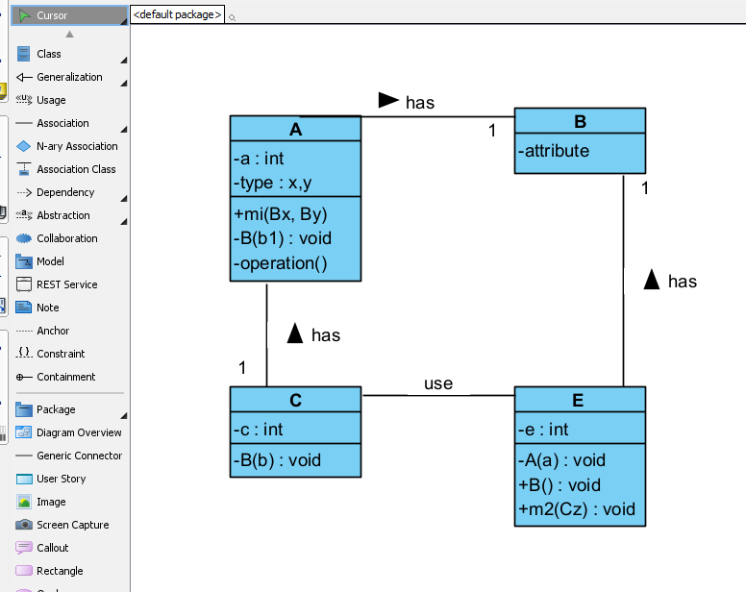

RUBIRC

1. A 1/1

2. B 1/1

3. C 0,5/1

4. E 1/1

5. POOExam1P27 0/1

6. A-B assoc 1/1

7. A-E assoc 0/1

8. E-B assoc 1/1

9. E-C depend 1/1

10. C-B assoc 0/1

11. POOExam1P27-E (or any other class) depend 0/10

12. A-B depend 0,5/1

TOTAL 7/10

27 MALDONADO BASTIDAS MATEO STEFANO

Inspector: Leonel Mantuano

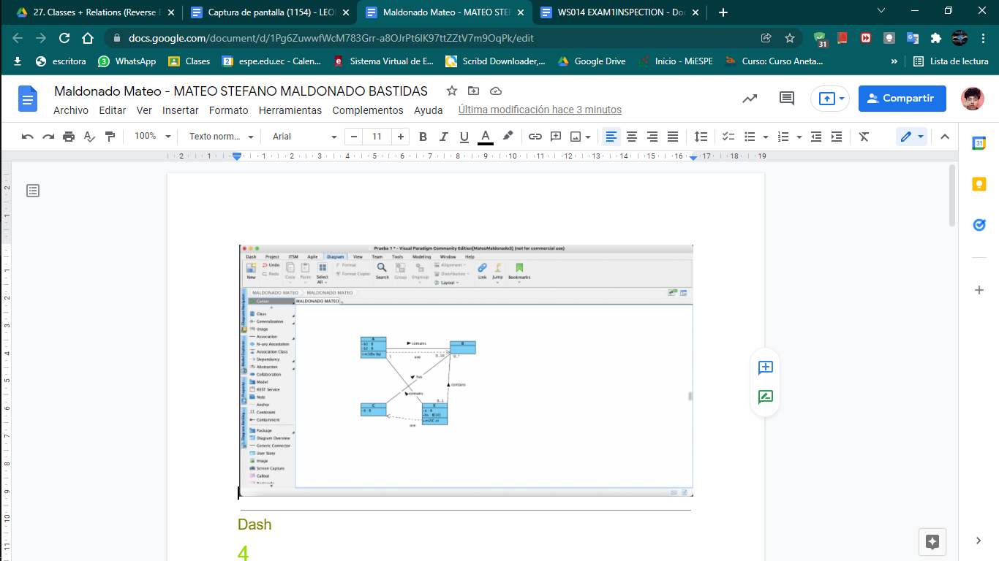

RUBIRC

1. A 1/1

2. B 1/1

3. C 1/1

4. E 1/1

5. POOExam1P27 /1

6. A-B assoc 1/1

7. A-E assoc 0.5/1

8. E-B assoc 1/1

9. E-C depend 1/1

10. C-B assoc 0.5/1

11. POOExam1P27-E (or any other class) depend 0/10

12. A-B depend 1/1

TOTAL 10/10

28 MANTUANO FERNANDEZ LEONEL FERNANDO

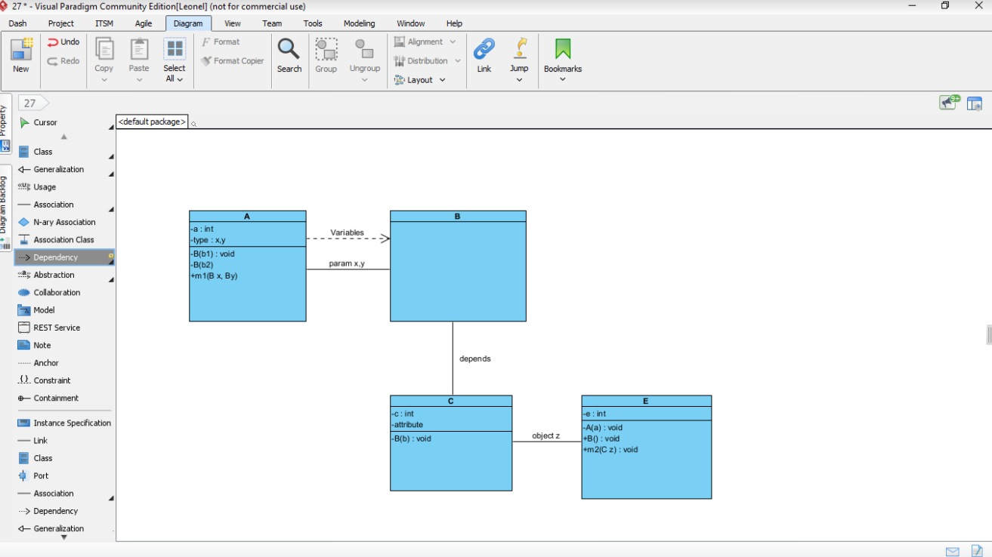

Inspector: Anthony Morales

RUBIRC

1. A 1/1

2. B 1/1

3. C 1/1

4. E 1/1

5. POOExam1P27 0/1

6. A-B assoc 0,5/1

7. A-E assoc 0/1

8. E-B assoc 0/1

9. E-C depend 0.5/1

10. C-B assoc 0,5/1

11. POOExam1P27-E (or any other class) depend 0/1

12. A-B depend 1/1

TOTAL 6.5/10

29 MORALES CAICEDO ANTHONY JAVIER

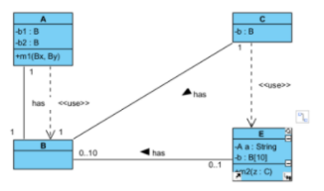

Inspector: Sebastian Palacios

RUBIRC

1. A 1/1

2. B 1/1

3. C 1/1

4. E 0.9/1

5. POOExam1P27 0/1

6. A-B assoc 1/1

7. A-E assoc 0/1

8. E-B assoc 1/1

9. E-C depend 0,5/1

10. C-B assoc 1/1

11. POOExam1P27-E (or any other class) depend 0/1

12. A-B depend 1/1

TOTAL 8,4/10

30 PALACIOS CANDO DIEGO SEBASTIAN

Inspector: Javier Paucar

RUBIRC

1. A 0.9/1

2. B 1/1

3. C 1/1

E 0.9/1

5. POOExam1P27 0/1

6. A-B assoc 0.9/1

7. A-E assoc 1/1

8. E-B assoc 0.75/1

9. E-C depend 1/1

10. C-B assoc 0.8/1

11. POOExam1P27-E (or any other class) depend 0/10

12. A-B depend 0.75/1

TOTAL 9/10

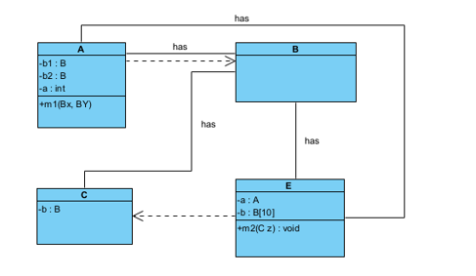

31 PAUCAR LEMA ALEX JAVIER

inspector: Leandro Quinga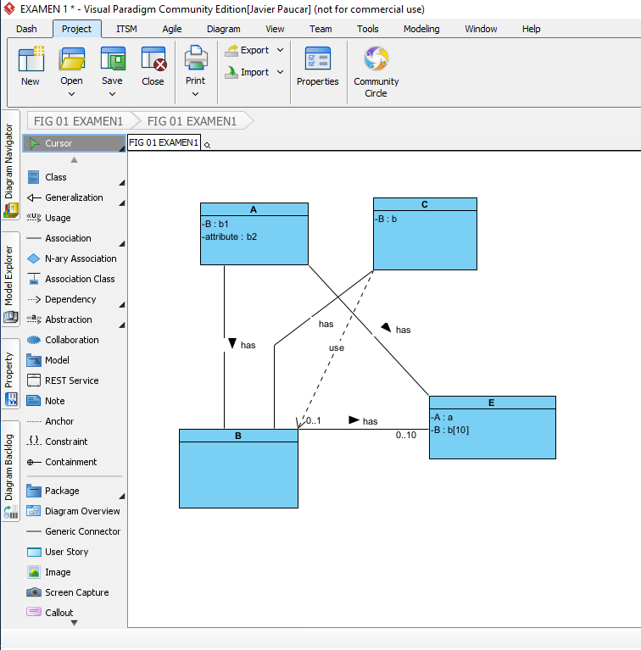

RUBIRC

1. A 0.5/1

2. B 1/1

3. C 1/1

4. E 0.5/1

5. POOExam1P27 0/1

6. A-B assoc 0.75/1

7. A-E assoc 0.75/1

8. E-B assoc 0.75/1

9. E-C depend 0/1

10. C-B assoc 0.75/1

11. POOExam1P27-E (or any other class) depend 6/10

32 QUINGA GUAYASAMIN LEANDRO ALEXANDER

inspector:Alexander Ruano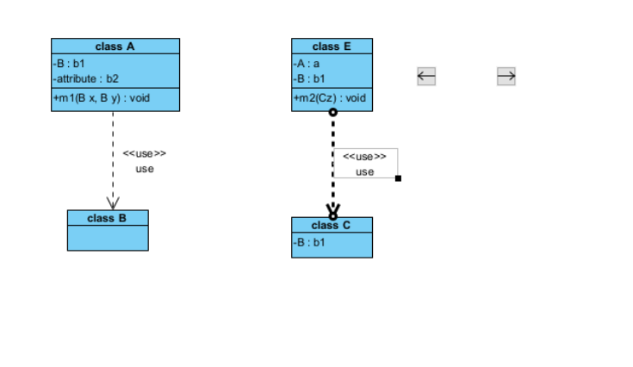

RUBIRC

1. A 1/1

2. B 1/1

3. C 1/1

4. E 1/1

5. POOExam1P27 0/1

6. A-B assoc 0/1

7. A-E assoc 0/1

8. E-B assoc 0/1

9. E-C depend 1/1

10. C-B assoc 0/1

11. POOExam1P27-E (or any other class) depend 0/1

12. A-B depend 0/1

TOTAL 5/10

33 RUANO PONCE ALEXANDER JAVIER

Inspector : Paul Saltos

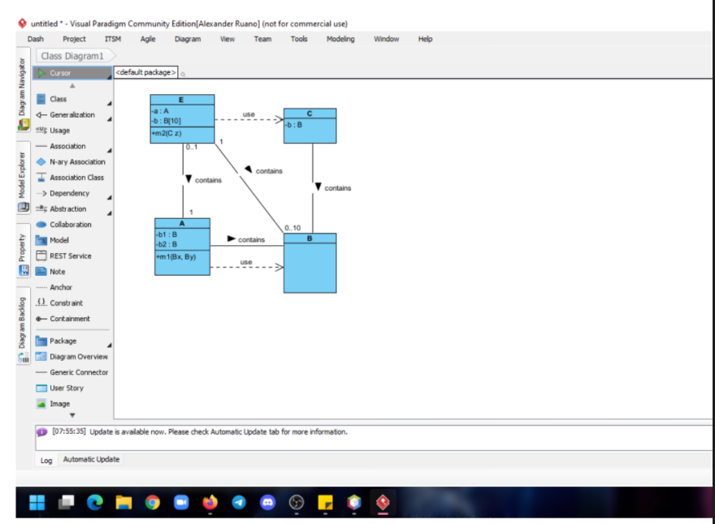

RUBIRC

1. A 1/1

2. B 1/1

3. C 1/1

4. E 1/1

5. POOExam1P27 0/1

6. A-B assoc 0.5/1

7. A-E assoc 1/1

8. E-B assoc 1/1

9. E-C depend 1/1

10. C-B assoc 0.5/1

11. POOExam1P27-E (or any other class) depend 0/1

12. A-B depend 0,5/1

Total 8/10

34 SALTOS TACO PAUL ALEXANDER

INSPECTOR: JOSÉ SÁNCHEZ

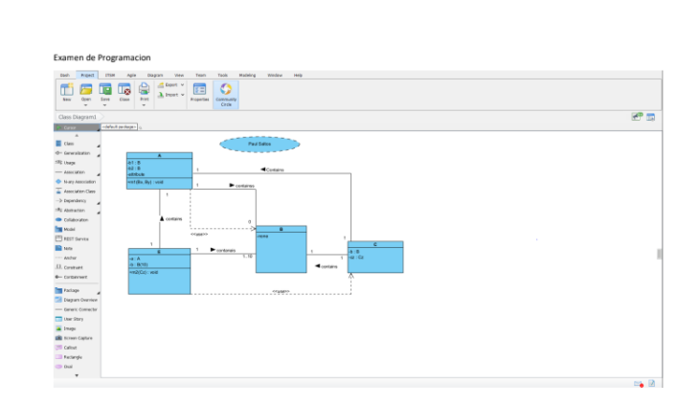

RUBIRC

1. A 1/1

2. B 1/1

3. C 1/1

4. E 1/1

5. POOExam1P27 0.5/1

6. A-B assoc 1/1

7. A-E assoc 1/1

8. E-B assoc 1/1

9. E-C depend 0.5/1

10. C-B assoc 0.5/1

11. POOExam1P27-E (or any other class) depend 0/10

12. A-B depend 0/1

TOTAL 8.5/10

35 SANCHEZ MISHQUERO JOSE FRANCISCO

Inspect:Alan Shuguli

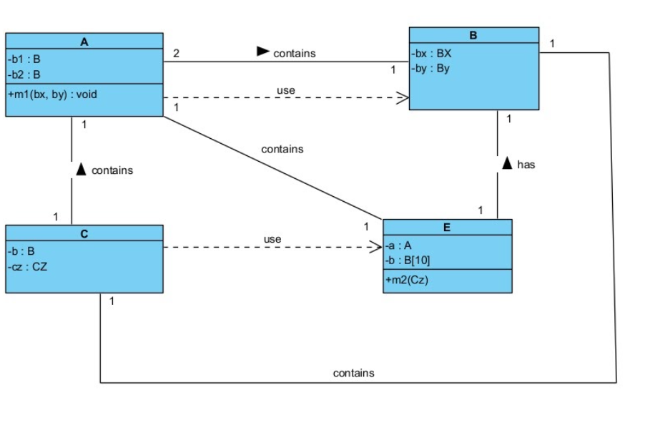

RUBIRC

1. A 1/1

2. B 0.5/1

3. C 0.5/1

4. E 0.5/1

5. POOExam1P27 0/1

6. A-B assoc 1/1

7. A-E assoc 1/1

8. E-B assoc 1/1

9. E-C depend 0/1

10. C-B assoc 1/1

11. POOExam1P27-E (or any other class) depend 0/10

12. A-B depend 1/1

TOTAL 7.5/10

36 SHUGULI REINOSO ALAN JESITH

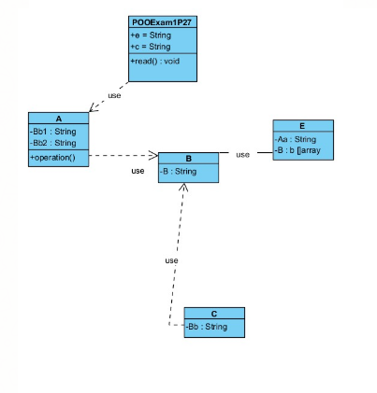

RUBIRC

1. A O.5/1

2. B 0.5/1

3. C 1/1

4. E 0.5/1

5. POOExam1P27 0.5/1

6. A-B assoc 0/1

7. A-E assoc ‘/1

8. E-B assoc 0/1

9. E-C depend 0/1

10. C-B assoc 0/1

11. POOExam1P27-E (or any other class) depend .05/10

12. A-B depend 1/1

TOTAL 5/10

Inspector Simbaña Gustavo

37 SIMBAÑA SIMBAÑA JONATHAN GUSTAVO

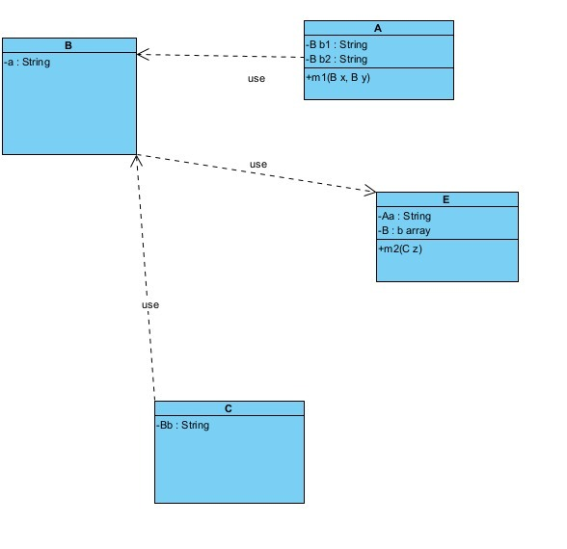

Inspector: Andrea Tapia

RUBIRC

1. A 1/1

2. B 0.5/1

3. C 1/1

4. E 1/1

5. POOExam1P27 0/1

6. A-B assoc 0/1

7. A-E assoc 0/1

8. E-B assoc 0/1

9. E-C depend 0/1

10. C-B assoc 0/1

11. POOExam1P27-E (or any other class) depend 0/10

12. A-B depend 1/1

TOTAL 4.5/10

38 TAPIA ALBAN ANDREA JULIANNA

Inspector: Sebastian Tayo

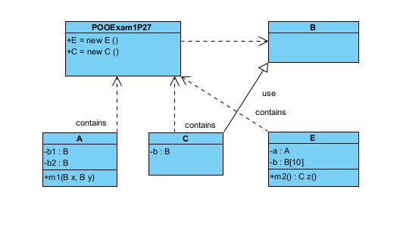

RUBIRC

1. A 1/1

2. B 1/1

3. C 1/1

4. E 1/1

5. POOExam1P27 1//1

6. A-B assoc 0 /1

7. A-E assoc 0/1

8. E-B assoc 0/1

9. E-C depend 0/1

10. C-B assoc 1/1

11. POOExam1P27-E (or any other class) depend 1/1

12. A-B depend 0/1

TOTAL 7/10

39 TAYO RUIZ SEBASTIAN ALEJANDRO

Inspector: Camila Teca

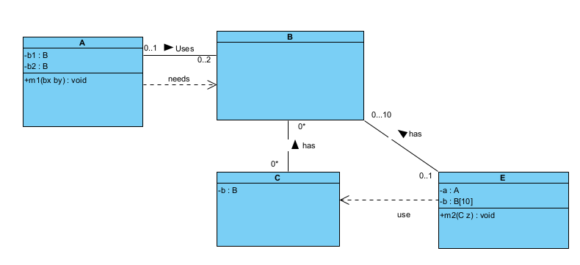

RUBIRC

1. A 1/1

2. B 1/1

3. C 1/1

4. E 1/1

5. POOExam1P27 0/1

6. A-B assoc 0.8/1

7. A-E assoc 0/1

8. E-B assoc 1/1

9. E-C depend 1/1

10. C-B assoc 1/1

11. POOExam1P27-E (or any other class) depend 0/1

12. A-B depend 0.5/1

TOTAL 8.3/10

40 TECA TELLO CAMILA MILENA

Inspector: Melanie Terán

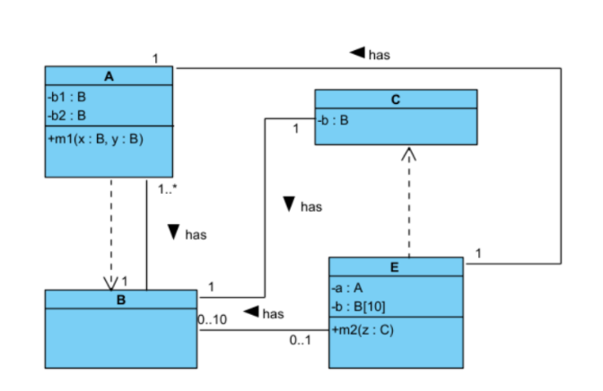

RUBIRC

1. A 1/1

2. B 1/1

3. C 1/1

4. E 1/1

5. POOExam1P27 0/1

6. A-B assoc 1/1

7. A-E assoc 1/1

8. E-B assoc 1/1

9. E-C depend 0.5/1

10. C-B assoc 1/1

11. POOExam1P27-E (or any other class) depend 0/1

12. A-B depend 0.5/1

TOTAL 9/10

41 TERAN FLORES MELANIE ELIZABETH

Inspector: Salma Villegas

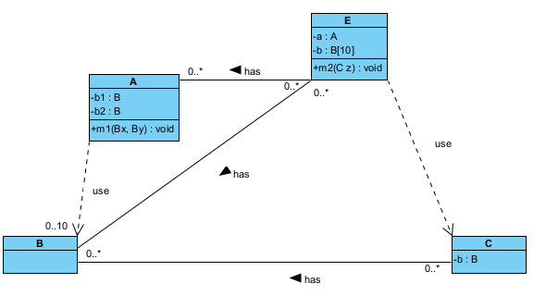

RUBIRC

1. A 1/1

2. B 1/1

3. C 1/1

4. E 1/1

5. POOExam1P27 0/1

6. A-B assoc 1/1

7. A-E assoc 1/1

8. E-B assoc 1/1

9. E-C depend 1/1

10. C-B assoc 1/1

11. POOExam1P27-E (or any other class) depend 0/10

12. A-B depend 1/1

TOTAL 10/10

42 VILLEGAS ESTRELLA SALMA ABIGAIL

Inspector: Joel Zeas

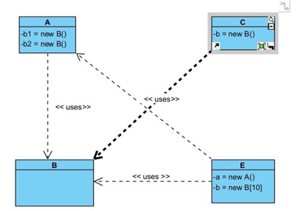

RUBIRC

1. A 1/1

2. B 1/1

3. C 1/1

4. E 1/1

5. POOExam1P27 0/1

6. A-B assoc 0/1

7. A-E assoc 0/1

8. E-B assoc 0/1

9. E-C depend 0.50/1

10. C-B assoc 0/1

11. POOExam1P27-E (or any other class) depend 0/1

12. A-B depend 1/1

TOTAL 5.50/10

43 ZEAS CLAVIJO JOEL ALEXANDER

Inspector: Anderson Almache

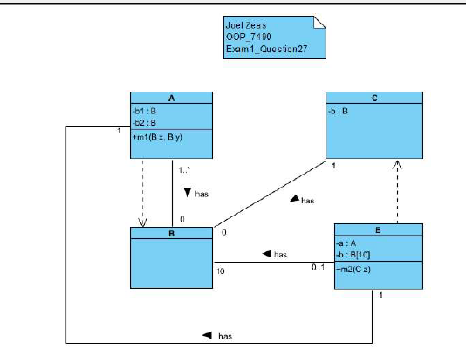

RUBIRC

1. A 1/1

2. B 1/1

3. C 1/1

4. E 1/1

5. POOExam1P27 0.5/1

6. A-B assoc 0.75/1

7. A-E assoc 1/1

8. E-B assoc 1/1

9. E-C depend 1/1

10. C-B assoc 0/1

11. POOExam1P27-E (or any other class) depend 0/1

12. A-B depend 1/1

TOTAL 9.25/10