**WS18-JSON**

**DATE: 16th december 2021**

3 ALVAREZ RAMIREZ MICHELLE ESTEFANIA

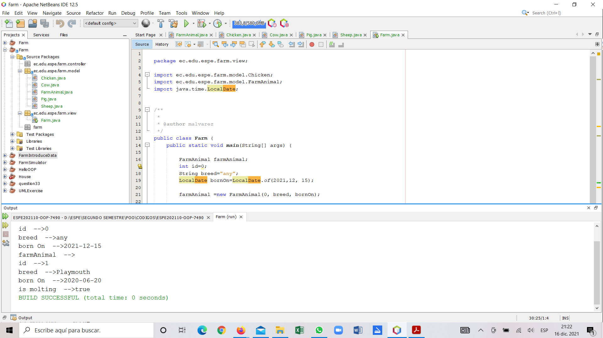

Inspector: Almache Anderson

one extra comma -1

{

"number":"001",

"name":"Holstein",

"dateOfBirth":"12/12/2020",

"isProducingMilk":"true",

}

{

"number":"002",

"name":"Plymouth",

"dateOfBirth":"06/27/2020",

"isProducingMilk":"false",

}

{

"number":"003",

"name":"Dorper",

"dateOfBirth":"01/30/2019",

"isProducingMilk":"10/10/2021",

}

{

"number":"004",

"name":"LargeWhite",

"dateOfBirth":"09/25/2021",

"isProducingMilk":"50",

}

Validate

{

"number": "001",

"name": "Holstein",

"dateOfBirth": "12/12/2020",

"isProducingMilk": "true"

}

{

"number": "002",

"name": "Plymouth",

"dateOfBirth": "06/27/2020",

"isProducingMilk": "false"

}

{

"number": "003",

"name": "Dorper",

"dateOfBirth": "01/30/2019",

"isProducingMilk": "10/10/2021"

}

{

"number": "004",

"name": "LargeWhite",

"dateOfBirth": "09/25/2021",

"isProducingMilk": "50"

}