**WS32 - GROUPS**

**DATE: 03th february 2021**

**TEAM 5:**

Alvarez Michelle

Correa Kerly

Eivar Jaime

Garcia Mayerly

Teca Camila

Teran Melanie

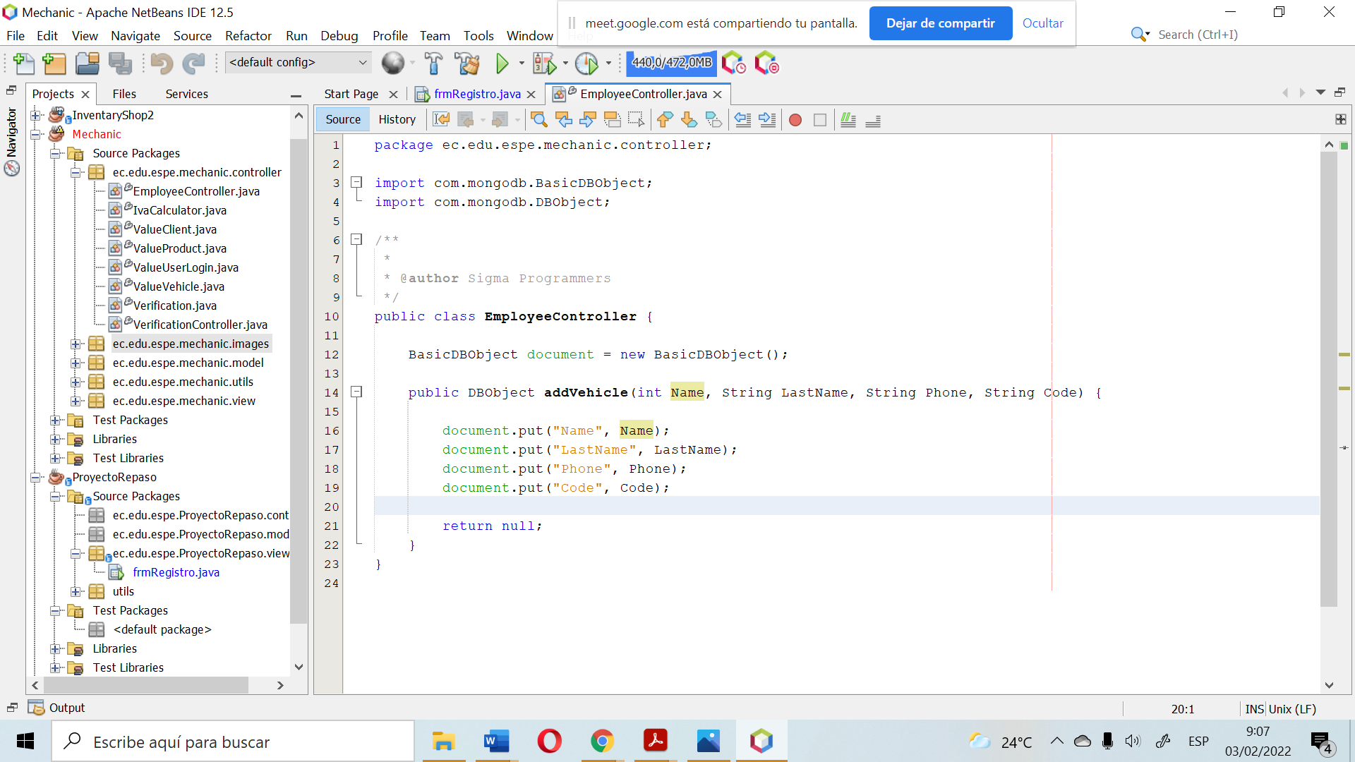

The name is declared as a int, it should be String - Bad quality code

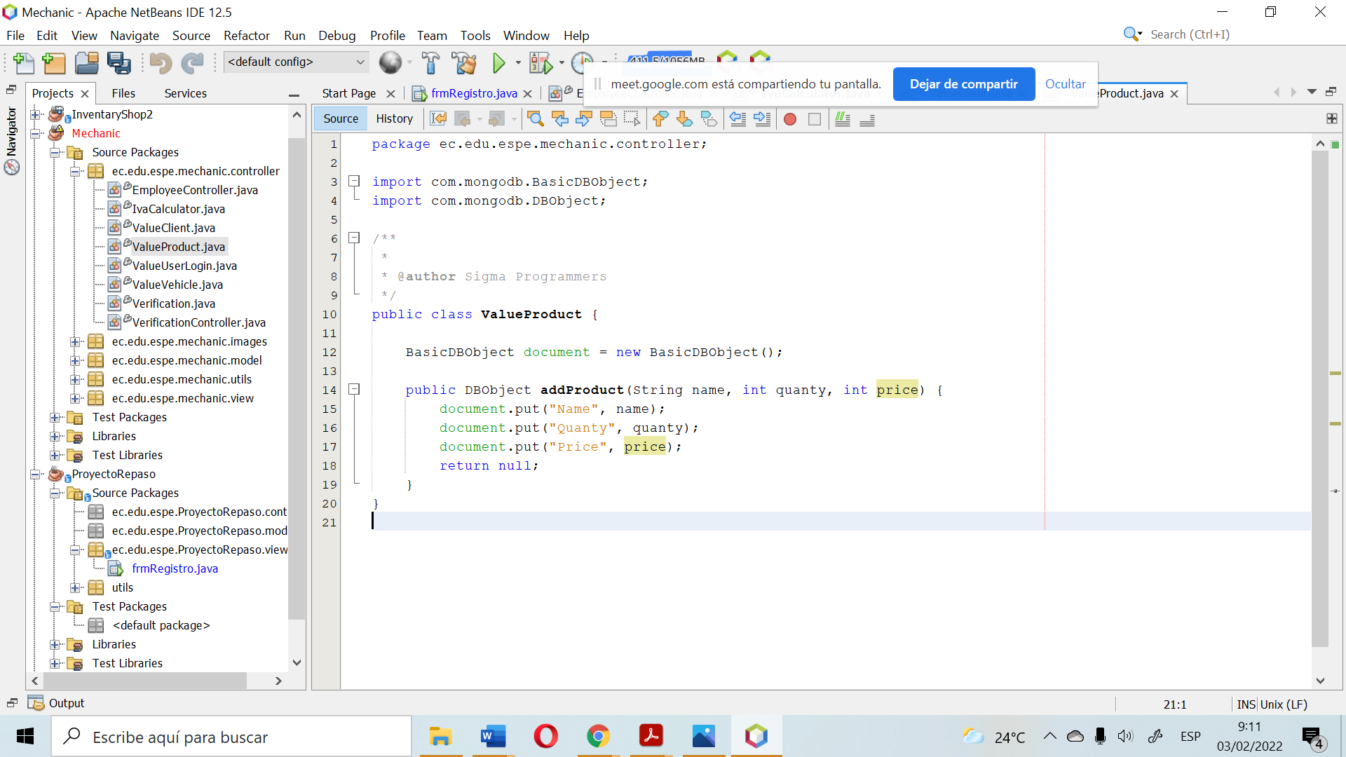

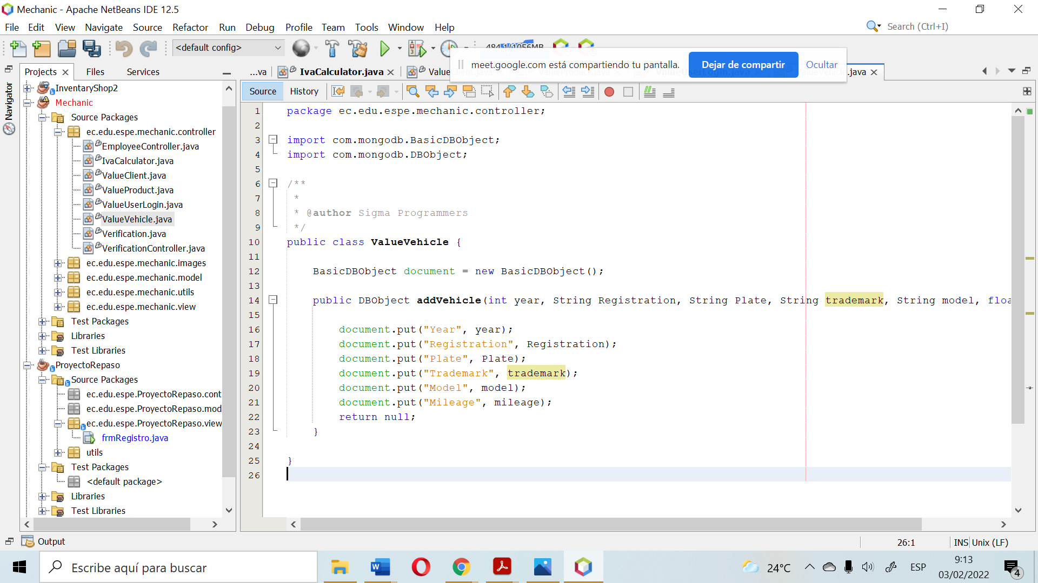

Incorrect class names. Classes are written in the singular:

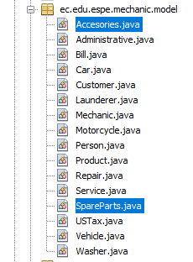

They are not names for the buttons:

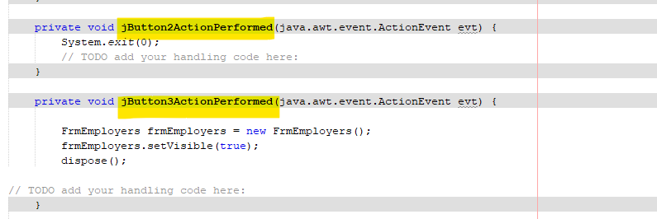

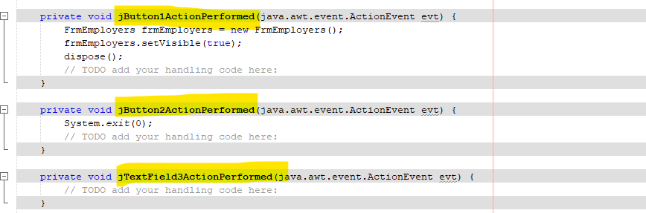

In the utils package there should be one class to the database, but no more than two classes connecting to the same database. (**Single Responsibility** )

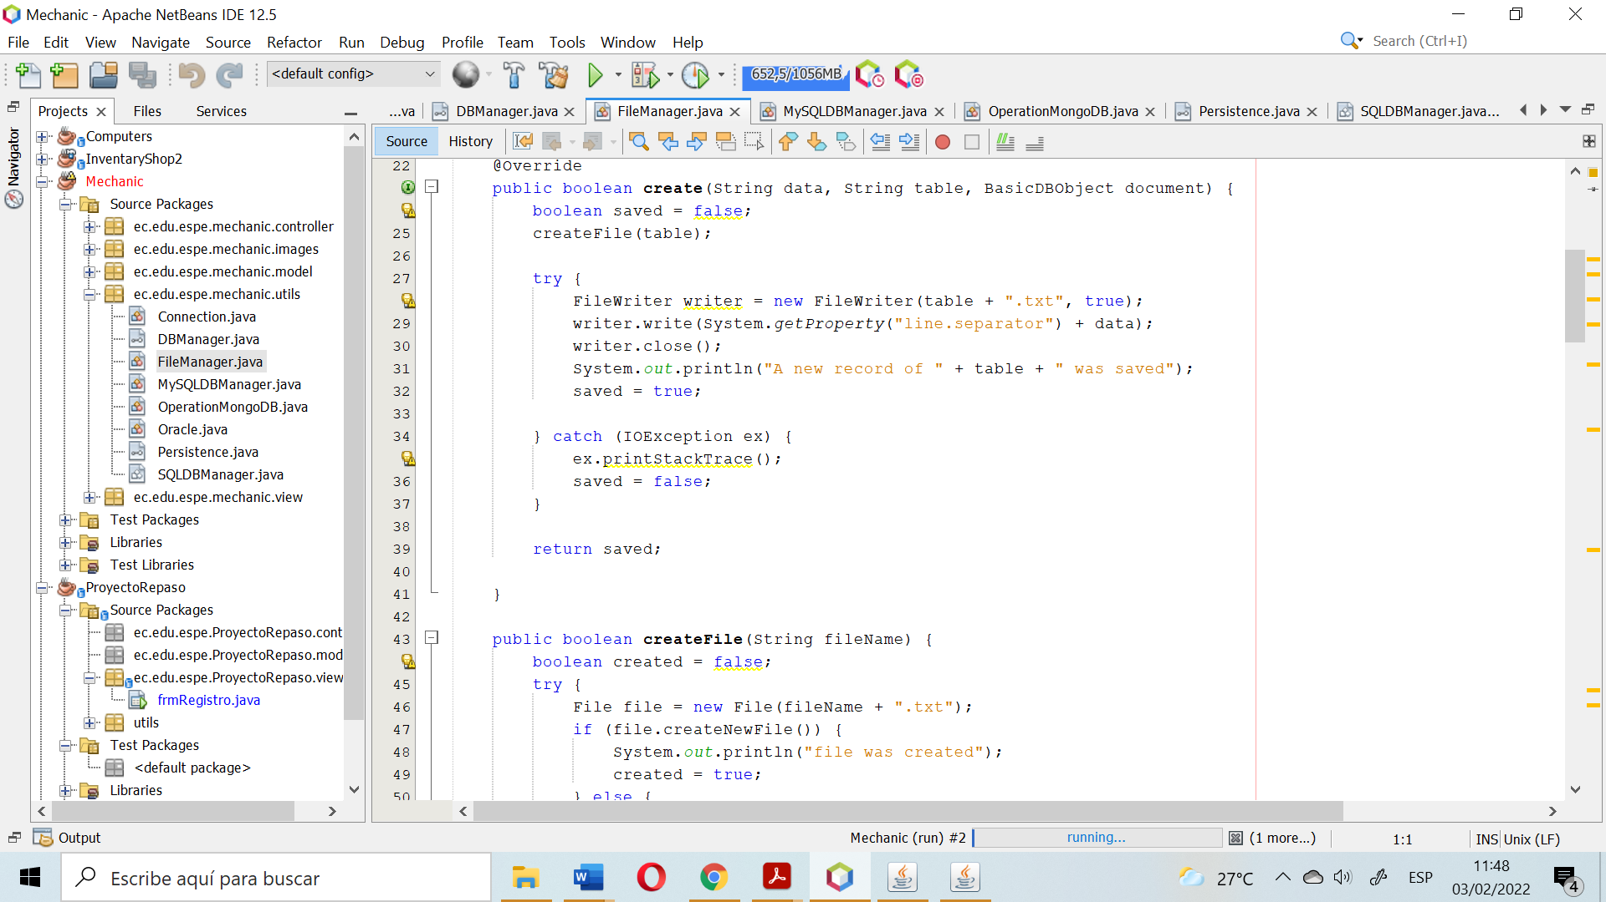

**The Interface segregation principle** is broken because the clients of the program should know what data is entered and which methods should actually be used.

Added or saved data is not displayed in the table

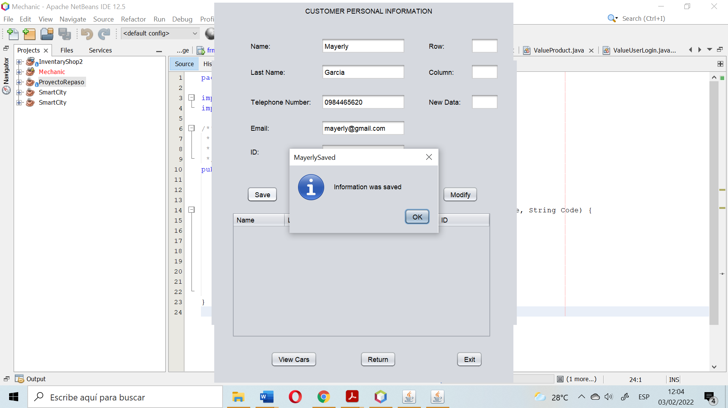

**Single Responsibility Principle** broken because has not relation with the data of the class:

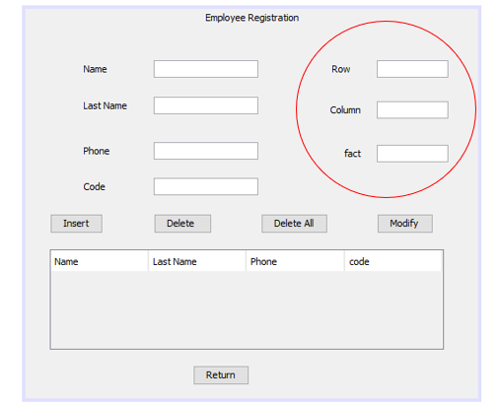

**Single Responsibility Principle** broken because the "add vehicle" object is not related to the "EmployeeController" class.

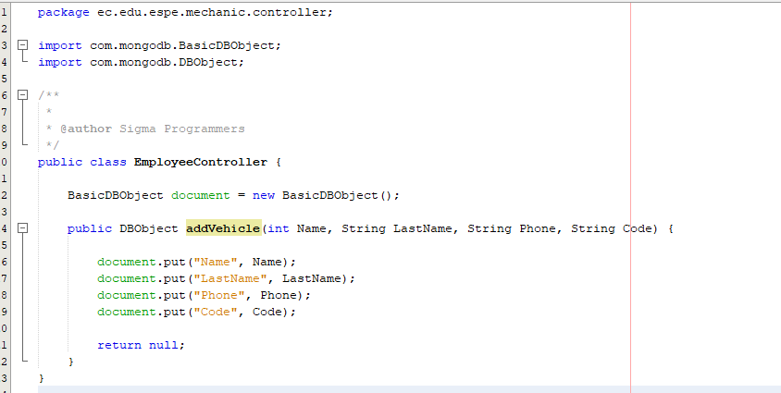

Bad declaration of the person Method of the Person class, missing to declarate id

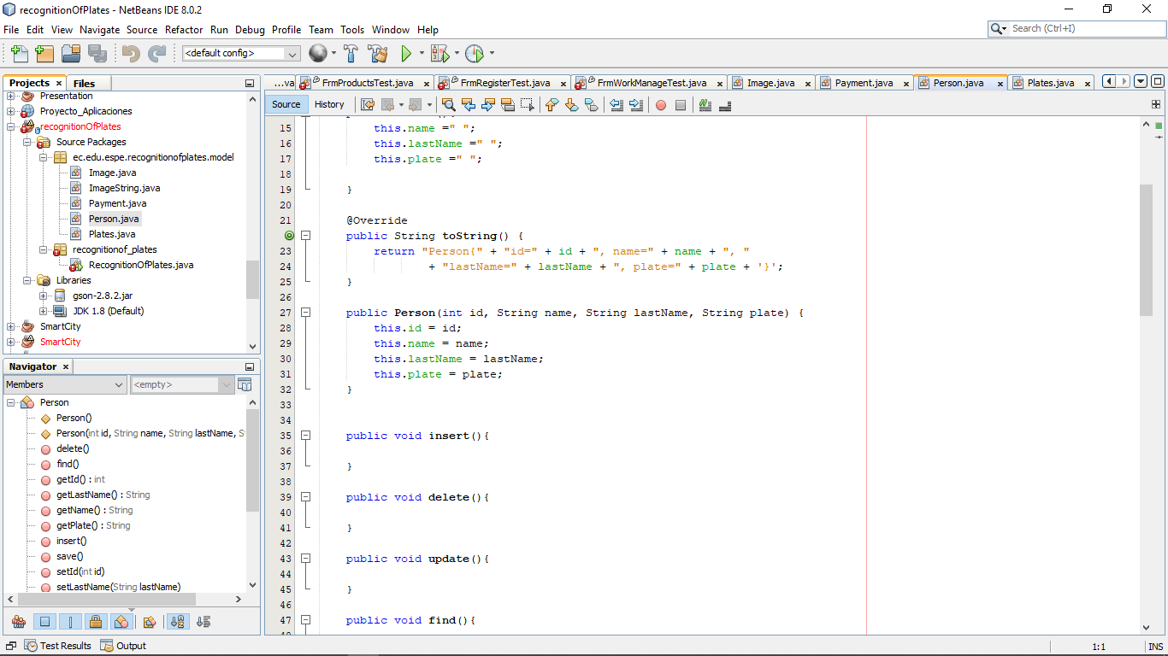

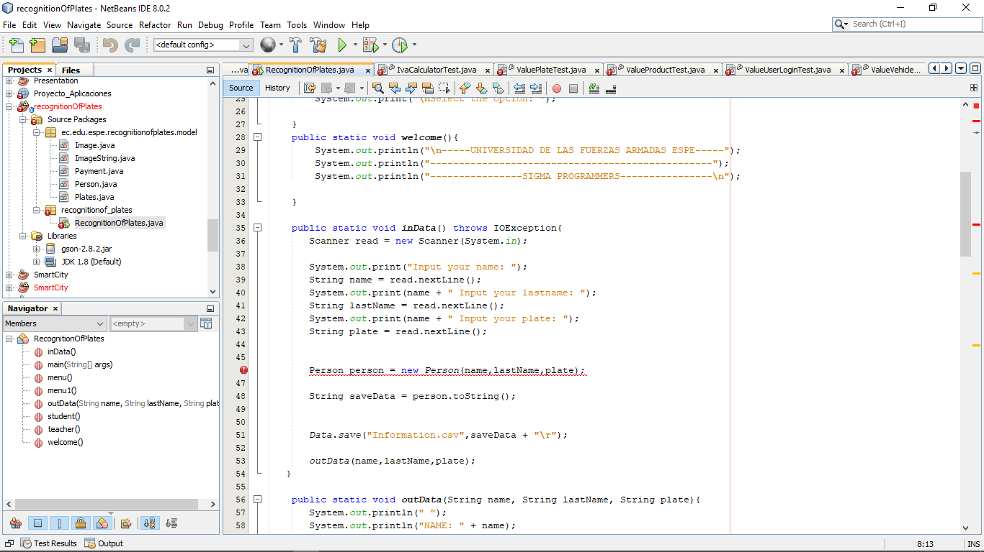

Bad names for button functions, FrmBill does not perform any function and comments not deleted

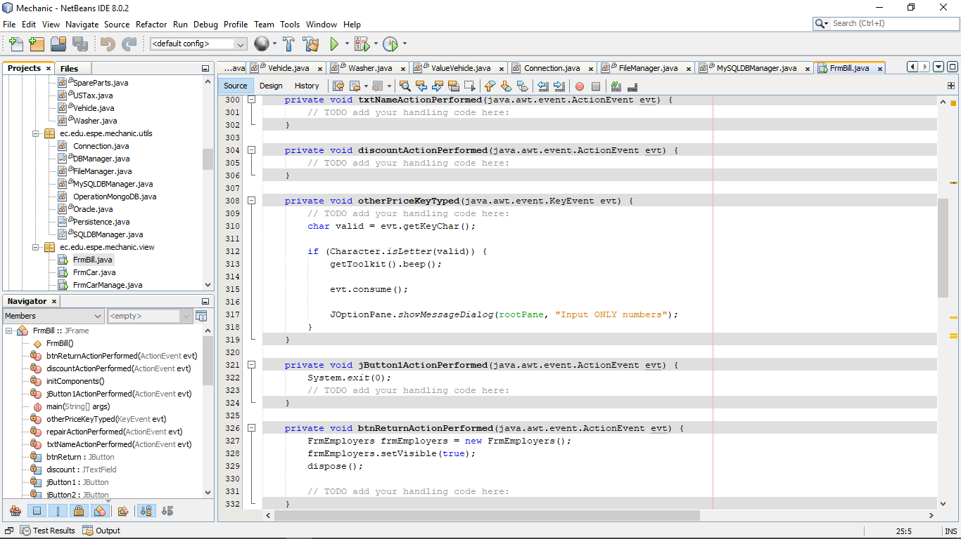

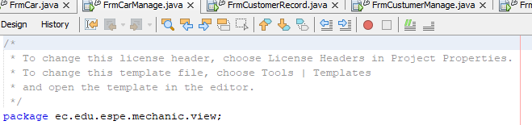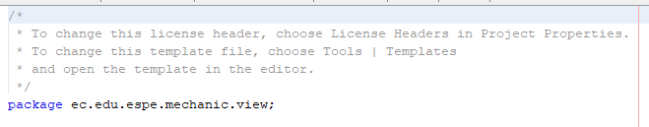

Unnecessary comments (FrmCarManage and FrmWorkManage )

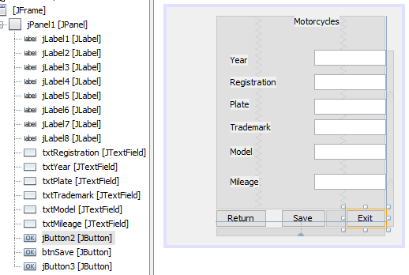

Bad names for Return and Exit buttons (FrmMotorcycles)



Table name in spanish (FrmWorkerRecord)

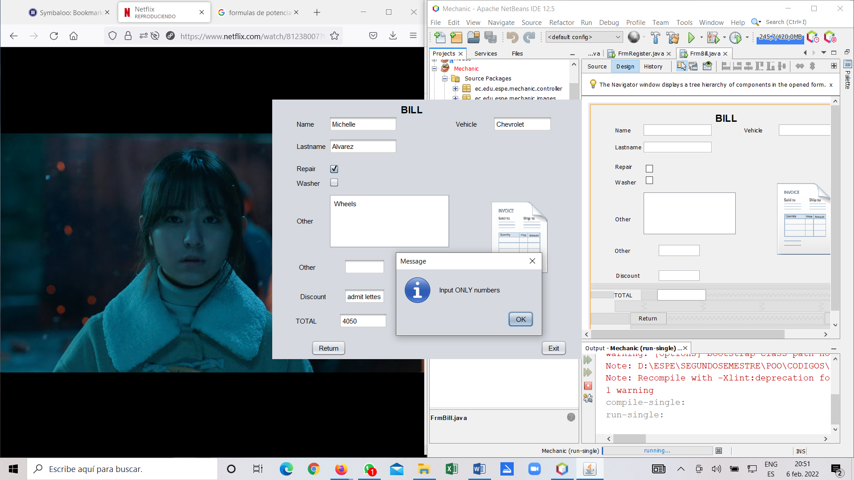

The FrmBill does not follow the **Liskov Substitution Principle** because it does not represent a window or public methods into the program. The are two fieds call “Other” and in one of them it is not clear which is the information that you have to righ. The field discount and TOTAL are not clear. They must be calculated into the program.

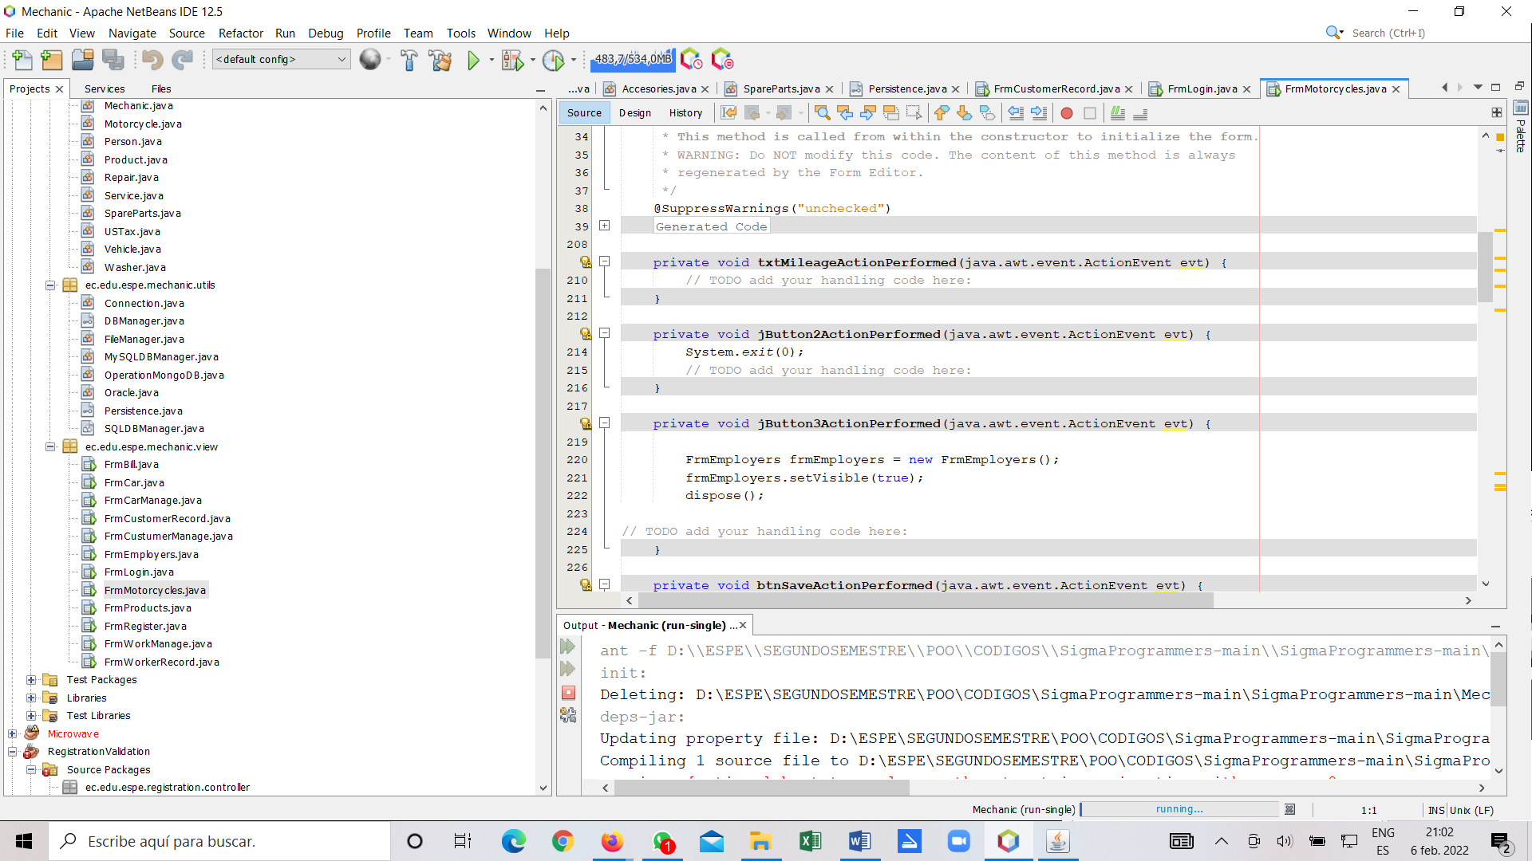

In the FrmMotorcycle the are some buttons without name so it is difficult to understand how the program works. **Unclean code.**

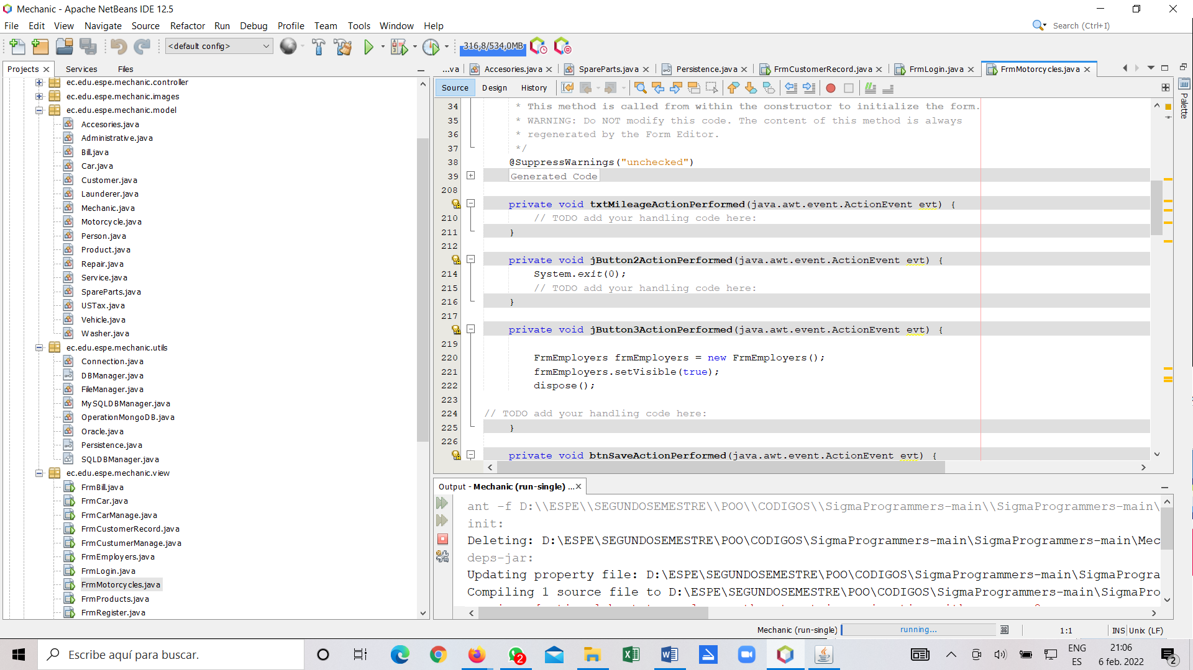

Each class should be responsible for only one part of the system's functionality. We can see there are many classes that allow the connection to the database, so it is not clear which class do a specific job. So in this part of the program does not follow the **Single Responsibility Principle.**