10 BUSTILLOS MONTENEGRO PABLO SEBASTIAN

Inspector:Benjamin Cadena

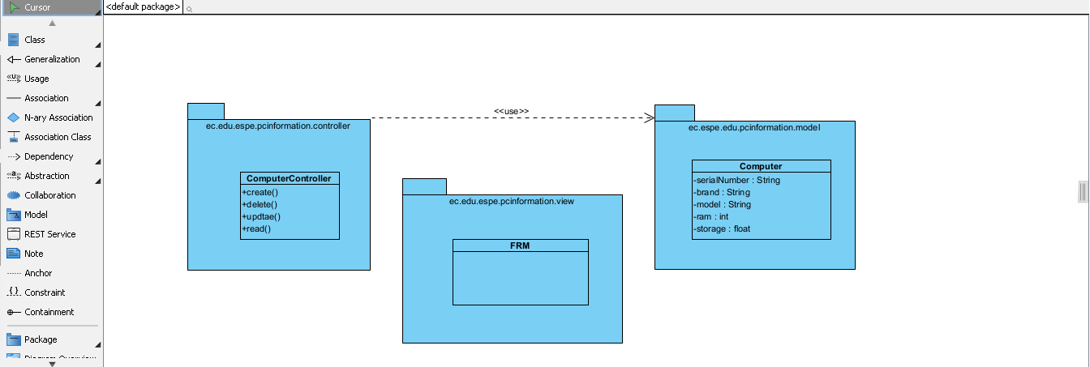

1.- Computer 1/1

2.- FrmCOmputer 0.3/1

3.- DBManager 0/1

4.- three packages 1/1

5.- dependencies 0.5/1

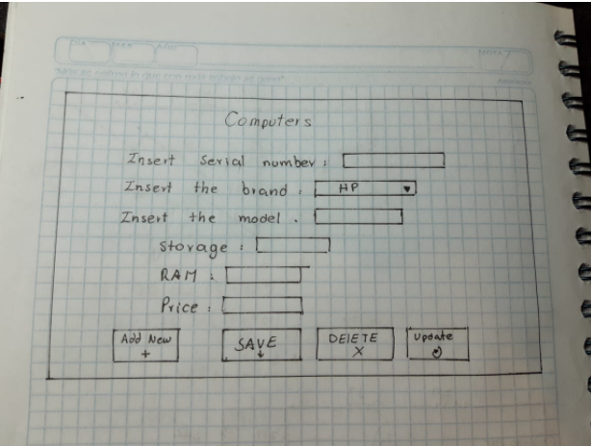

1.- menu 1.25/1.25

2.- add Computer 1.25/1.25

3.- listComputer 1.25/1.25

4.- updateComputer 1.25/1.25

5.- deleteComputer 1.25/1.25

Other solution: one screen with all buttons on it

1.- inputs 1/1

2 - 5.-buttons 4/4

Pablo Bustillos 5 + 2.8 = 7.8/10