Inspector:      T3: (TeamWorkBots)  Leader: Andy Calderon

Team:            T9 (No Leader Team) Leader: Zeas

Project:          Catering Planner

41 TERAN FLORES MELANIE ELIZABETH

42 VILLEGAS ESTRELLA SALMA ABIGAIL

43 ZEAS CLAVIJO JOEL ALEXANDER

Modularity 9/10     (no controller package)

Clean code 9/10     (commented code)

MVC 8/10

One design pattern 0/10

Diagrams consistency 10/10

Unit tests 10/10

GUI navigability 10/10

GUI fields validation 9/10

Functionality 10/10

MongoDB 10/10

______________________________

TOTAL             85 /100

**Modularity**

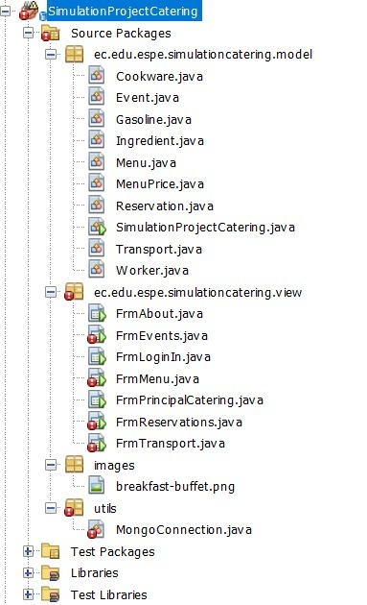

It is well distributed but missing controller package

**Clean code**

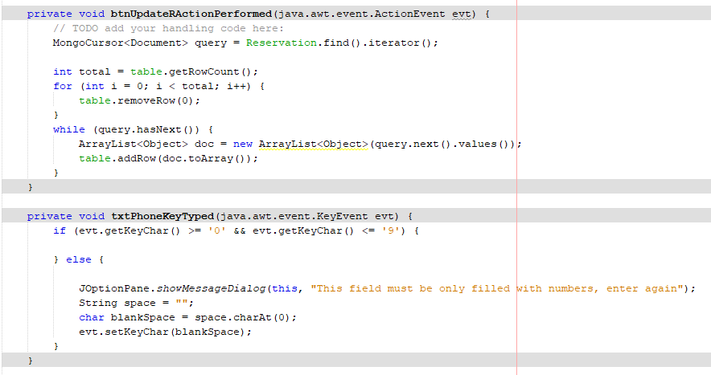

it has code on the buttons

**MVC**

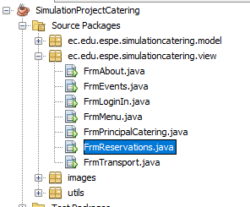

No controller package

**One design pattern**

No exist

**Diagrams consistency**

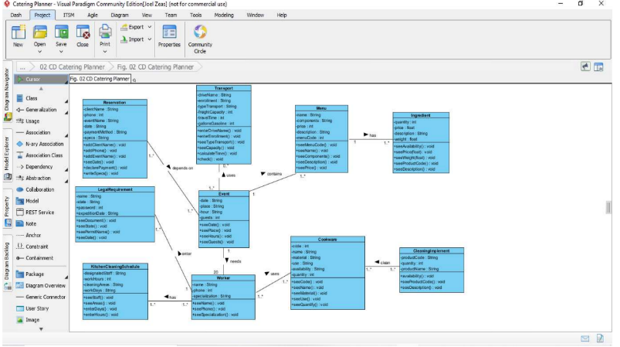

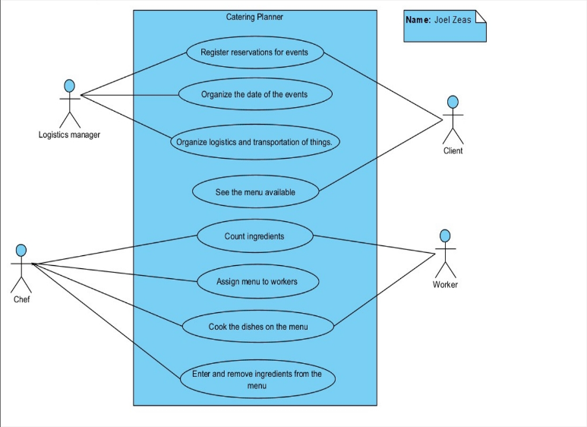

**Unit tests**

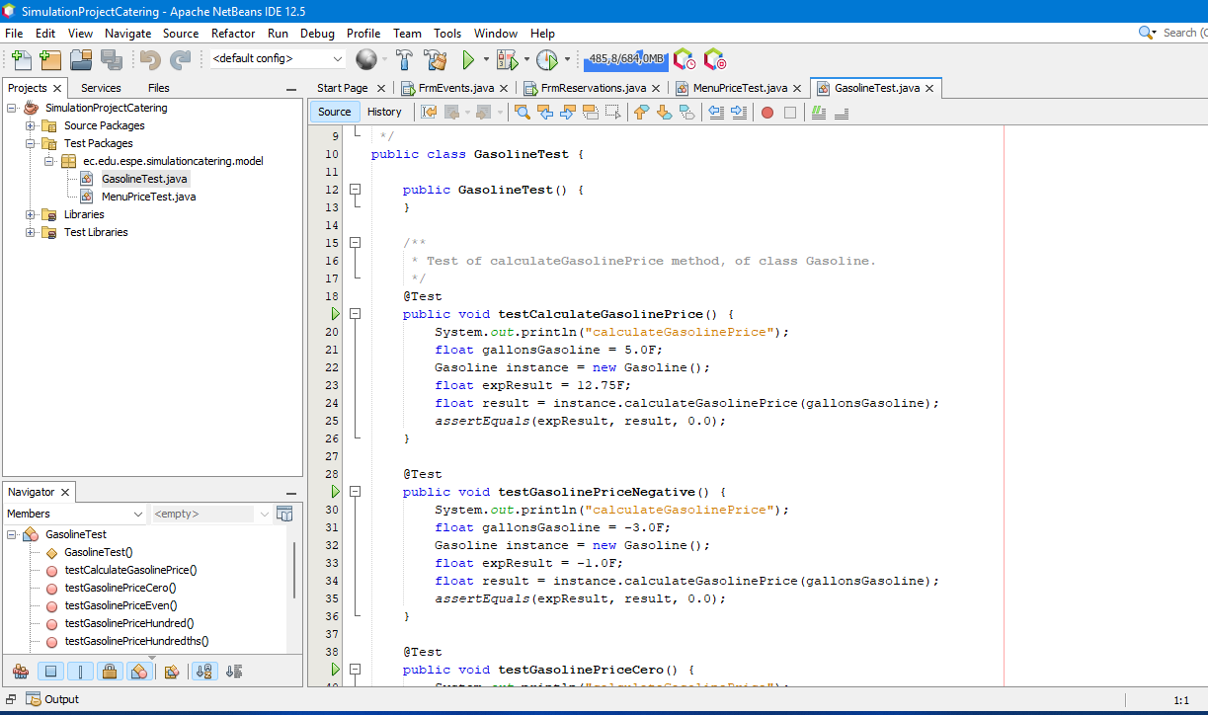

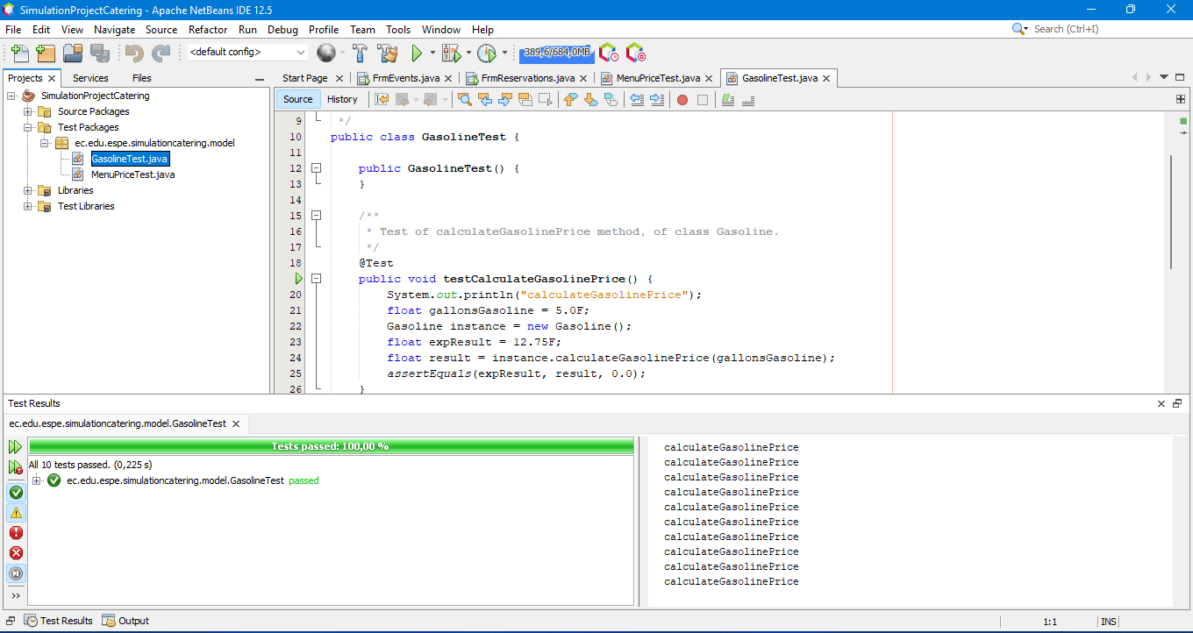

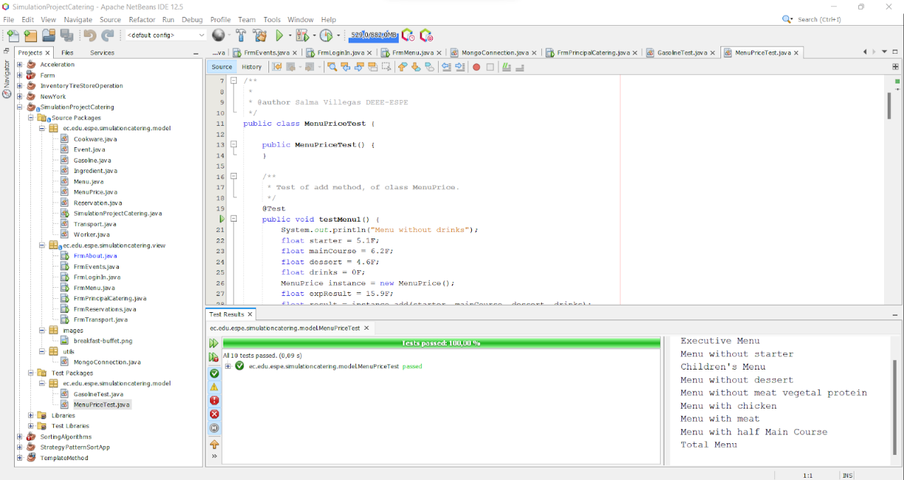

**GUI fields validation**

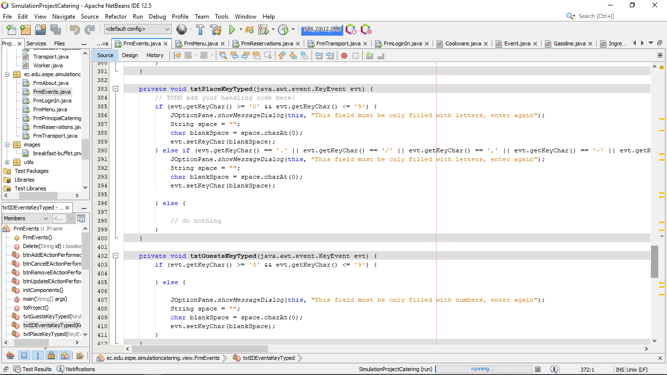

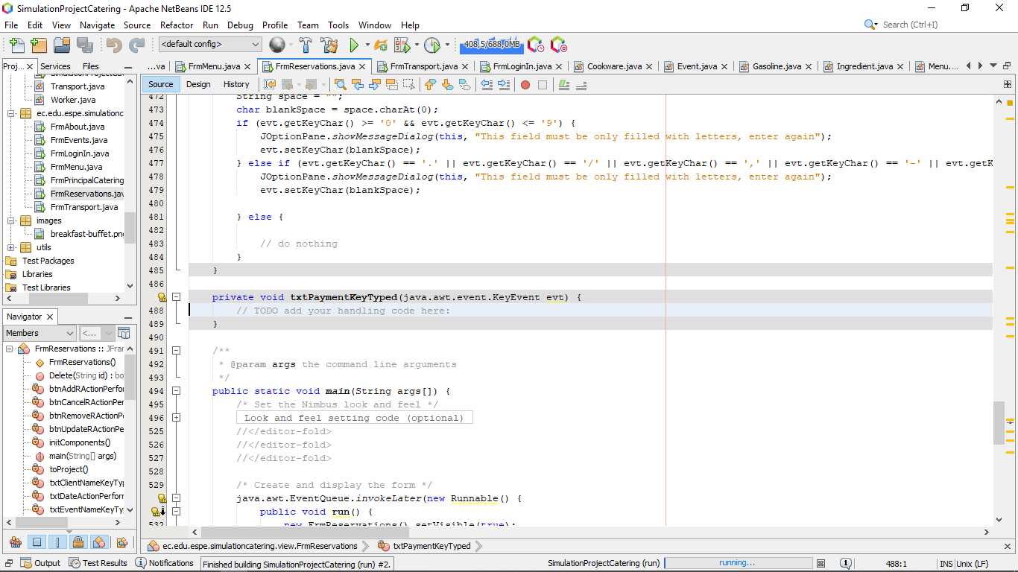

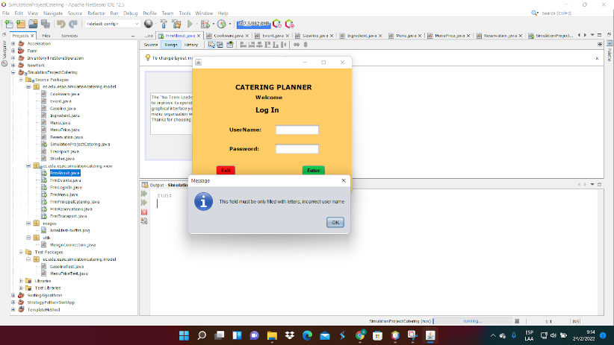

there is not validation in payment

**Functionality**

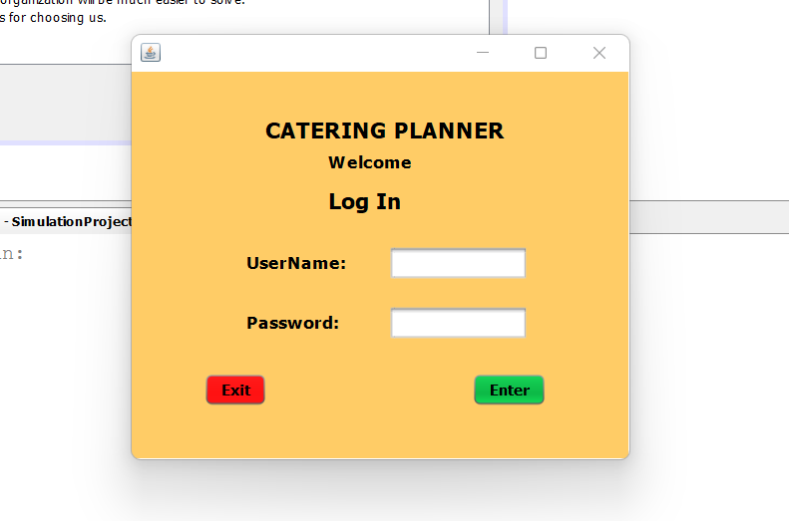

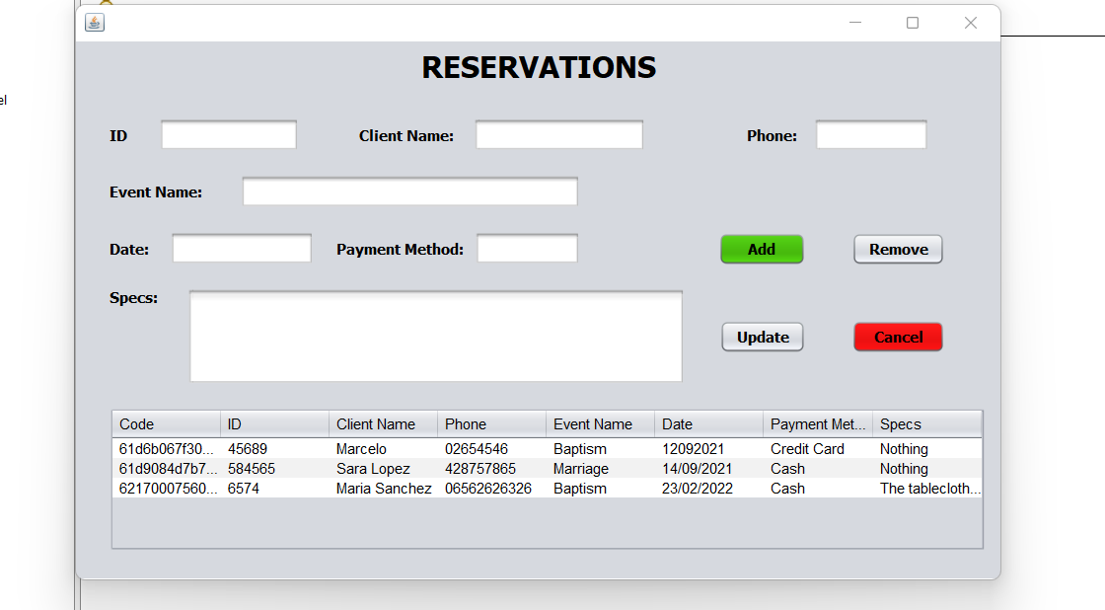

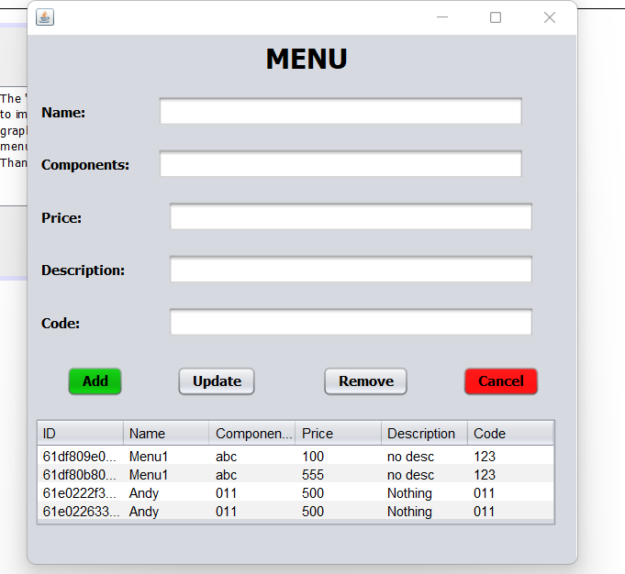

**MongoDB**

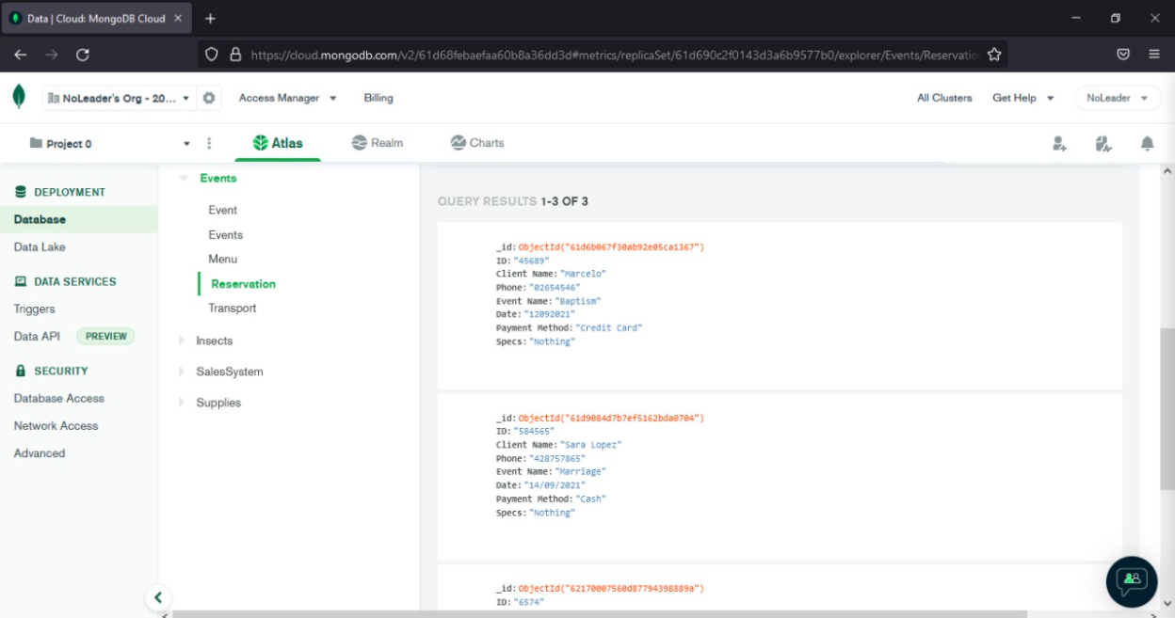

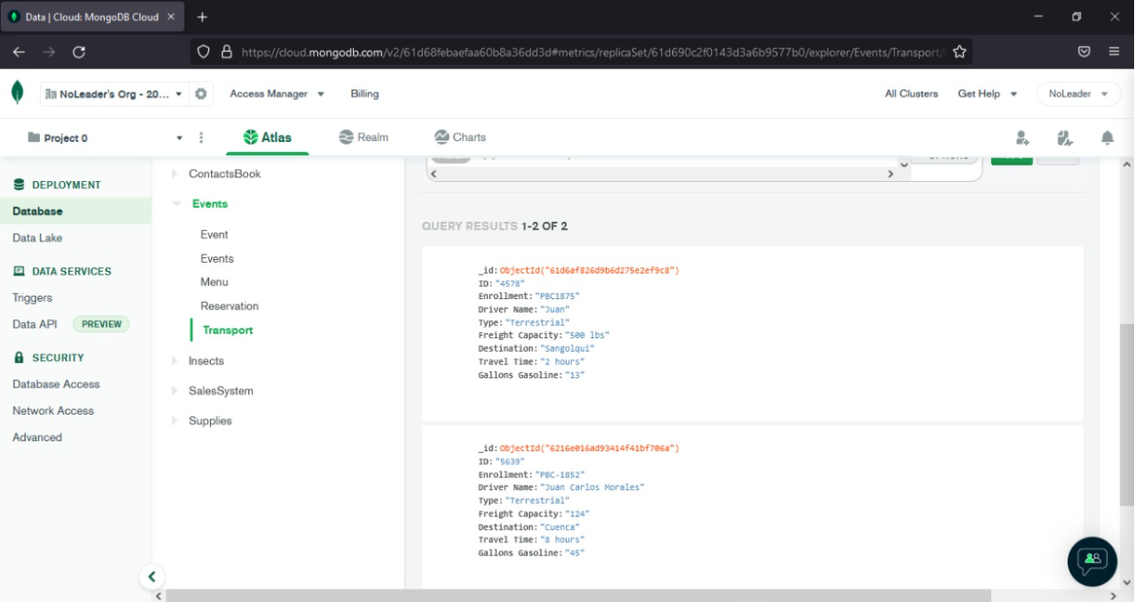

**GUI navigability Group 9¿**

**Execution Video Program Group 9**

[**https://drive.google.com/file/d/1XXOTqJqxpuwCNNH2JG3EELbIizxaufY_/view?usp=sharing**](https://drive.google.com/file/d/1XXOTqJqxpuwCNNH2JG3EELbIizxaufY_/view?usp=sharing)