**WS18-JSON**

**DATE: 16th december 2021**

**15 CRUZ PANTOJA DARLING MICAELA**

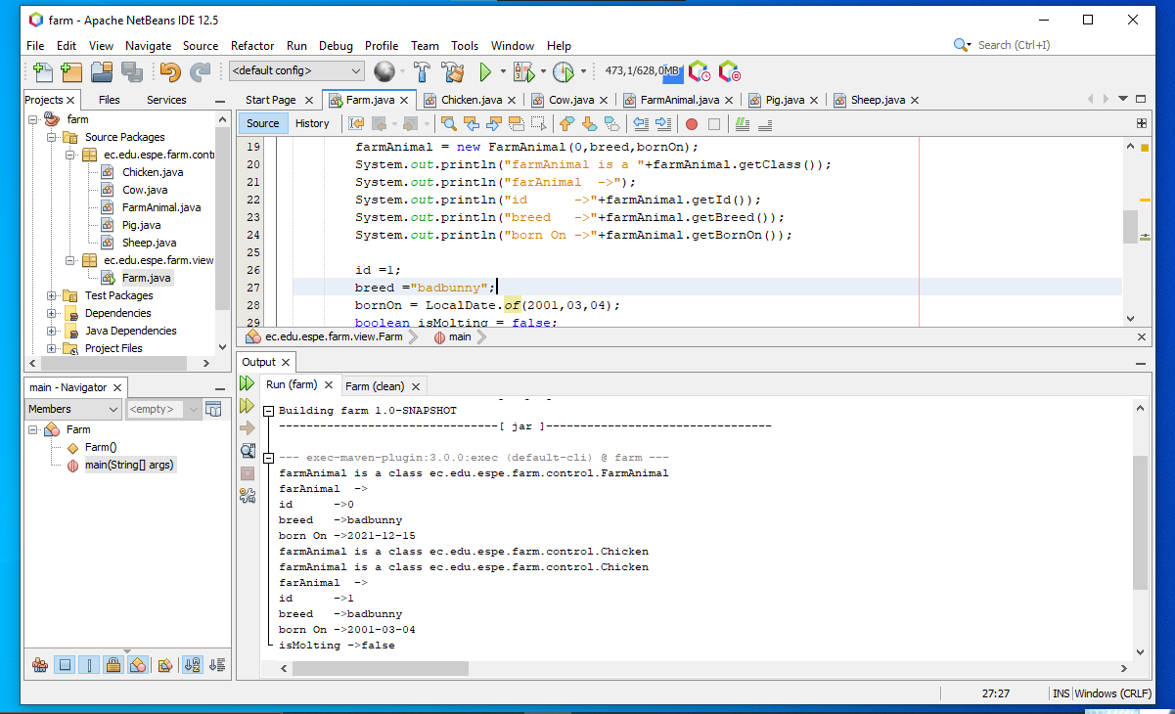

Inspector: Correa Kerly

* Extra three comma -1
* missing keys -1
* **Total —> 8/10**

001,Holstein,12/12/2020,true

002,Plymouth,06/27/2020,false

003,Dorper,01/30/2019,10/10/2021

004,Large White,09/25/2021,50

"001":"Holstein""12/12/2021":"true"

"002":"Plymouth":"06/27/2020":"false"

"003":"Dorper":"01/30/2019":"10/10/2021"

"004":"Large White":"09/25/2021":"50"

{

"id":"001",

"bread":"Plymouth",

"bornon":"06/27/2020",

"isMolting":"false"

}

{

"id":"002",

"race":"Plymouth",

"dateOfBirth":"06/27/2020",

"produceMilk":”false",

}

{

"id": "002",

"race": "Plymouth",

"dateOfBirth": "06/27/2020",

"produceMilk": "false"

}

{

"id":"003",

"race":"Dorper",

"dateOfBirth":"01/30/2019",

"produceMilk":"10/10/2021",

}

{

"id": "003",

"race": "Dorper",

"dateOfBirth": "01/30/2019",

"produceMilk": "10/10/2021"

}

"id:"004",

"race":"LargeWhite",

"dateOfBirth":"009/25/2021",

"produceMilk":"50",

}

{

"id": "004 ",

"race": "LargeWhite",

"dateOfBirth": "009/25/2021",

"produceMilk": "50"

}

_________________________________________________________________________

**16 DE LA CRUZ QUINGA ALEJANDRO SEBASTIAN**

Inspector: Darling Cruz

two mistakes in line number one

**Total → 8/10**

001, Holstein, 12/12/2020, true

002, Plymouth, 06/27/2020, false

003, Dorper, 01/30/2019, 10/10/2021

004, Large White, 09/25/2021, 50

{

"id": "001",

"String": "Plymouth",

"race": "12/12/2020",

"bool": "true"

}



{

"id":"002</id>”,

"race":”Holstein",

"date":”06/27/2020",

"bool":"false"

}

Two Error in line 1

{

"id": "002",

"race": "Holstein ",

"date": " 06 / 27 / 2020 ",

"bool": "false"

}

{

"id": "003",

"race": "Dorper ",

"date": "01 / 30 / 2019 ",

"cut": "10 / 10 / 2021 "

}



{

"id":"004",

"race":"Large White",

"date":"09/25/2021",

"weight":"50"

}

