**WS13-Project Inspections**

**DATE: 01th december 2021**

**Project Inspections**

Team 1: Alpha

URL: <https://github.com/mealvarez12/Group1_OOP_7490.git>

Team 5: JavaLegends

2. Requirements 10/10

3. UML Diagram 7,5/10 [in the methods (the verb is missing), associations (they are not in the third

person)]  
4. Classes 8/10 consistency of error in author and the first 4 lines of code

5. Code Quality 8/10 inconsistency between classes and diagrams(in the diagram they have 11 classes . and in the code only 14)

6. Execution 10/10

_______________________

TOTAL. /43,5

1.- Requierements

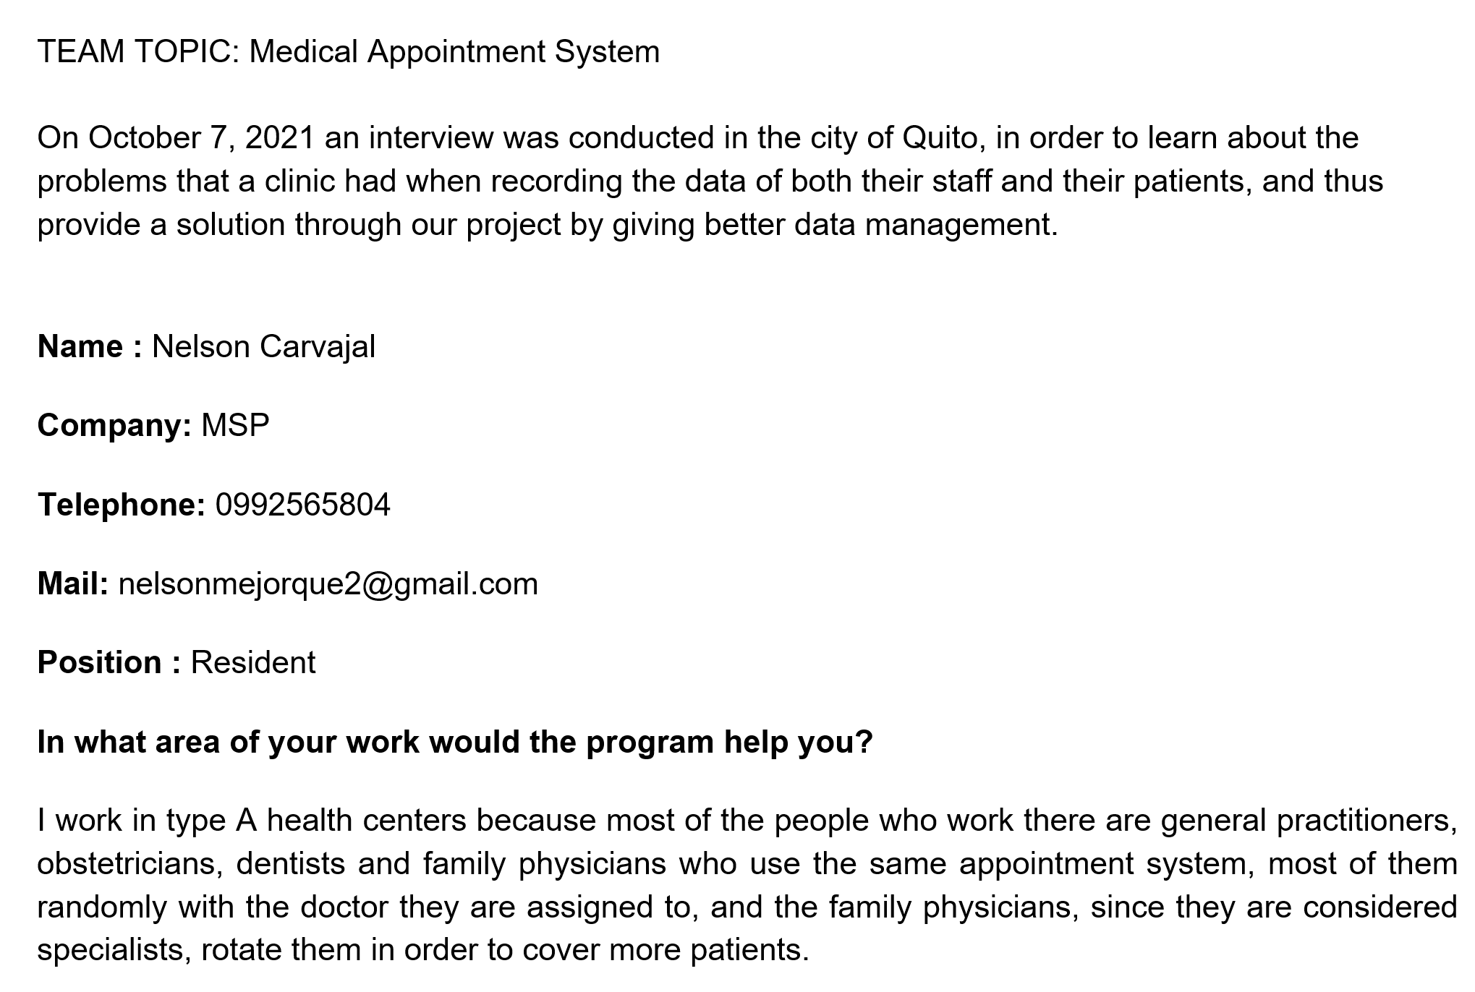

2.- diagram

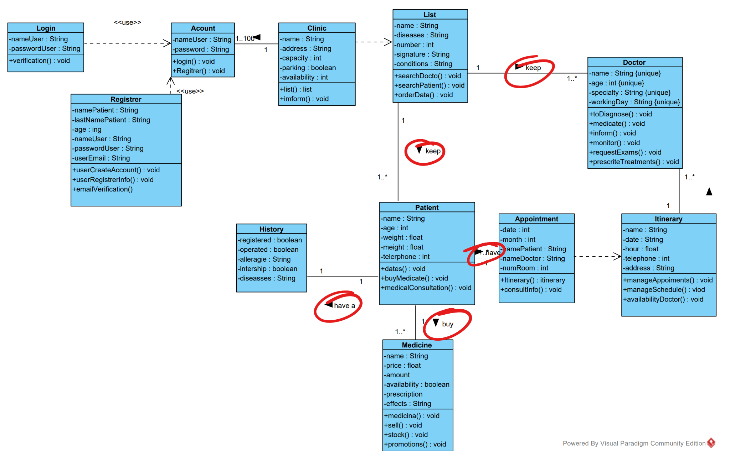

3.-classes

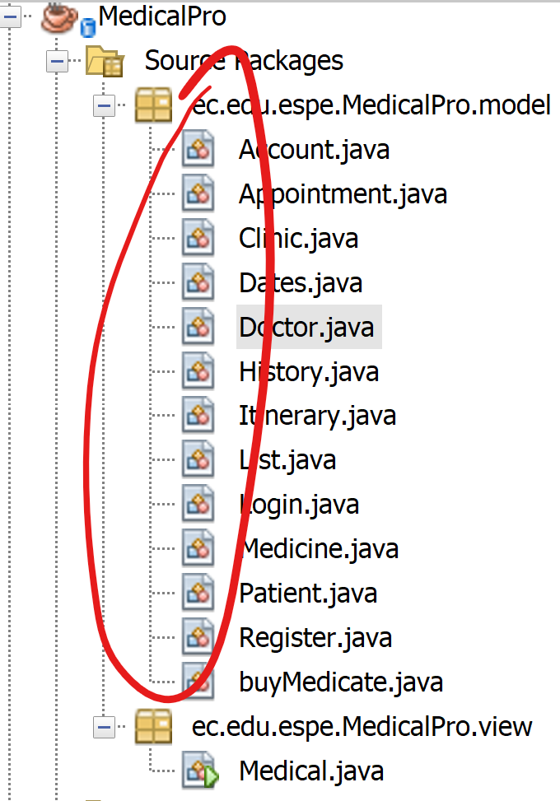

4.- code quality

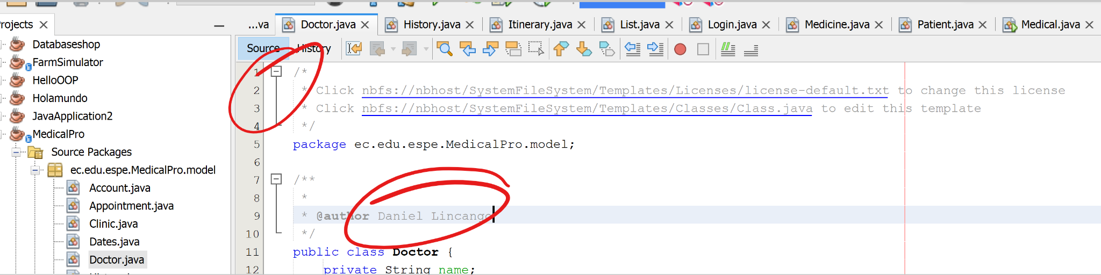

5.- execution

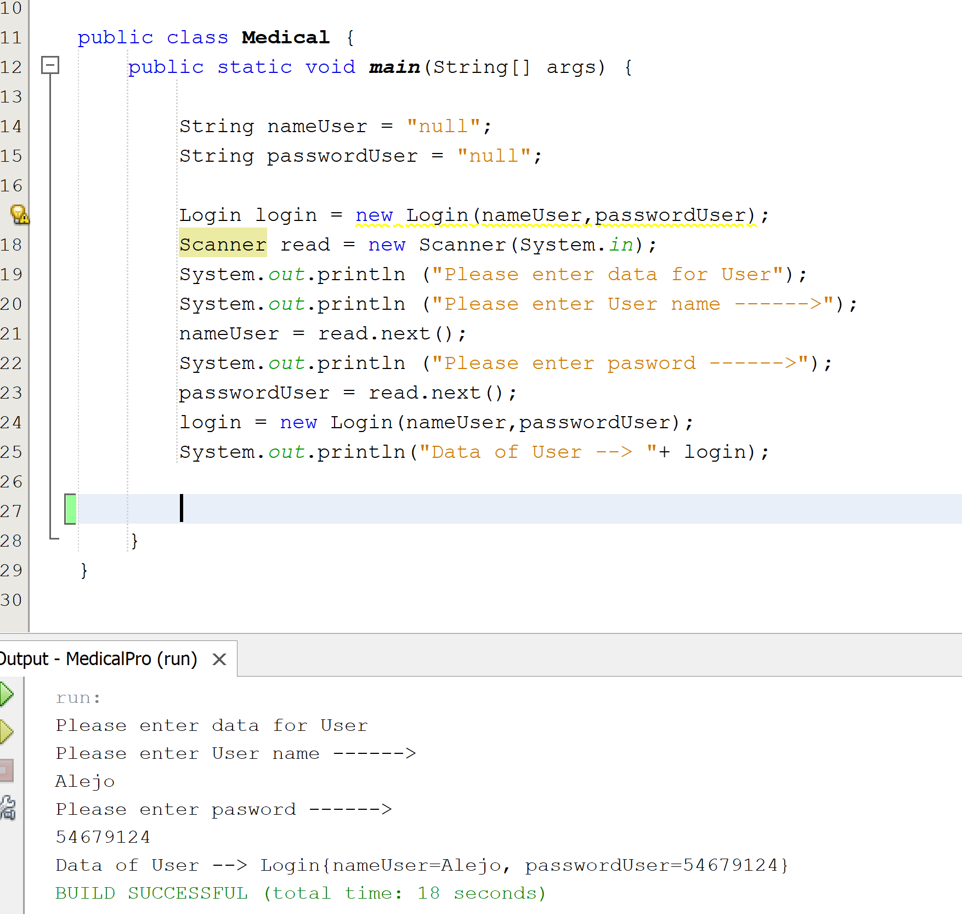

Methods should be verbs

The associations are not in the third person

Team4: The ½ Java programmer’s  
URL: <https://github.com/Aleshuga1020/ProjectValid.git>

Inspectors: Team 04 Alejandro De La Cruz

21 GUITARRA SANCHEZ JHON ALEXANDER 40

22 GUZMAN LOPEZ JOSE DAVID 20

23 INSUASTI LOPEZ JONATHAN ESTEBA 10

24 LANDAZURI SEGOVIA MATEO ISRAEL 10

25 LINCANGO CRIOLLO JOSE DANIEL 10

Team 6: Pro Java Developers

Inspectors: Team05 -Jhon Guitarra

https://github.com/LeonelFMantuano18/Team06_ProJavaDevelopers.git

26 MAISINCHO PAUCAR RICHAR ALEXANDER 30

27 MALDONADO BASTIDAS MATEO STEFANO 20

28 MANTUANO FERNANDEZ LEONEL FERNANDO 50

29 MORALES CAICEDO ANTHONY JAVIER 20

30 PALACIOS CANDO DIEGO SEBASTIAN 20

2. Requirements 9/10

3. UML Diagram 7,5/10

4. Classes 8/10

5. Code Quality 6.5/10

6. Execution 0/10

_______________________

TOTAL. 31 /50

2. Requirements Inspection

screenshots and errors

The object employees need to be clearly defined

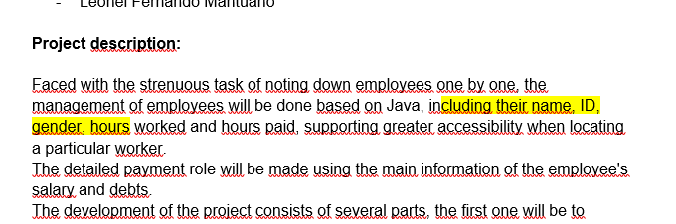

2 Requirements

3 UML Diagram

In plural

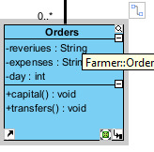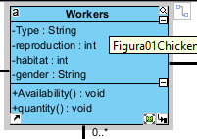

Proyect´s name

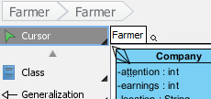

Doesn't existen associated with other classes

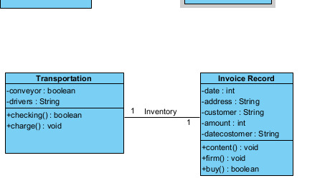

4 Classes

Doesn’t exist this class in the UML



There aren’t this class create in the project

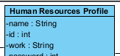

5 Code Quality



missing name of package model

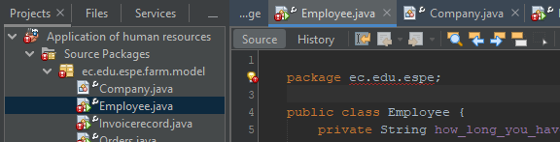

missing view

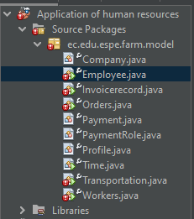

Objects in singular



Must be use camelcase







no execution

