**WS18-JSON**

**DATE: 16th december 2021**

21 GUITARRA SANCHEZ JHON ALEXANDER

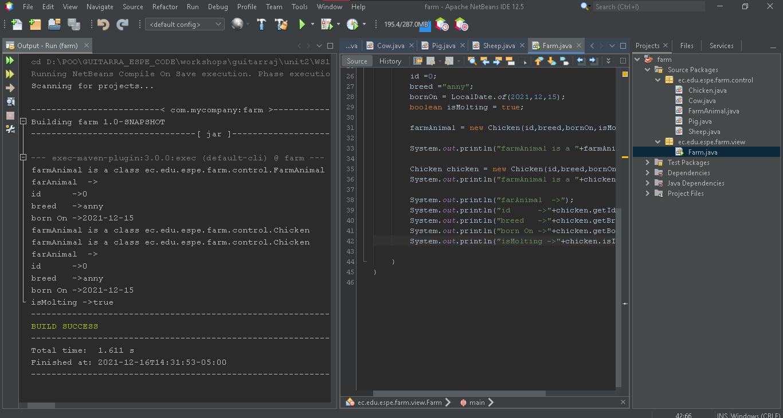  
Inspection :Angel Guaman

{

"position":"001",

"race":"Holstein",

"dateBirth":"12/12/2020",

"produceMilk":"true"

}

{

"position":"002",

"race":"Plymouth",

"dateBirth":"06/27/2020",

"produceMilk":"false"

}

{

"position":"003",

"race":"Dorper",

"dateBirth":"01/30/2019",

"produceMilk":"10/10/2021"

}

{

"position":"004",

"race":"LargeWhite",

"dateBirth":"09/25/2021",

"produceMilk":"50"

}  
  
Calificación 10/10

22 GUZMAN LOPEZ JOSE DAVID

Ispector:Guitarra Jhon

001,Holstein,12/12/2020,True

002,Plymouth,06/27/2020,False

003,Dorper,01/30/2019,10/10/2021

004,Large White,09/25/2021,50

{"Animals":

{

"id":"001"

"name":"Holstein"

"bornday":"12/12/2020"

"isProducingMilk":"True"

}

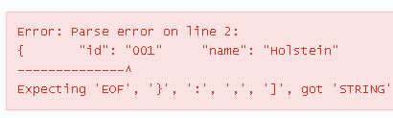

{

"id": "001",

"name": "Holstein",

"bornday": "12/12/2020",

"isProducingMilk": "True"

}

{

"id":"002"

"name":"Plymouth"

"bornday":"06/27/2020"

"isMolting":"False"

}

{

"id":"002",

"name":"Plymouth",

"bornday":"06/27/2020",

"isMolting":"False"

}

{

"id":"003"

"name":"Dorper"

"bornday":"01/30/2019"

"lastshear":"10/10/2021"

}

{

"id":"003",

"name":"Dorper",

"bornday":"01/30/2019",

"lastshear":"10/10/2021"

}

{

"id":"004"

"name":"Large White"

"bornday":"09/25/2021"

"pound":"50"

}

{

"id":"004",

"name":"Large White",

"bornday":"09/25/2021",

"pound":"50"

}

}

grate = 8/10