**Object Oriented Programming**

**WWS 37 - PROJECT INSPECTION**

**DATE: 24th february 2022**

Inspector Team

1 3

2 6

3 9

4 5

5 1

6 8

7 2

8 4

9 7

Modularity /10 packages 7:47-7:52

Clean code /10 variables, vertical/horizontal, CamelCase, nouns, verbs, comments 7:57-8:07

MVC /10 View (no code, calling to functions), Controller/Utils (functions), Model (no BR methods, only attributes POJO) 8:10 - 8:20

One design pattern /10 Singleton, Template Method, Strategy 8:22 - 8:27

Diagrams consistency /10 Use Case -> actions (GUI), Class Diagram -> View, Model 8:27 - 8:37

Unit tests /10 assert(expected,actual) -> 100, run (error (red), green 8:37 - 8:42

GUI navigability /10 navigate to the system options 8:47-8:52

GUI fields validation /10 every TextField must be validated (-1) 8:52:-9:02

Functionality /10 3 to 4 computations, MongoDB Atlas 9:02-9:07

MongoDB /10 Data in the Cloud 9:07-9:12

______________________________

TOTAL /100

Modularity

Clean code

MVC

One design pattern

Diagrams consistency

Unit tests

GUI navigability

GUI fields validation

Functionality

MongoDB

________________________________________________________________________

Inspector: T5 (JavaLegendsTeam) Leader: Guitarra Jhon

Team: T1 (Alpha Team) Leader: Altamirano Cristhian

Project: Smart Home

1 ALMACHE LITARDO ANDERSON MOISES

2 ALTAMIRANO BENALCAZAR CRISTHIAN ALEXANDER

3 ALVAREZ RAMIREZ MICHELLE ESTEFANIA

4 ANDRADE CARATE ALAN DAMIAN

5 ANDRANGO ESPINOSA ALEX PAÚL

Modularity 10/10

Clean code 9/10

MVC 8/10

One design pattern 0/10

Diagrams consistency 8/10

Unit tests 10/10

GUI navigability 10/10

GUI fields validation 10/10

Functionality 10/10

MongoDB 10/10

______________________________

TOTAL 85/100

Modularity

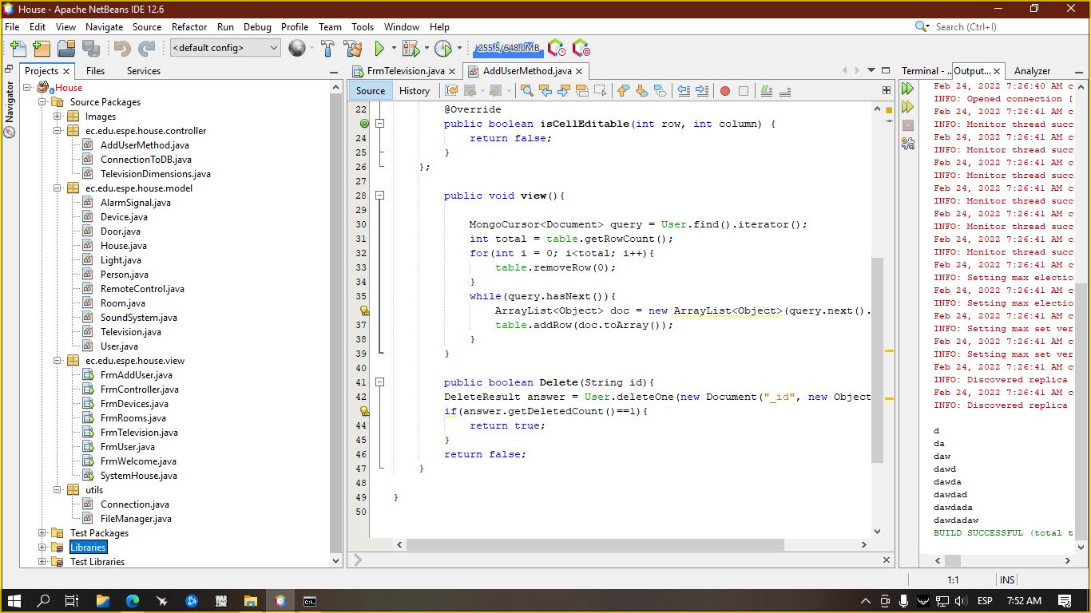

Clean code

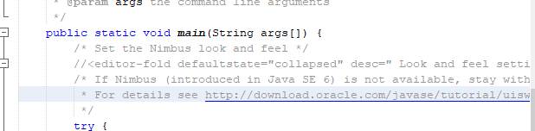

inspector: unremoved comments in code.

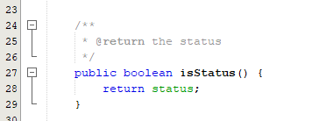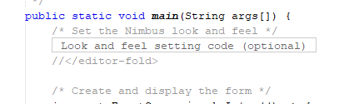

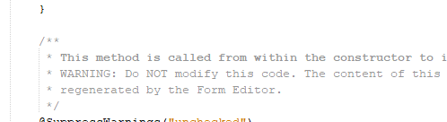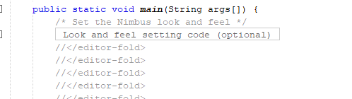

inspector: repeat mistake

MVC

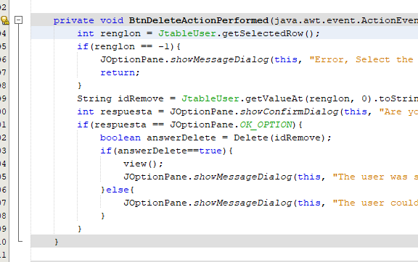

inspector: code in the button.

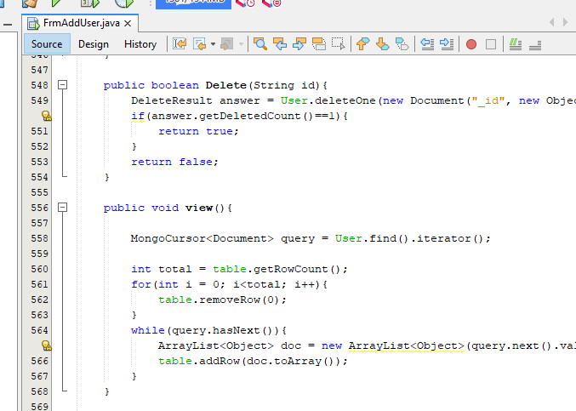}

inspector: Code in Frm(view)

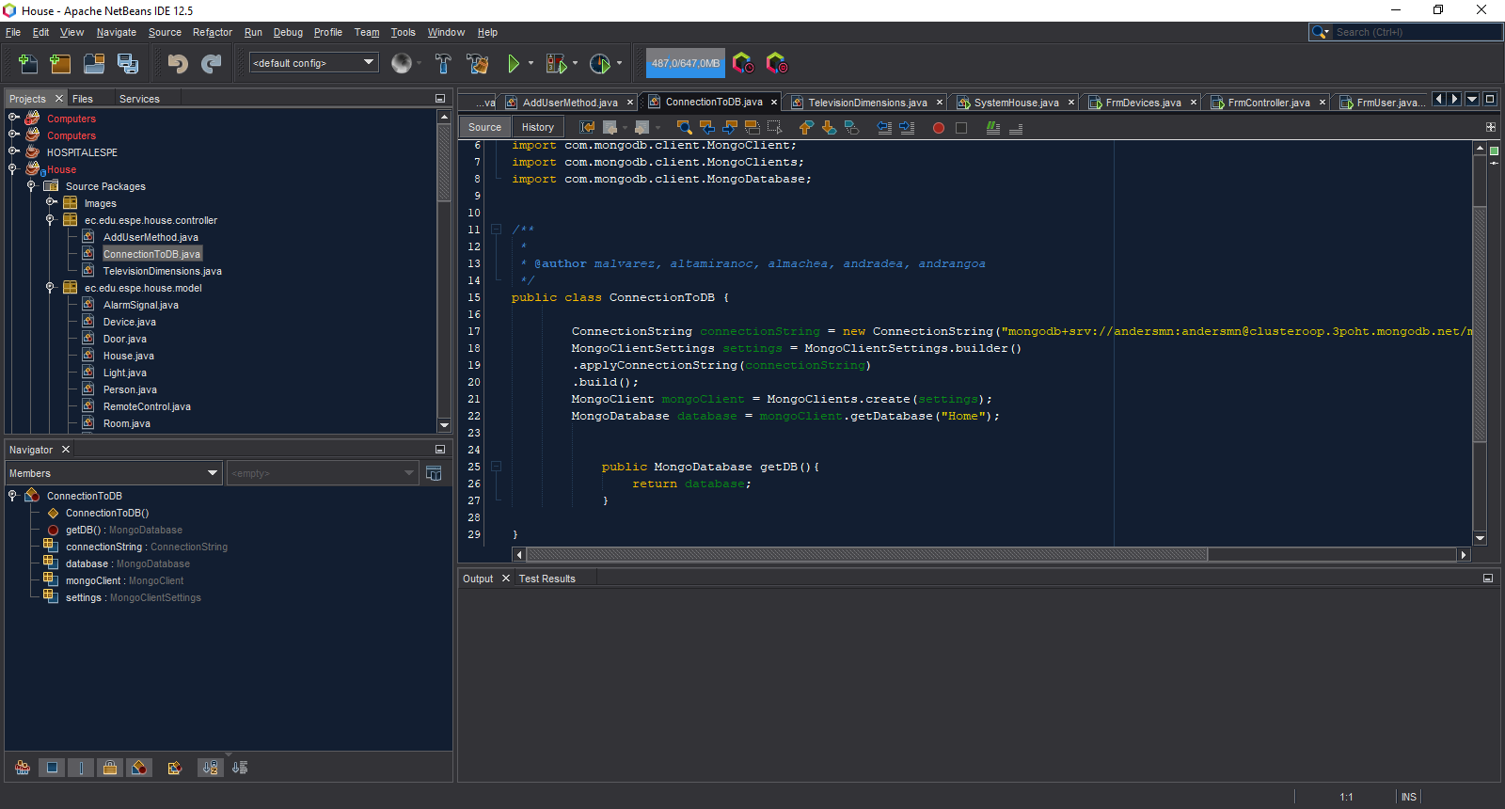

Connection is in the (Controller)

One design pattern

Diagrams consistency

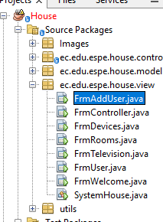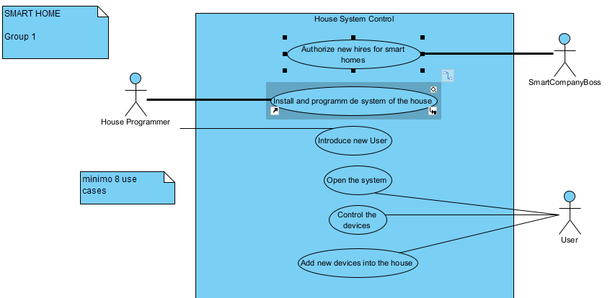

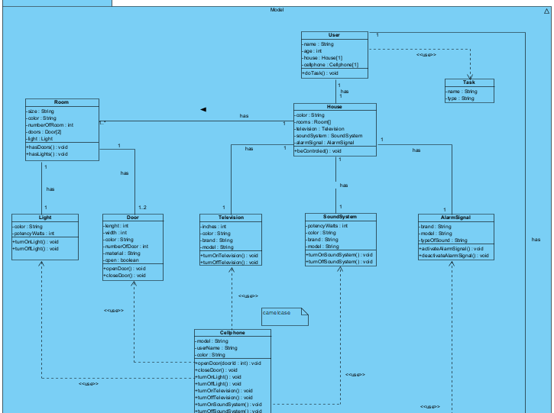

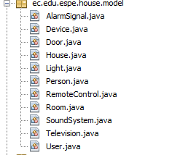

Unit tests

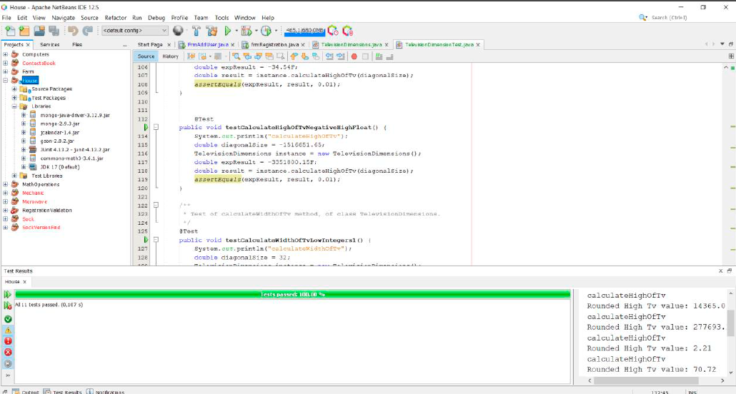

inspector: allp ok

GUI navigability

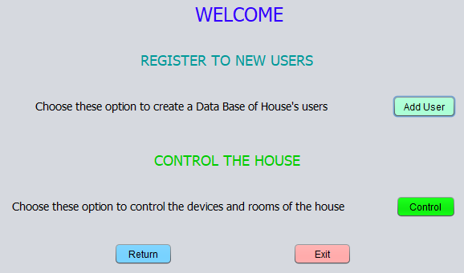

inspector:all OK

GUI fields validation

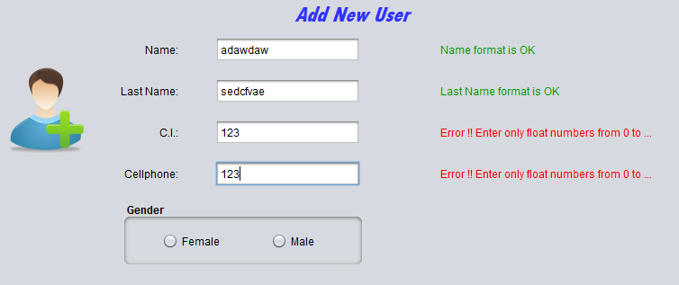

inspector: all OK

Functionality

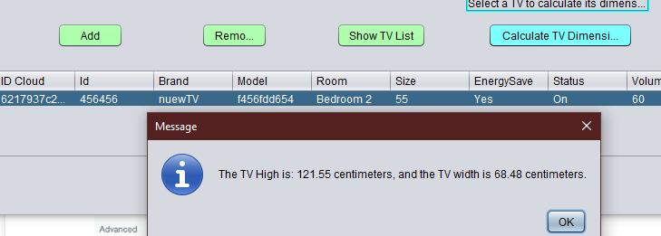

all ok

MongoDB

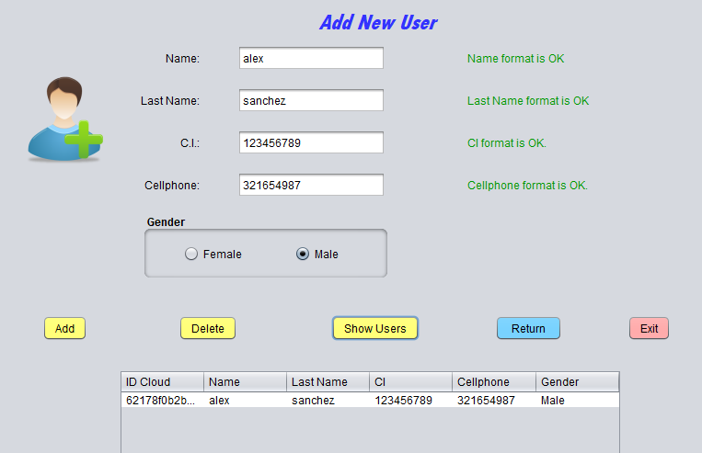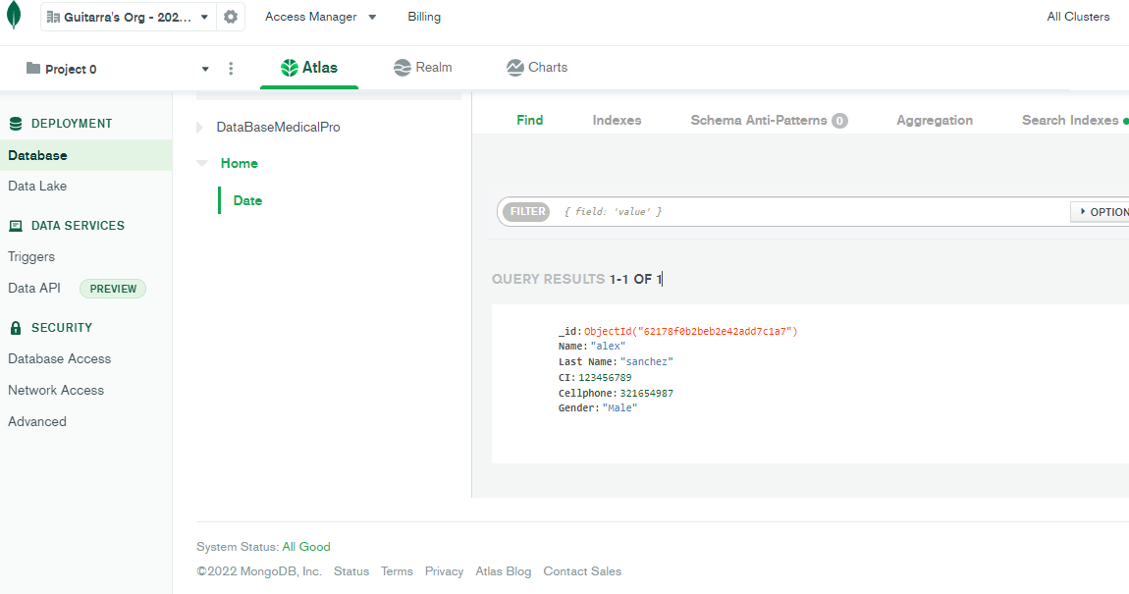

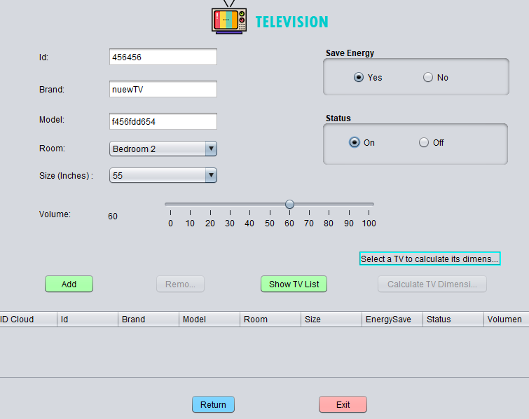

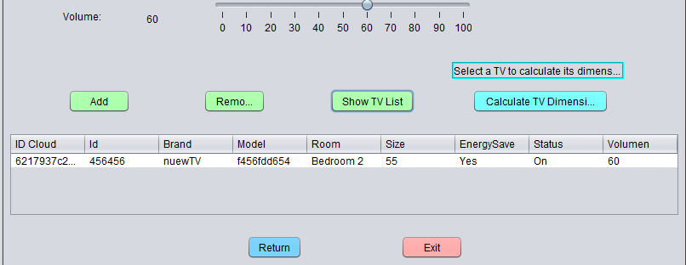

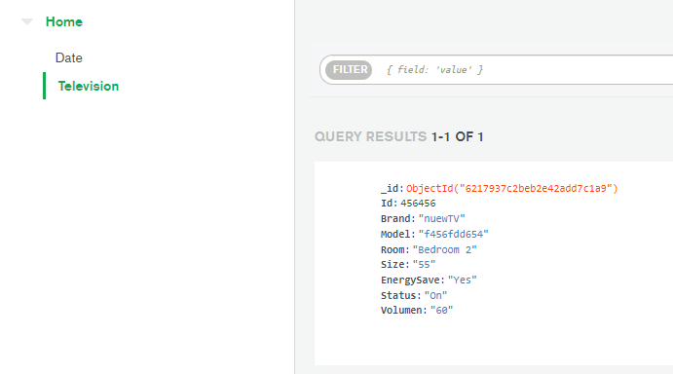

inspector: all OK

Inspector: T4(The ½ java programmer ) Leader:De la Cruz Alejandro

Team: T5 (JavaLegends) Leader. Guitarra Jhon

Project: MedicalPro

21 GUITARRA SANCHEZ JHON ALEXANDER

22 GUZMAN LOPEZ JOSE DAVID

23 INSUASTI LOPEZ JONATHAN ESTEBA

24 LANDAZURI SEGOVIA MATEO ISRAEL

25 LINCANGO CRIOLLO JOSE DANIEL

Modularity 9/10

Clean code 8/10

MVC 10/10

One design pattern 0 /10

Diagrams consistency 7.5/10

Unit tests 10/10

GUI navigability 9/10

GUI fields validation 0/10

Functionality 10/10

MongoDB 10/10

______________________________

TOTAL 73.5/100

**MODULARITY**

*It has a package of more than one, it does not comply with the concept of modularity.

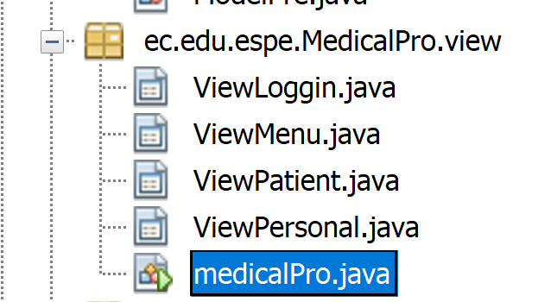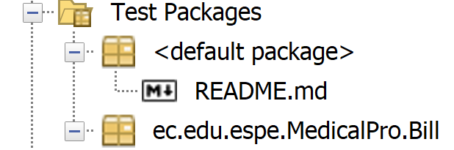

**CLEAN CODE**

* The names of the classes are not understandable, does not comply with the concept of clean code

* The medical pro class is not in the package it should be.  
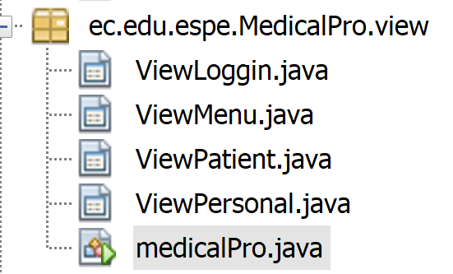

**MODEL, CONTROLLER AND VIEW**

All is it ok.

**ONE DESIGN PATTERN**

DOES NOT HAVE

**DIAGRAMS CONSISTENCY**

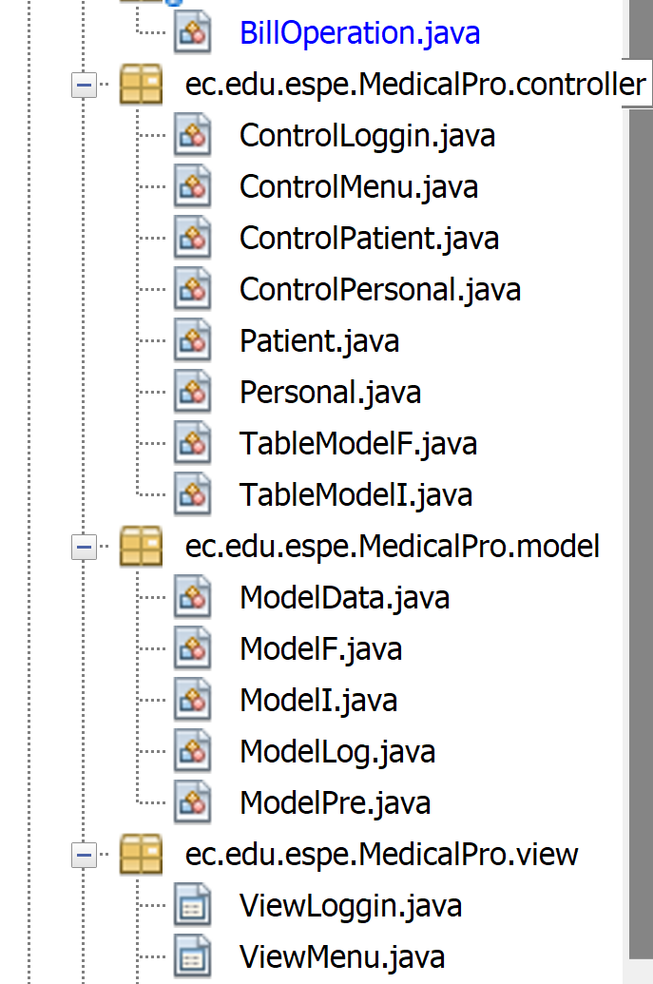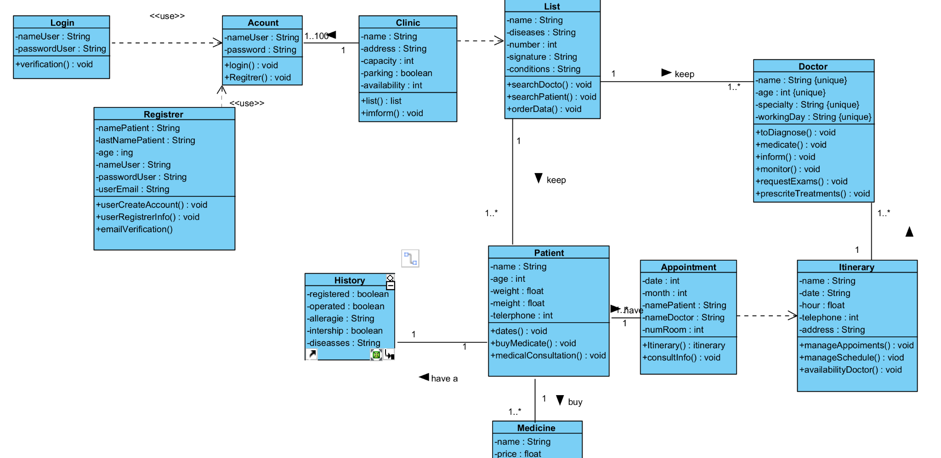

**UNIT TEST**

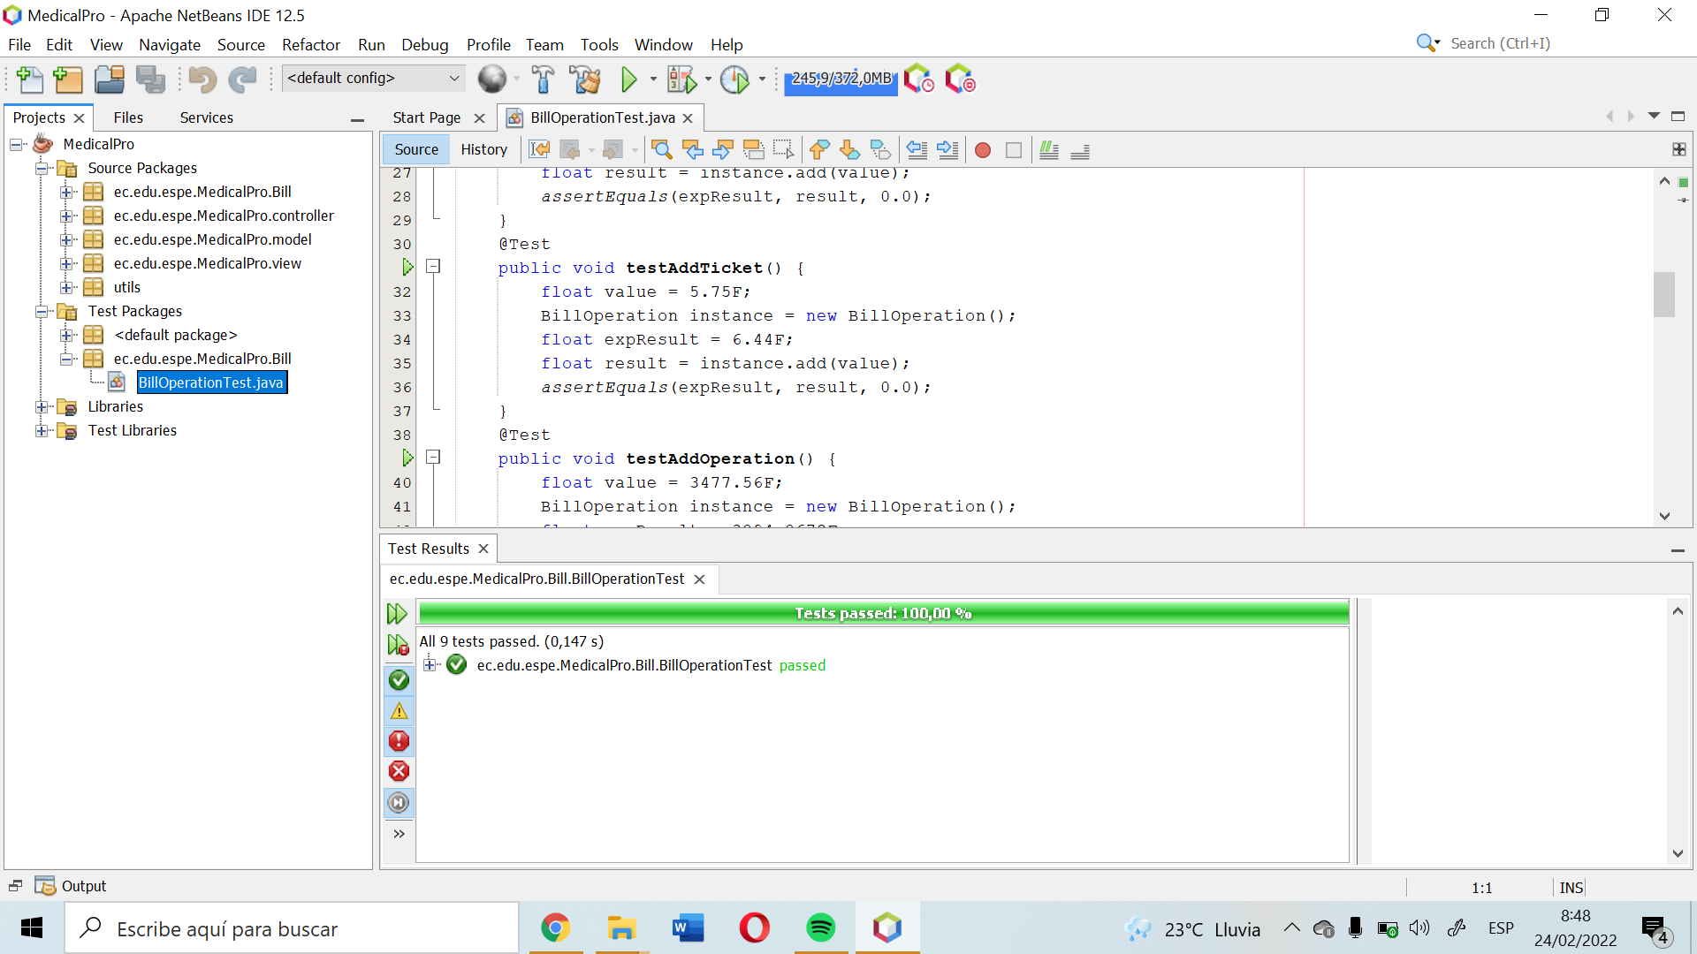

**GUI NAVIGABILITY**

its Ok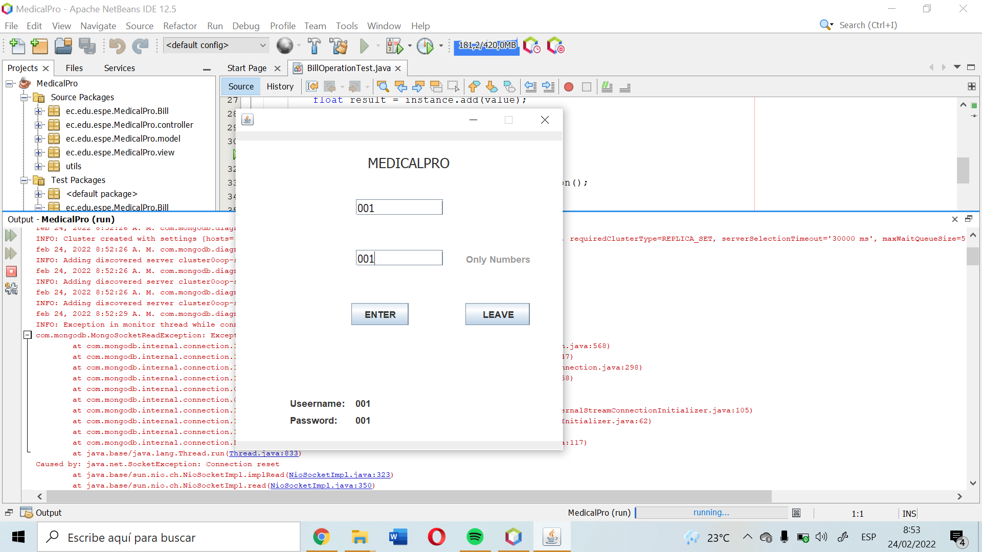

*Error inconsistency

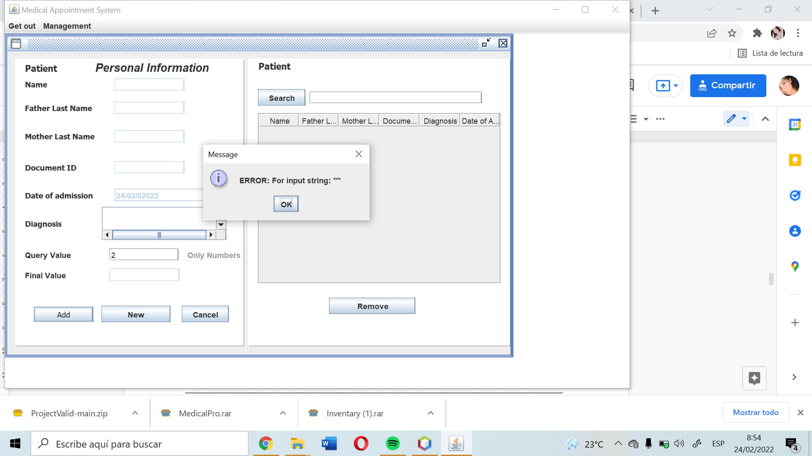

**GUI FIELDS VALIDATION**

*all right, if you add the data

