**WS39 - EXAM REVIEW**

**DATE: 02th march 2022**

21 GUITARRA SANCHEZ JHON ALEXANDER

Inspector: Angel Guaman

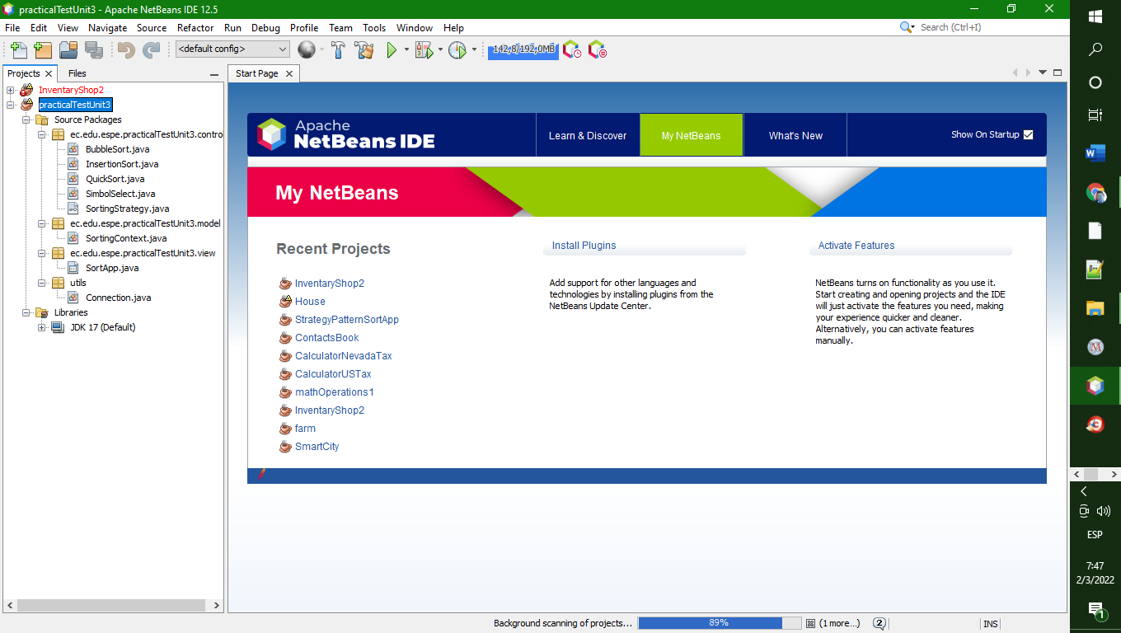

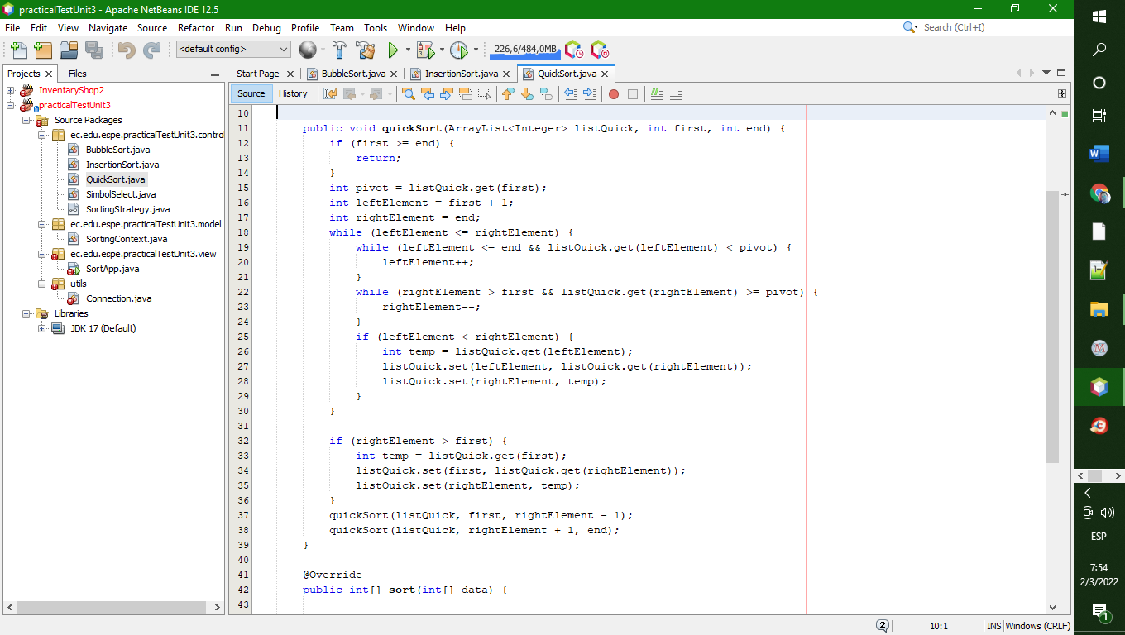

Strategy pattern:..........10/10

GUI:..............................10./10

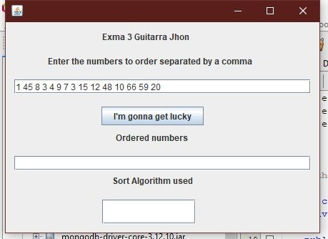

working algorithms:.....8/10

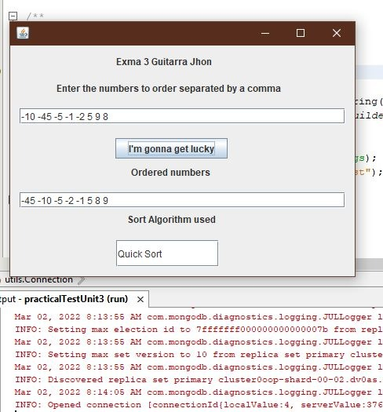

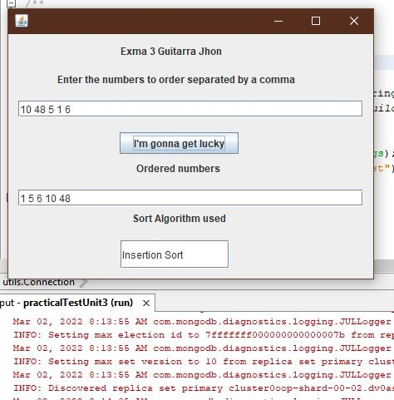

Clean code/principles:.9.5/10

JSON MongoDB:..........10/10

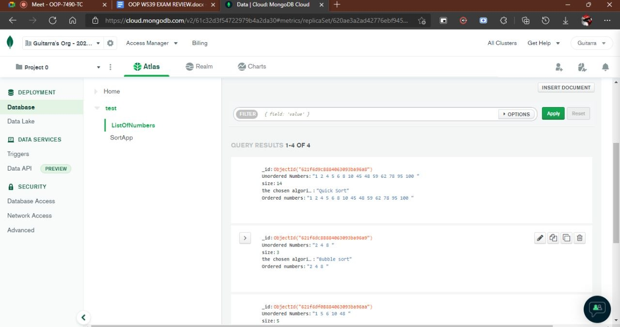

__________________________

TOTAL 47.5 /50

Strategy pattern

GUI

working algorithms

Clean code/principles

JSON MongoDB

22 GUZMAN LOPEZ JOSE DAVID

inspector : Guitarra Jhon

Jhon

Strategy pattern:..........10/10

GUI:...............................10/10

working algorithms:.....0/10

Clean code/principles:.8/10

JSON MongoDB:..........7.5/10

__________________________

TOTAL 35.5/50

Strategy pattern —---10/10

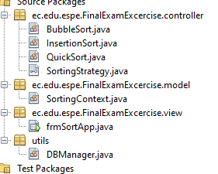

all ok

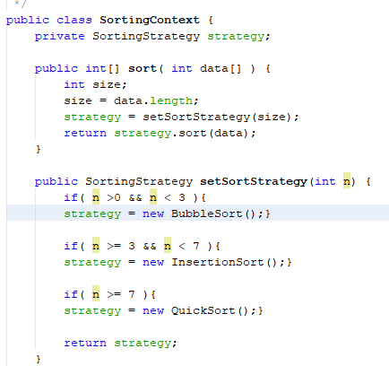

all ok

GUI…../10

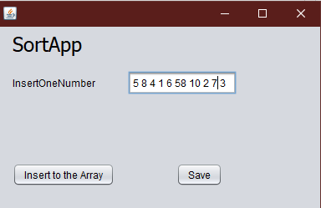

working algorithms……..0/10

Clean code/principles………..8/10

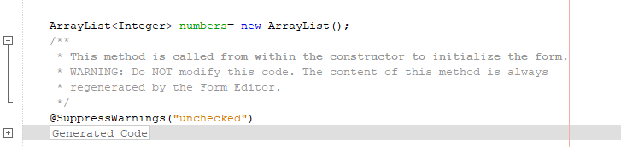

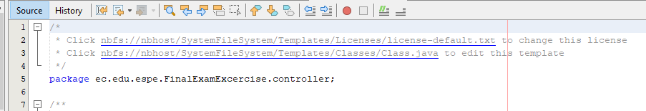

instructor: undeleted comments

JSON MongoDB………10/10

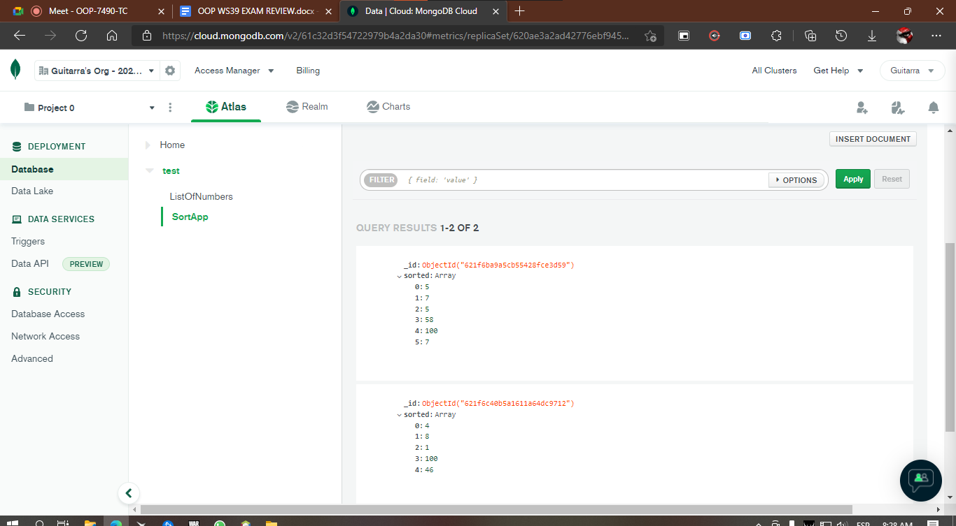

instructor: connection with mongo, all OK