**HWS09 OAUTH**

**JONATHAN ISMAEL ZAPATA SANDOVAL**

**OAUTH**

Open Authorization Performs Authorizations Or Accesses To Conte Users Also Hides The Credentials Of OTHER Users, Send Authorization Information Between Different Applications, Without Exposing The Data Of Any User, Also

It prevents us from being able to log in very easily on different websites, the condition for this to execute is within the https protocol, and

Redirects the User to the Client Application with an Access Code.

Oauth Allows Partial Access from one application to another, which is responsible for transforming it into an access token, finally

It is a great advantage in terms of access to services for the user (web pages and videogames).

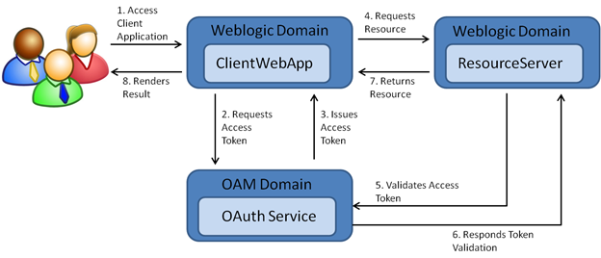

Reference:

[OAuth 2.0 (oracle.com)](https://docs.oracle.com/cd/E82085_01/160027/JOS%20Implementation%20Guide/Output/oauth.htm)