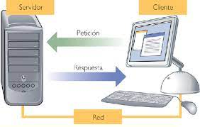



URI: [http://localhost:8080/MalteComputers/webresources/computers/{id}](http://localhost:8080/MalteComputers/webresources/computers/%7bid%7d)