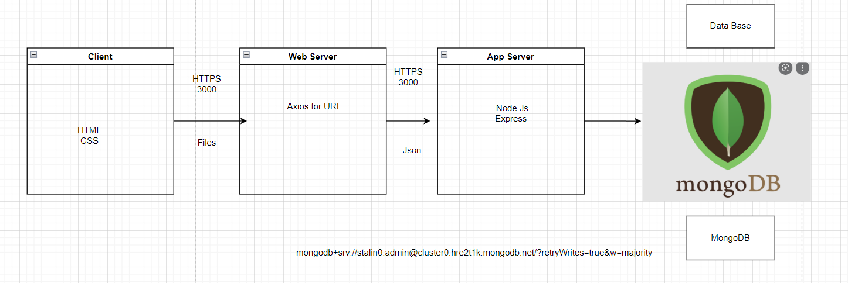

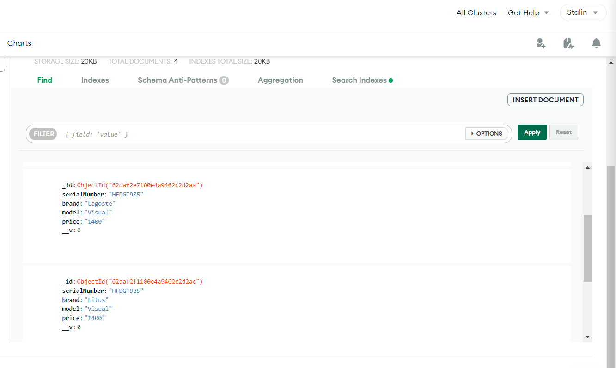

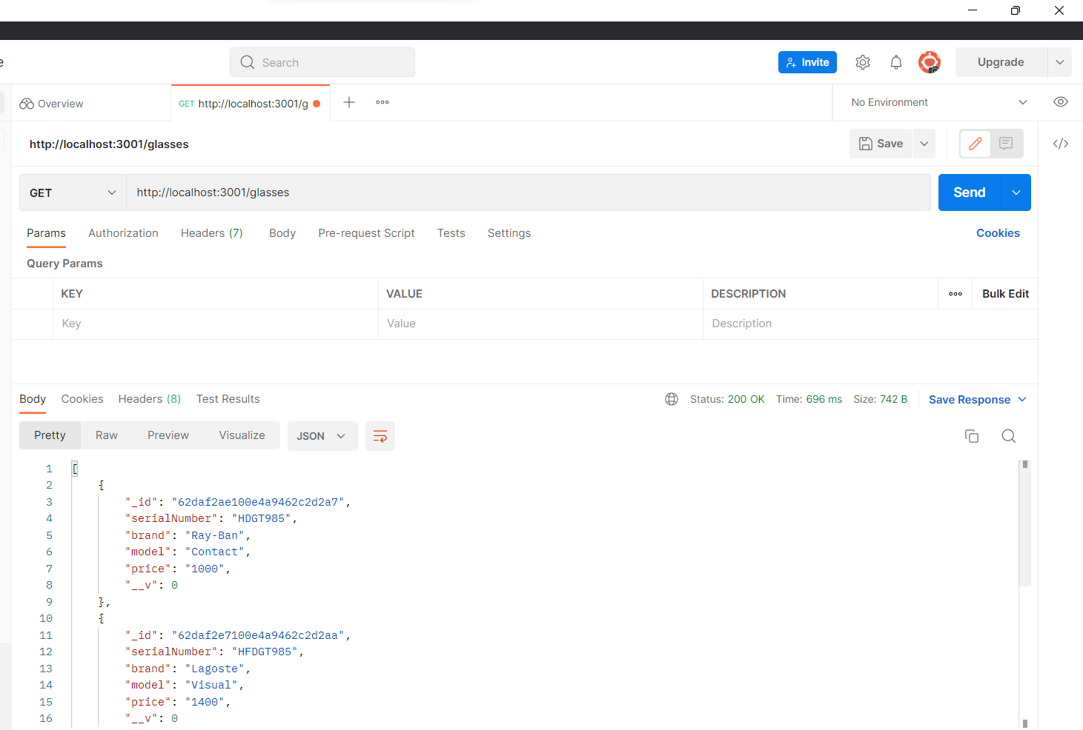

|  |  |
| --- | --- |
| **URI** | http://3.82.230.29:3001/glasses |
| **METHOD** | READ |
| **REQUEST** | N/Aipconfig |
| TYPE | JSON |
| **RESPONSE** | **200** |
| PARAMS | N/A |
| BODY | {      "_id": "62daf2ae100e4a9462c2d2a7",      "serialNumber": "HDGT985",      "brand": "Ray-Ban",      "model": "Contact",      "price": "1000",      "__v": 0    } |

