Edison Vaca NRC 5119

Date: 01/06/2022

1. **Architecture desing**

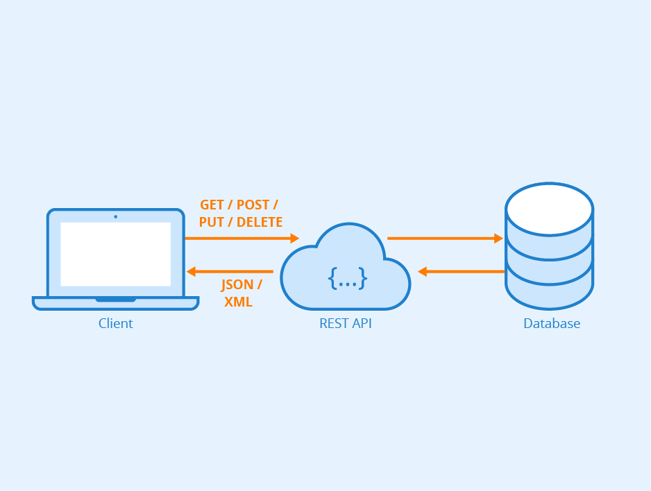

**MongoAtlas**

**JSON**

**GET**

1. **URIs**

<http://192.168.0.103:8080/WebCompany/webresources/student>

[http://192.168.0.103:8080/WebCompany/webresources/student/{idStudent}](http://192.168.0.103:8080/WebCompany/webresources/student/%7bidStudent%7d)