**Name:** Steven Cardenas

**GitHub:** [**https://github.com/elascano/ESPE202205-WEB-TI-5450/tree/main/exam2/cardenas**](https://github.com/elascano/ESPE202205-WEB-TI-5450/tree/main/exam2/cardenas)

**Code screenshots:**

-index.js

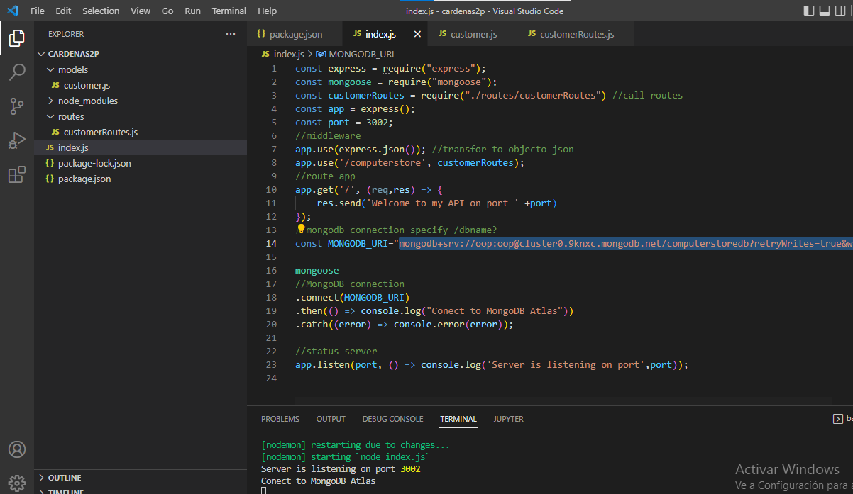

-model: customer.js

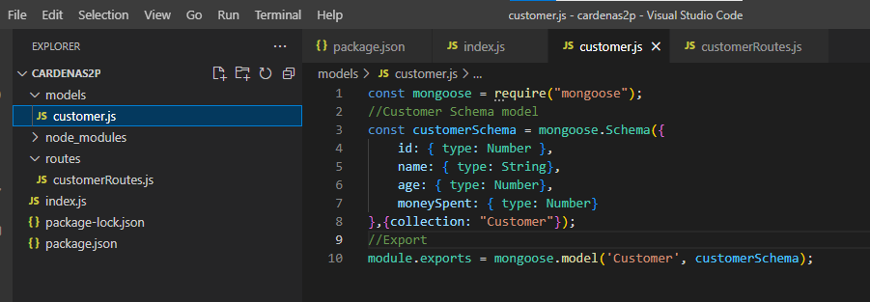

-routes:customerRoutes.js

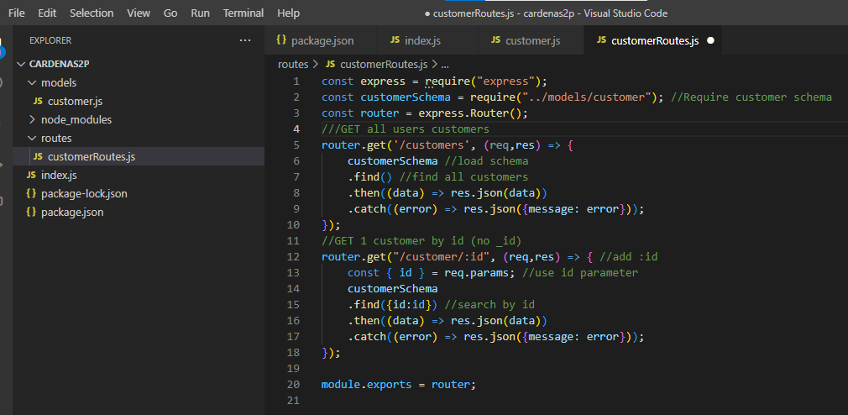

**Run screenshoots**

-Server running:

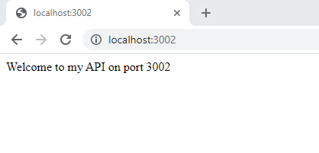

-Get all

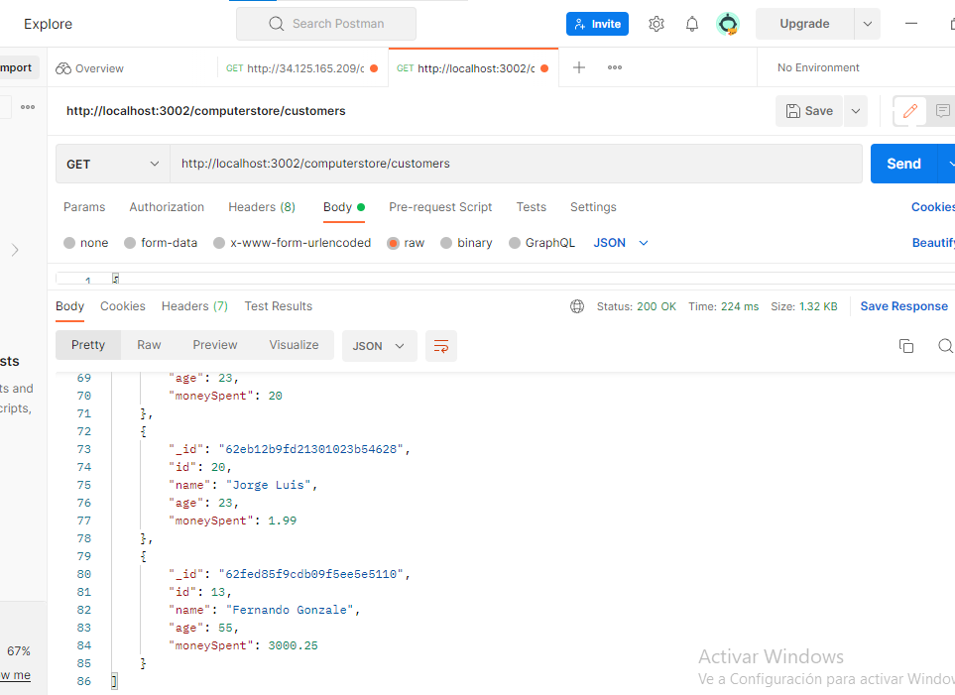

Get customer by id:

