

**Name:** Santiago Alejandro **Last Name:** Cuadrado Avilés

**Nrc:** 8399 **Date:** 10/02/2023

**Theme:** CHATGTP

**Definition**

Chat GPT is a language model developed by OpenAI, an artificial intelligence research organization based in San Francisco, California. It was founded in 2015 by a group of AI researchers and entrepreneurs including Elon Musk, Sam Altman, and Greg Brockman.

**Functioning**

Chat GPT is a project that is about an artificial intelligence with more than 175 million text data that includes books, articles, news, conversations, among others, which are used to teach the model how to understand and generate text in a way consistent, in such a way that you just ask it questions in the usual way and it understands them, this makes it a very useful tool for a variety of applications, such as generating answers automatically in chatbots or improving the accuracy of inquiry systems. information, it can also learn from the conversation patterns of users to provide even more appropriate answers, in addition to these functions it can also be useful for different areas such as generating reports and data summaries more efficiently where engineers can meet support of this system and can make the results of its analyzes more effectively understood and communicated, generate code go for data analysis applications, thus generating code in different programming languages, among other functions that make this system so interesting.

There are four key points within this GPT Chat language model that can be used:

* Text generation: It can be used to generate coherent and natural text of any type.
* Improved accuracy in search systems: Help improve accuracy in information search systems, since it can understand the context.
* Chatbot development: It can be used to develop chatbots that can have natural conversations with users, consistently and accurately answering their questions.
* Improved natural language processing: Improves natural language processing in various applications.

In conclusion, GPT chat is a very interesting and beneficial tool for the creation of chatbots and conversational agents, which is based on a huge network trained with a wide variety of data to simulate human language in a much more natural and exact way without the need for a detailed program of rules.

**Example**

**Question:** I am a Betic fan. Create a two-sentence story on this topic: Derby Real Betis vs. Sevilla CF

**Answer**: The Real Betis vs Sevilla CF derby had always been a passionate match, with fans yelling at each other and flags waving in the air. But this time, when Real Betis won in spectacular fashion, it was said that one could hear the wailing of the spirits of former Sevilla fans who had been forever cursed to wander the stadium, watching their team lose time and time again.

My Example

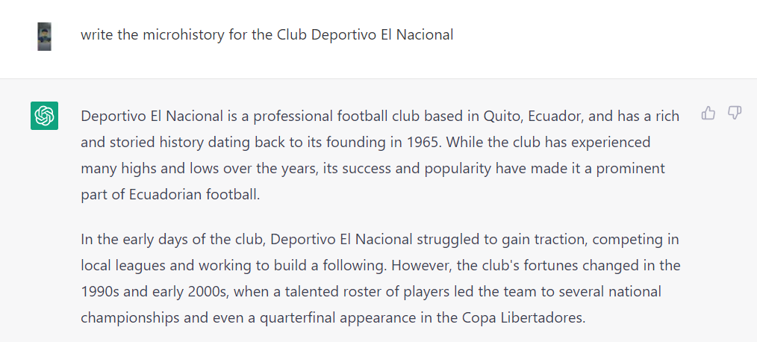

**REFERENCES**

* White, M. J. (2022, diciembre 9). Top 10 most insane things ChatGPT has done this week. *Springboard Blog*. https://www.springboard.com/blog/news/chatgpt-revolution/
* Rey, A. (2022, December 28). 25 tasks that I have tried with #ChatGPT: examples and results - Amalio Rey. Amalio Rey | Innovation blog with a humanist look. <https://www.amaliorey.com/2022/12/28/25-tareas-que-he-probado-con-chatgpt-> exemples-y-resultados/
* Pocock, K. (2023, febrero 9). *What Is Chat GPT? - what is it used for?* PC Guide. https://www.pcguide.com/apps/what-is-chat-gpt/