**TEAM 2**

1. Galarza Luis 10 10
2. Ludeña Edison 10 10
3. Miranda Alison 10 10

INSPECTOR: TEAM #1

***SOLID PRINCIPLES THAT ARE USE***

* **Class Connection**

Has single responsibility manages connection with MongoDB Database.

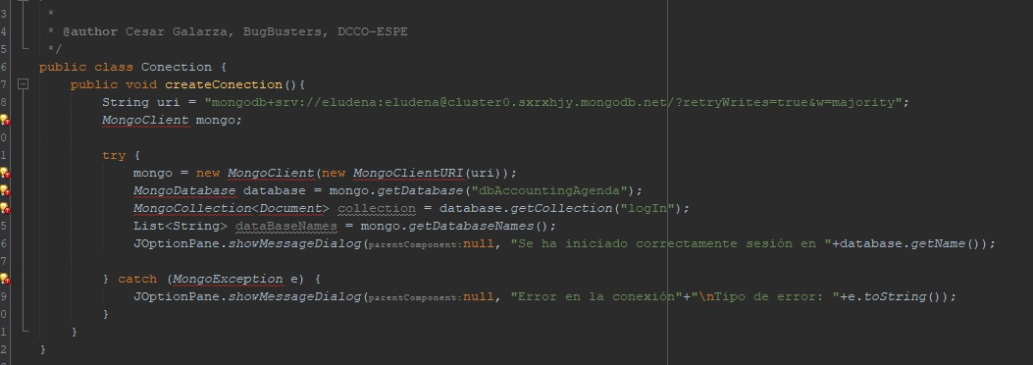

* **Class CostPerMeter**

Has single responsibility give information about the cost per square meter and give methods to access and edit that information.

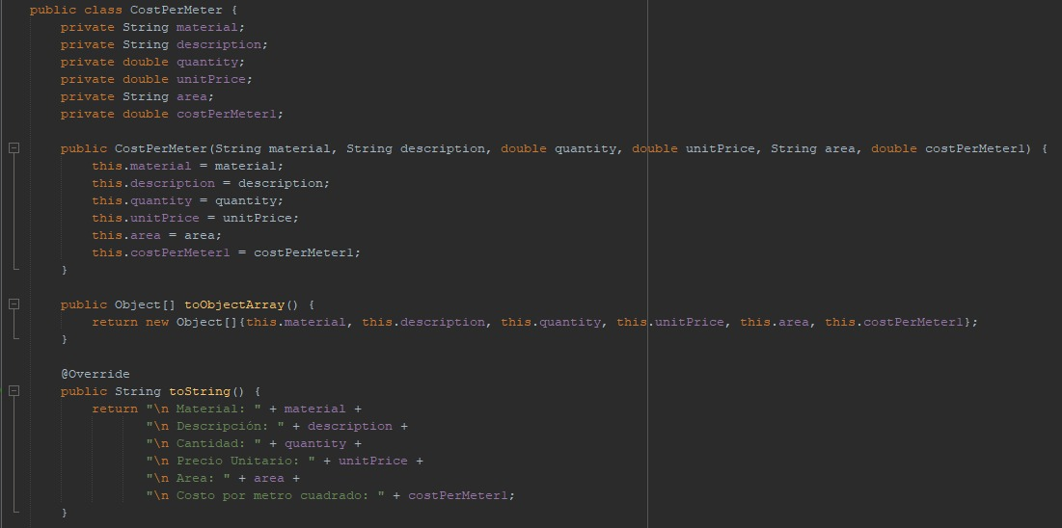

* **FrmBudget Class - Method addBudget()**

Has single responsibility, because make what needs to be made

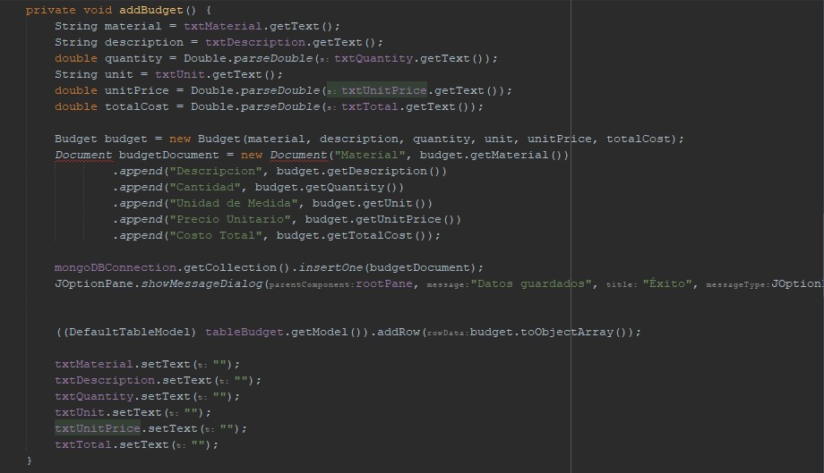

* **FrmBudget Class - Method addBudget()**

Has open/close, because can be used in other parts of the code, but can’t be modified.



* **Class TextPrompt**

Has single responsibility, because the main purpose is to manage and show the help text.

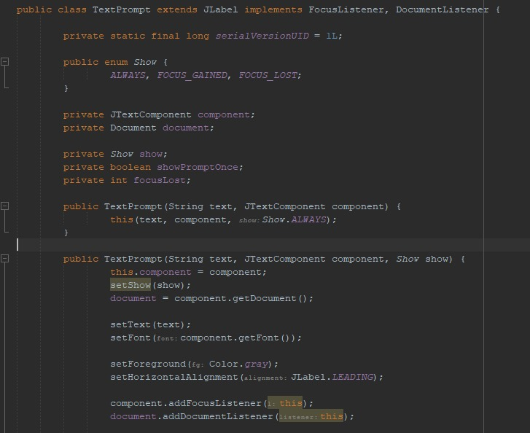

***SOLID PRINCIPLES THAT ARE NEED***

We can’t find more principles that the team can use.