**TEAM 1**

1. Báez Gabriel
2. Calderón Jilmar
3. Calvache Gabriel
4. Casignia Diego

Evidence with client:

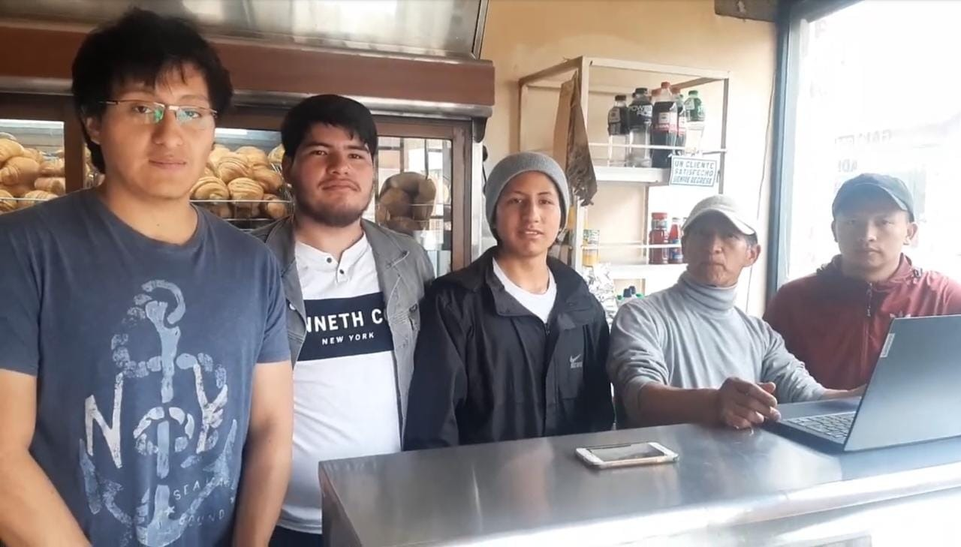

Evidence with work team:

