**Object-Oriented Programming**

**HomeWork #23**

**DATE: 14/08/2023**

**NRC: 9652**

**TEAM 2**

1. Galarza César
2. Ludeña Edison
3. Miranda Alison

Evidence with client:

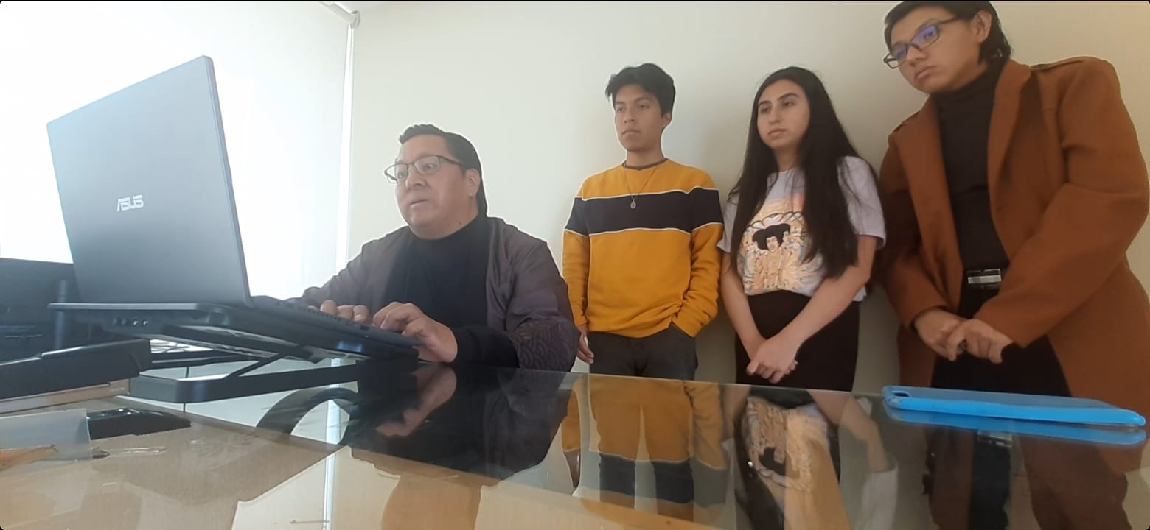

Evidence with work team:

