**UNIVERSIDAD DE LAS FUERZAS ARMADAS - ESPE**

DEPARTAMENTO DE CIENCIAS DE LA COMPUTACIÓN

**OBJECT ORIENTED PROGRAMMING**

**NRC: 9652**

**WORKSHOP #12**

DATE: 06/06/2023

DUE: 11pm

**Rubric**

Presentation

0.- GitHub /100

1.- Interview and Presentation /10 9:20 - 9:25

2.- Project definition /10

3.- Software Requirements /10

4.- Use Case /10

5.- Class Diagram /10

6.- Data files /10

7.- Execution /10

8-10.- Clean Code /30

TOTAL /100

**Evidence**

GitHub

1.- Interview and Presentation

2.- Project definition

3.- Software Requirements

4.- Use Case

5.- Class Diagram

6.- Data files

7.- Execution

8-10.- Clean Code

1. MORENO NAVARRETE PAUL SEBASTIAN
2. PASQUEL RUIZ JUAN DAVID
3. RAMOS YANCHALIQUIN SEGUNDO JAVIER
4. RUEDA VILATUÑA JUAN SEBASTIAN

Presentation: 5/10

**Rubric**

Presentation

0.- GitHub /100

1.- Interview and Presentation 10/10

2.- Project definition 10/10

3.- Software Requirements 8/10

4.- Use Case 7/10

5.- Class Diagram 8/10

6.- Data files 6/10

7.- Execution 4/10

8-10.- Clean Code 23/30

TOTAL /100

**Evidence**

GitHub

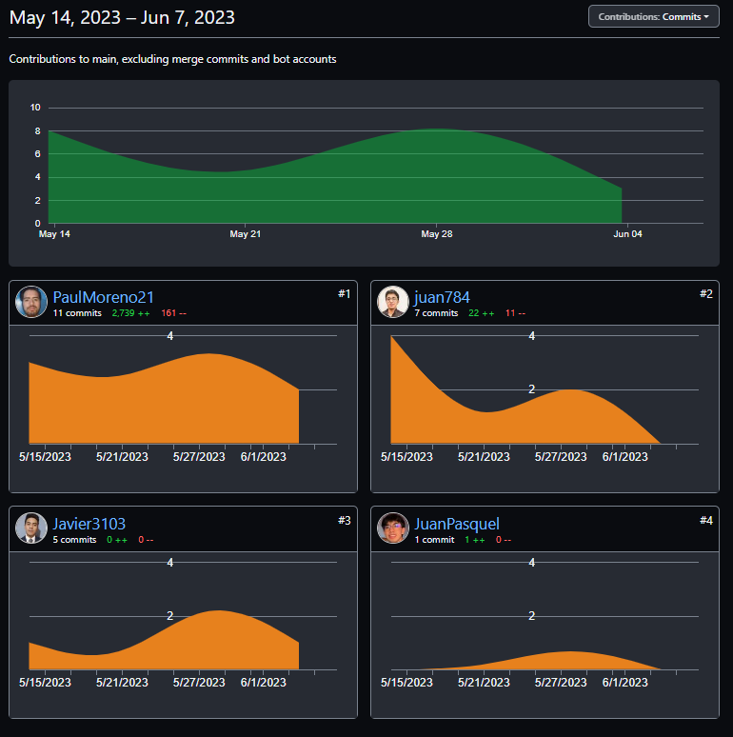

1.- Interview and Presentation

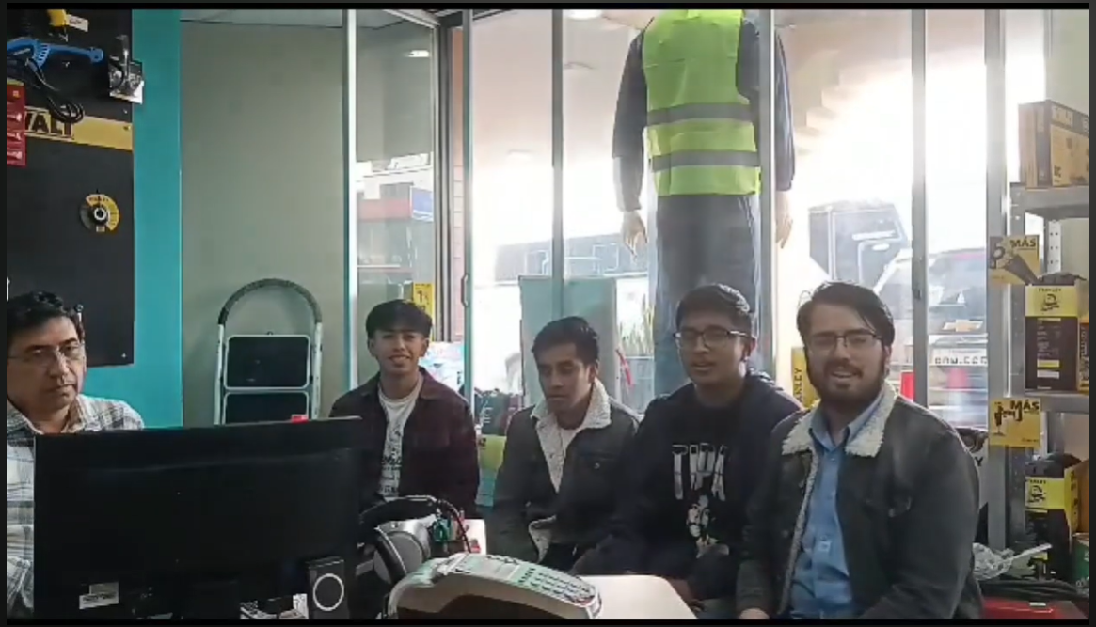

2.- Project definition

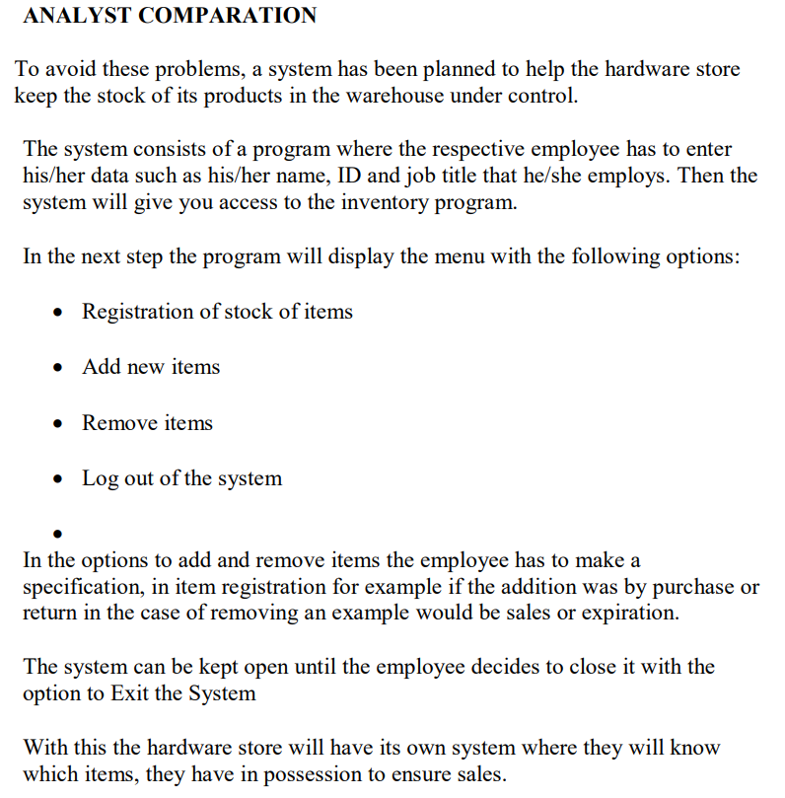

3.- Software Requirements

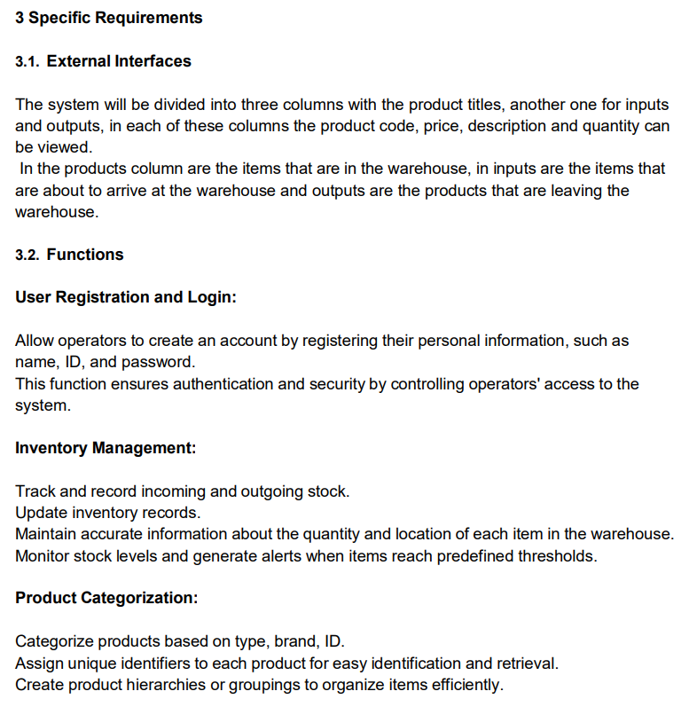

4.- Use Case

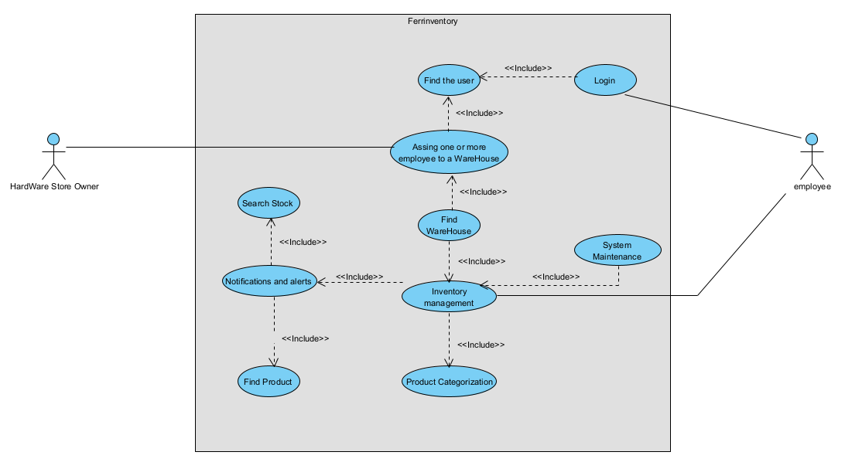

5.- Class Diagram

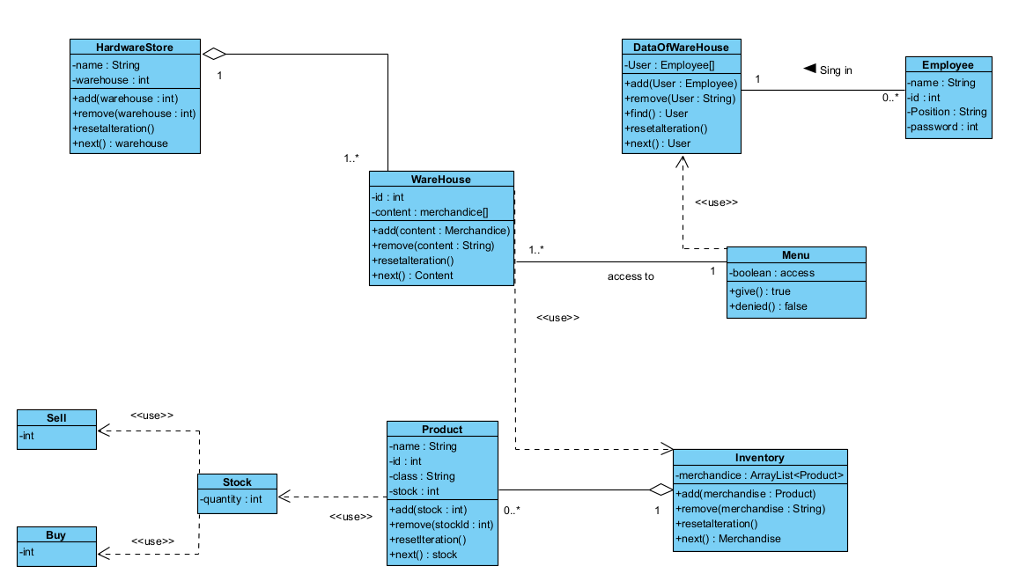

6.- Data files

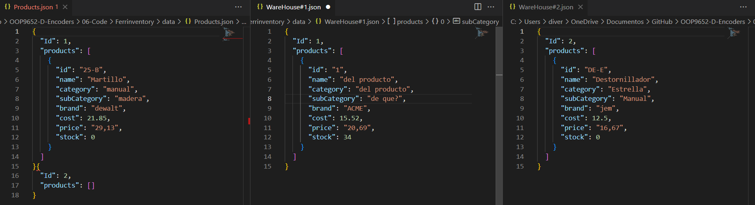

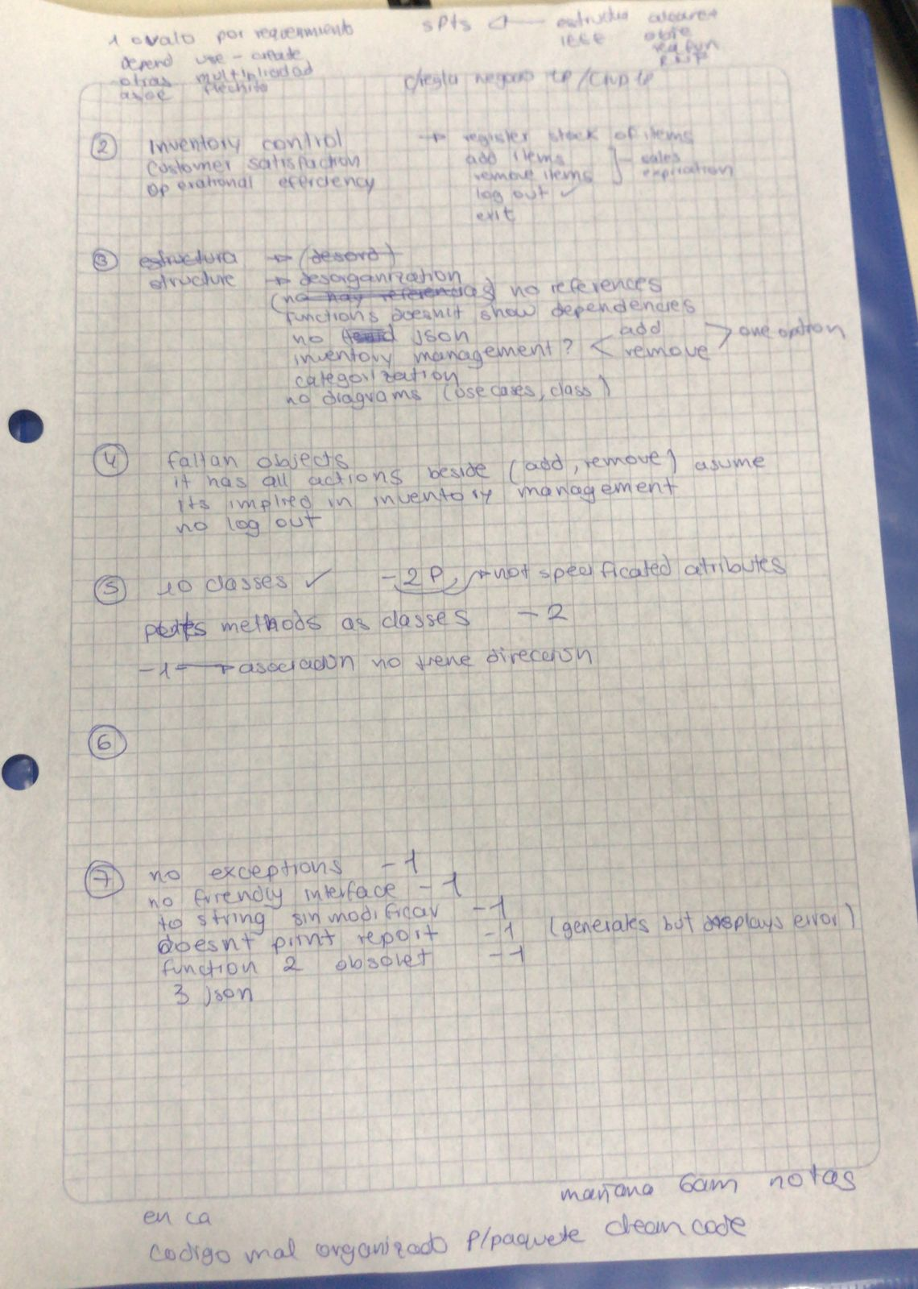

7.- Execution

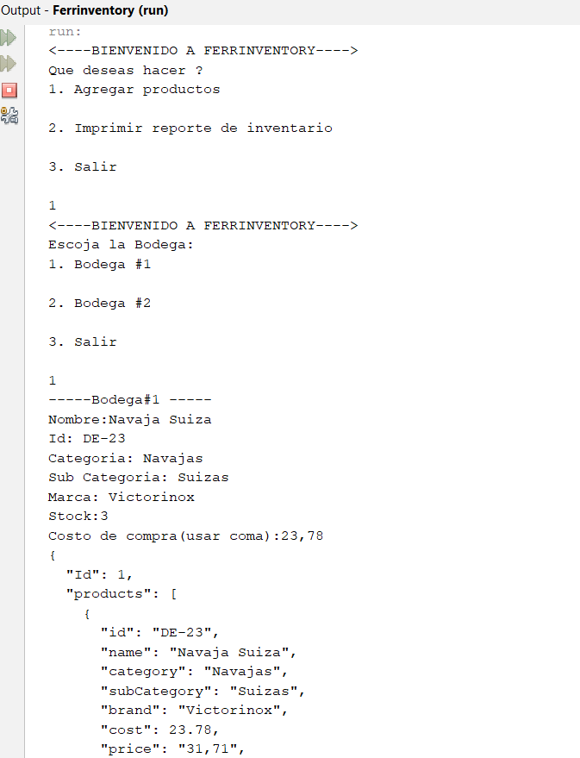

8-10.- Clean Code

● The controller package is used

● The classes “Save” and “RegisterProduct” are verbs.

● Attribute ”products” is in plural

● (Use to String)

● Does not use camelCase in the class “menuproduct”.

● The classes “MenuProduct” and “Ferrinventory” have unnecessary comments.

● Output messages does not reveal intent.