**UNIVERSIDAD DE LAS FUERZAS ARMADAS - ESPE**

DEPARTAMENTO DE CIENCIAS DE LA COMPUTACIÓN

**OBJECT ORIENTED PROGRAMMING**

**NRC: 9652**

**WORKSHOP #13**

DATE: /06/2023

DUE:

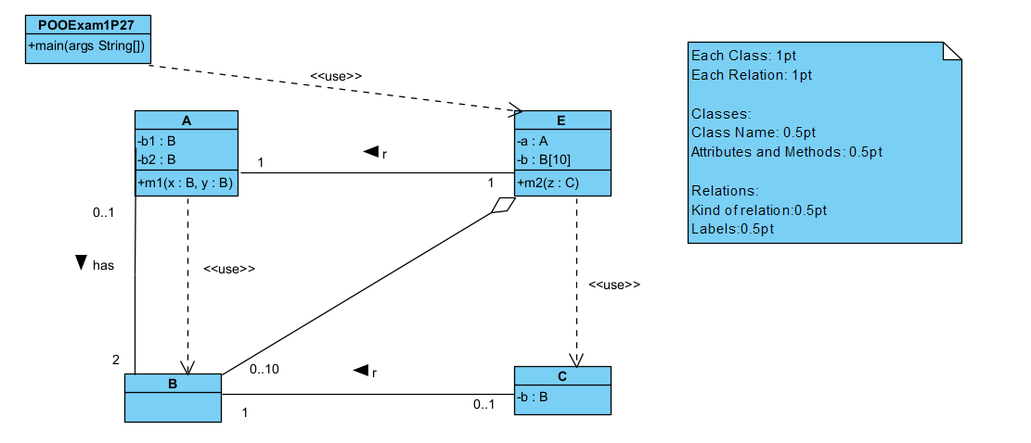

Rubric:

Classes:

POOExam1P27 0.5/1 No attributes and methods

A /1

B /1

C /1

E /1

POO - E /1

A -> B 0/1 No relation, wrong relation

A -> B /1

E -> A /1

E -> B /1

E -> C /1

C -> B /1

TOTAL: 12/10

1. LUDEÑA QUICHIMBO EDISON WILFRIDO

Inspector: César Galarza

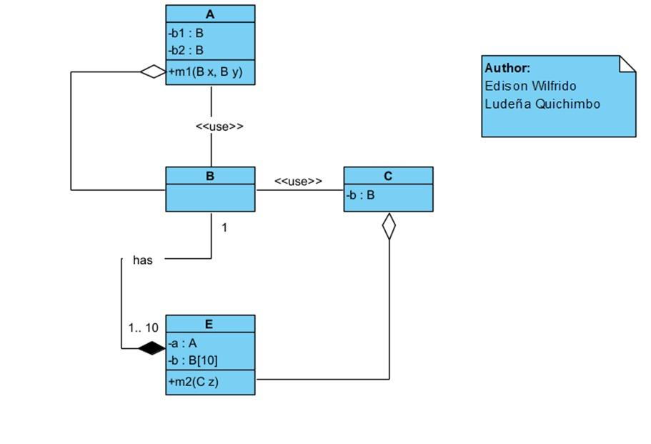

**Rubric:**

**Classes:**

POOExam1P27 0/1 No class

A 1/1 Correct class name - Correct attributes and methods

B 1/1 Correct class name

C 1/1 Correct class name - Correct attributes and methods

E 1/1 Correct class name - Correct attributes and methods

**Relations:**

POO - E 0/1 No relation

A -> B 0.5/1 Correct kind - No multiplicity

A -> B 0.5/1 Incorrect kind - Correct label

E -> A 0/1 No relation

E -> B 1/1 Correct kind - Correct label

E -> C 0.5/1 Incorrect kind - Correct label

C -> B 0.5/1 Incorrect kind - Correct label

**TOTAL: 7/10**