**UNIVERSIDAD DE LAS FUERZAS ARMADAS - ESPE**

DEPARTAMENTO DE CIENCIAS DE LA COMPUTACIÓN

**OBJECT ORIENTED PROGRAMMING**

**NRC: 9652**

**WORKSHOP #14CodingReview**

DATE: /06/2023

DUE:

Rubric:

1) class modeling 10 pts.

2) Running program 10 pts.

3) Printing/counting/deleting objects from JSON File 10 pts.

4) Saving JSON data 10pts.

5) Code Quality 10 pts.

TOTAL: ...................... 50 pts.

Evidence

1) class modeling (Class diagram)

2) Running program (cmd line executing the program)

3) Printing/counting/deleting objects from JSON File (according to the roster number)

4) Saving JSON data (screenshot of the json file)

5) Code Quality (lines of code with stinky code)

1. LUDEÑA QUICHIMBO EDISON WILFRIDO **17/50**

**Inspector:** Galarza César

Topic: Soccer

1) Print All objects

Rubric:

1) class modeling 8/10 pts. //-2 pts for each missing method

2) Running program 0/10 pts. //Doesn’t have main class

3) Printing objects from JSON File 0/10 pts. //Doesn’t executed = Doesn’t create the JSON

4) Saving JSON data 0/10pts. //Doesn’t executed = Doesn’t create the JSON

5) Code Quality 9/10 pts. //-1 pts unused library/variable

TOTAL: ...................... 17/50 pts.

Evidence

1) class modeling (Class diagram)

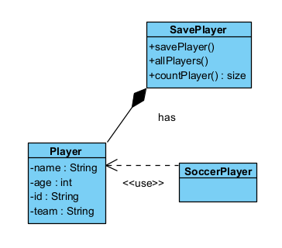

2) Running program (cmd line executing the program)

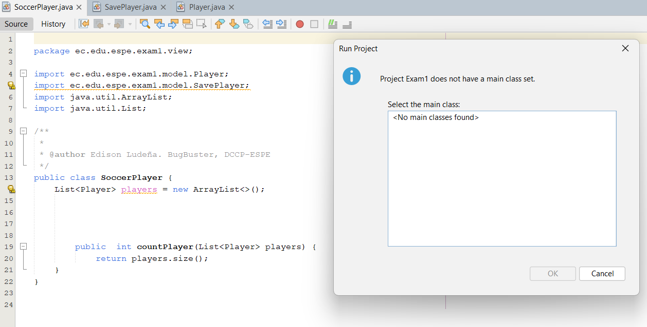

3) Printing/counting/deleting objects from JSON File (according to the roster number)

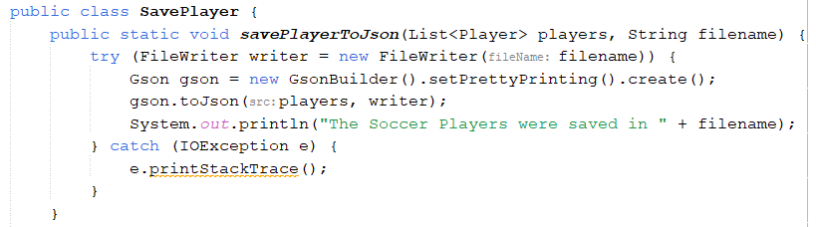

4) Saving JSON data (screenshot of the json file)



5) Code Quality (lines of code with stinky code)

