**Object-Oriented Programming**

**WorkShop #31**

**DATE: 19/07/2023**

**NRC: 9652**

GitHub /10

Google Doc /10

MongoDB /10

Class Diagram /10

Use Case /10

MVC /10

Polymorphism /10*

Test Cases /10

* Unit Test

Gui /10

Menú /10

* Forms
* Tables
* Printouts

CRUD /10

* Business Rules

1. Cedeño Rony (NO MORE)
2. Galarza Luis
3. Ludeña Edison
4. Miranda Alison /10

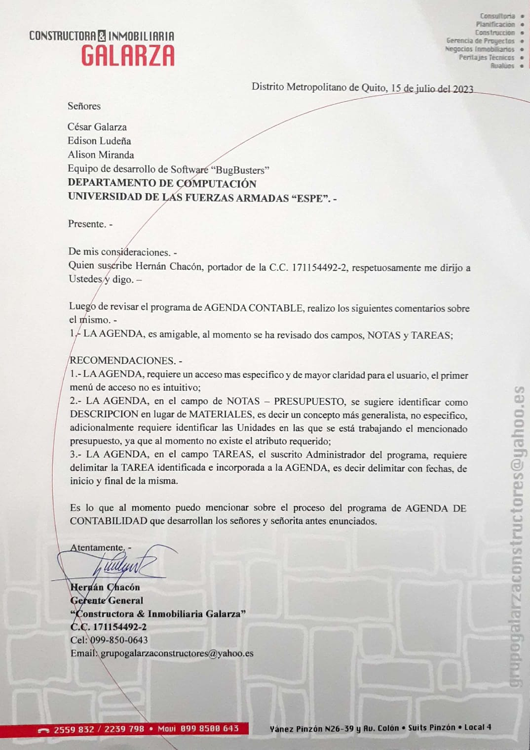

GitHub 10/10

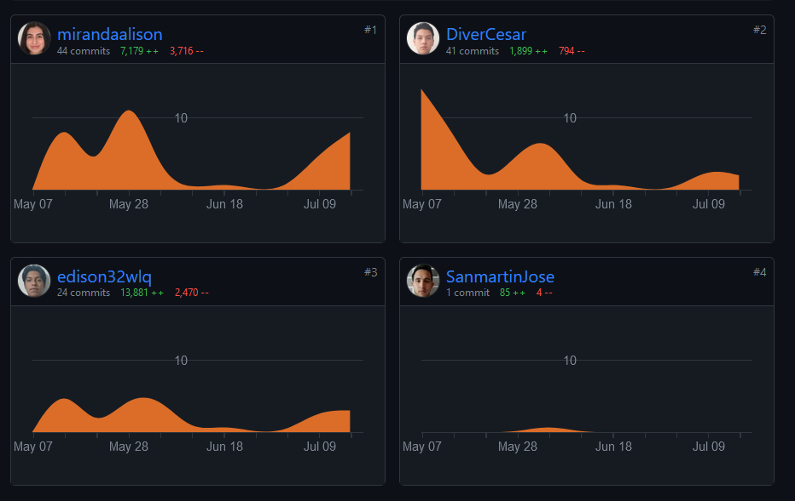

Google Doc 10/10

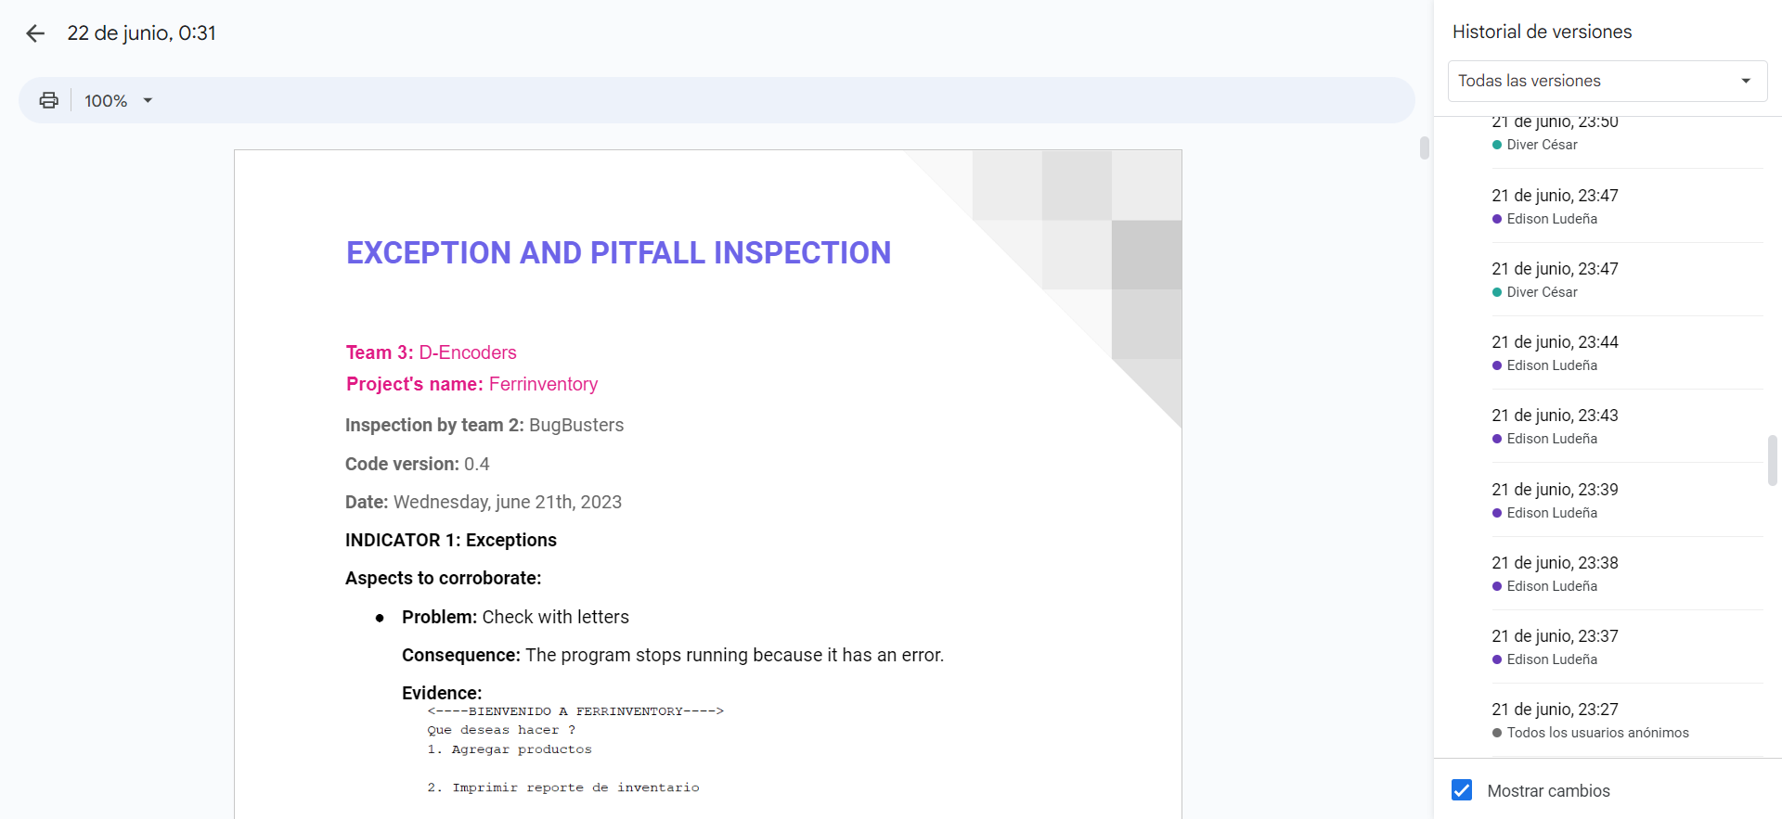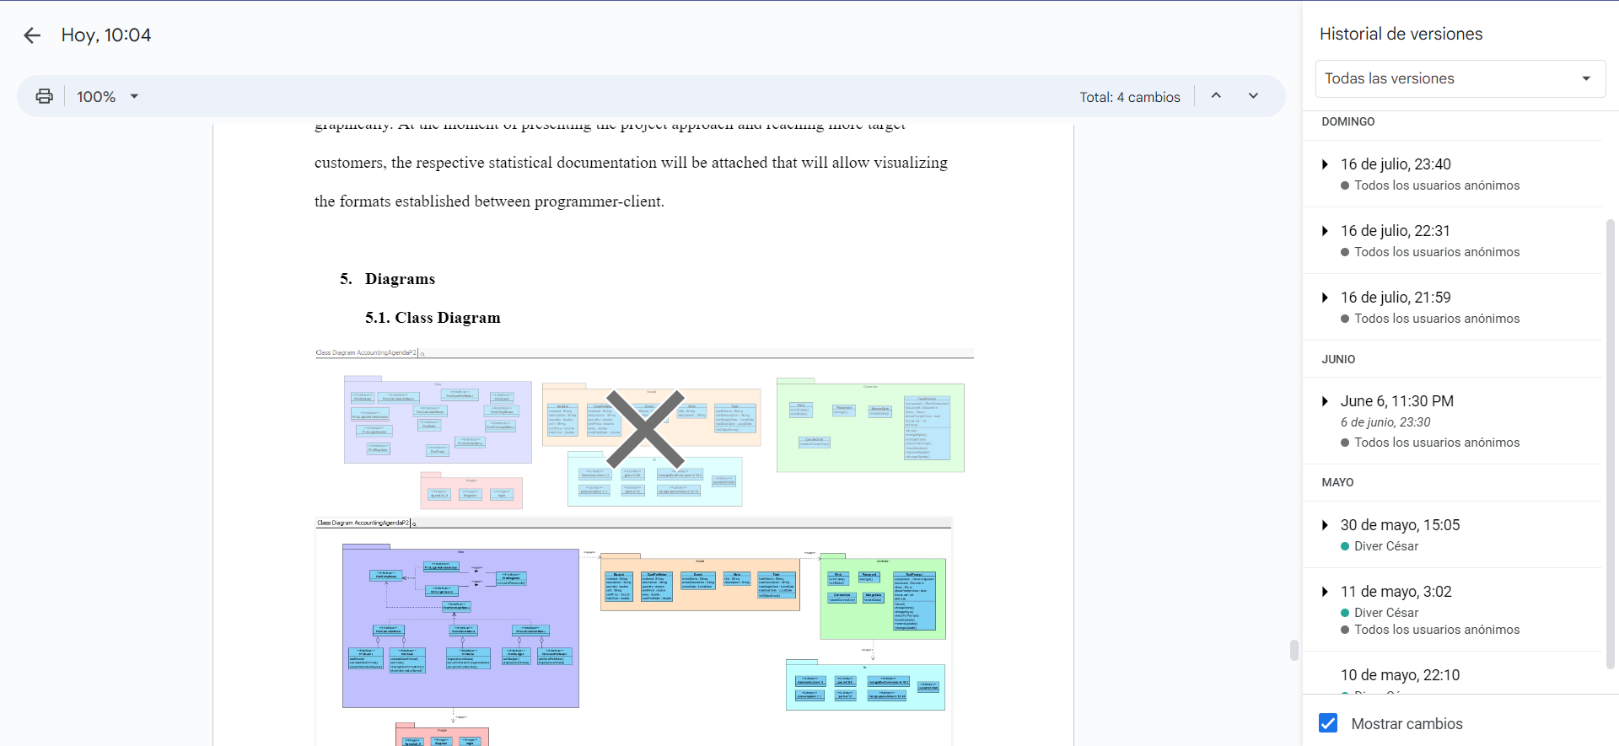MongoDB 8/10

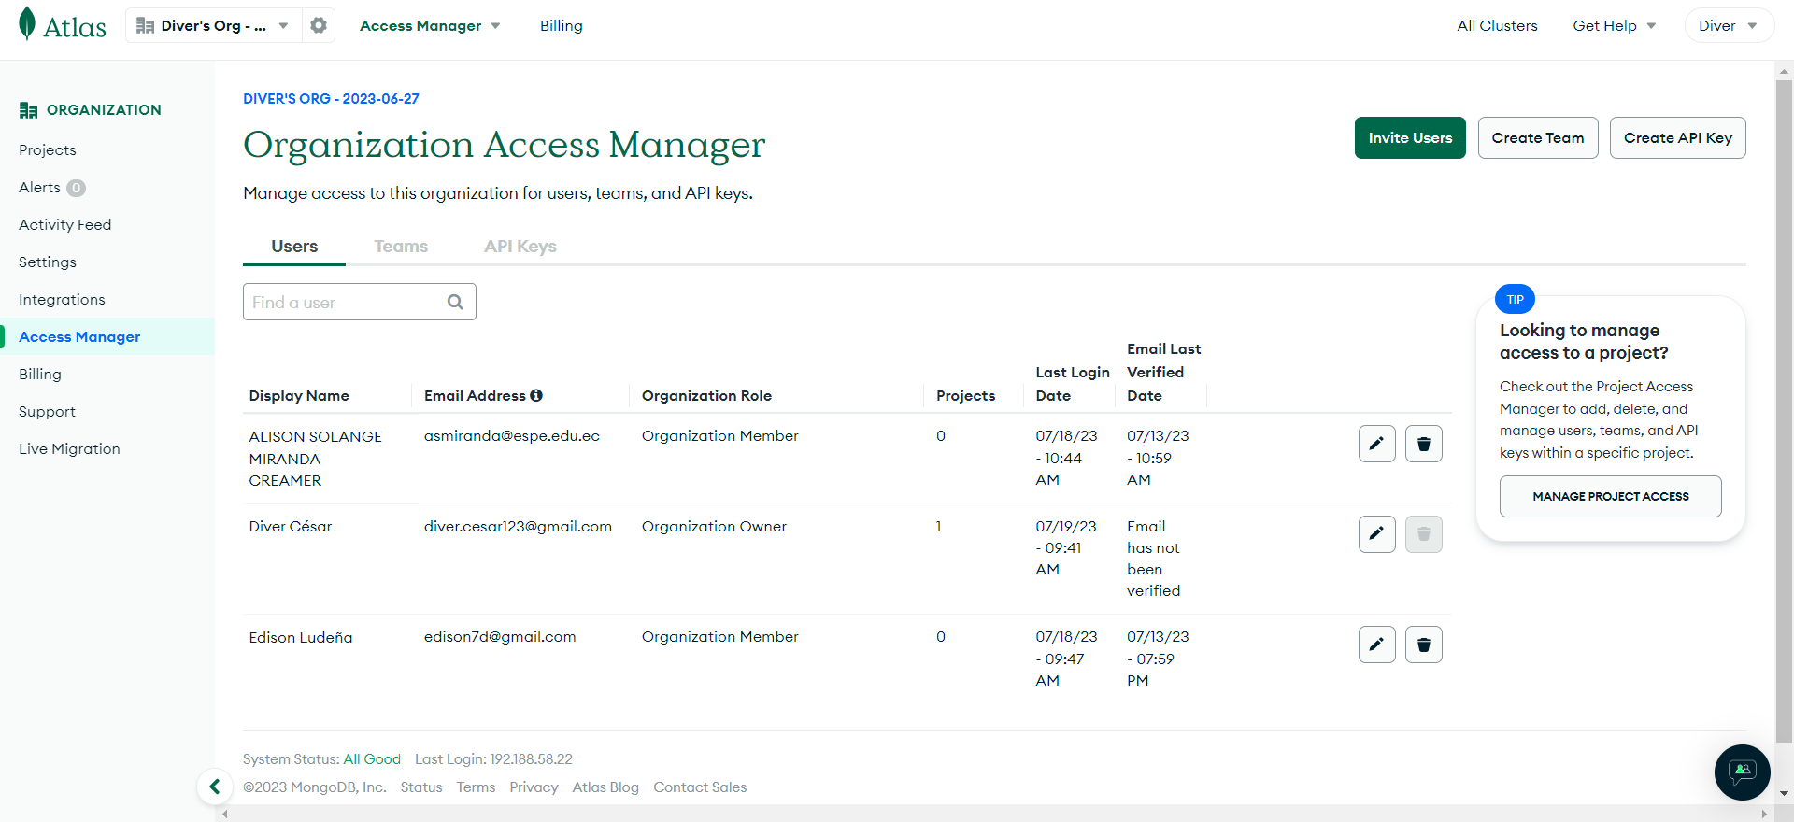

Class Diagram 8/10

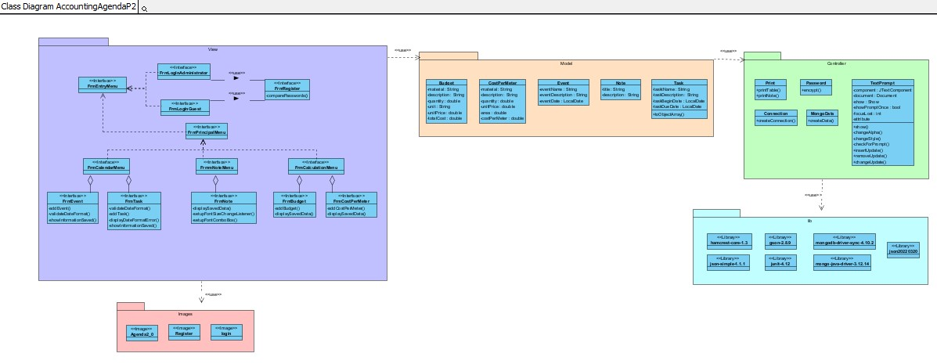

Use Case 10/10

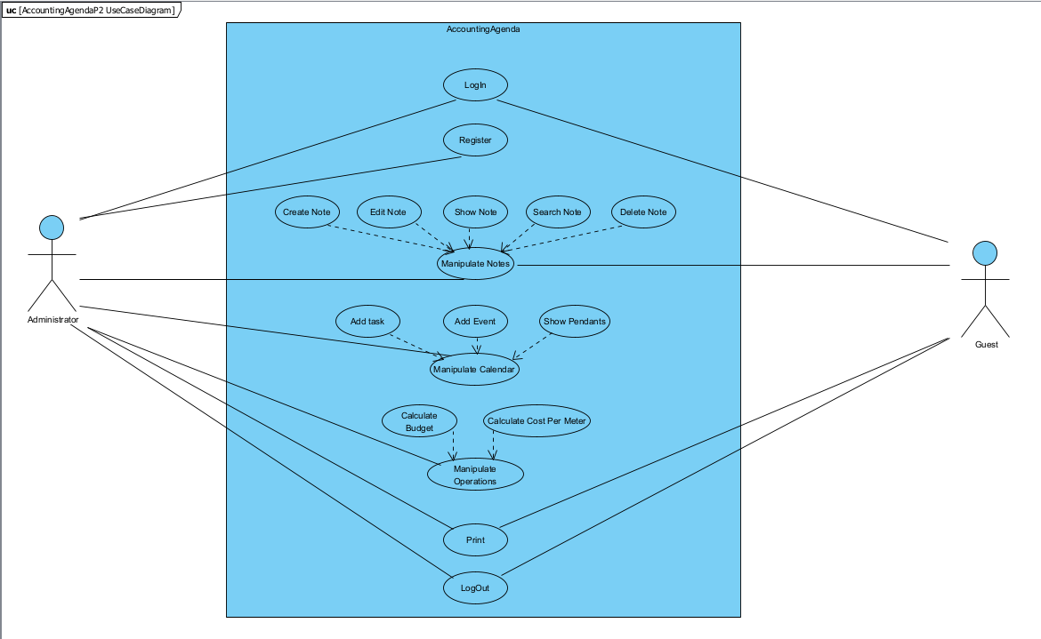

MVC 9/10

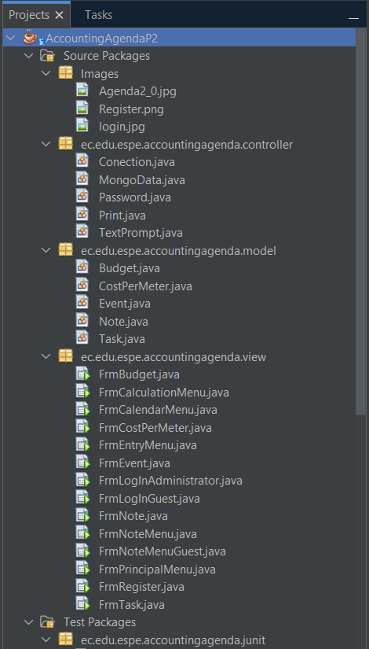

Polymorphism 10/10*

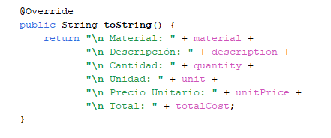

Test Cases 10/10

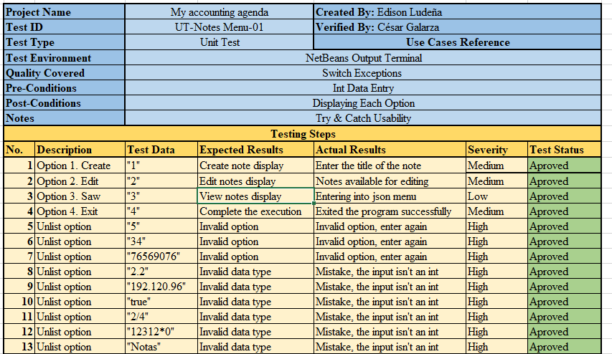

* Unit Test

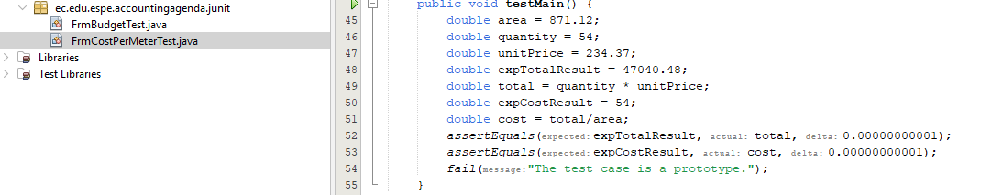

Gui 10/10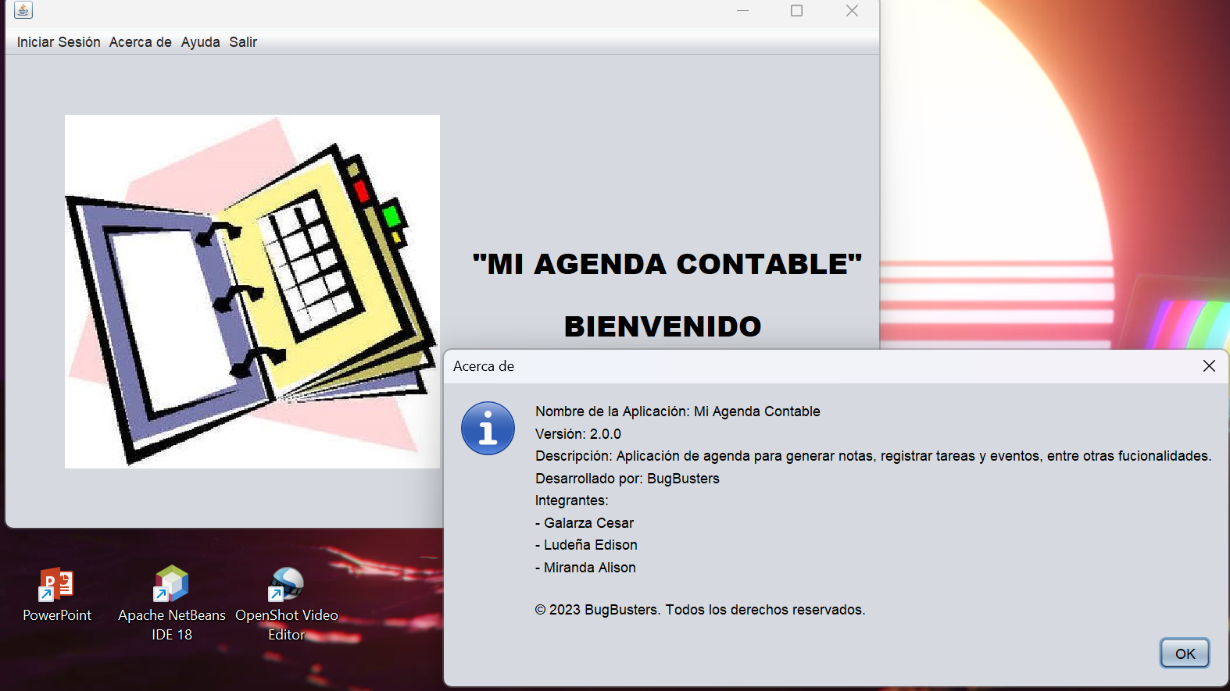

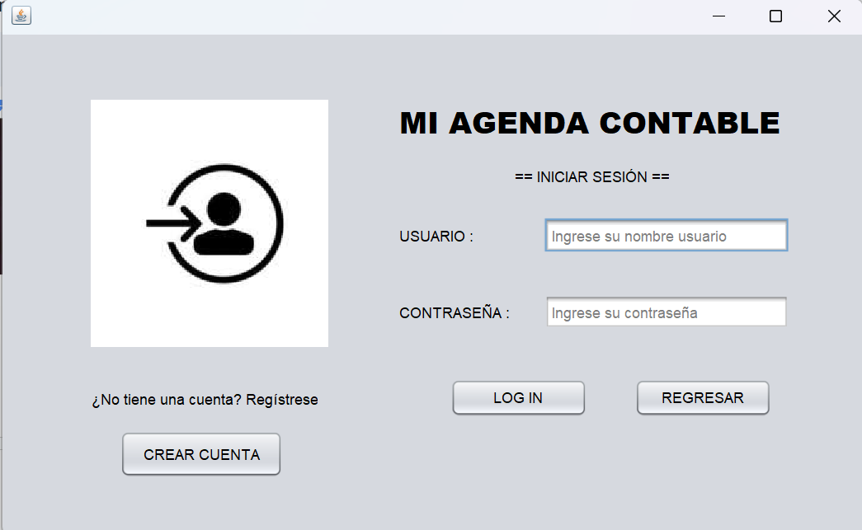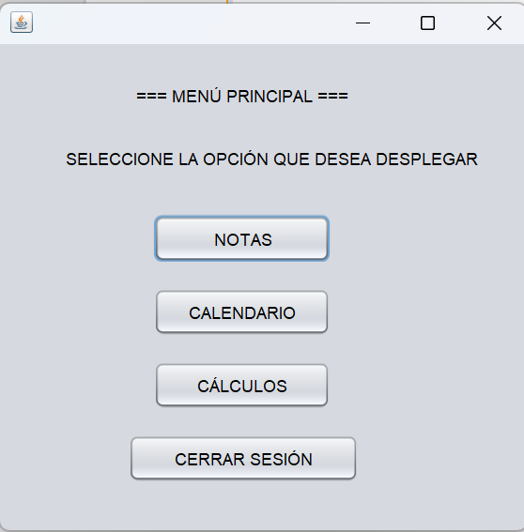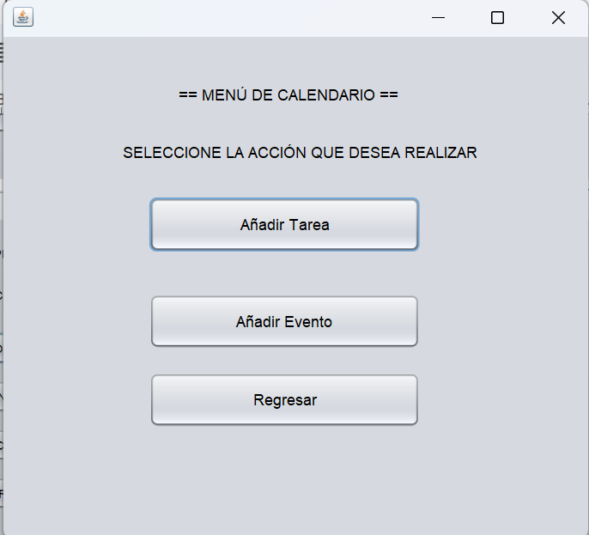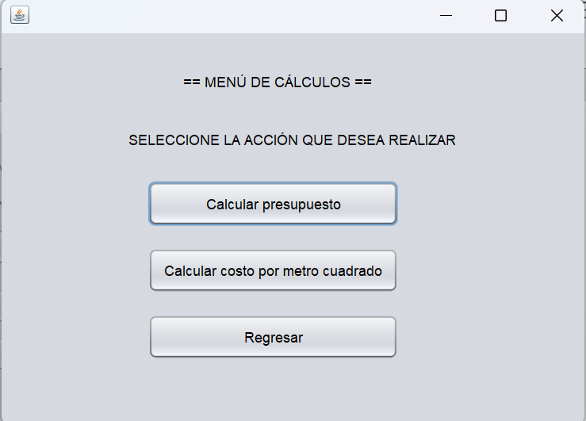

Menú 10/10

* Forms

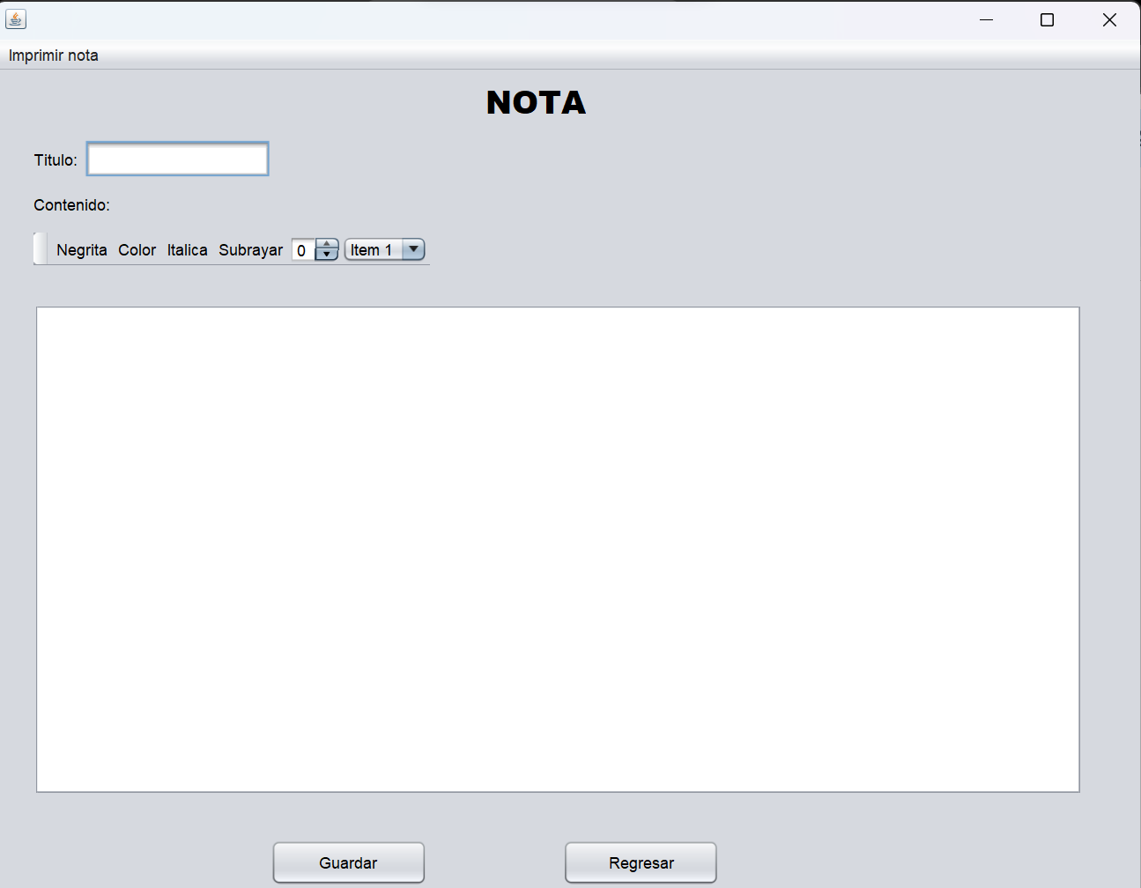

* Tables

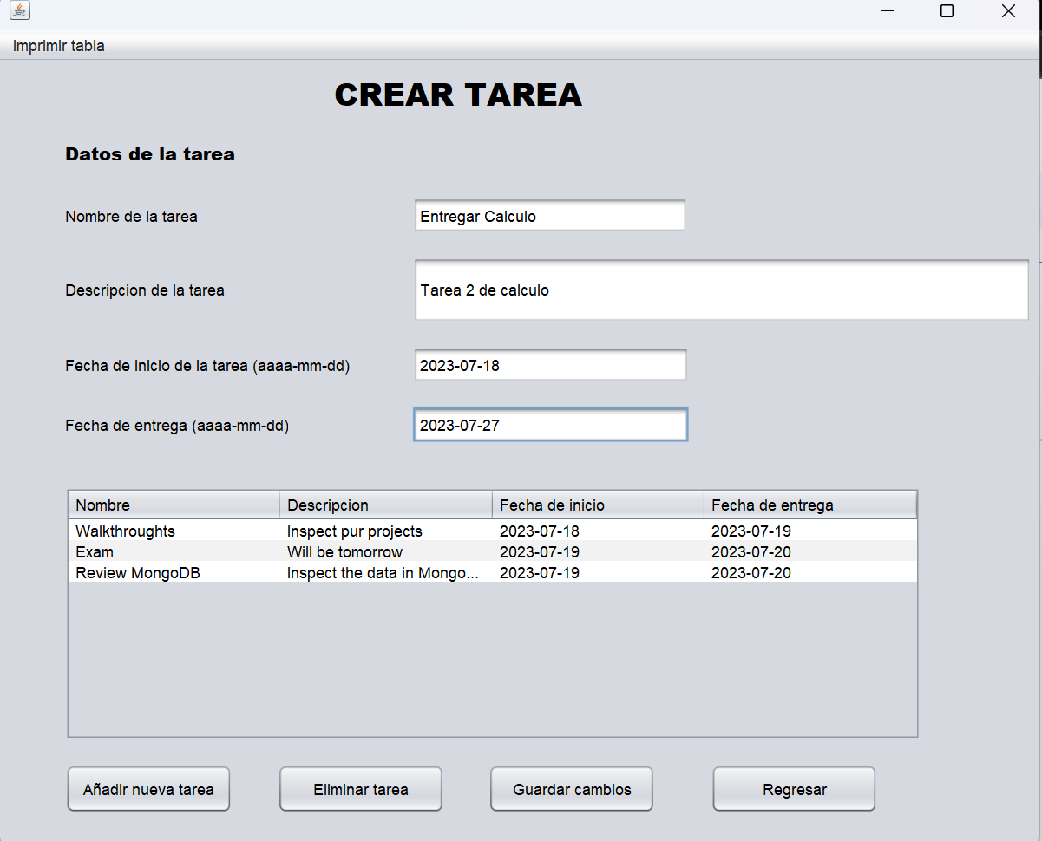

* Printouts

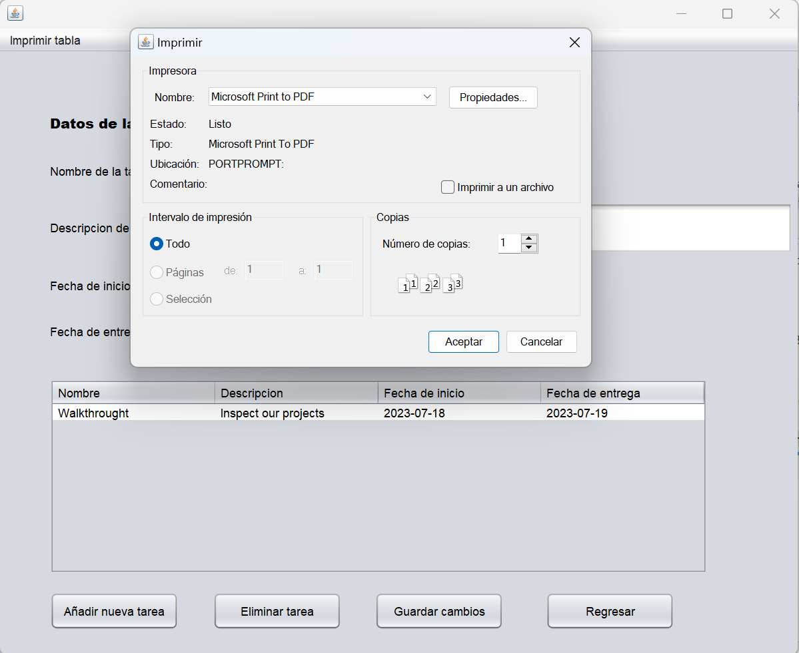

CRUD 10/10

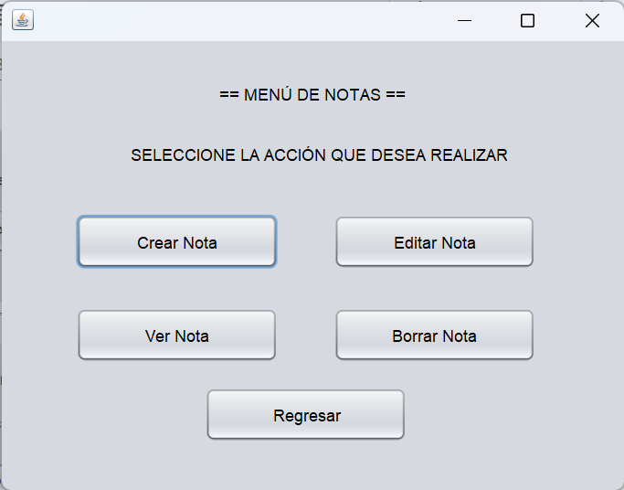

* Business Rules

