**Object-Oriented Programming**

**WorkShop #32**

**DATE: 24/07/2023**

**NRC: 9652**

**RUBRIC:**

**Theory Exercise: /15**

**Class Diagram: /10**

* Design the class diagram following the MVC pattern (5 points),
* Two GUI screens (menu, create/add, list), specifying the type of widgets you would use (5 points).

Use Visual Paradigm for the class diagram and a piece of paper or a mockup tool for the GUI design. If you don't have access to Visual Paradigm, you can draw the diagram in a piece of paper IF YOU DON'T UPLOAD THE DESIGN, your grade in the exercise WILL BE ZERO (0/40)

**Code: /30**

MVC:.......................... 5 pts

GUI implementation:. 5 pts. (Create: good use of widgets, read all: good use of tables)

DB implementation:.. 5 pts.

Data persistence:..... 10 pts. (your application inserts into MongoDB Atlas, your application read from MongoDB Atlas)

Clean code:................ 5 pts.

**Killer: Name**

1. Casignia Diego

**Theory Exercise: 9/15**

**Class Diagram: 6/10 (Bad implementation of GUI screens)**

* Design the class diagram following the MVC pattern (5 points),
* Two GUI screens (menu, create/add, list), specifying the type of widgets you would use (5 points).

Use Visual Paradigm for the class diagram and a piece of paper or a mockup tool for the GUI design. If you don't have access to Visual Paradigm, you can draw the diagram in a piece of paper IF YOU DON'T UPLOAD THE DESIGN, your grade in the exercise WILL BE ZERO (0/40)

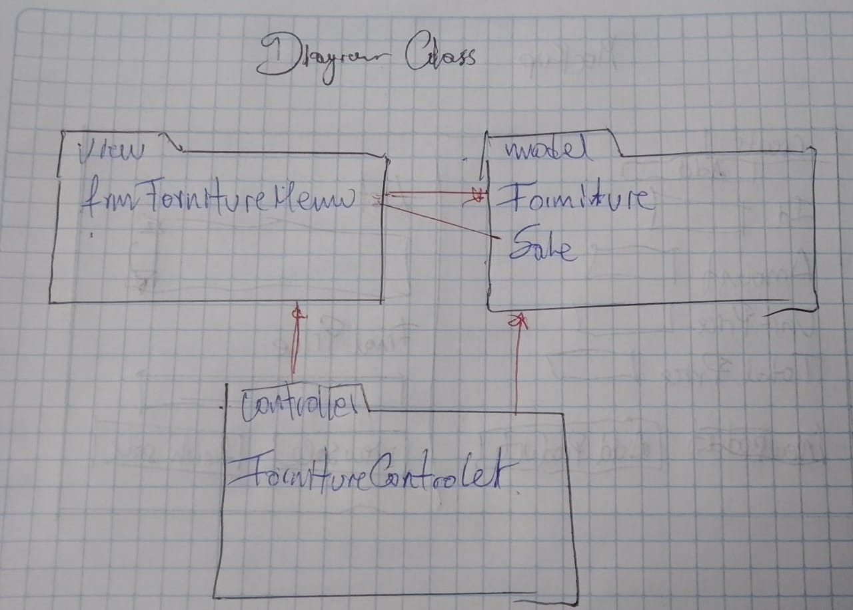

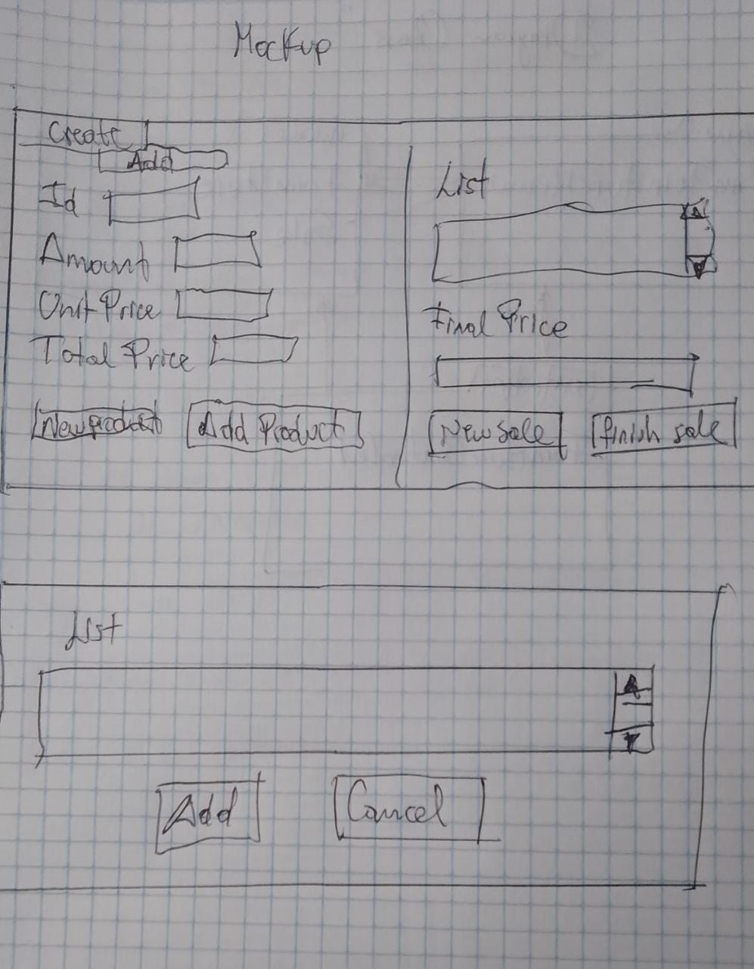

**Code: 30/30**

MVC:.......................... 5/5 pts. (Divided packages)

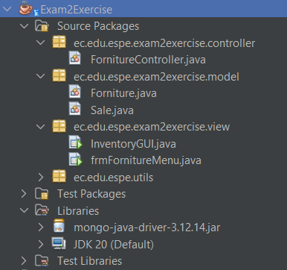

GUI implementation:. 5/5 pts. (Create: good use of widgets, read all: good use of tables)

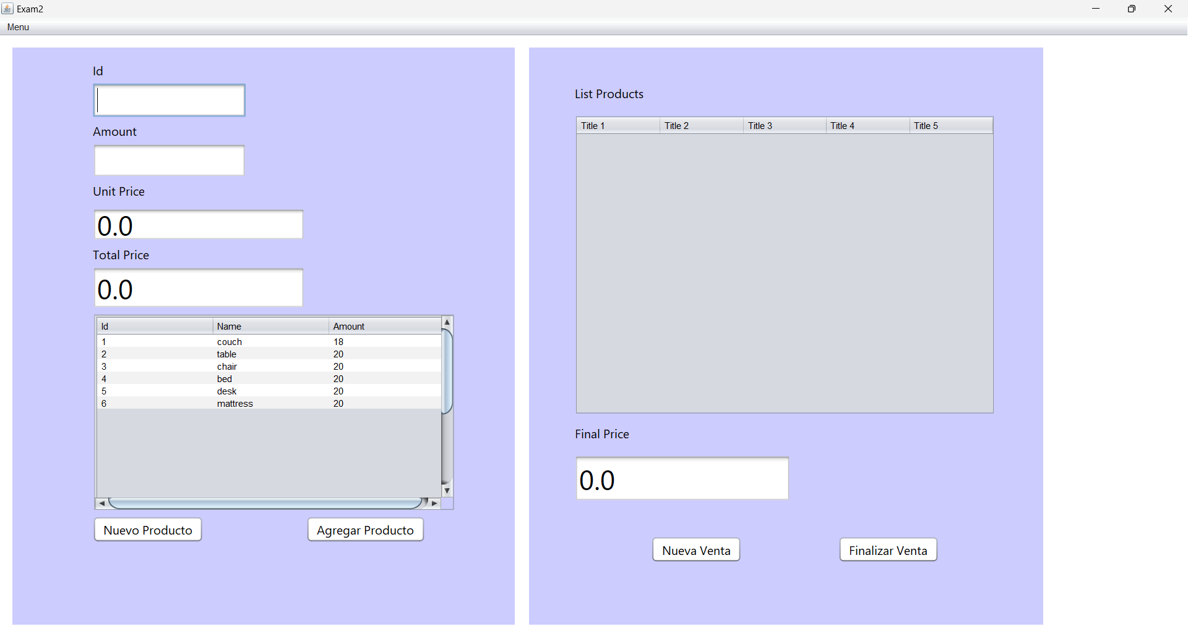

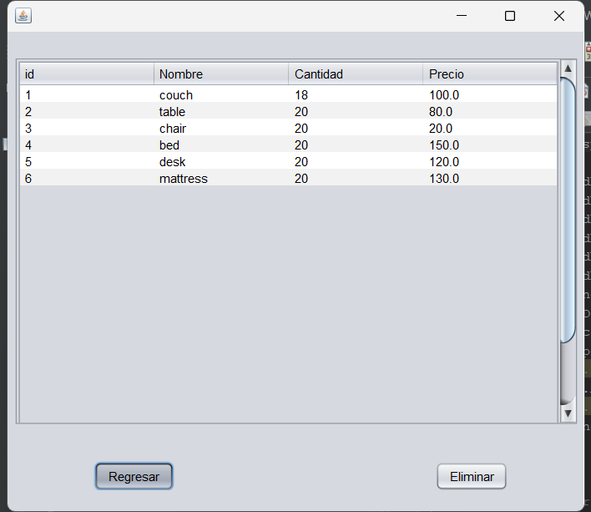

DB implementation:.. 5/5 pts.

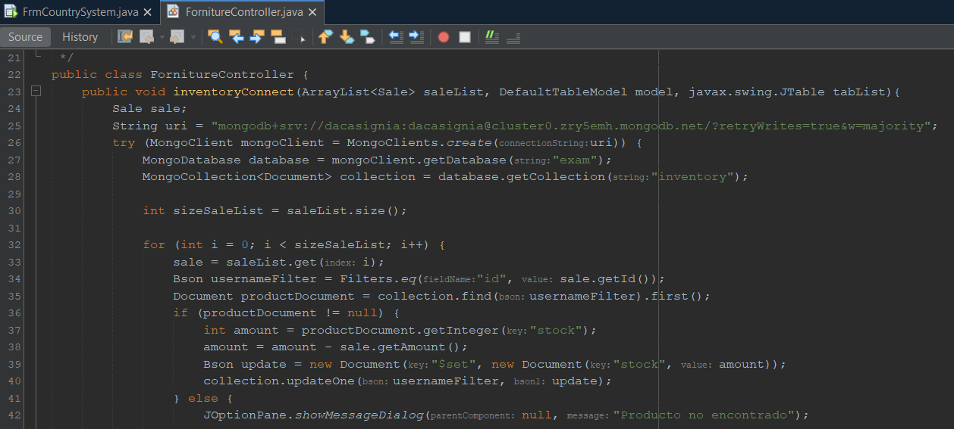

Data persistence:..... 10/10 pts. (your application inserts into MongoDB Atlas, your application read from MongoDB Atlas)

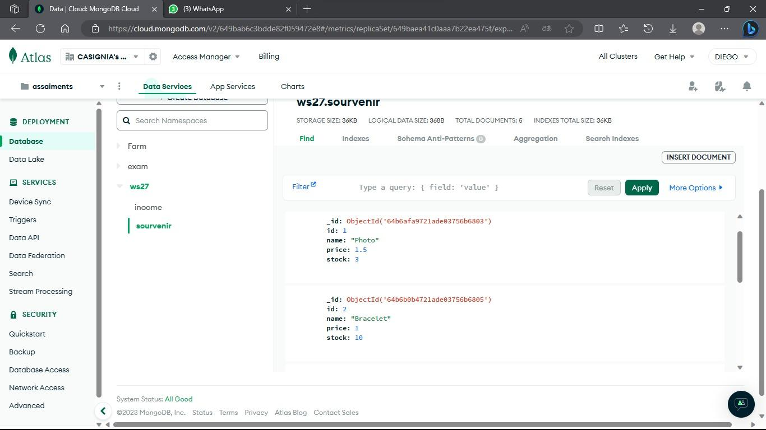

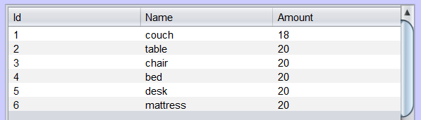

Clean code:................ 5/5 pts.

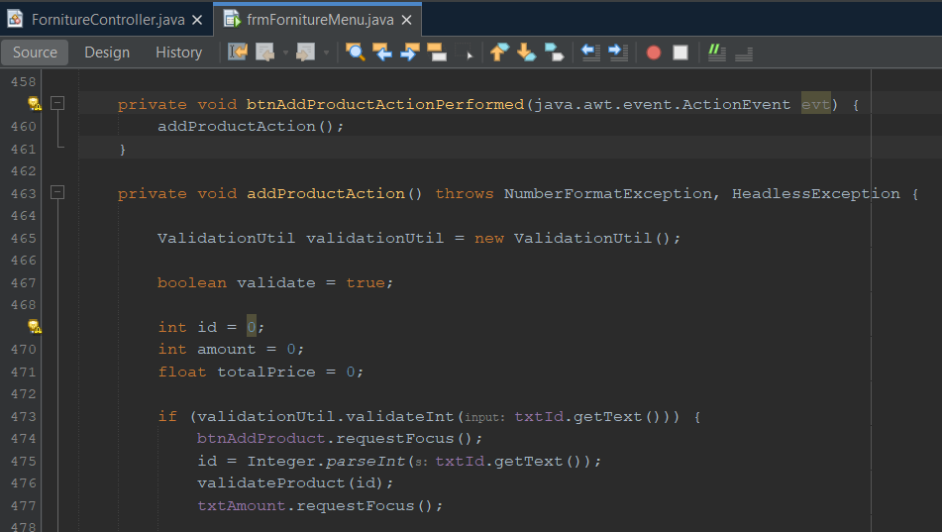

**Killer:** César Galarza

1. Cedeño Rony (Didn’t come more)

**Theory Exercise: 0/15**

**Class Diagram: 0/10**

* Design the class diagram following the MVC pattern (5 points),
* Two GUI screens (menu, create/add, list), specifying the type of widgets you would use (5 points).

Use Visual Paradigm for the class diagram and a piece of paper or a mockup tool for the GUI design. If you don't have access to Visual Paradigm, you can draw the diagram in a piece of paper IF YOU DON'T UPLOAD THE DESIGN, your grade in the exercise WILL BE ZERO (0/40)

**Code: 0/30**

MVC:.......................... 0/5 pts

GUI implementation:. 0/5 pts. (Create: good use of widgets, read all: good use of tables)

DB implementation:.. 0/5 pts.

Data persistence:..... 0/10 pts. (your application inserts into MongoDB Atlas, your application read from MongoDB Atlas)

Clean code:................ 0/5 pts.

**Killer:** César Galarza

1. Galarza César

**RUBRIC:**

**Theory Exercise: 9/15**

Class Diagram: 10/10

* Design the class diagram following the MVC pattern (5 points),
* Two GUI screens (menu, create/add, list), specifying the type of widgets you would use (5 points).

Use Visual Paradigm for the class diagram and a piece of paper or a mockup tool for the GUI design. If you don't have access to Visual Paradigm, you can draw the diagram in a piece of paper IF YOU DON'T UPLOAD THE DESIGN, your grade in the exercise WILL BE ZERO (0/40)

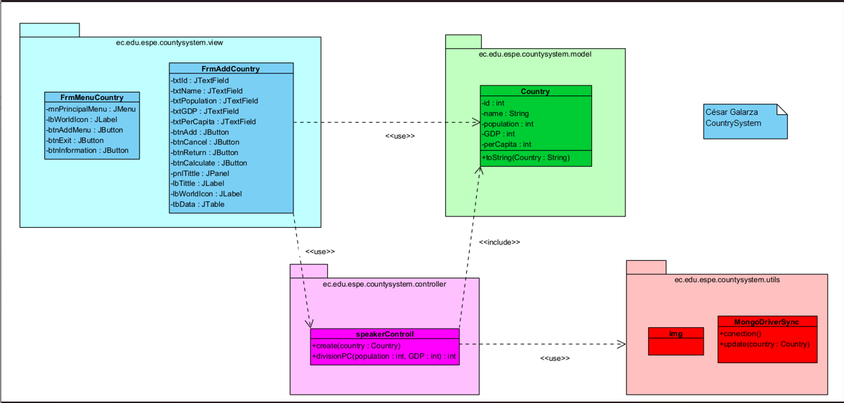

Code: 17/30

MVC:.......................... 5/5 pts

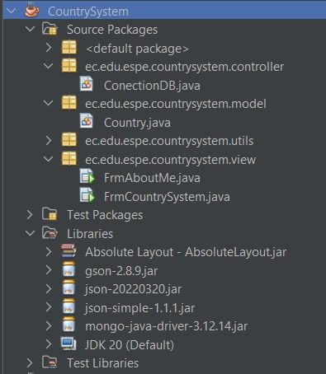

GUI implementation:. 4/5 pts. (Create: good use of widgets, read all: good use of tables)

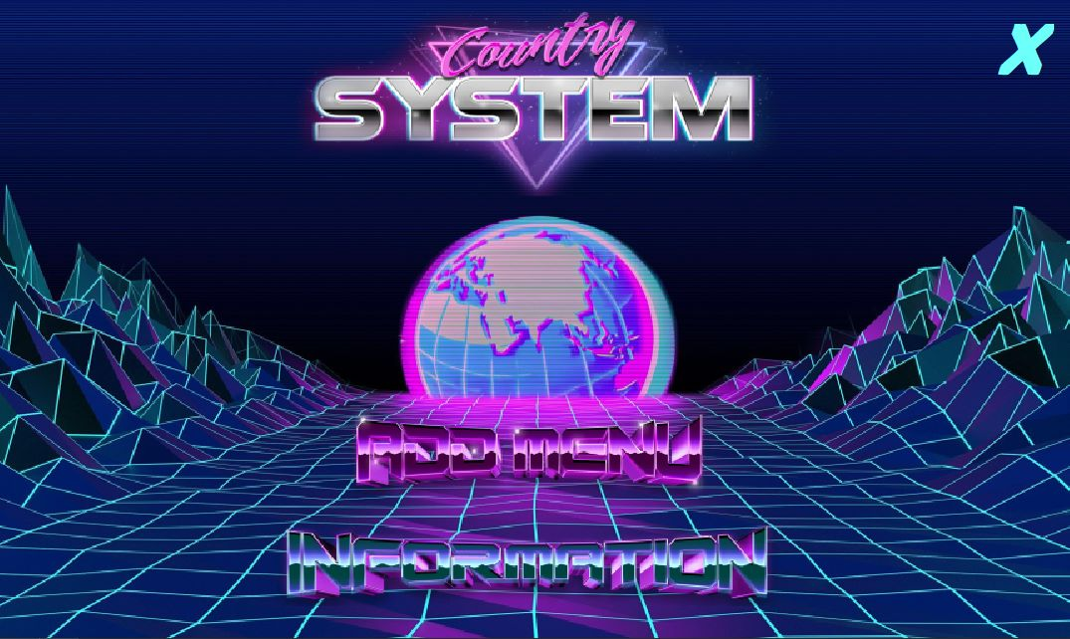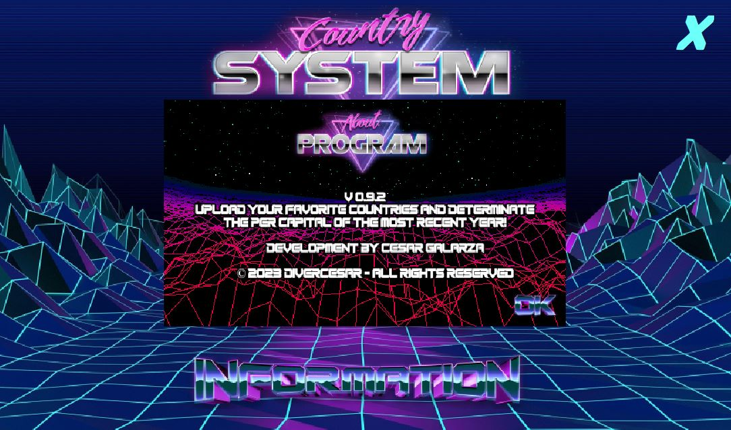

DB implementation:.. 3/5 pts.

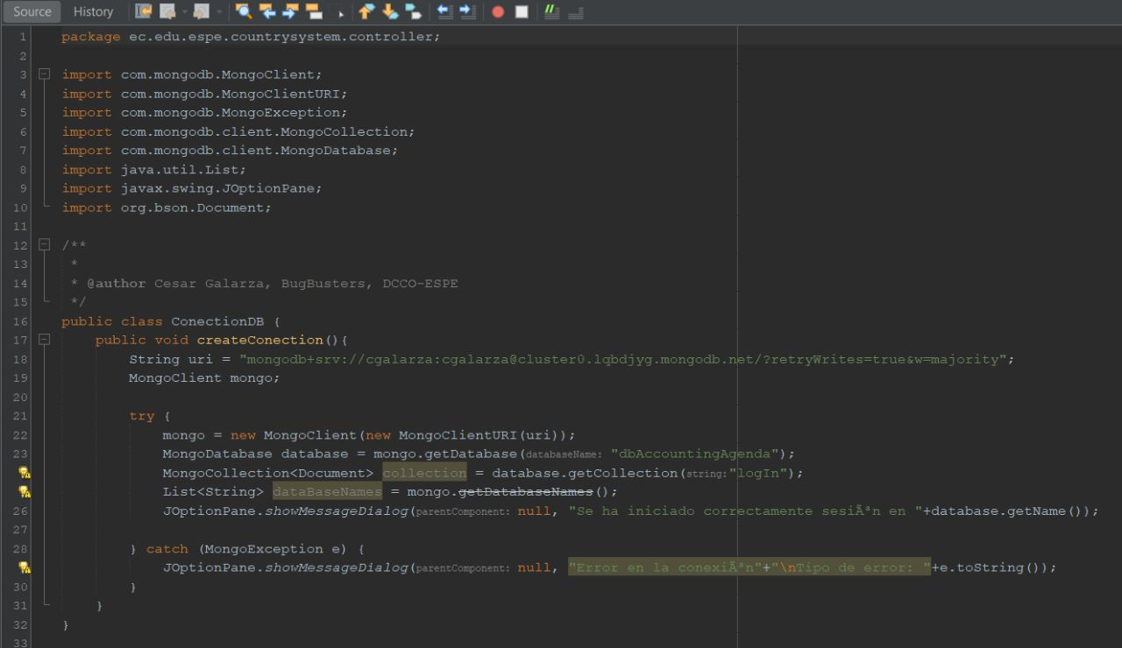

Data persistence:..... 0/10 pts. (your application inserts into MongoDB Atlas, your application read from MongoDB Atlas)

doesn’t perform eny action

Clean code:................ 5/5 pts.

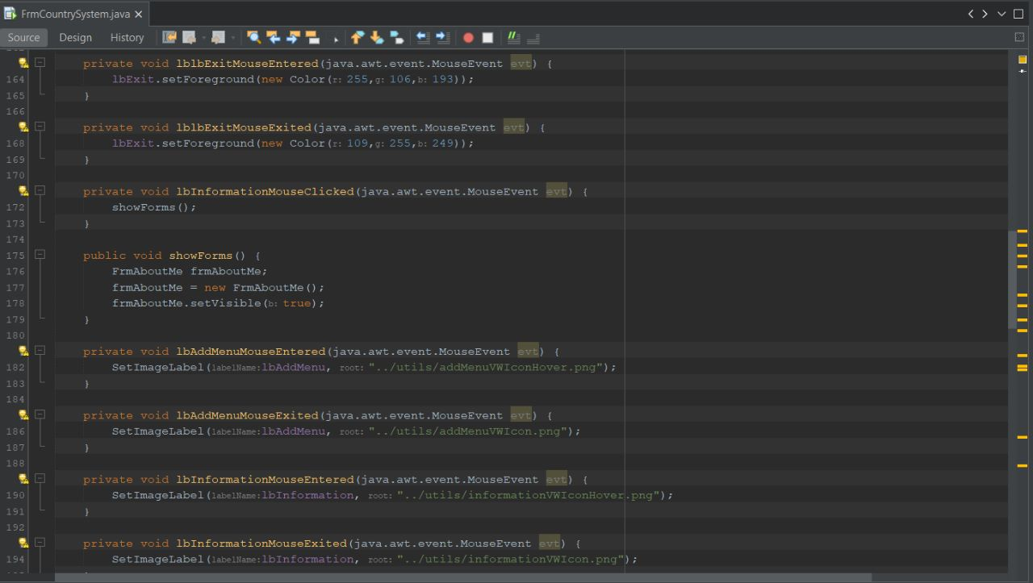

Inspector: Edison Ludeña