**Object-Oriented Programming**

**WorkShop #38**

**DATE: 22/08/2023**

**NRC: 9652**

Rubric:

Project GitHub /25 (Individual Contribution)

Project Review (Inspection) /25

* Requirements and modeling (updated and design patterns) /5
* Principles, CleanCode, Pitfalls /5
* Functional Requirements user test (No CRUD operations) /5
* MongoDB /5
* Design patterns code /5

Project Maintenance /25 (Time effort)

Project Letter /25 (Letter of acceptance or revie

Evidence:

Project GitHub

Project Review (Inspection)

* Requirements and modeling (updated and design patterns)
* Principles, Clean Code, Pitfalls
* Functional Requirements user test (No CRUD operations)
* MongoDB
* Design patterns code

Project Maintenance

Project Letter

1. Cedeño Rony
2. Galarza Luis
3. Ludeña Edison
4. Miranda Alison

Project GitHub /25 (Individual Contribution)

Project Review (Inspection) 22.5/25

* Requirements and modeling (updated and design patterns) 2.5/5
* Principles, CleanCode, Pitfalls 5/5
* Functional Requirements user test (No CRUD operations) 4/5
* MongoDB 5/5
* Design patterns code 5/5

Project Maintenance 23/25 (Time effort)

new user type 9/10

report screen 9/10

print out 5/5

Project Letter 25/25 (Letter of acceptance or revie

Evidence:

Project GitHub

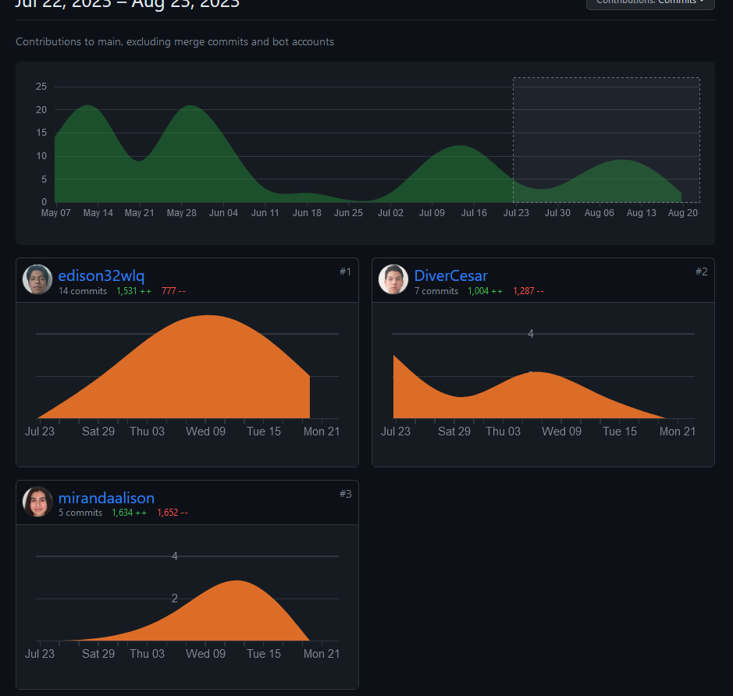

Project Review (Inspection)

* Requirements and modeling (updated and design patterns)

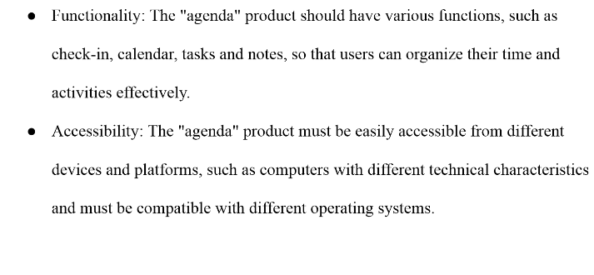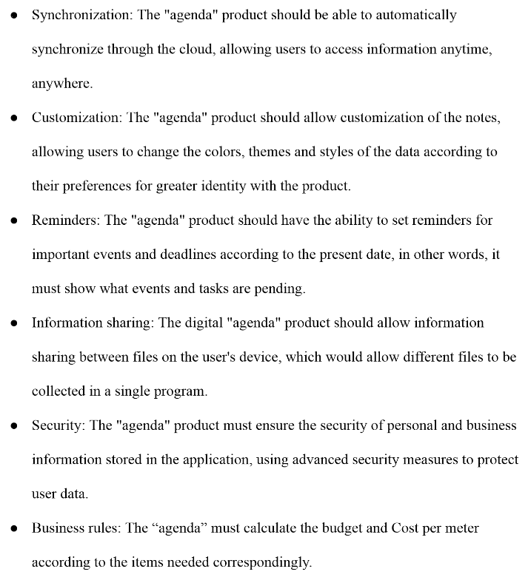

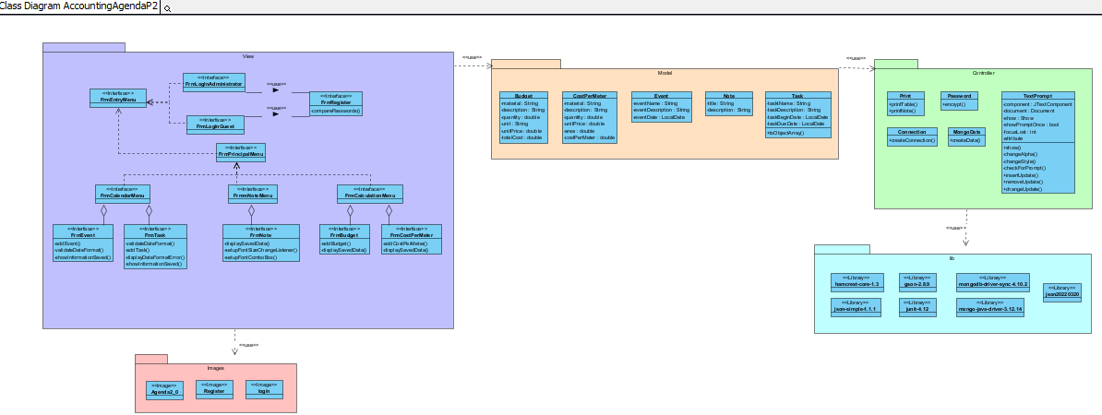

* Principles, Clean Code, Pitfalls

Single Responsibility

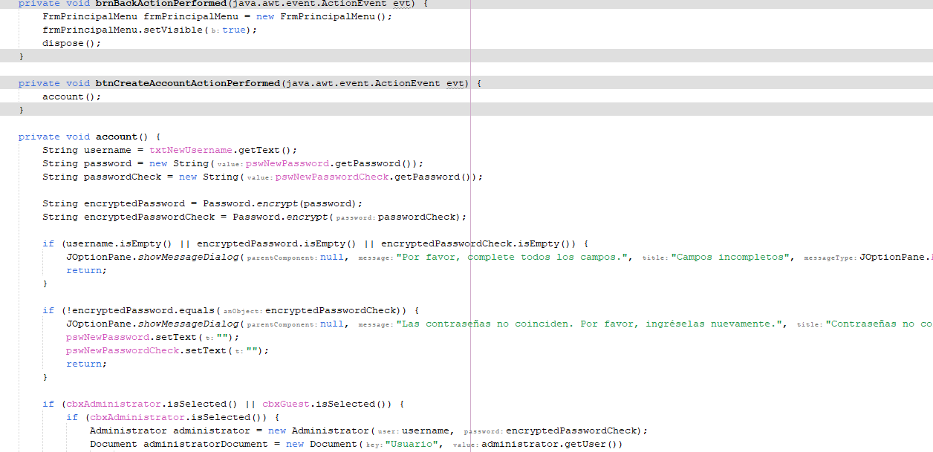

Clean Code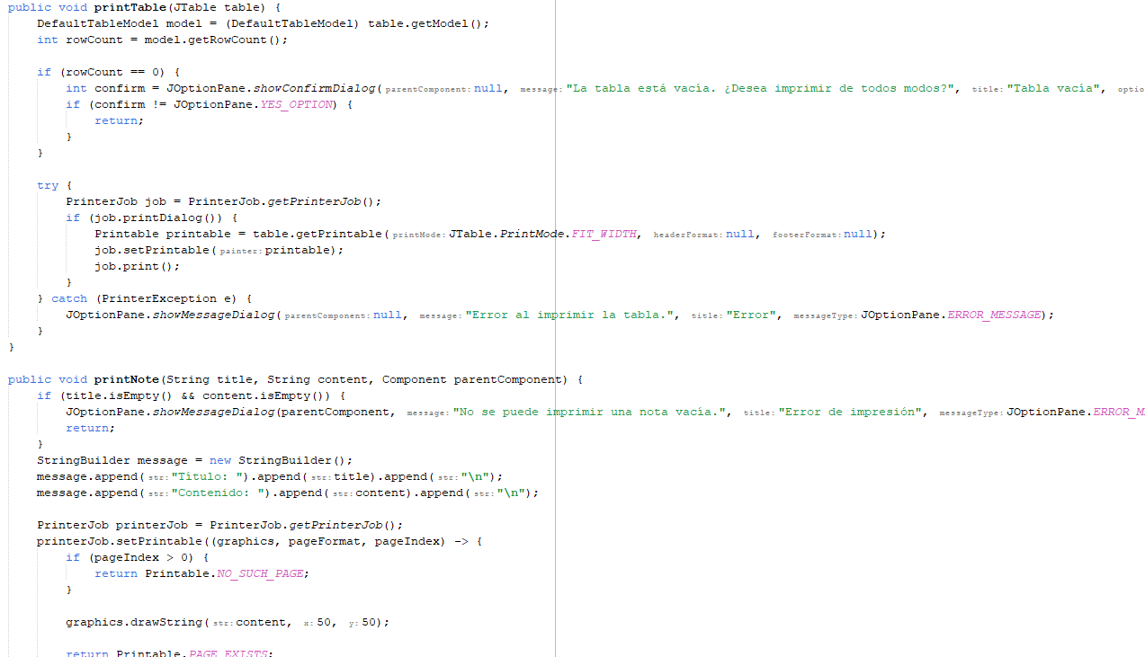

* Functional Requirements user test (No CRUD operations)

Do interactive notes

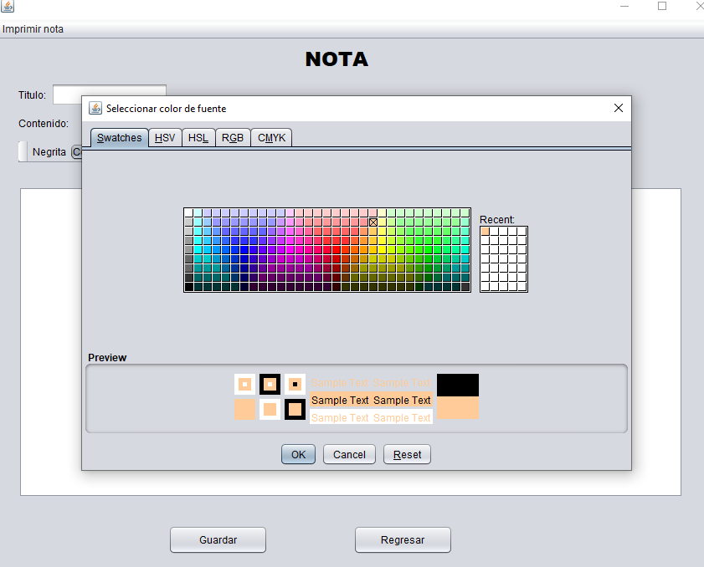

Calculate Budget

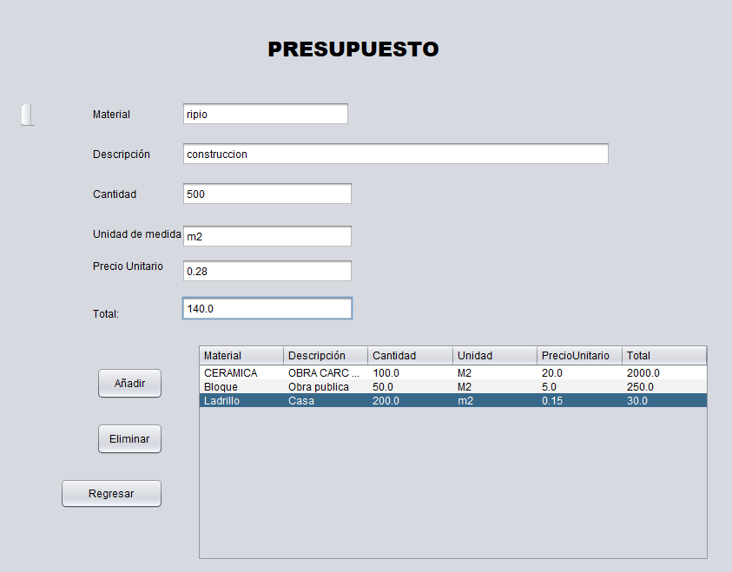

Crud

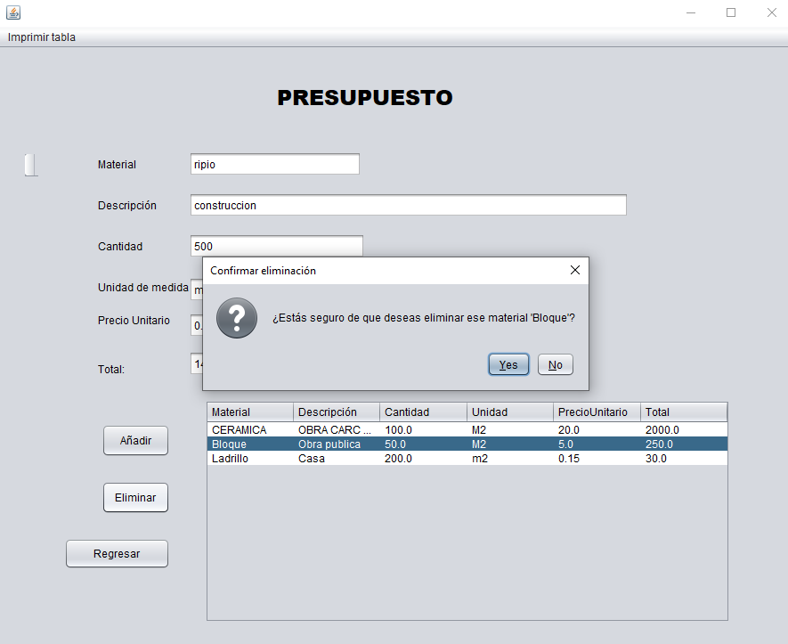

* MongoDB

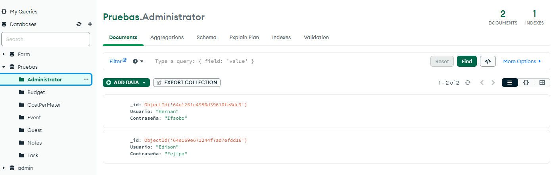

* Design patterns code

Singleton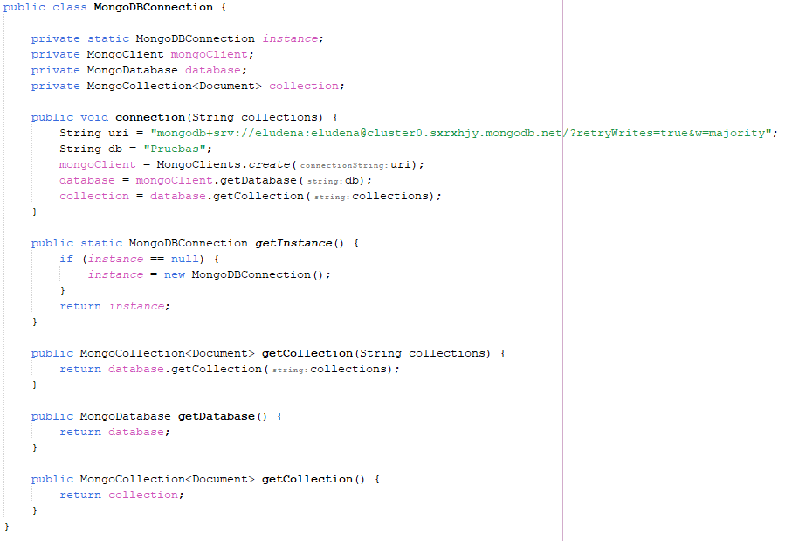

Composite

