**Team #03: Jezhe Software Engineers association**

1. **RICARDO ANDRES LAINEZ SUAREZ**
2. **JERSON STIVEN LLUMIQUINGA MORENO**
3. **ZAITH ALEJANDRO MANANGON VINUEZA**
4. **HEIDY SOLANGE MERA ROSERO**

[**https://www.youtube.com/watch?v=5WS-kGwtLZw&ab_channel=JEZHESoftwareEngineersAssociation**](https://www.youtube.com/watch?v=5WS-kGwtLZw&ab_channel=JEZHESoftwareEngineersAssociation)

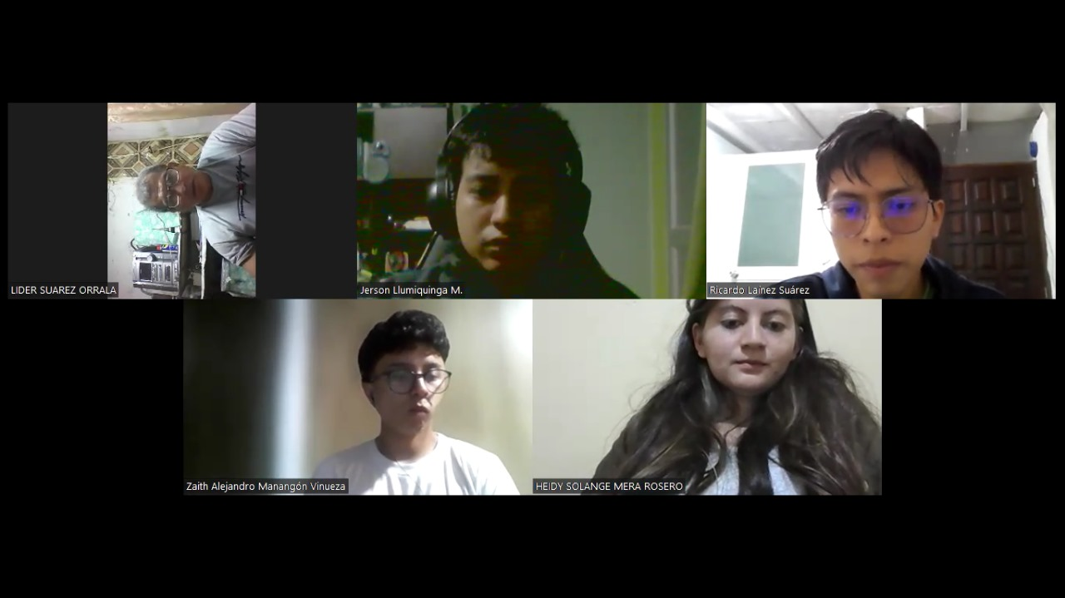

**main requirements (for the moment):**

1. The system should handle up to 10 points in total for each partial, each assignment, test, exam and grade project should be measured by percentages.
2. The system should not bounce the system at the time of putting a grade, an example would be if a student has a 7.40 and in the system after a few days has 7.10, avoid this.
3. That the entry of the program is governed by a username and password, only the teacher is allowed to enter this so it is only a page for teachers.
4. When the partial is finished, the system should send a report about the student's grade.
5. That the transfer of grades is efficient.
6. To be able to add, delete, and edit the data, or grades of a student.
7. The student capacity will be between 20 to 30 students.
8. Grades will range from 0 to 10.

**Conclusions:**

By satisfying these requirements, the grade recording software will provide teachers with an efficient and secure tool for academic management, improving the accuracy of grade recording and facilitating the management of student performance. This will not only optimize teachers' time and effort, but will also contribute significantly to the educational quality of the institution.