**Team 4: [ CodeCrafting Engineers]**

1. **GABRIEL ANTHONY MOLINA GALLEGOS**
2. **LEYDI ESPERANZA OÑA SUQUILLO**
3. **MARCO ADRIAN PADILLA TRIVIÑO**
4. **DAVID ALEXANDER PILAGUANO CHISAGUANO**

**Link:** <https://youtu.be/uykaysUmZEE?si=HZNSTpS617KPxXcK>

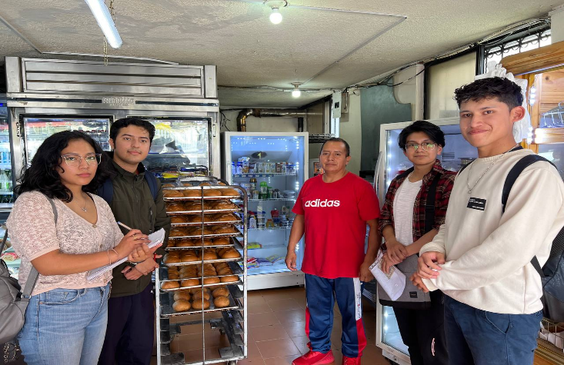

**Main Requirements for the Software:**

**Inventory Management:**

* It must generate alerts when stock levels are low and suggest reorder quantities.

**Cash Register Integration:**

* It must provide daily, weekly, and monthly sales reports for financial tracking.

**Product Management:**

* It must allow easy updates to product lists, prices, and descriptions.

**Order and Sales Processing:**

* It must record detailed sales information, including customer data, order contents, and payment status.

**Reports and Analysis:**

* The system must generate various reports, including sales trends, inventory usage, and customer behavior analysis.

**User Access and Security:**

* The system must have user authentication and role-based access control to ensure security.

**Support and Assistance:**

* It must have an option to contact support for troubleshooting and assistance.

**Conclusion:**

The management software for the bakery must be comprehensive and flexible, covering critical functions such as inventory management with stock alerts, detailed financial reports, easy product updates, detailed sales records, analytical report generation, security through access control and authentication, and robust technical support. This approach will ensure efficient operations, better financial control, and an improved customer experience.