**hw22-FixThePitfalls**

**Solution:**

**Oddball Solution**

Simplify the isValidId method in the Validations class.  
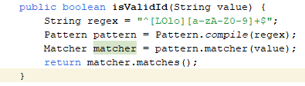

**Type embedded in names:**

**Change it to employeeFilePath to avoid having the type (file) in the name.**



**Conditional Complexity:**

Use a stream to simplify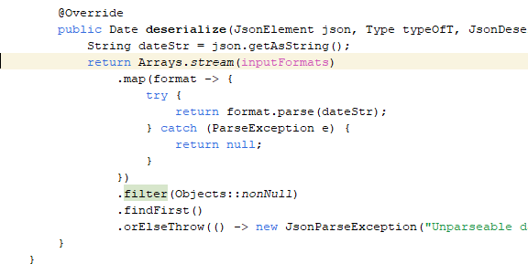

Long Methods:

Split into smaller methods

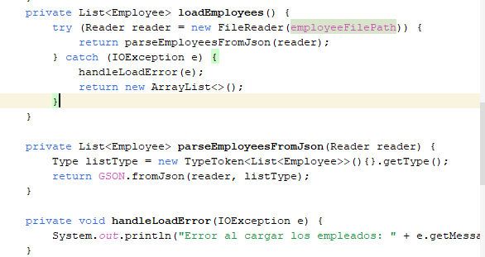

**Dead Code**:

Remove code from getIntInput

**Non-descriptive variable names:**

They should have clearer names that indicate their exact purpose, such as gsonInstance or employeeList or employees.

