**Hw-23SOLIDPrinciples**  
**Single Responsibility Principle (SRP):**

The EmployeeManager class has too many responsibilities. We could separate the persistence logic (save/load employees) into a separate class, for example EmployeePersistence.

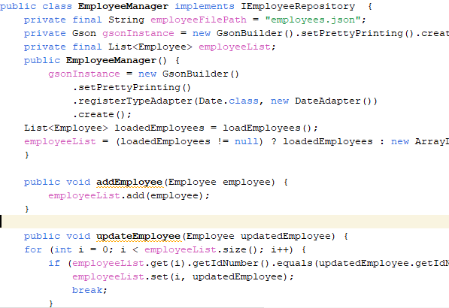

The Calculator class could be split into smaller, more specific classes, such as SalaryCalculator, DeductionCalculator, etc.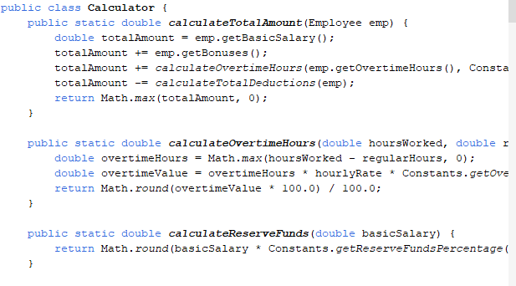

**Open/Closed Principle (OCP):**

We could create an IEmployeeRepository interface that defines methods to add, update, and delete employees. Then implement this interface for different storage types (MongoDB, JSON, etc.).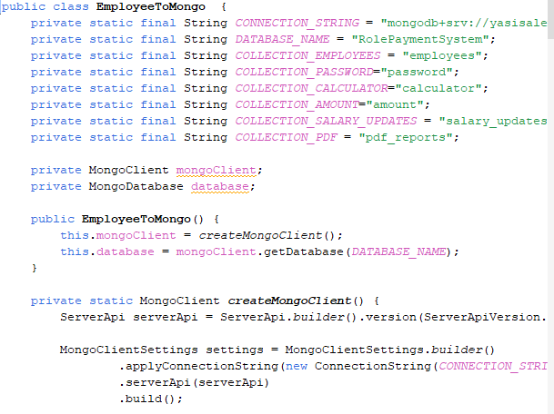

Second:

